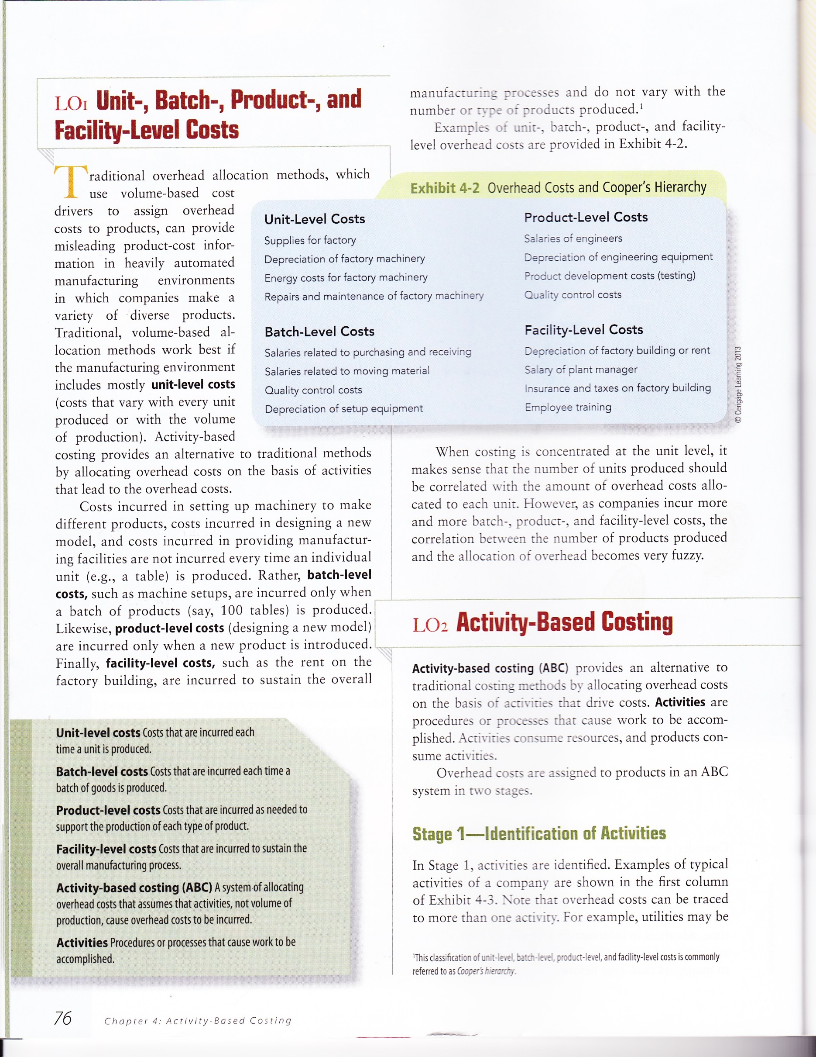

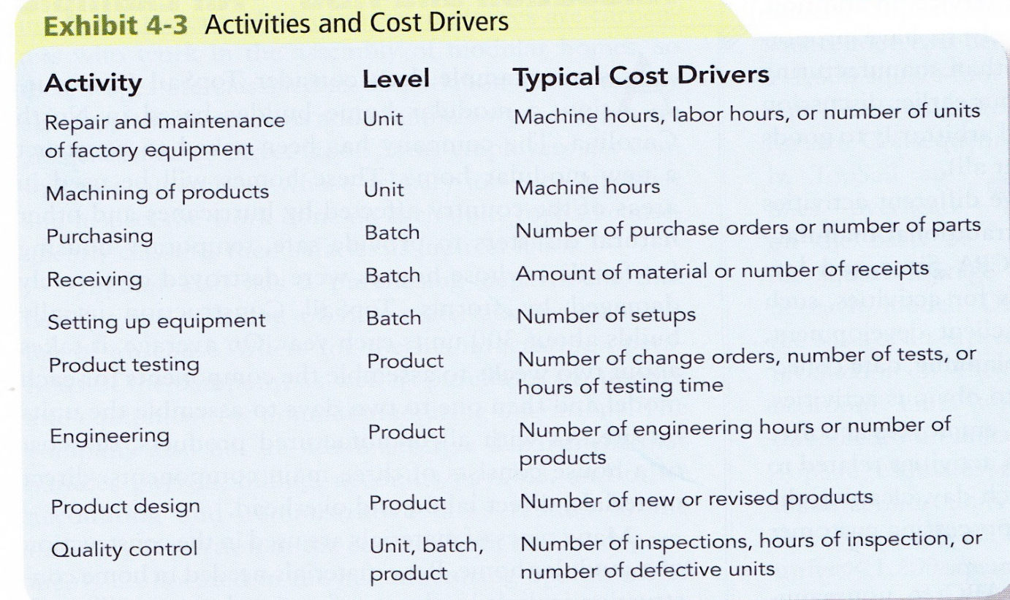

Traditional versus ABC Costing
TRADITIONAL
Estimated Overhead Costs
Estimated Driver equals Factory-wide overhead rate

ABC COSTING
Estimated Activity Costs
Estimated Activity Driver equals activity rate

APPLIED OVERHEAD = RATE TIMES ACTUAL DRIVER

PROBLEM 7-18 Comparing Traditional and Activity-Based Product Margins [LO1, LO3, LO4, LO5]
Rocky Mountain Corporation makes two types of hiking boots—Xactive and the Pathbreaker. Data concerning these two product lines appear below:
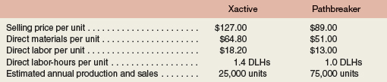
The company has a traditional costing system in which manufacturing overhead is applied to units based on direct labor-hours. Data concerning manufacturing overhead and direct labor-hours for the upcoming year appear below:
= $20.00 PER DLHOUR
Required:
1. |  | Using Exhibit 7-12 as a guide, compute the product margins for the Xactive and the Pathbreaker products under the company's traditional costing system.
2. |  | The company is considering replacing its traditional costing system with an activity-based costing system that would assign its manufacturing overhead to the following four activity cost pools (the Other cost pool includes organization-sustaining costs and idle capacity costs):  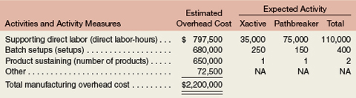  Using Exhibit 7-10 as a guide, compute the product margins for the Xactive and the Pathbreaker products under the activity-based costing system.
3. |  | Using Exhibit 7-13 as a guide, prepare a quantitative comparison of the traditional and activity-based cost assignments. Explain why the traditional and activity-based cost assignments differ.  Support $7.25 per dlh Batch Setup $1700 per batch

X active Pathbreaker Total
Traditional $20x35=700,000 $20x75=1500000 $2,200000
ABC
Support $7.25/dlh 35=253750 75=543750
Setup $1700/batch 250=425000 150=255000
Product Sust 325000 325000
Applied OH 1,003750 1,123750 $2,127500
Not assigned 72500
Total 2,200000

Difference 303750 (376250)

Product Margin- Traditional
 |  | Xactive | Pathbreaker |  |  | Total
Sales | $ | 3,175,000 | $ | 6,675,000 | $ | 9,850,000
Direct materials |  | 1,620,000 |  | 3,825,000 |  | 5,445,000
Direct labor |  | 455,000 |  | 975,000 |  | 1,430,000
Manufacturing overhead  applied @ $20.00 per direct labor-hour |  | 700,000 |  | 1,500,000 |  | 2,200,000
Total manufacturing cost |  | 2,775,000 |  | 6,300,000 |  | 9,075,000
Product margin | $ | 400,000 | $ | 375,000 | $ | 775,000

Product Margin – ABC
Sales | $ | 3,175,000 | $ | 6,675,000 | $ | 9,850,000
Direct materials |  | 1,620,000 |  | 3,825,000 |  | 5,445,000
Direct labor |  | 455,000 |  | 975,000 |  | 1,430,000
Supporting direct labor |  | 253,750 |  | 543,750 |  | 797,500
Batch setups |  | 425,000 |  | 255,000 |  | 680,000
Product sustaining |  | 325,000 |  | 325,000 |  | 650,000
Total cost |  | 3,078,750 |  | 5,923,750 |  | 9,002,500
Product margin | $ | 96,250 | $ | 751,250 | $ | 847,500

