Link and Learn Instructions
WEBSITE: http://www.irs.gov/app/vita/index.jsp - 16.8KB
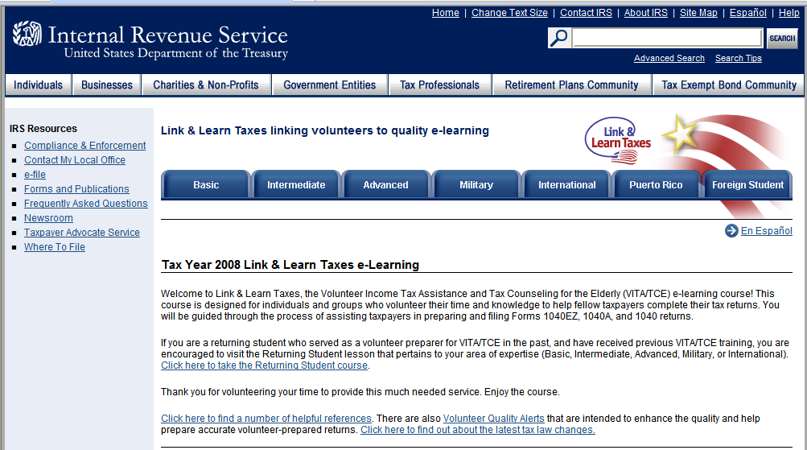
Link and Learn Introduction
How to Take this Course
The following Link & Learn Taxes e-Learning courses represent a complete certification track:
- Basic - Includes income from wages, interest and dividends, and tax credits (excluding education credits) for individuals and couples. All volunteers are required to take this course.
- Intermediate - Includes all tax topics in the Basic course plus education credits, additional income topics (alimony, social security income, etc.), itemized deductions, adjustments to income, and some pension issues for individuals and families with no stock or sale of home considerations.
- Advanced - Includes all tax topics in the Basic and Intermediate courses plus additional pension topics. Also covered are stock and sale of home issues for individuals and families.
- Military - Includes the Advanced course with special emphasis on tax issues that affect U.S. Armed Forces members and their families, such as combat pay, moving expenses, etc.
- International - Includes the Advanced course with special emphasis on international tax law for nonmilitary U.S. residents living outside the U.S., especially those served by U.S. embassies and consulates.
- Puerto Rico (for U.S. citizens who are bona fide residents of Puerto Rico)
- Foreign Student (for international students and scholars)
You should take the recommended course that pertains to your level of experience and to the type of taxpayers with whom you will be working. Read through each student description to identify which type of student you are. Ask your sponsor or Site Coordinator for assistance if you are unsure which course you should take.
NOTE: To receive the full benefits of the interactive functionality of this online course, you must have Javascript enabled on your computer. If you cannot enable Javascript on your computer, an alternative copy of the printed product is available at a volunteer center or through irs.gov.
You also need to have Adobe Acrobat Reader version 7.0 or later loaded onto your computer. For further information about the forms used in Link & Learn Taxes or to download Acrobat Reader, please click here.
Table of Contents for Link and Learn Course
Tax Year 2008 Link & Learn Taxes e-Learning
Basic Menu:
Introduction
Administrative Guidelines
Personal and Dependency Exemptions
Who Should File
Filing Status
Income
Introduction
Taxable and Nontaxable Income
Where to Report Income
Earned Income
Interest Income
Dividends and Corporate Distributions
Other Income Topics
Summary and Exercises
Standard Vs. Itemized Deductions
Earned Income Credit
Child Tax Credit
Credit for Child and Dependent Care Expenses
Credit for the Elderly or the Disabled
Miscellaneous Tax Credits
Finishing the Return
Evaluation
Test

Intermediate Menu:
Introduction
Administrative Guidelines
Personal and Dependency Exemptions
Who Should File
Filing Status
Income
Introduction
Taxable and Nontaxable Income
Where to Report Income
Earned Income
Interest Income
Dividends and Corporate Distributions
Other Income Topics
State and Local Refunds and Alimony
Summary and Exercises
Self-Employment Income
Pension Income
Introduction
Retirement Income
Taking a Look at the Forms
Pensions with Taxable Amount Determined
Pensions: Other Issues
Summary and Exercises
Adjustments
Adjustments
Individual Retirement Arrangements
Standard and Itemized Deductions
Earned Income Credit
Child Tax Credit
Credit for Child and Dependent Care Expenses
Education Credits
Credit for the Elderly or the Disabled
Miscellaneous Tax Credits
Finishing the Return
Evaluation
Test
Advanced Menu:
Introduction
Administrative Guidelines
Personal and Dependency Exemptions
Who Should File
Filing Status
Income
Introduction
Taxable and Nontaxable Income
Where to Report Income
Earned Income
Interest Income
Dividends and Corporate Distributions
Other Income Topics
State and Local Refunds and Alimony
Capital Gains and Pension and Annuities
Summary and Exercises
Self-Employment Income
Pension Income
Introduction
Retirement Income
Taking a Look at the Forms
Determining the Taxable Portion
Reporting the Retirement Income
Pensions: Other Issues
Summary and Exercises
Sale of Investment Property
Sale of Home
Adjustments
Adjustments
Individual Retirement Arrangements
Standard and Itemized Deductions
Earned Income Credit
Child Tax Credit
Credit for Child and Dependent Care Expenses
Education Credits
Credit for the Elderly or the Disabled
Miscellaneous Tax Credits
Finishing the Return
Evaluation
Test

Military Menu:
Introduction
Administrative Guidelines
Personal and Dependency Exemptions
Aliens
Who Should File
Filing Status
Military Exemption and Filing Status Issues
Wage Income
Introduction
Taxable and Nontaxable Income
Where to Report Income
Earned Income
Interest Income
Dividends and Corporate Distributions
Other Income Topics
State and Local Income Tax Refunds and Alimony
Capital Gains and Pensions and Annuities
Summary and Exercises
Self-Employment Income
Income - Military
Military Income
Tax Options for Combat Zone Participants
Rental Income and Expenses
Sale of Investment Property
Sale of Home
Adjustments
Adjustments
Individual Retirement Arrangements
Military Moving Expenses
Military Travel Expenses
Standard and Itemized Deductions
Military Itemized Deductions
Home Leave
Earned Income Credit
Child Tax Credit
Credit for Child and Dependent Care Expenses
Education Credits
Thrift Savings Plan
Credit for the Elderly or the Disabled
Miscellaneous Tax Credits
Finishing the Return
Military Finishing the Return
Evaluation
Test
International Student Certification:
Introduction
Administrative Guidelines
Personal and Dependency Exemptions
Aliens
Who Should File
Filing Status
Income
Wage Income
Introduction
Taxable and Nontaxable Income
Where to Report Income
Earned Income
Interest Income
Dividends and Corporate Distributions
Other Income Topics
State and Local Refunds and Alimony
Capital Gains and Pensions and Annuities
Summary and Exercises
Self-Employment Income
International and Self-Employment Income
Foreign Income Exclusion
Rental Income and Expenses
Sale of Investment Property
Sale of Home
Adjustments
Adjustments
Individual Retirement Arrangements
Standard and Itemized Deductions
Home Leave
Earned Income Credit
Child Tax Credit
Credit for Child and Dependent Care Expenses
Education Credits
Foreign Tax Credit
Thrift Savings Plan
Credit for the Elderly or Disabled
Miscellaneous Tax Credits
Finishing the Return
Military Finishing the Return
Evaluation
Test
Foreign Student Menu:
Residency Status
Filing Requirements
Tax Treaties
Family and Other Issues
Nonresident Taxation
Completing Form 8843
Finishing the Return
Social Security Tax
State Income Tax
Evaluation
Test
Puerto Rico Menu Level 1:
Filing Requirements
Sources of Income
Standard Deduction
Additional Child Tax Credit
Evaluation
Test
Puerto Rico Menu Level 2:
Adjustments to Income
Itemized Deductions
Social Security Benefits
Foreign Tax Credit and Completing Form 1116
Self-Employment
Evaluation
Test
Puerto Rico Menú Nivel 1:
Requisitos para declarar
Fuentes de Ingreso
Deducción Estándar
Crédito Tributario Adicional por Hijos(as)
Evaluación
Examen
Puerto Rico Menú Nivel 2:
Adjustes al Ingreso
Deducciones Detalladas
Beneficios del Seguro Social
Crédito de Impuesto Extranjero y Completando la Forma 1116
Trabajo por cuenta propia
Evaluación
Examen
Returning Student Menu:
Module Overview
Tax Law Changes for Basic volunteers
Tax Law Changes for Intermediate volunteers
Tax Law Changes for Advanced volunteers
Tax Law Changes for Military volunteers
Tax Law changes for International volunteers
Evaluation
Test

Link and Learn Testing and Certification
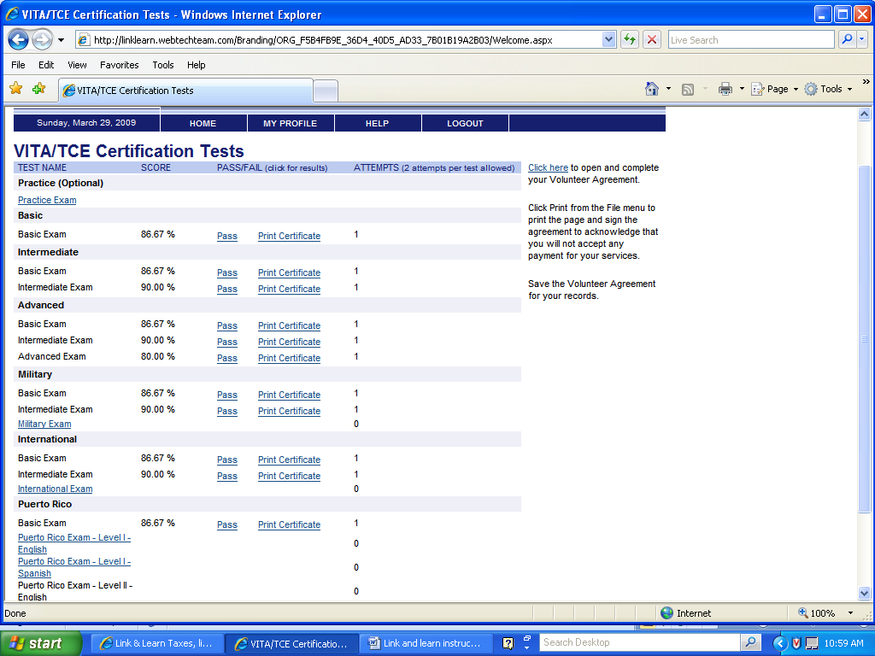
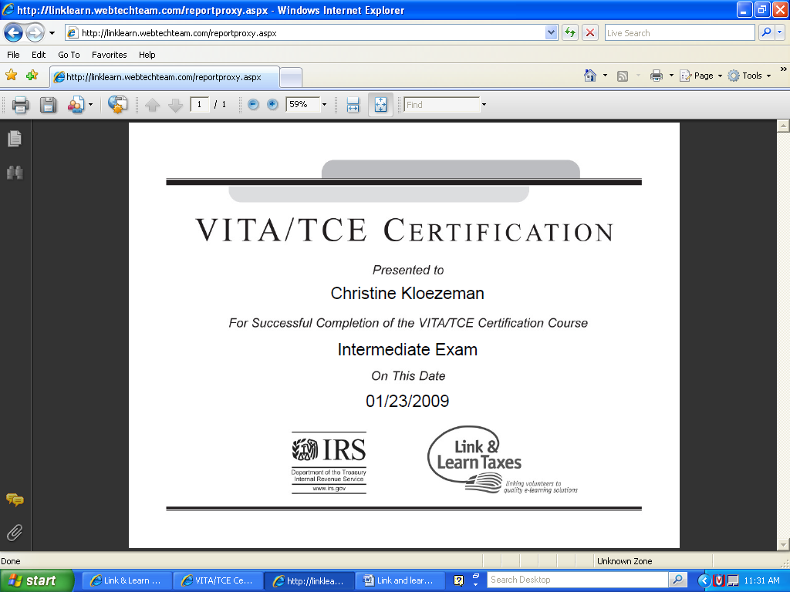

TaxWise Online Training- Practice Lab

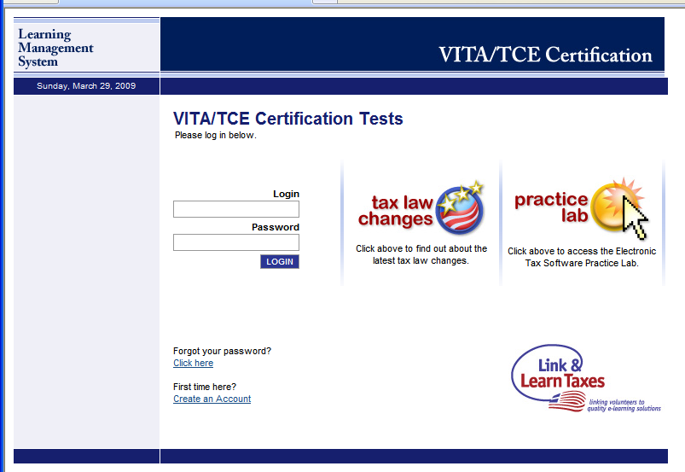
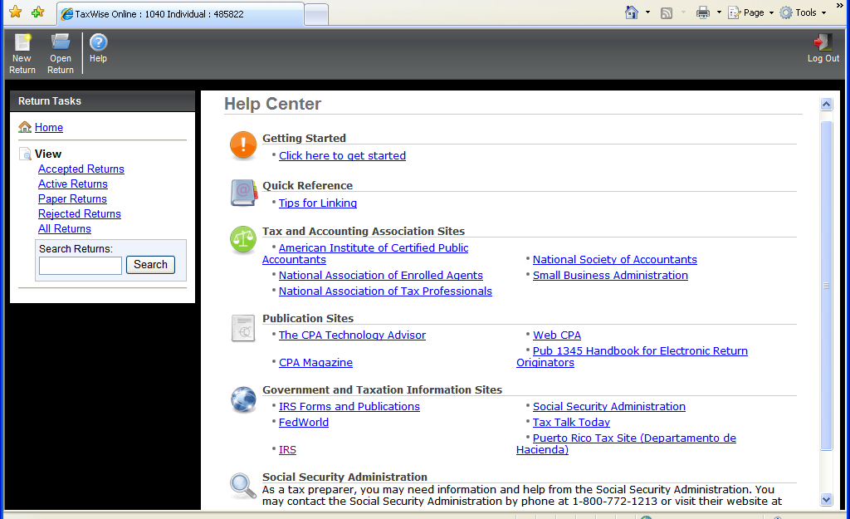

First Step: Create a New Return
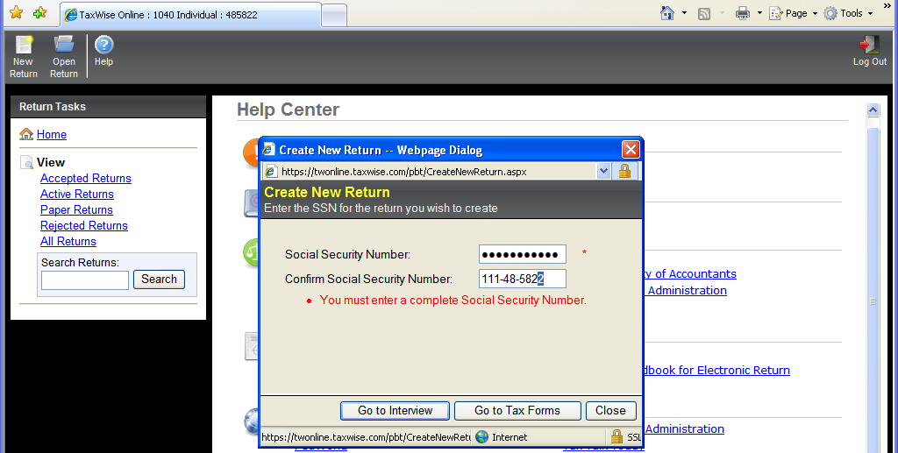
Enter Main Information – Using Tax Forms
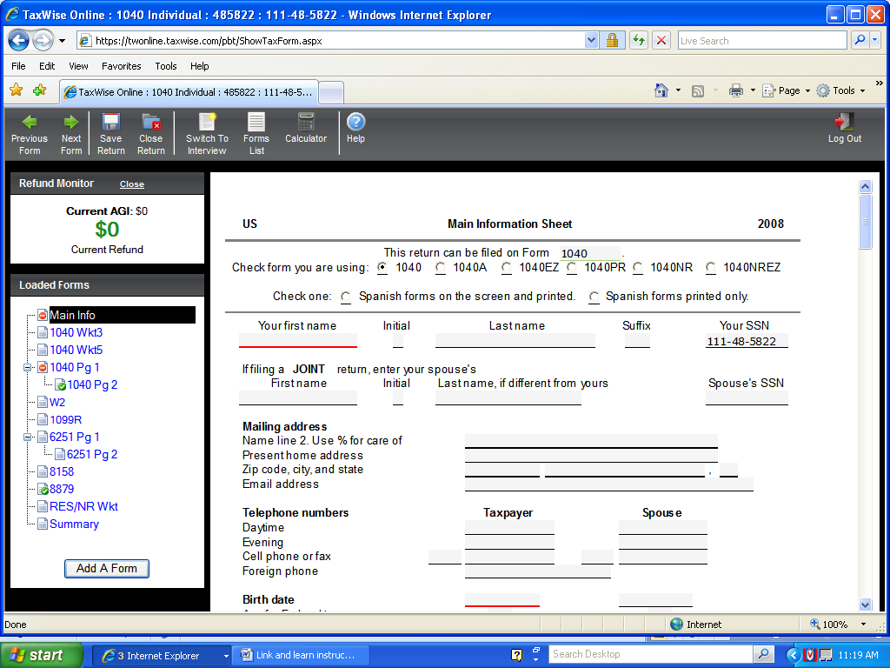
Enter W-2 Using Tax Form
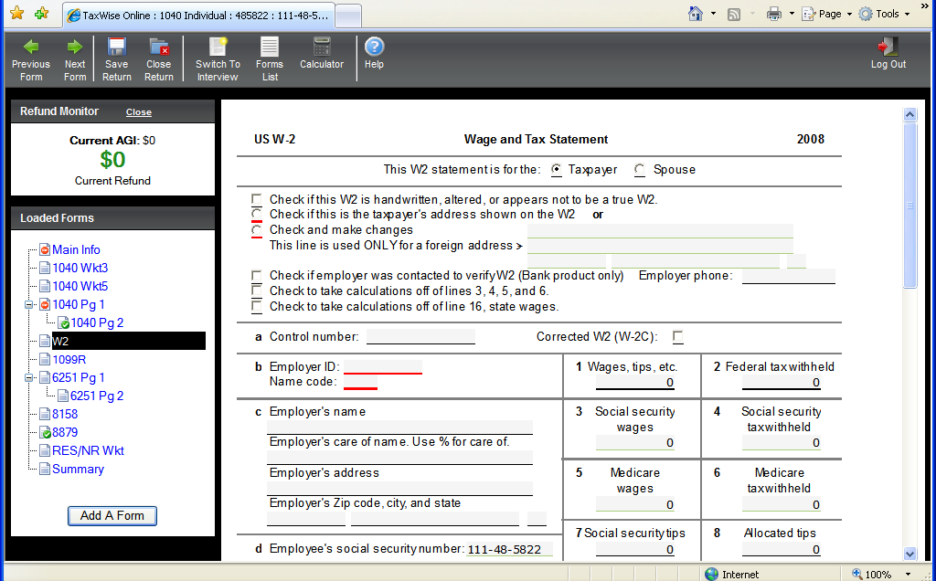

Start Return Using Interview Method