Name __________________________ Date_____________

Kim’s Kake Bakery

Cover Sheet-Chapter Five
Order of Reports to be attached :
Vendor List
A/P Detail Report - 9/1/0X
Sales Journal with Invoices
Cash Receipt Journal
Purchases Journal with Purchase Orders
Check Register with checks
Adjustments and Credit Memo
A/R and A/P Aged Invoice Listing- AR 1,370 AP 110
Journal Detail Report - Current Batches
Statements
A/R and A/P Subsidiary Ledger
Adjusted Trial Balance
General Journal Report
Income Statement MTD 5,362 YTD 7,122
Balance Sheet 9/30/0X $10,032
General Ledger
Income Statement date 10/01/0X

Did you make a back-up/archival copy?

Section 3: Student Application
Sample Problem: Kim’s Balloon Service, Accounts Payable, September Transactions

Kim’s business has been booming and she has decided to accept larger orders. She has decided to place all orders in the purchase account. She plans on taking advantage of all the discounts available. New accounts for purchases, purchase return and allowance, purchase discounts need to be added.

Kim has also changed her bank and her check numbers are now starting at 2000. She plans to pay her bills at the end of each week.

Set - up Accounts Payable
Instruction 1: Update the Chart of Account by adding the following accounts:
212 Sales Tax Payable
- Purchase Returns and Allowances
- Purchase Discount

Aug 1, 200x KIM’S BALLOON SERVICE-KEY
8:22 pm Chart of Accounts

Sub
Account # Account Description Account Type Type PSC-Through
========= ============================== ====================== ==== ===========
111.00 CASH Current Assets P
112.00 ACCOUNTS RECEIVABLE Current Assets P
113.00 DECORATING SUPPLIES Current Assets P
150.00 EQUIPMENT Fixed Assets P
151.00 ACCUM DEPR-EQUIPMENT Fixed Assets P
160.00 TRUCK Fixed Assets P
161.00 ACCUM DEPR-TRUCK Fixed Assets P
211.00 ACCOUNTS PAYABLE Current Liabilities P
212.00 Sales Tax Payable Current Liabilities P
311.00 SUSAN CASEY, CAPITAL Equity P
312.00 SUSAN CASEY, DRAWING Equity P
399.00 RETAINED EARNINGS Retained Earnings P
411.00 INCOME FROM SERVICES Sales P
420.00 SALES RETURNS & ALLOWANCES Sales Adjustments P
421.00 SALES DISCOUNT Sales Adjustments P
440.00 FRIEGHT REVENUE Sales P
445.00 FINANCE CHARGE REVENUE Sales P
450.00 PURCHASES Cost of Goods Sold P
451.00 PURCHASE RETURN & ALLOWANCES Cost of Goods Sold P
452.00 PURCHASE DISCOUNT Cost of Goods Sold P
501.00 WAGES EXPENSE Expenses P
506.00 UTILITIES EXPENSE Expenses P
512.00 SUPPLIES EXPENSE Expenses P
601.00 ADVERTISING EXPENSE Expenses P
605.00 BALLOON ACCESSORIES EXPENSE Expenses P
615.00 DEPRECIATION EXPENSE Expenses P
620.00 BAD DEBT EXPENSE Expenses P

Instruction 2: Create A/P Data Files. Press enter pass the three prompts until you get to the below screen. Enter the following data.
September 200X

Instruction 4: Set up A/P Parmeters. Select Utilities - Maintain A/P/ Parameters
Months: 12
Last month: November
Length of Aging 30 30 30
X Reconcile Checks
X Invoice Reference
A/P 211
A/P Discount 452

Instruction 5: Enter Cash Accounts. Click on Cash Accounts Button while still in A/P Parameters.
Cash Account Next Check 2000 Cash Acct 111, Select OK.

Instruction 6: Select the form button from the A/P Parameters screen. Make sure a bottom Stub form is highlighted, the click on OK. Then OK to save the A/P Parameters.

Instruction 7: Add the vendors. Stay in the Set-up mode. The program will automatically place you in the new mode for the first vendor. After the first vendor is entered you must click on the "new" icon for each successive vendor. Ballooner’s Supply, 123 Sperry St., Glendale, CA 91208

Instruction 8: Print a Vendor List

Aug 1, 200X KIM’S BALLOON SERVICE-KEY
9:45 pm Vendor List

Vendor Name/Address/Phone/Fax Vendor Information
============ ==================================================================
BALLON BALLOONER'S SUPPLY Paid: Balance: 0.00
123 SPERRY ST. Amt: Open Cr: 0.00
GLENDALE, CA 91208 Chk #: YTD Purch: 0.00
Pmts: 0.00
CASEY SUSAN CASEY Paid: Balance: 0.00
Amt: Open Cr: 0.00
Chk #: YTD Purch: 0.00
Pmts: 0.00
CONWIN CONWIN CABONICS Paid: Balance: 0.00
145 SAN FERNANDO RD Amt: Open Cr: 0.00
LOS ANGELES, CA 90032 Chk #: YTD Purch: 0.00
Pmts: 0.00
STAR STAR NEWS Paid: Balance: 0.00
800 MARENGO BLVD Amt: Open Cr: 0.00
ALTADENA, CA 91001 Chk #: YTD Purch: 0.00
Pmts: 0.00
TARGET TARGET DEPARTMENT Paid: Balance: 0.00
9890 ATLANTIC AVE Amt: Open Cr: 0.00
ALHAMBRA, CA 91801 Chk #: YTD Purch: 0.00
WILLIS KAREN WILLIS Paid: Balance: 0.00
1941 MILAN AVE Amt: Open Cr: 0.00
LOS ANGELES, CA 90032 Chk #: YTD Purch: 0.00
Instruction 9: Enter A/P Open Items: Target Invoice $200 #630 8/15/0X
Select Invoices, Enter
Still in Setup mode: Yes
Enter the invoice and post.

Instruction 10: Print A/P Subsidiary Ledger. Double Check that the Subsidiary Ledger equals the General Ledger A/P account.

Aug 1, 200X KIM’S BALLOON SERVICE-KEY
10:16 pm Accounts Payable Detail Report
All Current Transactions

Invoice Due Transaction Original Current
Number Date Date Reference Amount Balance Balance
============= ======== ===== ============ =========== =========== ===========
TARGET TARGET DEPARTMENT
630 08/15/00 08/15 200.00 200.00
Instruction 11: Maintain Payment Terms-- Select Utilities - Maintain Payment Terms

MAKE A BACKUP COPY AND LABEL IT "A/P SET UP"

Instruction 12: Get out of Set up. Select Utilities- Display Status. When the screen asks if you want to stay in setup select No. Confirmation screen asks if it is OK. Enter OK, then select OK.

MONTHLY TRANSACTIONS

Purchase of decorating supplies on Account - A/P
a. Sept 1, 200X Purchased decorating supplies, P.O. 45678. Decorating House $900 2/10 Net 30, Inv 638..

Sale on Account - A/R
b. Sept 3, 200X Billed Lost Hills School District for 900 mini cupcakes @ $1.00 each Terms: 2/10 Net 30 P.O. 4532 Delivered, no sales tax.

Weekly Payments - A/P
c. Sept 7, 200X Pay Decorating House invoice receiving a discount & August Target Inv

Purchase on Account - A/P
d. Sept 9, 200X Purchased 50 cake pans for resale from Smart and Final. Inv #639, $550, P.O. 12345. Terms: 2/10 Net 30

Purchase for Cash with New Vendor and New Account - A/P Instant Check
e. Sept 10, 200X Decided to go to a cooking conference. Need an immediate check for $300 to be included in registration. Artistic Cakes Association,1731 Hot Shot St., Glendale, CA 91208. 650-Conference Expense. Inv#640, P.O. #12346

Purchase Returns - A/P
f. Sept 11, 200X Returned 5 cake pans to Smart & Final that were defective. $150

Sale on Account - A/R
- Sept 12, 200X Sold 40 sheet cakes @ 10.00 each to Marshall's to be
used at an open house at 502 Belmont, Anaheim, CA.
Terms 2/10 Net 30. P.O. M51322. Taxable 10%. Delivery charge $50

Receipt of Bill for expenses - A/P (record invoice)
h. Sept 14, 200X Received a telephone bill from pacific Bell, 1220 E. Colorado, Glendale, CA Invoice #642, $75, Net 10 days P.O. Box #0999

15th Payments on Accounts - A/P
i. Sept 15, 200X Pay Smart & Final invoice

Cash Receipts from Customer with Discount - A/R
j. Sept 16, 200X Received Ck 52812 from Marshall's. $???? Inv # dated 9/12, discount.

Purchase of Asset on Account with New Terms - A/P
k. Sept 16, 200X Purchased new mixer from Conwin, $400. P.O. 12446. Inv. 643. Add term 2/10 Net 60

24th Payments - A/P
l. Sept 24, 200X Pay Conwin $400 for Invoice dated 9/16
Pay Telephone bill $75

Purchase Expenses on Account - A/P
m. Sept 27,200X Purchased an ad in the Star News, 800 Marengo Blvd, Pasadena, CA $110 for one week. Net 30 Inv 644.

Month Cash Sales - A/R
n. Sept 30, 200X Record cash sales 300 cupcakes at $3.50 each from the cash register.

EOM Payments - September 30, 200X-
o. Paid Employee Paid Joy Willis $500 for her part time help Inv #9/30/0X
p. Owner Withdrawal Kim Withdrew $1500, Inv #646

Create a payments list and then the check
q. Pay Target Pay 8/15 Target invoice

Adjusting Entries - G/L September 30 ,200X
- Truck Depreciation $100
- Equipment Depreciation $100
- Supplies USED $50

MONTHLY TRANSACTIONS – Detail Instructions

Purchase of decorating supplies on Account - A/P
a. Sept 1, 200X Purchased decorating supplies, P.O. 45678. Decorating House $900 2/10 Net 30, Inv 638.
- Select Vendors-Enter Bills.
- Select Decorating House as the vendor from the pull down arrow.
- Enter the date as 9/1/xx, and the amount due of 900.
- Select 2/10 Net 30 terms form the pull down arrow. The discount and bill due date will calculate automatically.
- Double check for accuracy and select “Save and Close”.

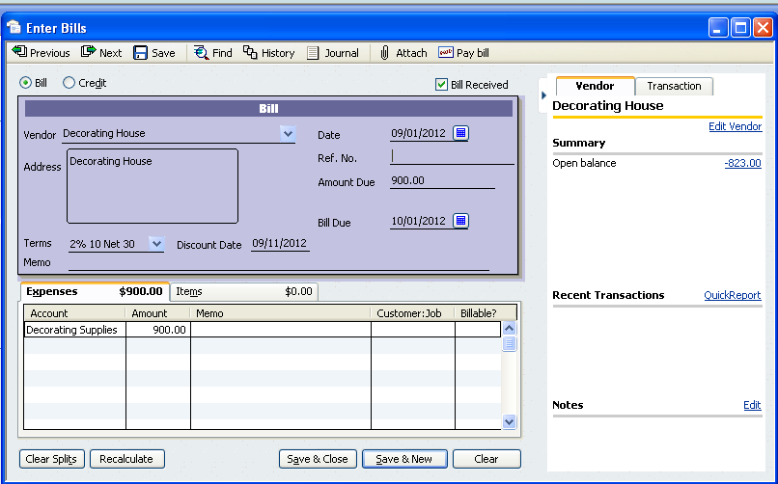

Sale on Account - A/R
b. Sept 3, 200X Billed Lost Hills School District for 900 mini cupcakes @ $1.00 each Terms: 2/10 Net 30 P.O. 4532 Delivered, no sales tax.
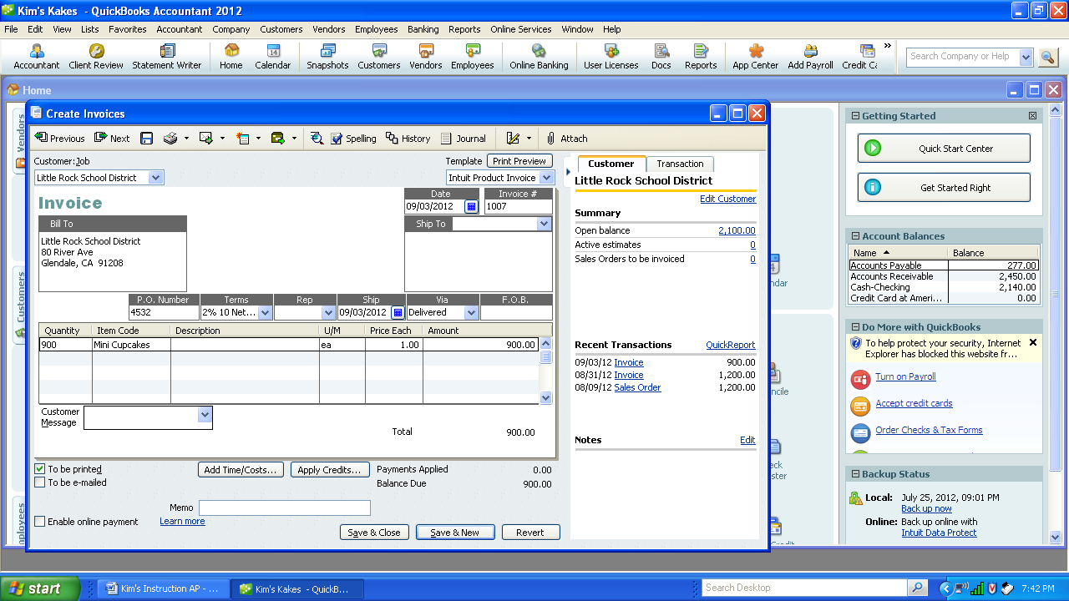

Weekly Payments - A/P
c. Sept 7, 200X Pay Decorating House invoice receiving a discount and August Target Invoice $200.

- Select Vendors – Pay Bills
- Change date to September 7, 20XX
- Check the box for Decorating House
- Click “Set Discount”, enter $18 in Amount of Discount and Select Account for discount. Click on Done.
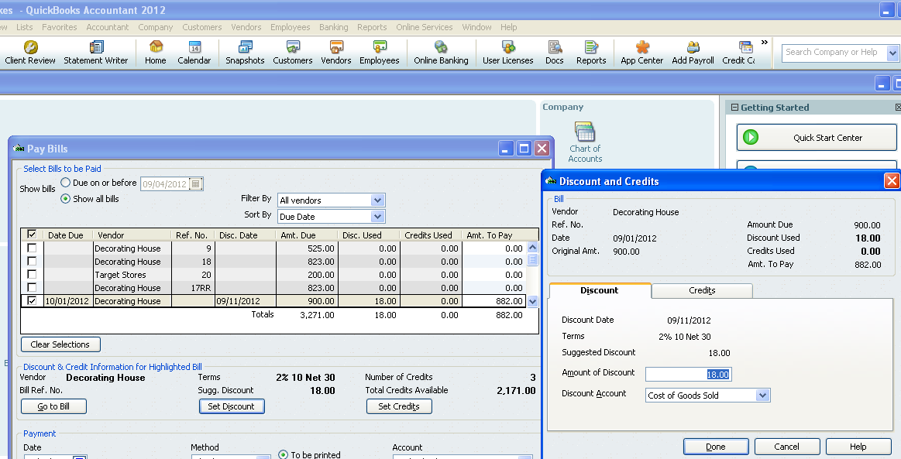

- Check Target Invoice for $200.
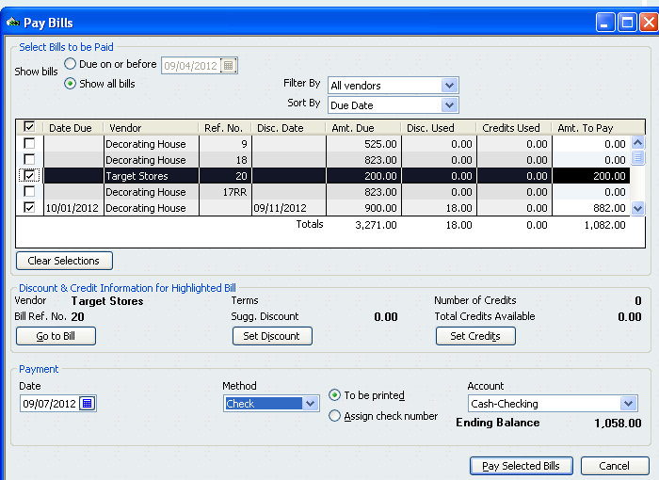

- Select “Pay Selected Bills. A summary appears to verify the amount of check to be written. Correct or click on “print checks” if correct.

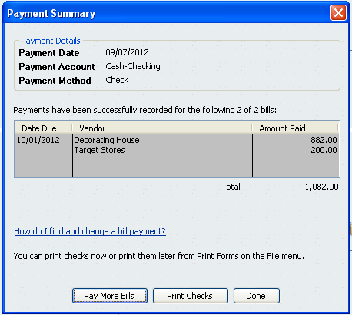
- Change the check number to 109. Once again check the amount of checks and payee. If correct click on OK.

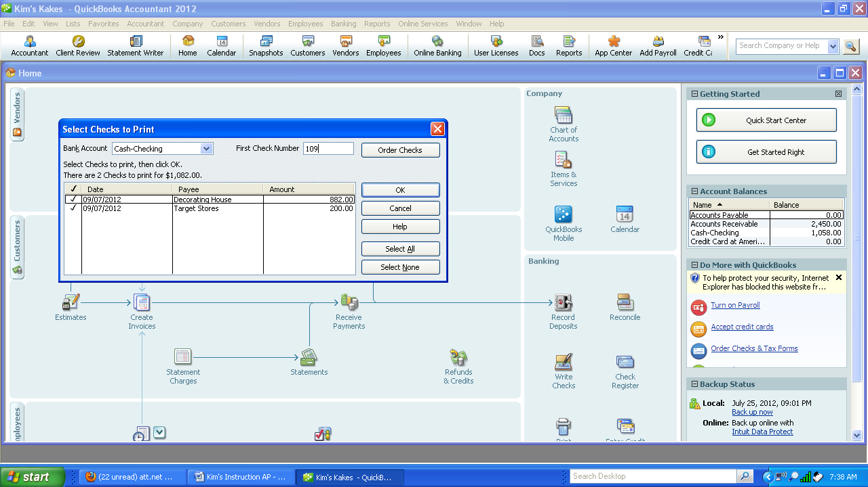

- Normally you would enter 2 as the number of copies-one to mail and one to keep. However, during the learning process simply print one. If you print 3 and use collated color paper you can have one check for the vendor, one for the vendor file and one for the numerical check file.
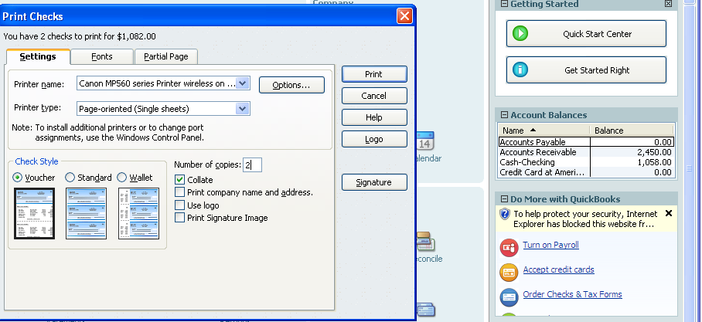
- Make sure the balance in Accounts Payable is 0 by looking at the Account Balance Summary

Cash Receipt including discount and deposit cash
d. Sept 8, 20XX Received CK # 901 for $2082 from Little Rock for Inv #1006, 1007.
1. Select Customers-Receive Payments and record the necessary information. Once correct Save
& Close.

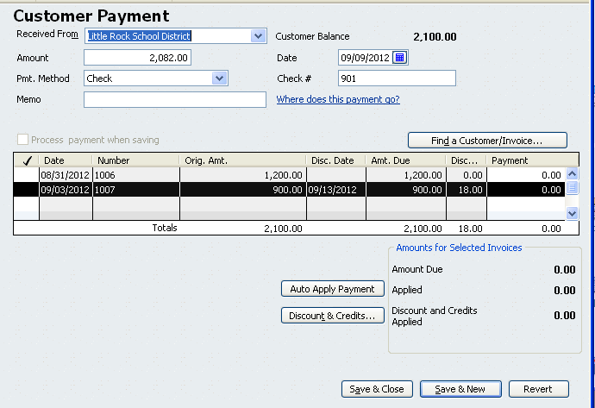

2. Select Banking – Record deposit. Check Little Rock Check #901 for $2082. Click on OK. Click on Save and Close. Notice the change in the Cash Account.
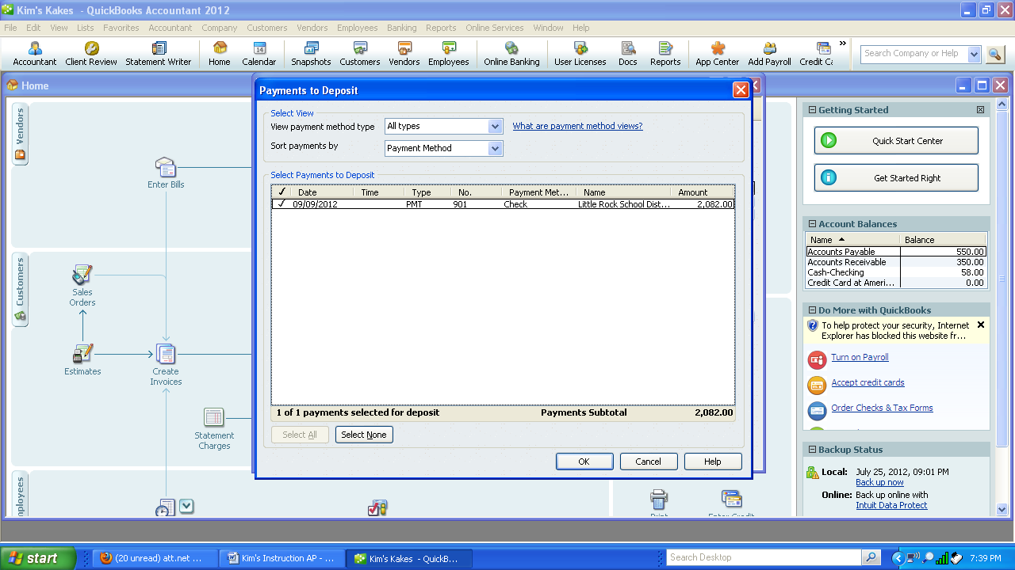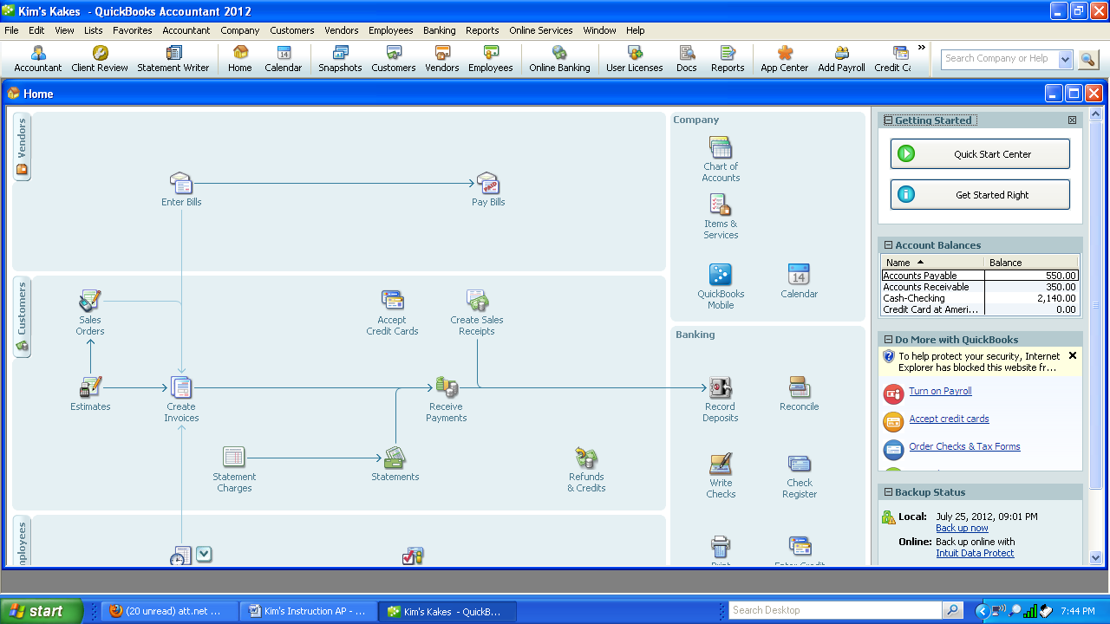

Purchase on Account - A/P Add New Vendor
e. Sept 9, 20XX Purchased 50 cake pans for resale from Smart and Final,1800 N. Pasadena Ave, $550, P.O. 12345. Terms: 2/10 Net 30

1. Select Vendors-Enter Bills. Enter all the information. Once correct click on Save and Close.
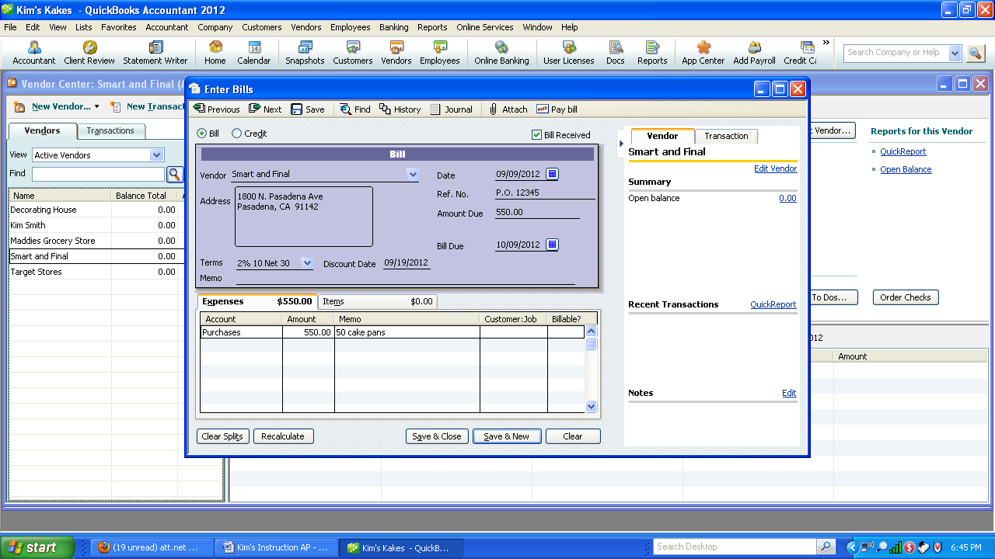

2. Preview the Vendor information to check the account and amount is correct.
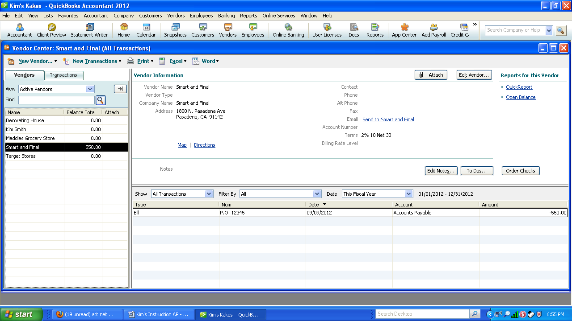

Purchase for Cash with New Vendor and New Account - A/P Check
f. Sept 10, 200X Decided to go to a cooking conference. Need an immediate check for $300 to be included in registration. Artistic Cakes Association, 1731 Hot Air St., Glendale, CA 91208. Conference Expense. P.O. #12346

- Select Banking—Write Checks
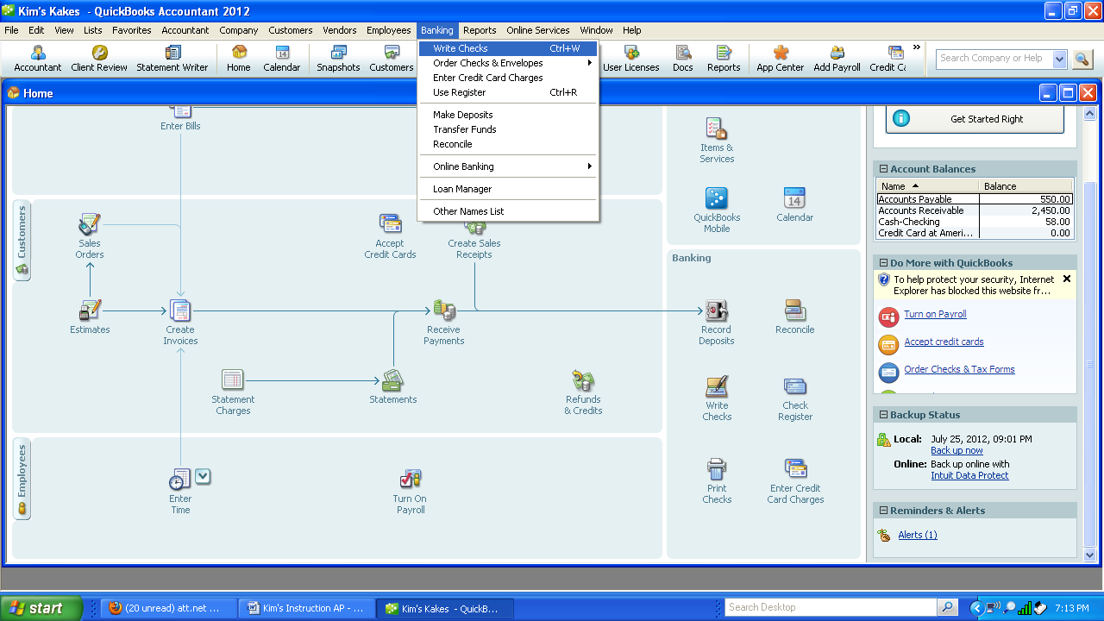
- Add the new vendor “Artistic Cakes Association” as a quick vendor. Enter the remaining information in the check screen. When correct select “Save & Close”.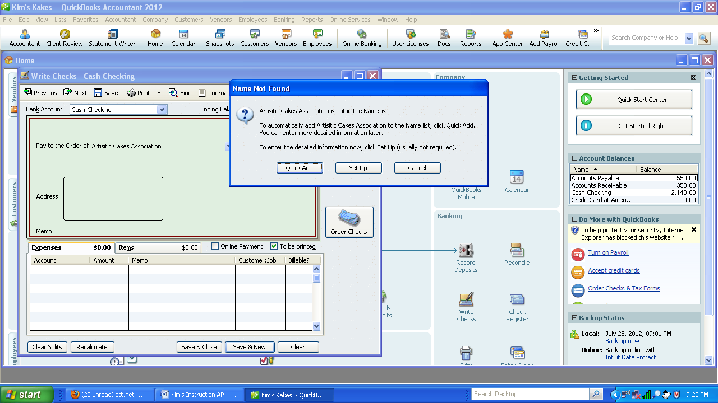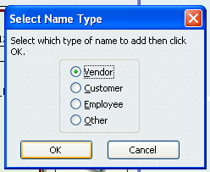 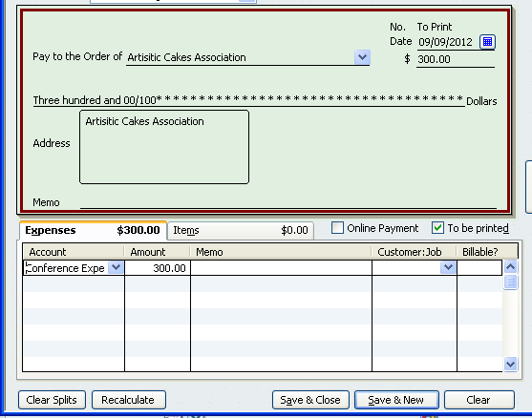

- Select Banking—Print Checks. Check the Artistic Cake Association check.
- Select OK
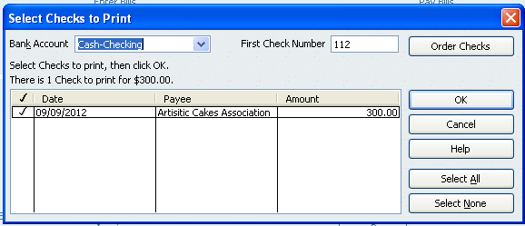

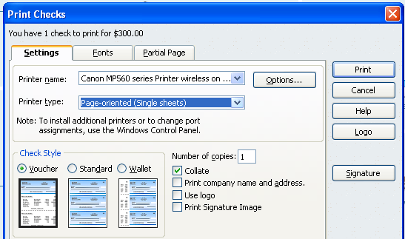

Purchase Returns - A/P
g. Sept 11, 200X Returned 5 cake pans to Smart & Final that were defective. $150

1. Select Vendor—Enter Bills—Click on the Credit Radio button.
2. Enter Smart and Final as vendor, date, Ref No PO 12345, credit amount $150.
3. Memo: 5 cake pans defective.
4. Add new the account “Purchase Returns and Allowance” as an expense.
5. Save and Close.
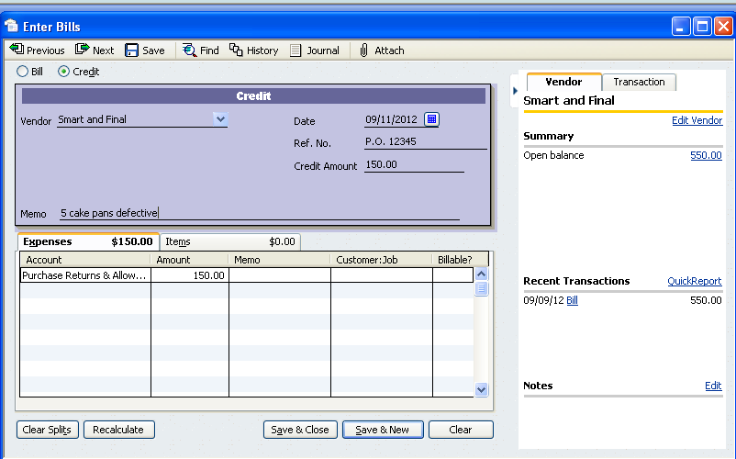

- Notice that Accounts Payable in the summary has changed.
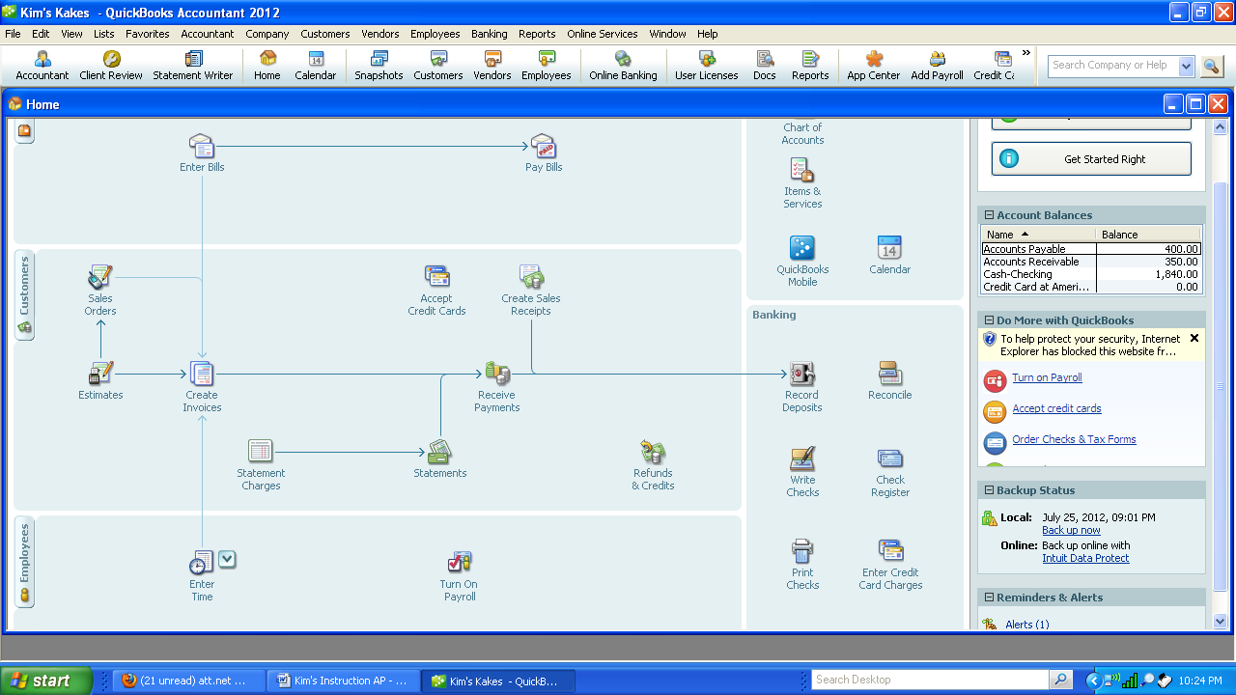

Sale on Account - A/R – Set up tax accounts
- Sept 12, 200X Sold 4 sheet cakes @ 40.00 each to Marshall's to be
served at an open house at 502 Belmont, Anaheim, CA.
Terms 2/10 Net 30. P.O. M51322. Taxable 10%.
- Select Edit – Company Preferences- Sales Tax
- Select Sales Tax item. Enter from the pull down menu “Sales Tax Item”. Add a new item and give it the name “State Sales Tax” at 10%, with the Tax Agency as “State Board of Equalization” and a new vendor. Click OK.

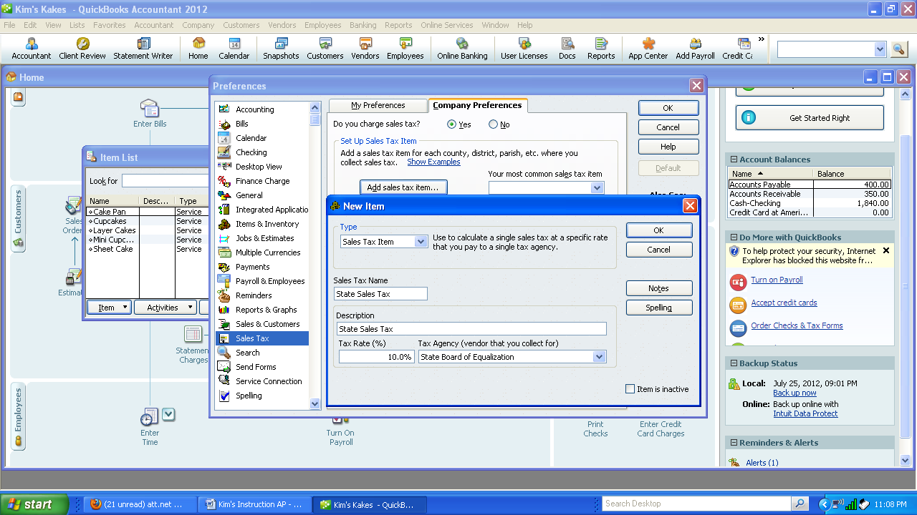
3. Under the Section “Assign Sales Tax Codes. Select Tax item code as Tax and non taxable code as Non. Select the accrual basis for when you owe sales tax and you pay sales tax monthly.
Updating Sales Tax making all customers and items as taxable.

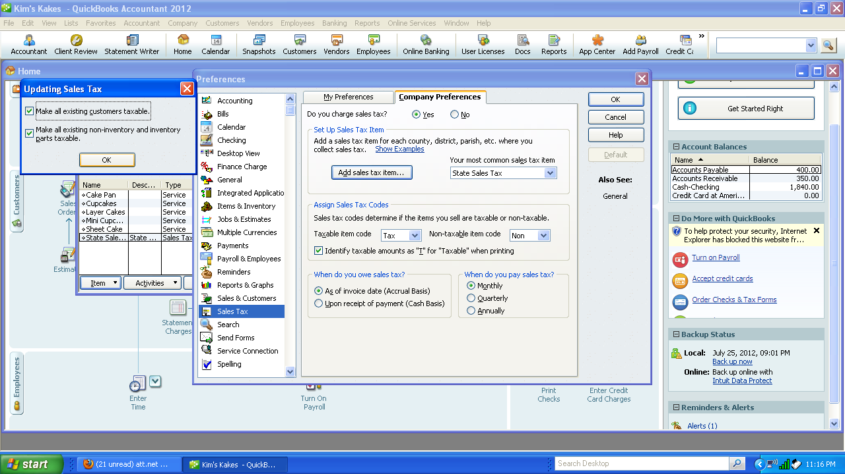

4 . Create Invoice using the given information. Once correct, save and close.
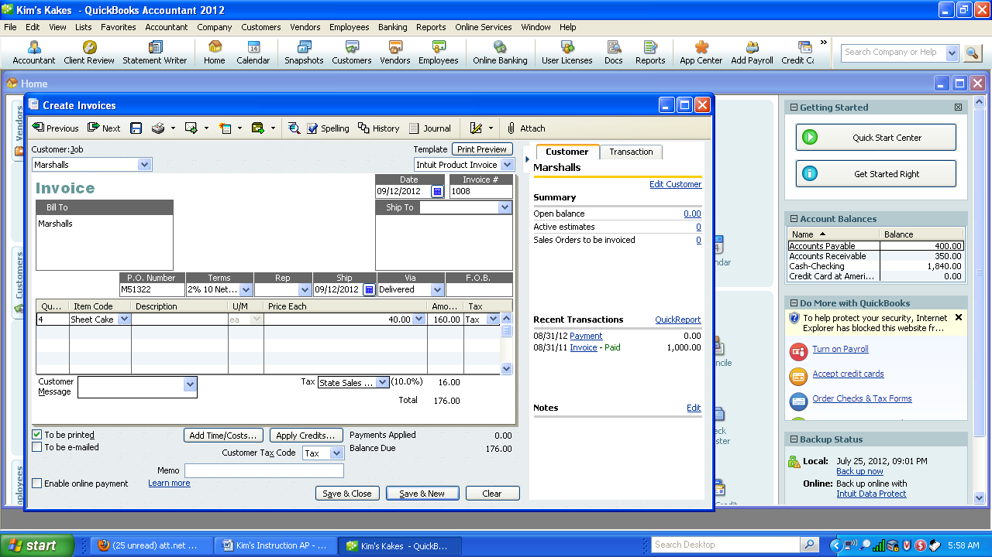

Receipt of Bill for expenses - A/P (record invoice)
i. Sept 14, 200X Received a telephone bill from Pacific Bell, 1220 E. Colorado, Glendale, CA Invoice #642, $75, Net 10 days P.O. Box #0999
1. Select Enter Bills from the vendor pull down menu or icon.
2. Add quick vendor Pacific Bell using the given information. Save & Close.
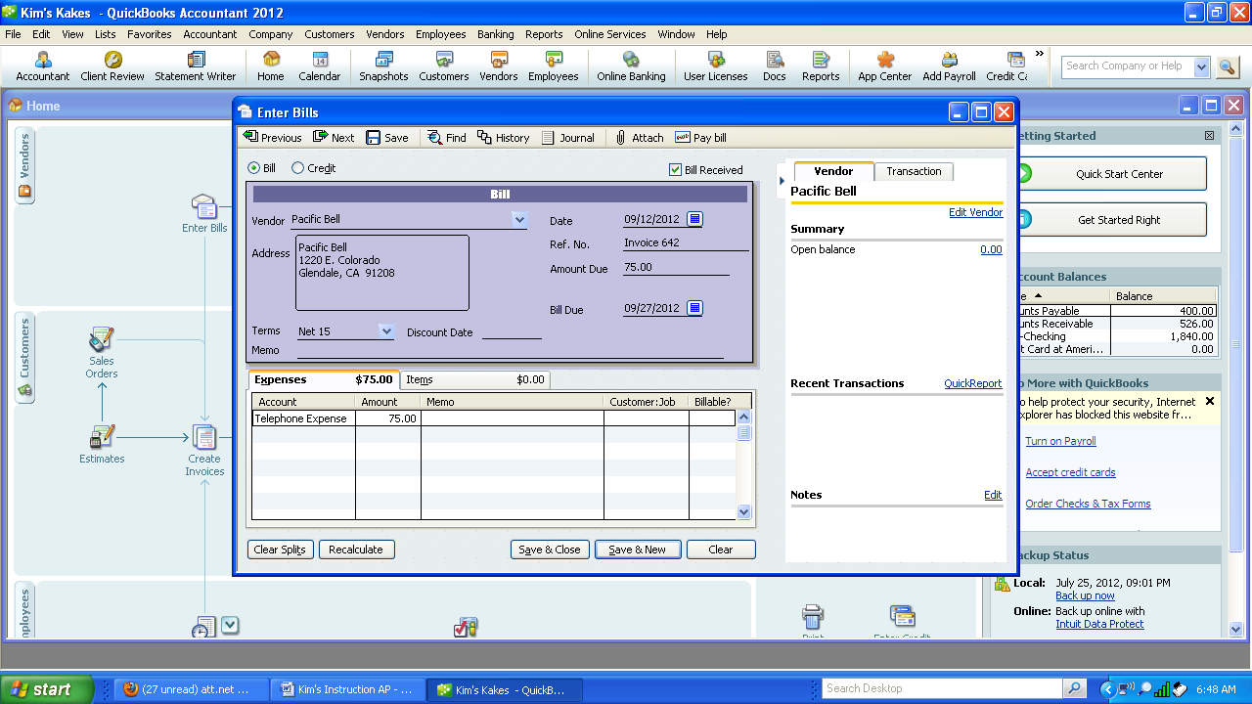

15th Payments on Accounts - A/P with Discount and Credit Memo
j. Sept 15, 200X Pay Smart & Final invoice from transaction e and g.
1. Select Pay Bills under the Vendor menu.
2. Filter by Smart and Final. Check the 9/9/XX invoice. Select “Set Credits” to include the 9/11/XX credit.
3. Double check Purchase Discount of $11. Click on “Go to Bill” if there are any questions on the Smart and final Bill. Note the ending Cash balance at the bottom right of the screen
4. Select “Pay Selected Bills” when correct.

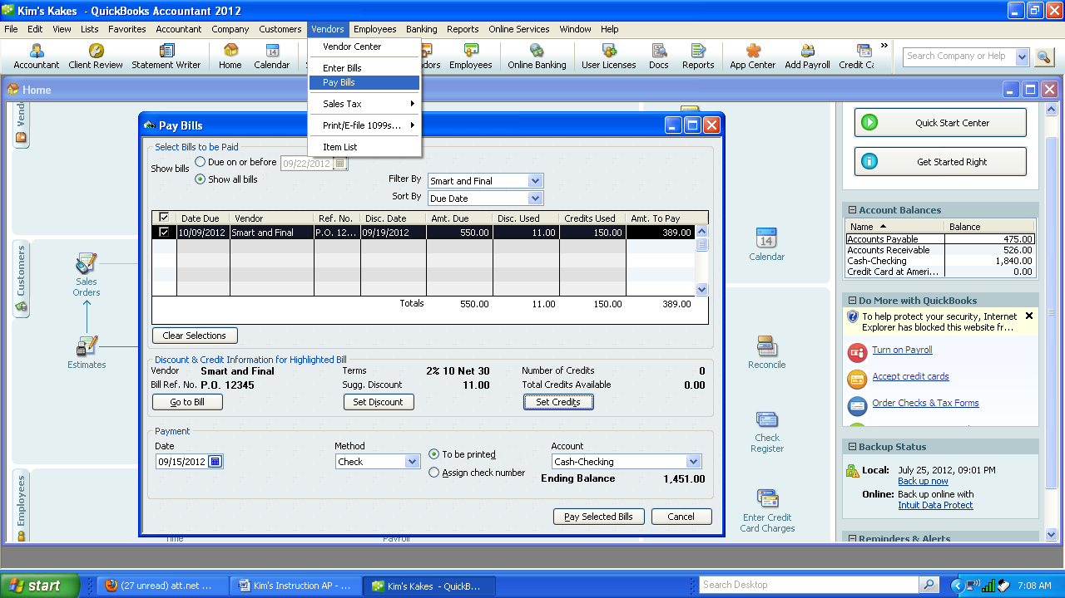
- Double Check the summary to make sure it is correct.
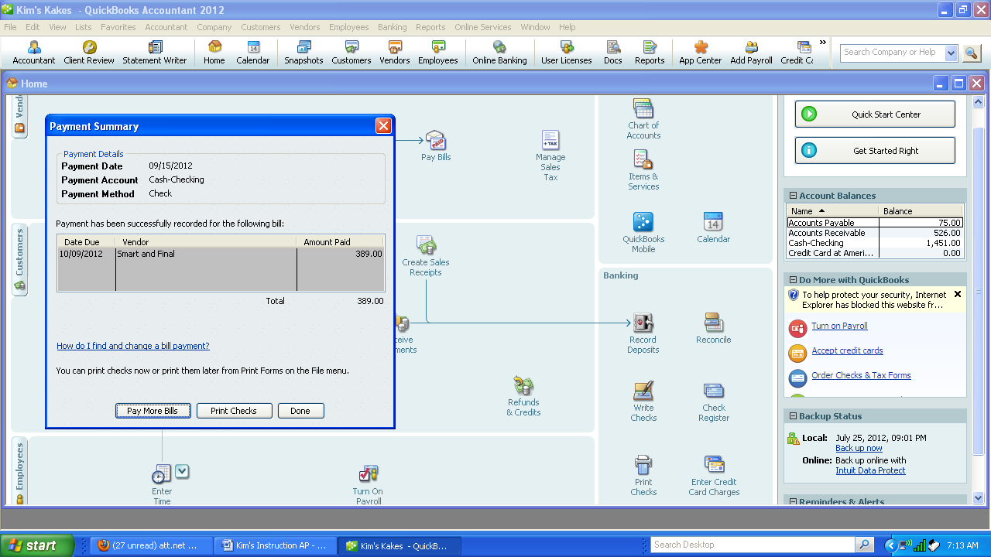

- Select Print Checks.
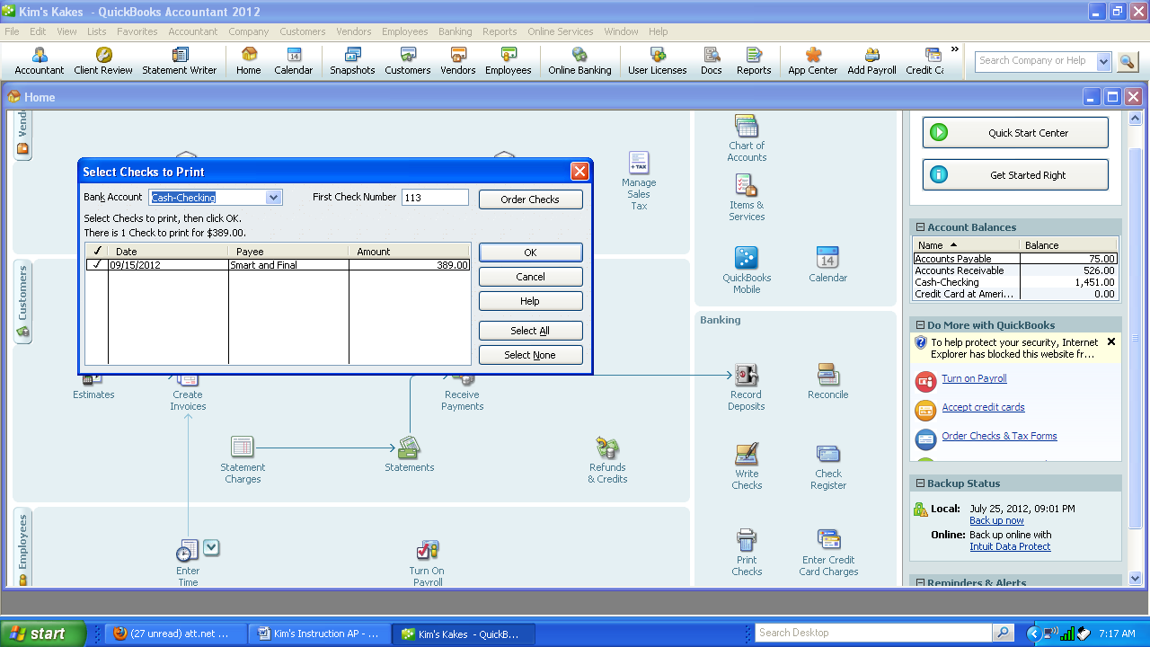
- Click OK to print the check for Smart and Final.

Cash Receipts from Customer with Discount & Apply Credit - A/R
k. Sept 16, 200X Received Ck 52812 from Marshall's. $1376 Inv # dated 9/12, discount. Apply the $1200 credit from 7/12/XX invoice.
1. Select Customer-Received Payments. Enter Marshalls as the customer. It was discovered that the journal entry in July did not clear the July invoice. Click on Discounts and Credits.
2. Highlight the 7/2 invoice and click on discounts & Credits. Click on the invoice to apply the $1200 credit. Cash is not affected but the invoice is cleared.

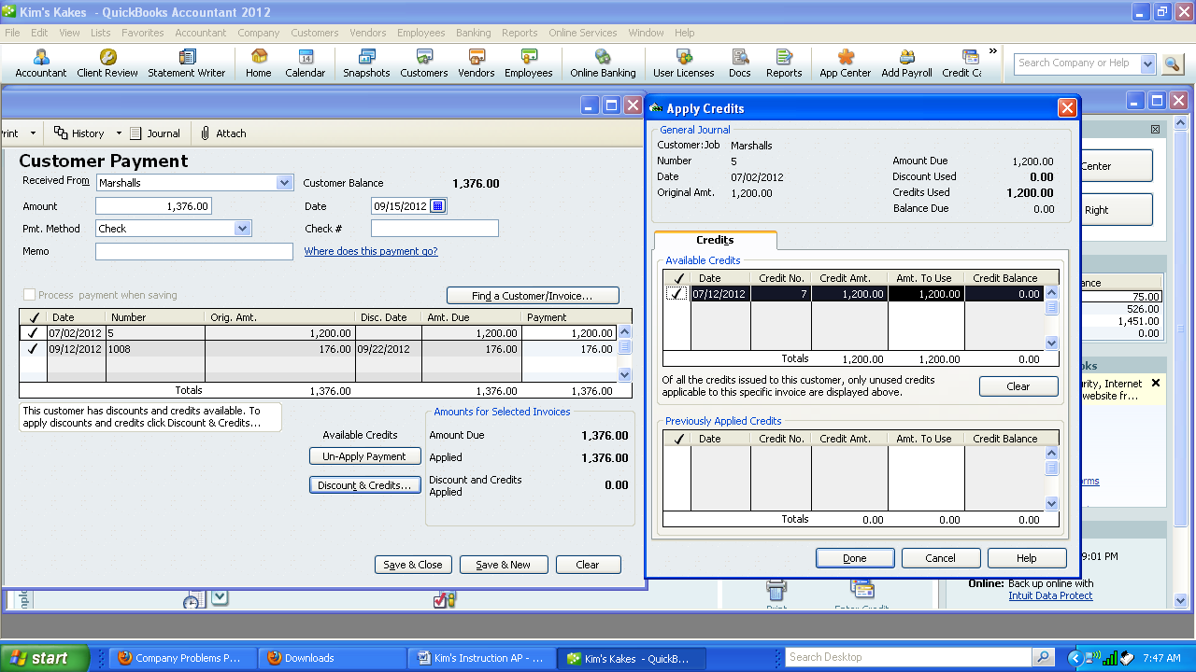

- Select the 9/12 invoice and click on Discounts and Credits. Click done.
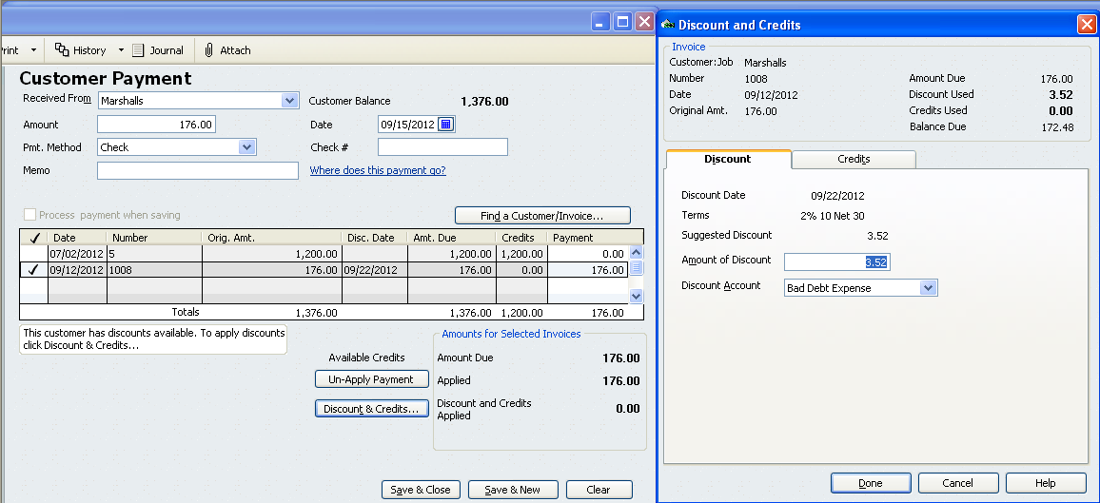

- Once correct, select Save and Close.
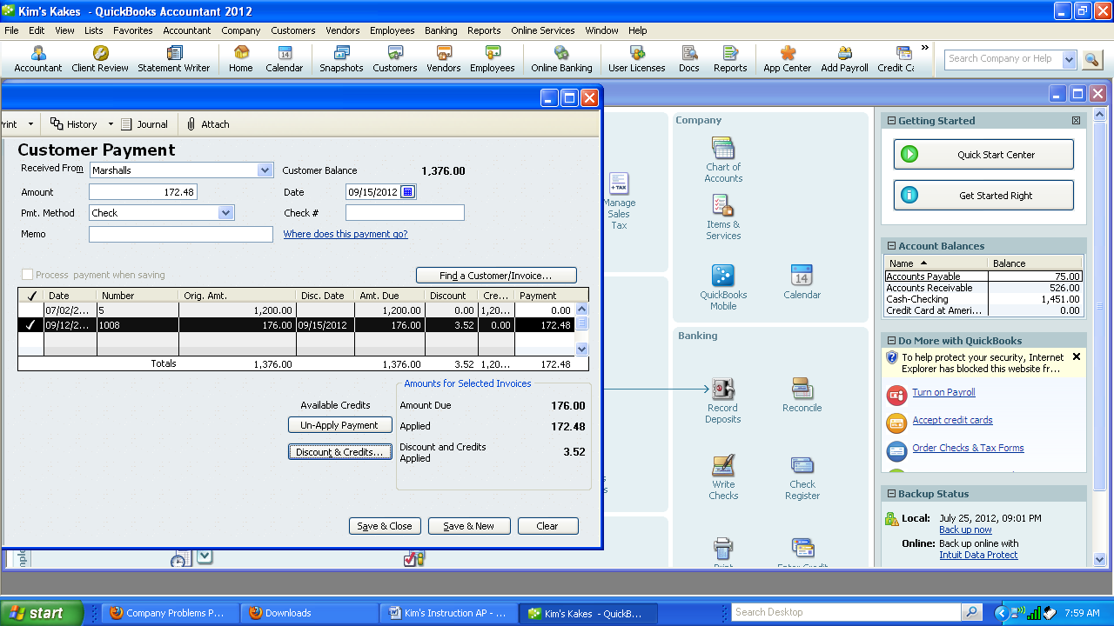

Purchase of Asset on Account with New Terms - A/P
l. Sept 16, 200X Purchased new mixer from Conwin Equipment, 346 Hawthorne St, Glendale, CA 91208 $400. P.O. 12446. Add term 2/10 Net 60.

- Select Vendor-Enter Bills. Add Conwin’s new address and add 2/10 Net 60 as a new term. Select OK.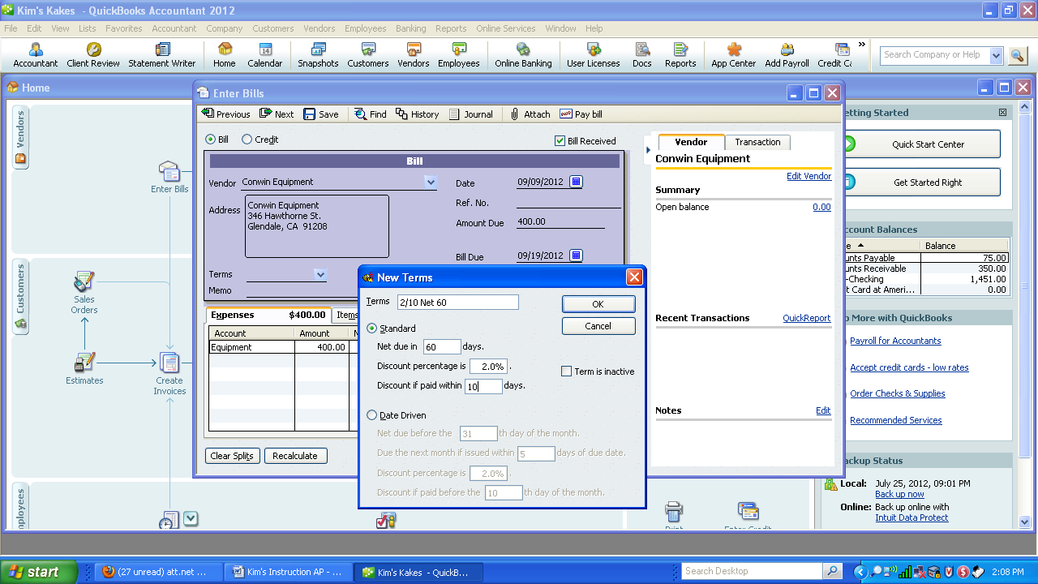
- Click on OK for new address and new terms for Conwin.

24th Payments - A/P
m. Sept 24, 200X Pay Conwin $400 for Invoice dated 9/16
Pay Telephone bill $75

- Select Vendor –Pay Bills—Place a check by Conwin and click on Set Discount. Click Done.

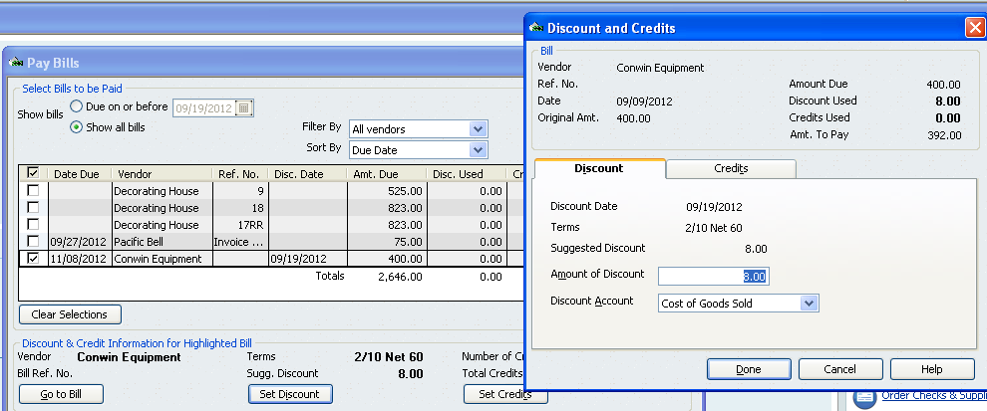

- Check Pacific Bell $75 line. Once the screen is correct select “Pay Selected Bills”.
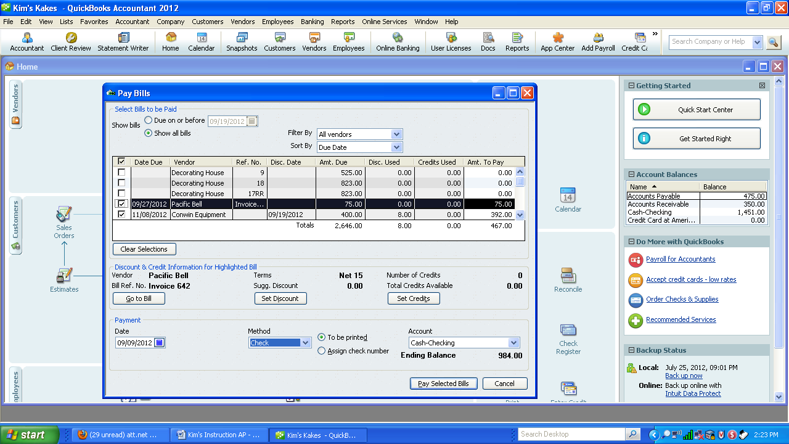
- Select Print Checks. Make sure the first check number is correct. Select OK. .
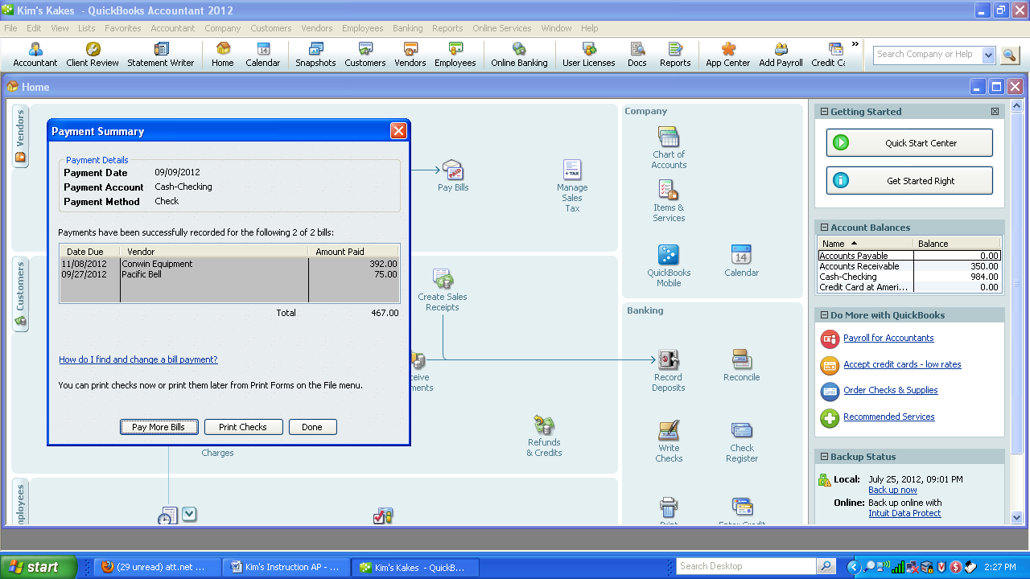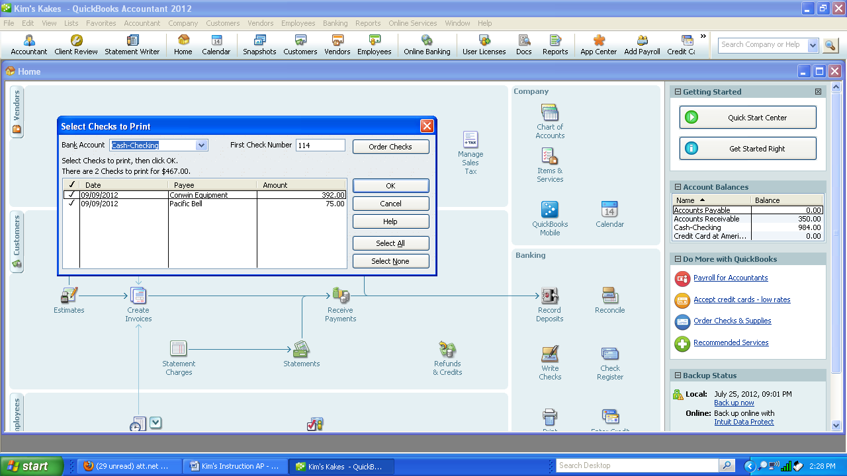

- Print the checks making sure you have the correct number of copies. One for the vendor and one for your files.

Purchase Expenses on Account - A/P
n. Sept 27,200X Purchased an ad in the Star News, 800 Marengo Blvd, Pasadena, CA $110 for one week. Net 30 Inv 644.
1. Select Vendor—Enter Bills. Add quick Vendor Star News. Enter the remaining information.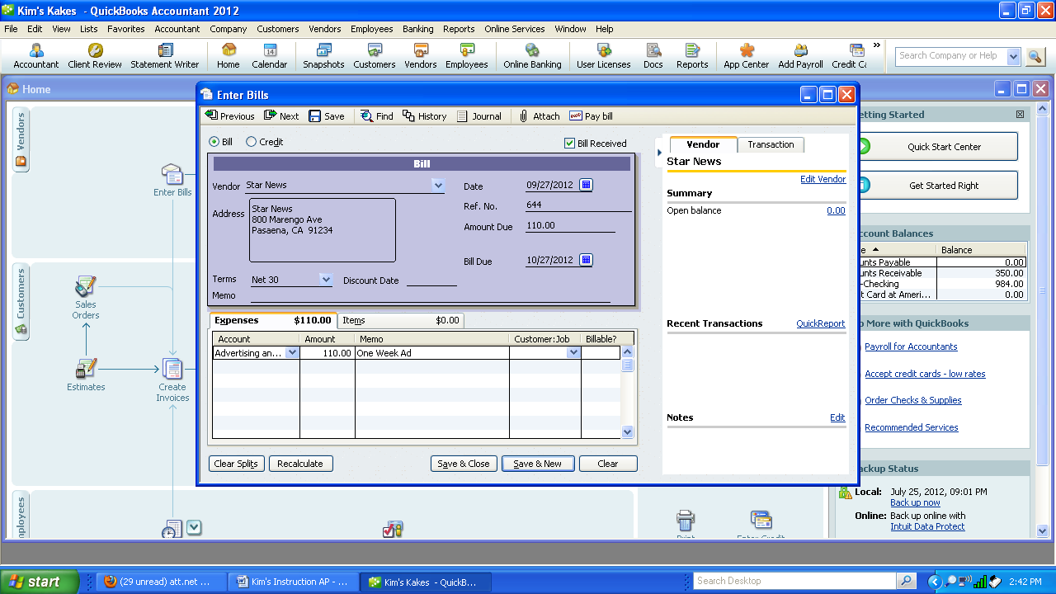

Month Cash Sales and Deposit Cash - A/R
o. Sept 30, 200X Record cash sales 300 cupcakes at $3.50 each from the cash register. Record the deposit of cash sales and the Marshall’s check.
1. Select Customer – Enter Sales Receipts
2. Add Customer – Cash Sales—Add as Quick.
3. Enter Cupcakes as the item and 300 as the quantity.
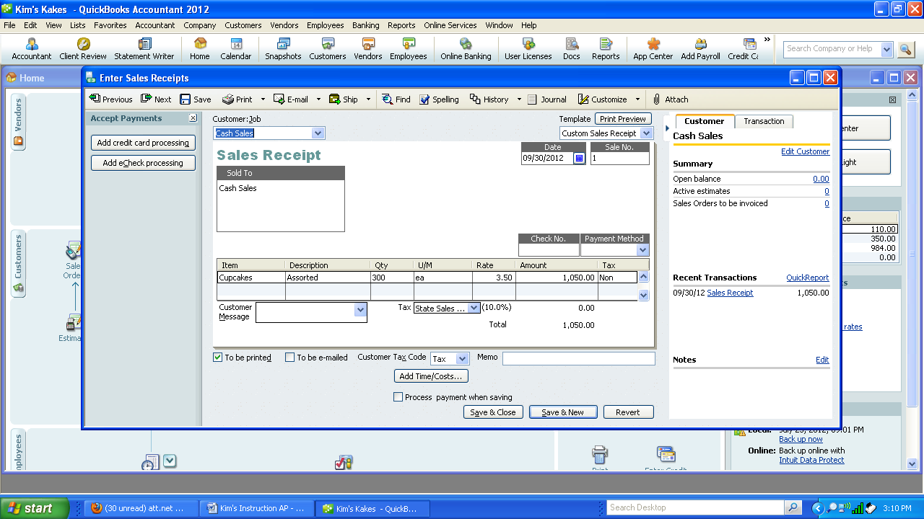
4. Once correct select “Save and Close.”
5. Select “Make Deposits” and place a check on the two lines. Select OK.
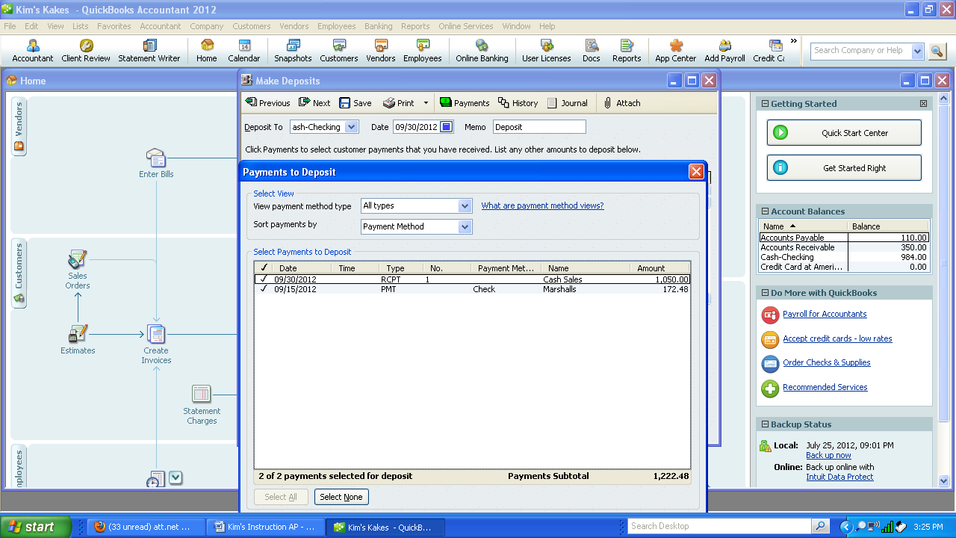
6. Save and Close. Check the balance in the cash account under Account Balances.
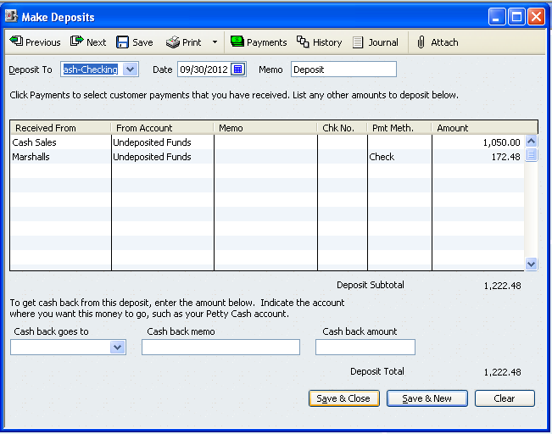

EOM Payments - September 30, 200X-
p. Pay Employee Paid Joy Willis $500 for her part time help Inv #9/30/0X

1. Select Banking – Write Checks
2. Add Joy Willis as a quick Vendor.
3. Record the $500 as payroll expense.
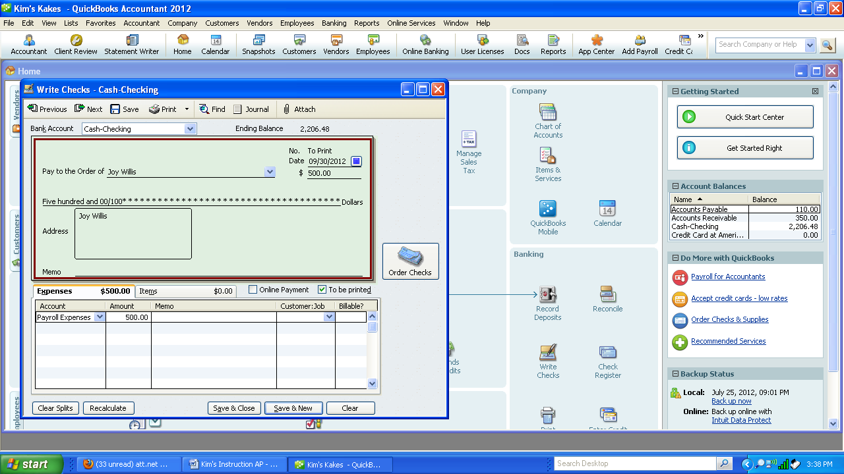
4. Save and Close

q. Owner Withdrawal Kim Withdrew $1500
1. Select Banking-Write Checks.
2. Enter Vendor-Kim Smith, make sure the date is correct, enter the $1000.
3. Enter Kim Smith, Drawing in the Account field.
4. Click on Save and Close.
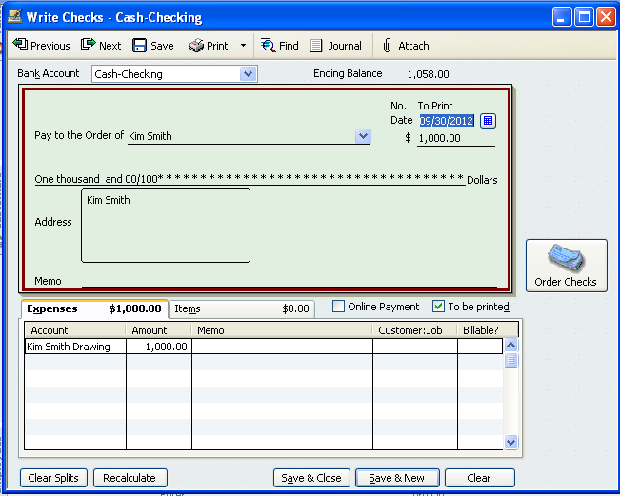

5. Select Banking-Print Checks- Select both checks
6. Check the First Check number as the next check. Click on OK.
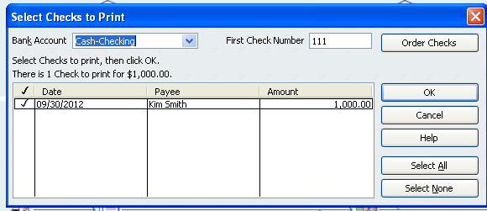
7. Check properties screen appear.
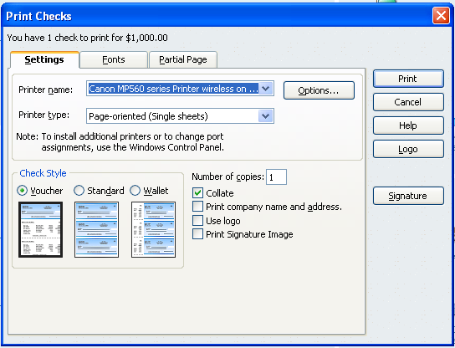

r. Pay Sales Tax $16
1. Select Manage Sales Tax
2. Print the Sales Tax Liability Report making sure the dates are correct.

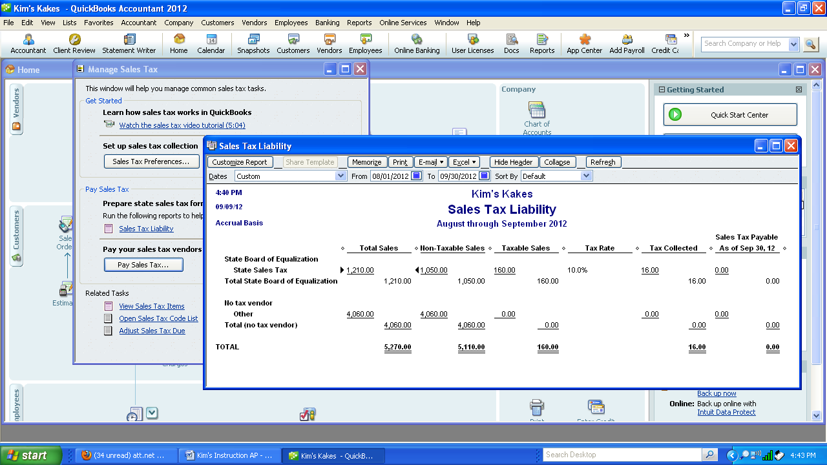

3. Select Pay Sales Tax. Make sure the dates are correct. Put a check on the line next to the Item. Click OK.
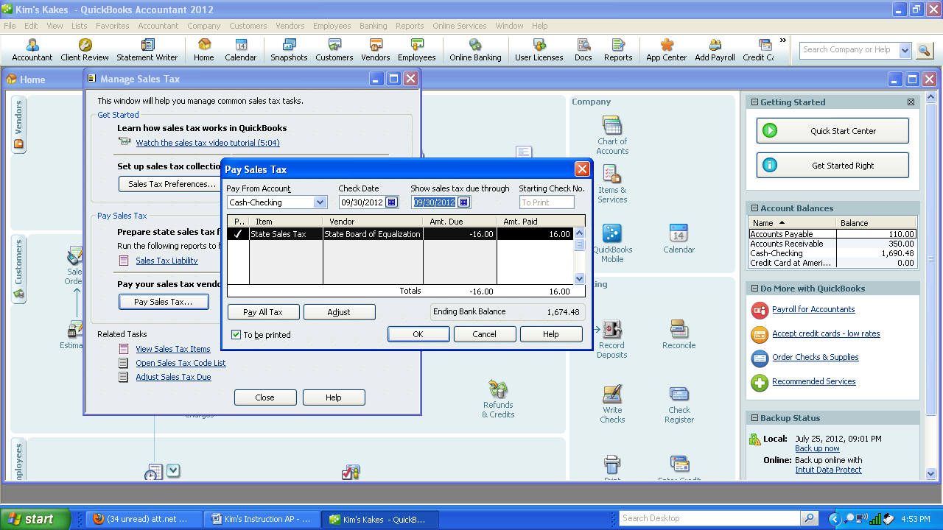
4. Select Banking--Print Checks and print the check for the State Board of Equalization. Always check the dates. Check should be dated 9/30/XX.

Adjusting Entries - G/L September 30 ,200X
1. Select Company-Make General Journal Entries. Make sure the date is 9/30/XX and it is marked as an adjusting entry. Enter the three transactions, select “Save and New” after the first adjusting entry. Select “Save and Close” after the last transaction.

s. Truck Depreciation $100
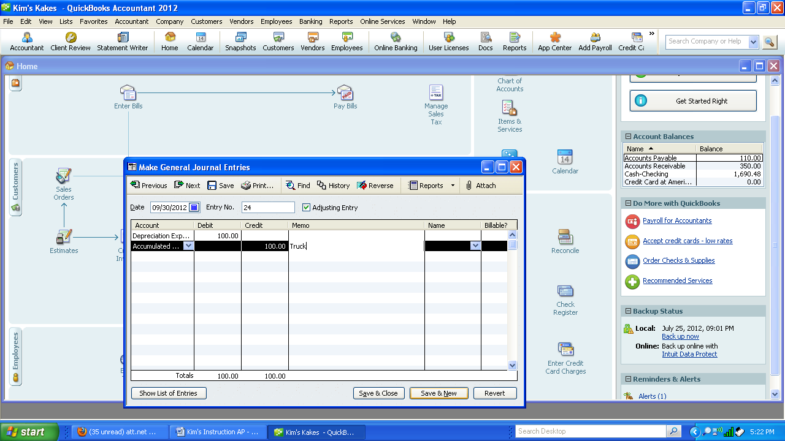
t. Equipment Depreciation $100

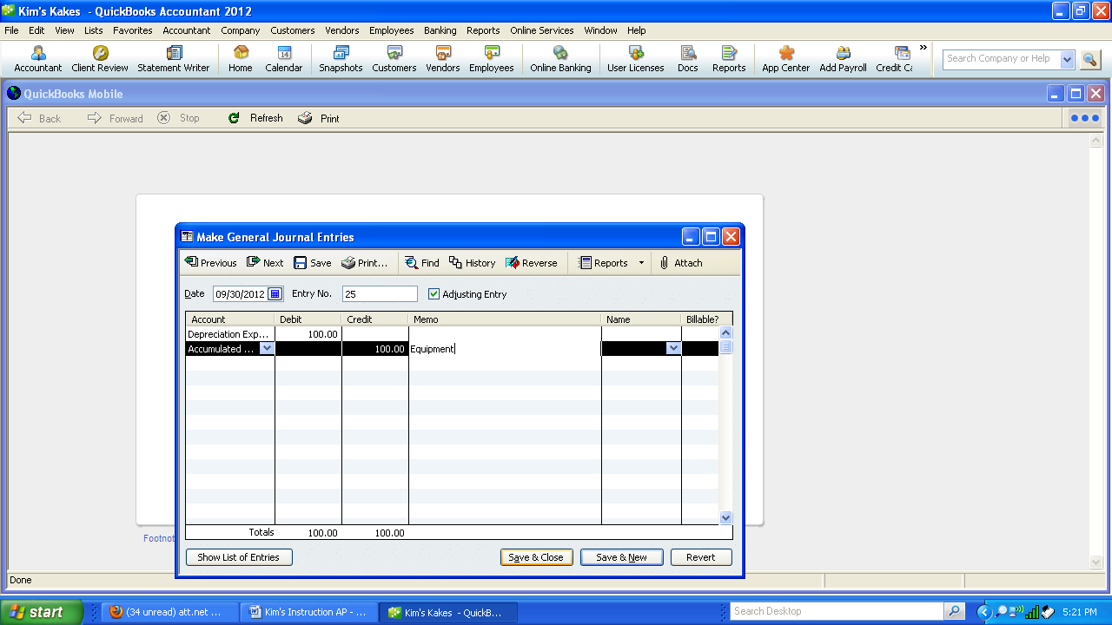
u. Decorating Supplies USED $50

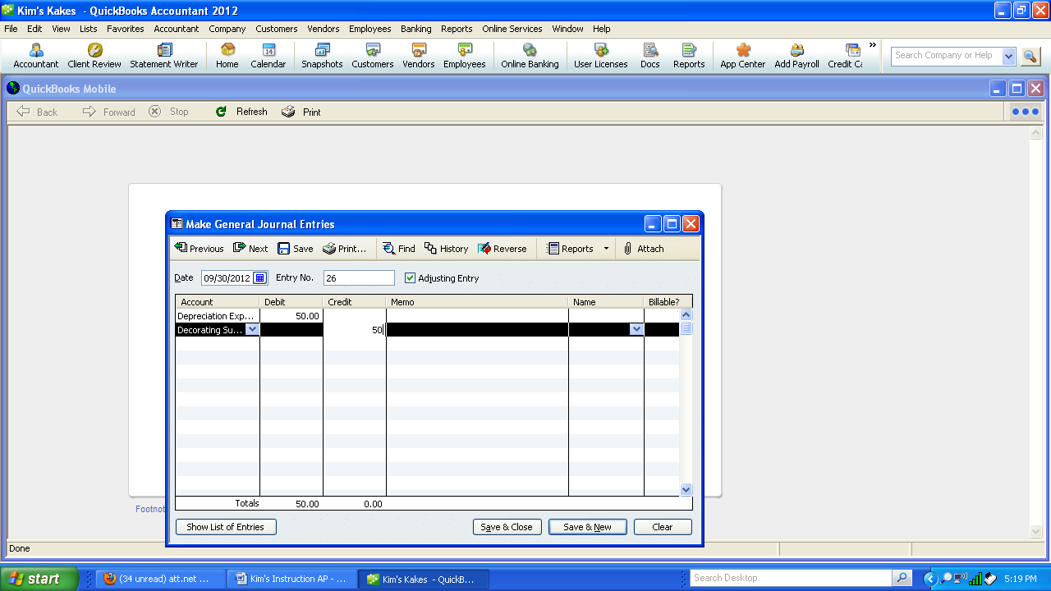

Instruction 2: Print the General Journal to check for correctness. If correct, print.

Instruction 3: Print the following reports:
Sales Journal
Cash Receipts journal
Purchases Journal
Cash Disbursement journal

Month End Activities

Instruction 1: Print the following reports:
A/R Aged Invoice report
A/R subsidiary ledger
Statements
A/ P Aging
A/P Subsidiary Ledger
Trial Balance
Income Statement
Balance Sheet
General Ledger

Instruction 2: Make an archival disk
Instruction 3: Close the month for all three modules. Be sure the General Ledger is the last to close.
Instruction 4: Print Income statement to show the month is closed.

AUDIT TEST - Chapter 5

KIM

1. How much cash was brought into the company? _________
2. How much cash did the company pay out? _________
3. What is the balance in A/R? _________
4. What is the balance in A/P? _________
5. What was the activity for the period? _________
6. Balance in Owner's Equity? _________
7. Total Income from Services or Sales? _________
8. Total Purchase? _________
9. Total Purchase Returns & Allowance? _________
10. Total Purchase Discount? _________
11. Total Sales Discount? _________
12. What customers are represented by the balance
in A/R? _________
13. Total expenses for the month? _________
14. What is the aging of the open items in A/P? _________
15. What is the year-to-date income? _________

