Instructions for Microsoft Dynamics sample program

- Logon to the Academic Alliance Website at
https://www.dynamicscloud.com

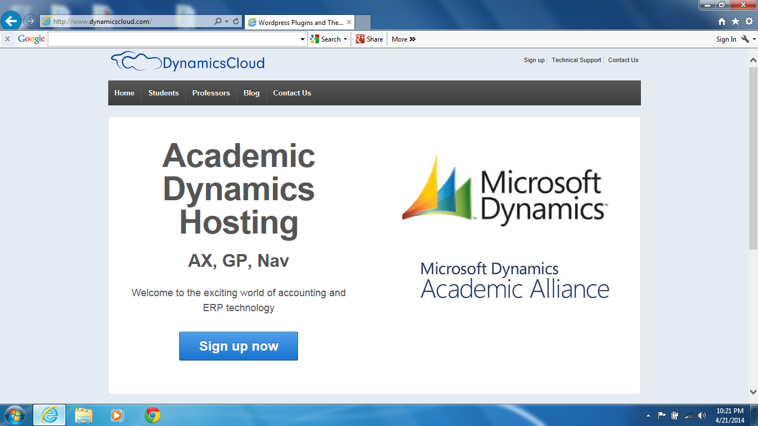
- Select “Sign up now. The sign up screen appears. Enter the required information. Select Glendale in “Which University do you attend?” Don’t forget to enter the code in the red box (reCaptcha screen). This is to keep people from spamming the site. Select submit.
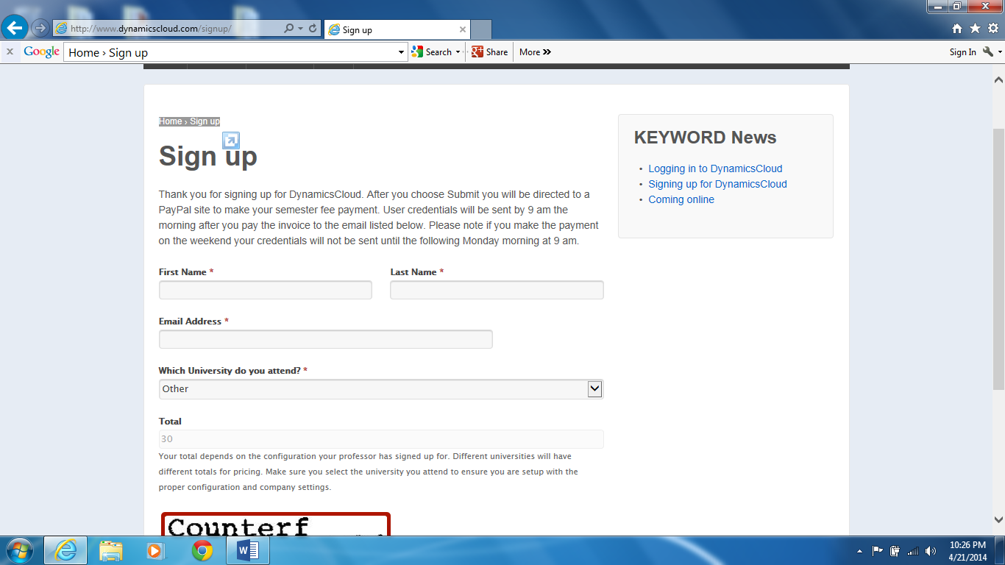
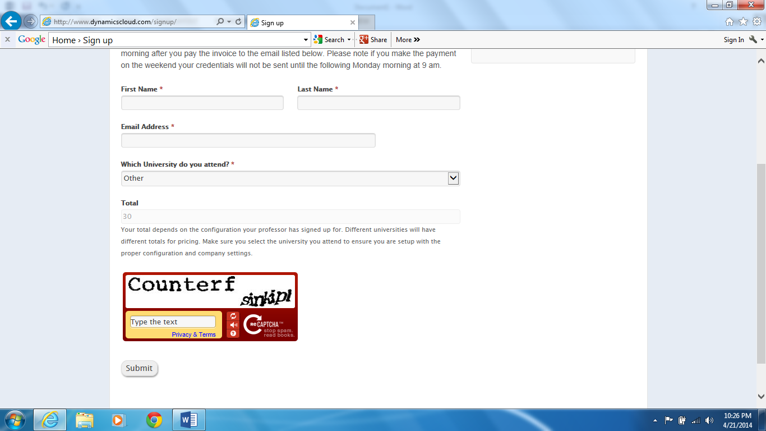
- Enter your information and select ‘Continue”.
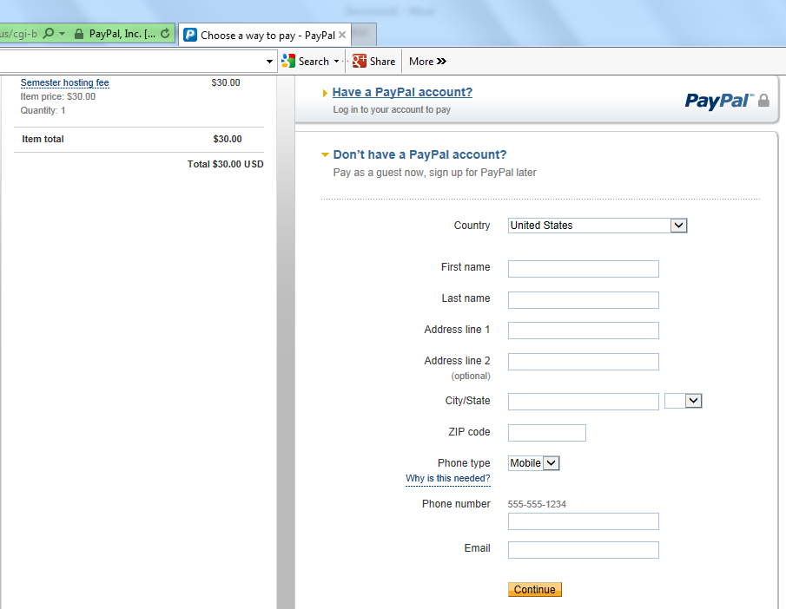

- The pay screen appears. Select how you plan to pay and press continue.
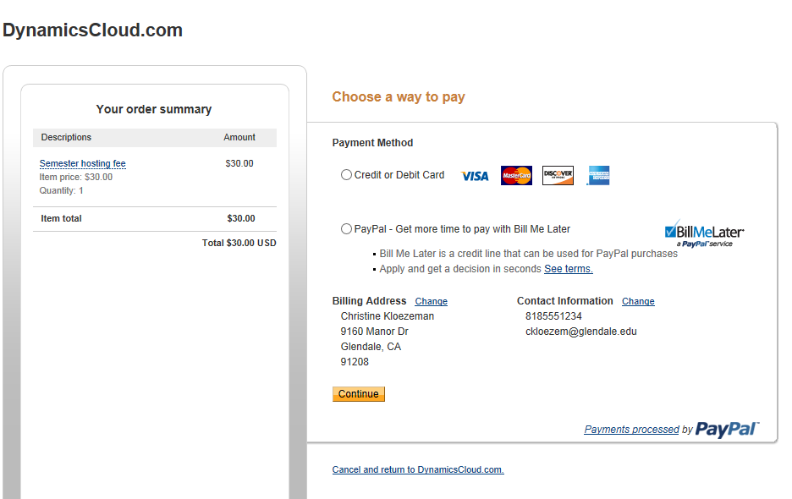

- After you have made your payment Dynamics Cloud will send your user credentials in a follow up email. This will take a while so check your email tomorrow morning. Email support@dynamicscloud.com for support.

- Once you receive your credentials (user name and password) you will go to the following website:
https://dynaa.dynamicscloud.com/GP/Views/LogOn.aspx

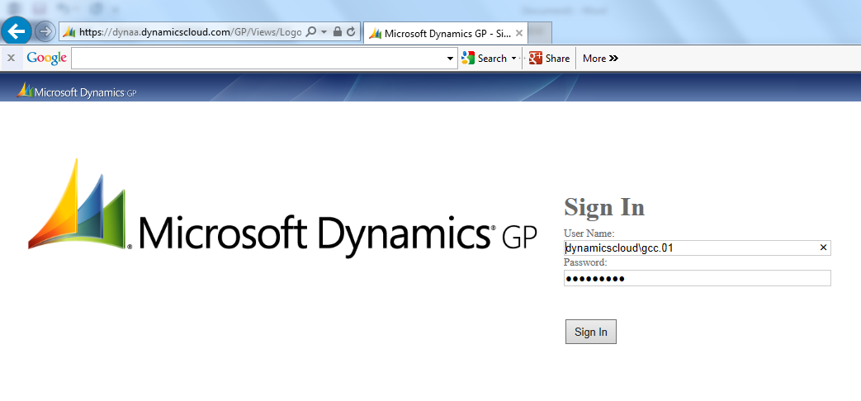

- Wait while “Loading Session Information” appears. Fabrikam, Inc. appears as your company.

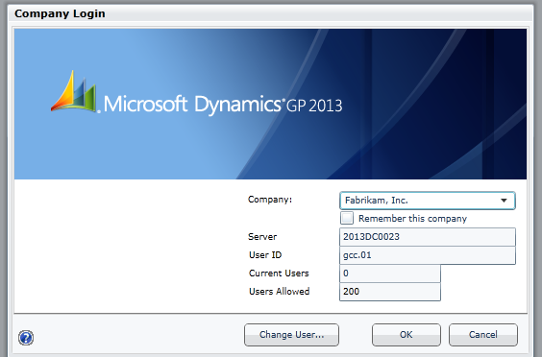
- Click “OK”. The date notice appears stating that you should use April 12, 2017 for your date.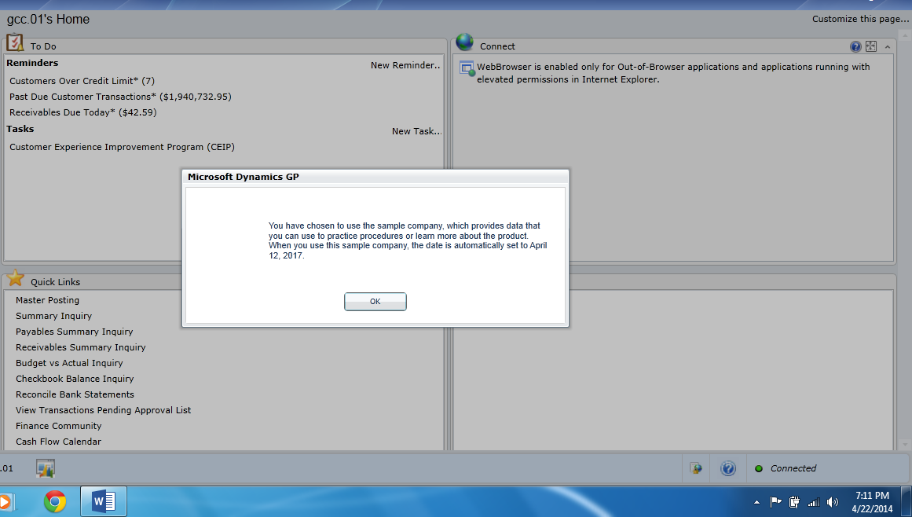

- Click ok again.
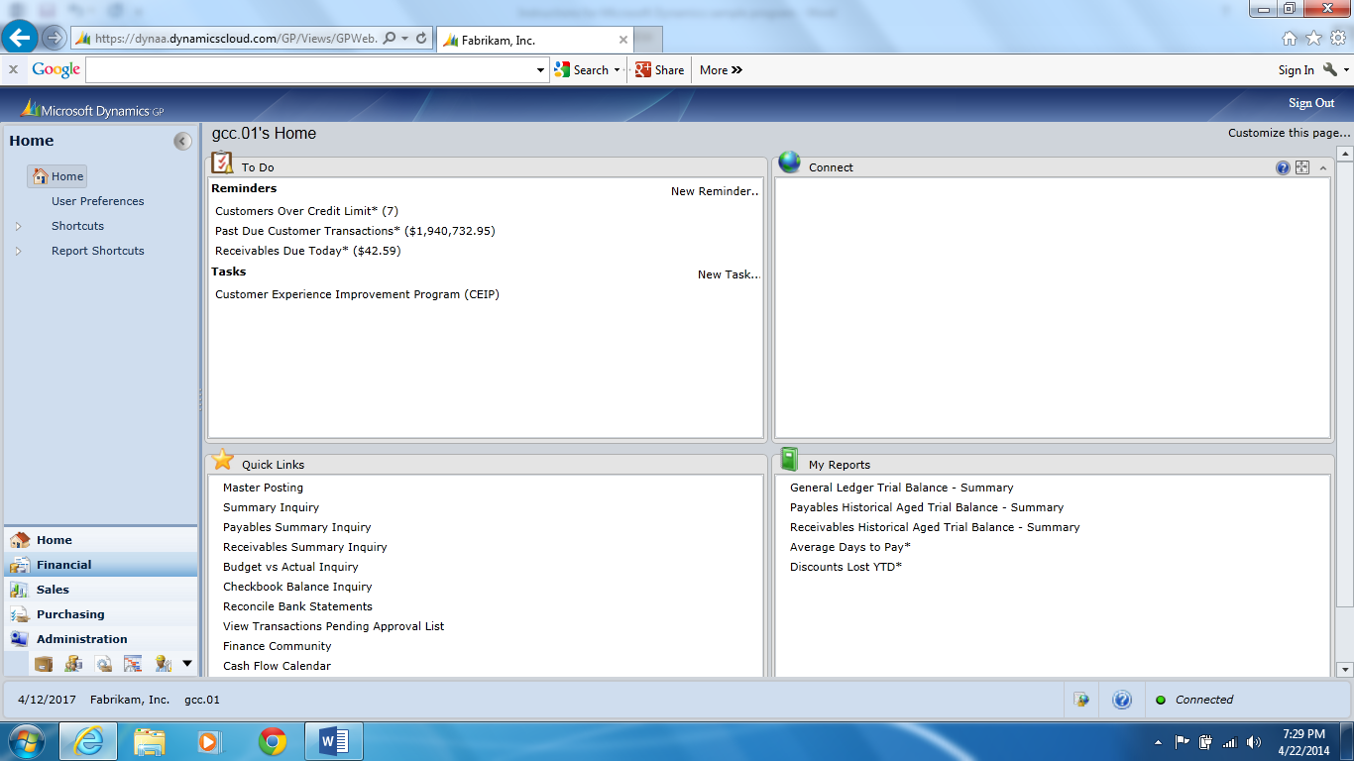

- Select Financial on the left side.

