*GENERIC DATA*

A method to learn and evaluate any accounting program

The Generic Data Approach

A method to learn and evaluate any accounting program

PREFACE

The purpose of this booklet is to provide data that an individual can use in any accounting program whether it be a simple Quicken Accounting Program or an Enterprise Resource Program such as Microsoft Dynamics. This data is simplistic in nature and represents basic transactions that occur in any business.

Having standard data and the results of that data will give the individual a basis to decide if the data was entered correctly and if the program will provide the accounting reports that the business requires.

The data will be a simple bakery that starts out in an owner’s kitchen and works up to a store front business.

Table of Contents

Preface

How to use generic data

Kim’s Cake Scenario

General Ledger Data

General Ledger Key

Accounts Receivable Data

Accounts Receivable Key

Accounts Payable Data

Accounts Payable Key

**How to use Generic Data**

In entering the generic data there are three basic steps to testing any module. First to enter the main file data. In the General Ledger module it is the Chart of Accounts, in the Accounts Receivable module it is the Customer file, and in the Accounts Payable module it is the Vendor file.

The second step is to enter transactions in that module. In the General Ledger it would simply be several journal entries. In Accounts Receivable it is sales invoices and receiving the payment from the customers of these invoices. In Accounts Payable it is purchase orders and writing checks to pay for these purchases and expenses.

The third step is to print reports that will summarize the data in a format required by basic accounting principles. In the General Ledger these reports would be the general journal, general ledger, income statement and balance sheet. In the Accounts Receivable it would be the sales journal, the cash receipts journal, and the aged accounts receivable. In Accounts Payable, the purchases journal, the check register and the aged accounts payable should be able to be produced.

In summary the steps for each module are:

1. Enter the main file information
2. Enter transactions
3. Produce reports

Using data that starts with the General Ledger data in the first month, then Accounts Receivable data in the second month and Accounts Payable data in the third month will easily isolate any problem by module instead of confusing the data among all these modules.

General Ledger

**The first step is to enter the Chart of Accounts**. Some accounting programs use only three digits while others can use a more complex system with three digits to represent the company, four digits to represent the account and two digits to represent the department. The individual will need to adjust the Chart of Accounts for the system used.

There will be no beginning balances since the theory is to provide simple data to evaluate the program. Entering data from a beginning company will provide the most transparent system to follow the data.

**The second step is to enter the journal entries.** Entering the journal entries will provide the individual the ability to produce a General Journal, General Ledger, Trial Balance, Income Statement and Balance Sheet. These reports are basic reports of any accounting program. If a problem occurs at this point the individual should determine if it is due to the data entry or the accounting program. It is determined to be the accounting program then no more time should be wasted using this accounting program.

**The third step is to produce end of month reports.** These reports would be the General Journal, General Ledger, Trial Balance, Income Statement and Balance Sheet. Verification that the reports agree with the key will determine if the accounting program at this point is sufficient. Double check at this point that the reports can be presented in the manner expected by the company. Check that a good audit trail has been provided. That each journal entry can be tracked from the general journal to the general ledger and to the appropriate financial statement. If there is problems at this point do not go further as this is the most basic function of any accounting program.

Accounts Receivable

**The first step is to enter the customers.**  There are some programs that require the individual user to enter the customers at the same time the account “accounts receivable” is entered. If this is required just enter the customers from the accounts receivable section at the same time as the Chart of Accounts is entered. If it is not required just enter the customers, making up any data that is not provided. This will determine if the program will make all the necessary calculations such as Sales discount and Sales Allowances.

**The second step is to enter Sales Invoices and customer payments.**  Once again simple data is provided and if necessary additional data should be made up. However, remember to be consistent in this “made-up” data. Do not be too complex or the basics of the Accounts Receivable or Customers will not be tested. Too much time would be wasted finding those little errors that do not provide any evaluation data.

After the invoices have been entered payments should be recorded and match to the specific invoice. This will test whether the sales discounts and sales tax features are properly set up and applied. It will test whether a program can accommodate several discounts and a variety of sales tax structures, if necessary.

**The third step is to produce end of month reports.** At this time both the General Ledger and Accounts Receivable reports are to be produced. Besides the reports mentioned in the General Ledger you will need to produce a Sales Journal, Cash Receipts journal and the Aged Accounts receivable reports. Double check that the Accounts Receivable transactions can easily be identified in the General Ledger and the totals of the transactions are reflected properly in the income statement and balance sheet. Make sure you can track a sales invoice from its inception to the payment in full with the correct sales discount and sales tax, if necessary.

Accounts Payable

**The first step is to enter the vendors** or companies that items will be purchased or to whom bills will be paid. Some programs will call these creditors or suppliers. Whatever the program uses for vendors these are companies that will receive checks from your accounting program. As with the Accounts Receivable, some accounting program will require the vendor to be identified when entering the Accounts Payable account. Simply go to the Accounts Payable data for this information. Also if some data is not provided make up data for this field being careful to make the data consistent with all the vendors.

**The second step is divided into three transaction**: 1) record purchase invoices, 2) make the payments for these invoices and 3) make payments for standard business expenses. Some programs use the term purchase orders instead of purchase invoices. The best way to determine where to record a transaction is to identify what the data entry screen is trying to record. This will tell you what transaction to record in the particular screen. When you record invoices make sure there is a method to match the invoice to the check. This will make sure you’re A/P subsidiary ledger is correct. This is also called the Vendors journal.

With the general business expenses such as rent and utilities, some programs require a purchase order to write the check. Other programs will record the expense by simply writing a check. Some programs allow both methods. Note the method that is the easiest and provides the best audit trail.

**The third step is to produce the purchase journal**, cash disbursement journal and the aged accounts payable ledger. Make sure that the purchase invoice can be easily seen as paid in the cash disbursement journal and on the aged accounts payable ledger. Tracking an expense from writing the check to the general ledger expense account is an important audit function that should be verified.

Kim’s Cakes Scenario

**

General Ledger Scenario 1

Kimberly Smith is a Culinary Arts student. She has been making cakes for her friends for many years. Her friends have spread the word that she is fantastic and very creative. Because of this she is having a hard time filling cake requests while both working and going to school. She has calculated that selling three cakes a week would give her the same pay as her present job. As such, she has decided to quit her 20 hour per week low paying job and start her own cake decorating business. She also calculated that she will work in her home until she receives orders for 2 cakes per day, which is her beginning business level. Her address is 1900 Hope St, Pasadena, CA 91103. Her phone number is 626-796-4111. Once her beginning business level has been reached, she will search for a storefront on a busy street. Kim has decided to only use the General Ledger (Company) module until her business improves.

Accounts Receivable Scenario 2

After a month of work, Kim feels that she made the right decision to start her own business. She is beginning to get return customers from the business community. Her business customers need invoices and to buy on credit. This is best recorded in the Customer or Accounts Receivable module. She is going to start with very basic invoices, which in later months will be more elaborate. Her friends tell her that cupcakes are very popular. She has decided to sell both large and mini cupcakes as well as her sheet cakes and layered cakes. She has accepted large orders and will need occasional help but does not yet have any employees.

Kim has found a company called *Decorating House* that has all the materials she needs to make her cakes. This is the only vendor she has, so she will continue to use handwritten checks, recording them in the general ledger.

No Sales Tax will be included in the invoices because it is Business to Business.

Accounts Payable Scenario 3

Kim’s business has really picked up requiring her to buy her materials in bulk sizes. She will have a new vendor for flour, sugar and eggs. She will continue to buy from Decorating House for her decorating supplies.

She is thinking she might need a loan to grow her business. She wants to look more like a professional business instead of a home based business. As a result, Kim has purchased new checks that can be printed from the printer. She will start with check number 101.

She still feels she cannot afford to hire a full time assistant and will continue to pay helpers on a week by week basis.

General Ledger Generic Data-Chart of Accounts

111 Cash- Checking

112 Accounts Receivable

113 Decorating Supplies

120 Cake Pan Inventory for resale

150 Equipment

151 Accumulated Depreciation – Equipment

155 Furniture and Fixtures

156 Accumulated Depreciation – Furniture and Fixtures

160 Truck

161 Accumulated Depreciation – Truck

211 Accounts Payable

212 Sales Tax Payable

213 Payroll Taxes Payable

311 Kimberly Smith, Capital

312 Kimberly Smith, Drawing

399 Retained Earnings

411 Cake Sales

420 Sales Returns and Allowance

421 Sales Discount

440 Freight Revenue

445 Finance Charge

450 Purchases

451 Purchase returns and allowances

452 Purchase discount

501 Wages Expense

506 Utilities Expense

512 Baking Supplies Expense

601 Advertising and Promotion Expense

605 Decorating Accessories

610 Automobile Expense

612 Bank Service Charge Expense

615 Depreciation Expense

620 Bad Debt Expense

650 Conference Expense

General Ledger Generic Transaction Data

# Original Investment

a. July 1, 20X2 Kim Smith invested $1,000 cash, $700 equipment, $4,000 truck.

# Purchased Supplies with Cash

b. July 1, 20X2 Purchased decorating supplies from Michaels Store for $65, Check #101

## Sale on Account

c. July 2, 20X2 Kim baked several sheet cakes for Marshall’s Open House, $1,200 Net 30.

## Purchases for Cash

## d. July 10, 20X2 Purchased baking supplies (cake mixes, frosting etc) from Maddie’s Grocery Store, $250, Check #102

**Received Payment on Account**

e. July 12, 20X2 Received $1,200 from Marshall’s, Inc., Check #15123.

**Owner Withdrawals**

f. July 15, 20X2 Kim withdrew $300, Check #103.

**Purchase on Account**

g. July 15, 20X2 Purchased cake pans for resale on account from Decorating House, $525, 2/10 net 30

**Cash Sale**

h. July 16, 20X2 Created a decorated 5 layer cake for Seda Evans’s Wedding. Received full payment at the end of the wedding, $750, Check # 760.

**Paid Vendor on Account**

i. July 30, 20X2 Paid Decorating House $525, Check #104. No Discount

**Owner Withdrawals**

j. July 31, 20X2 Kim withdrew $300, Check # 105.

**Adjusting entries**

k. July 31, 20X2 Truck Depreciation, $100.

l. July 31, 20X2 Equipment depreciation, $75.

m. July 31, 20X2 Decorating supplies on hand, $25 (adj. $40).

AUDIT Data -- General Ledger

1. How much cash was received by the company? ________

(How much is on the debit side of the cash account)

1. How much cash did the company pay out? ________

(How much is on the credit side of the cash account)

1. What is the balance in A/R? ________
2. What is the balance in A/P? ________
3. Balance in Owner's Equity? ________
4. Total Sales or Service Income? ________
5. Total Advertising Expense, if any ________
6. What is the account balance for Cash? ________
7. What is the Total Expense for the month? ________
8. What is the total Net Income for the month? ________
9. How much is the total assets? ________

General Ledger Data Key

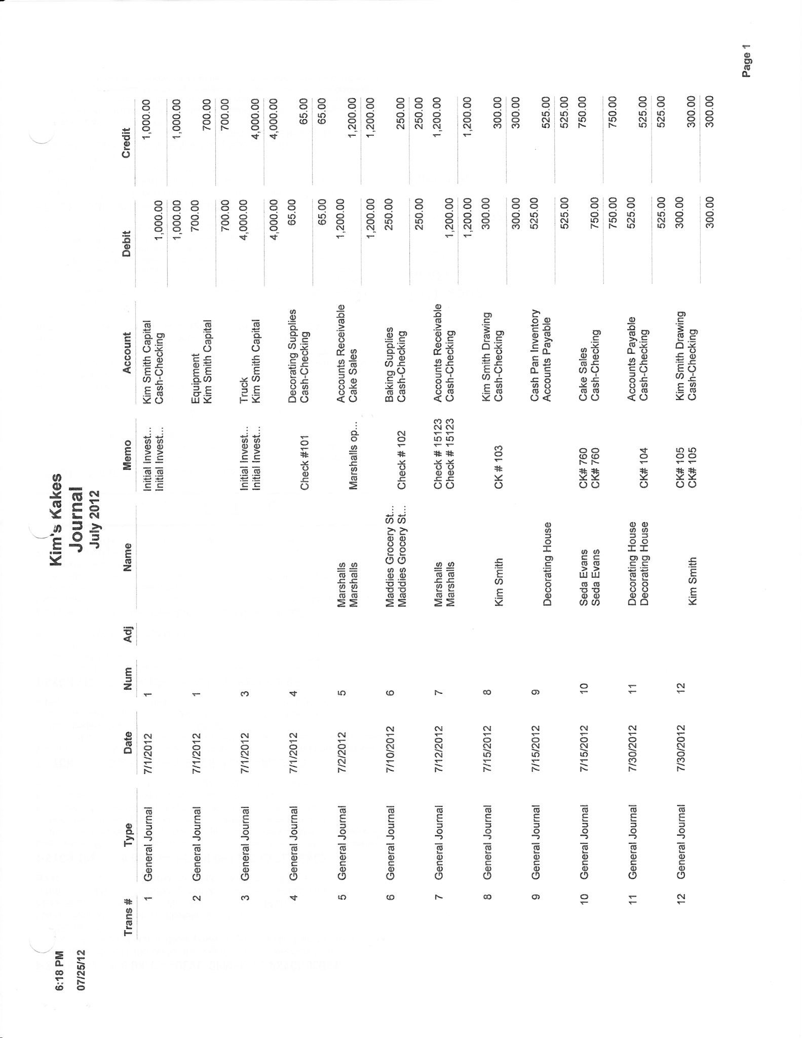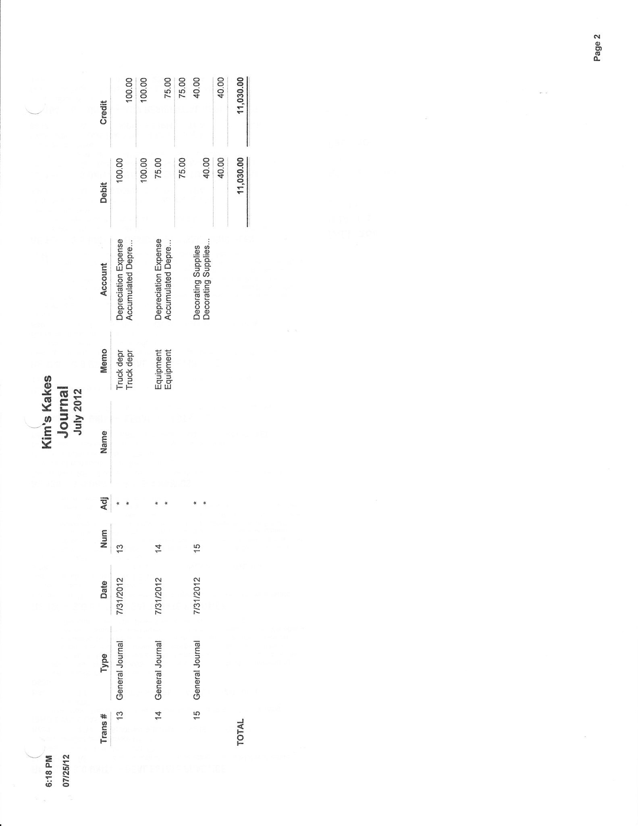

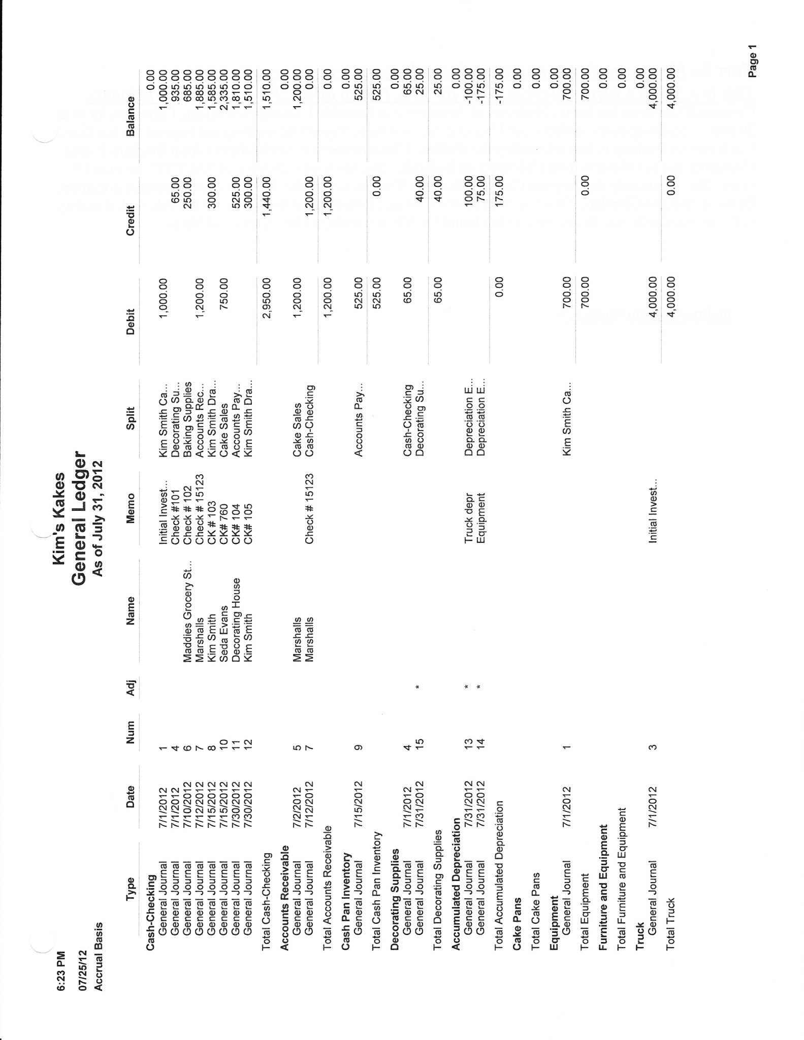

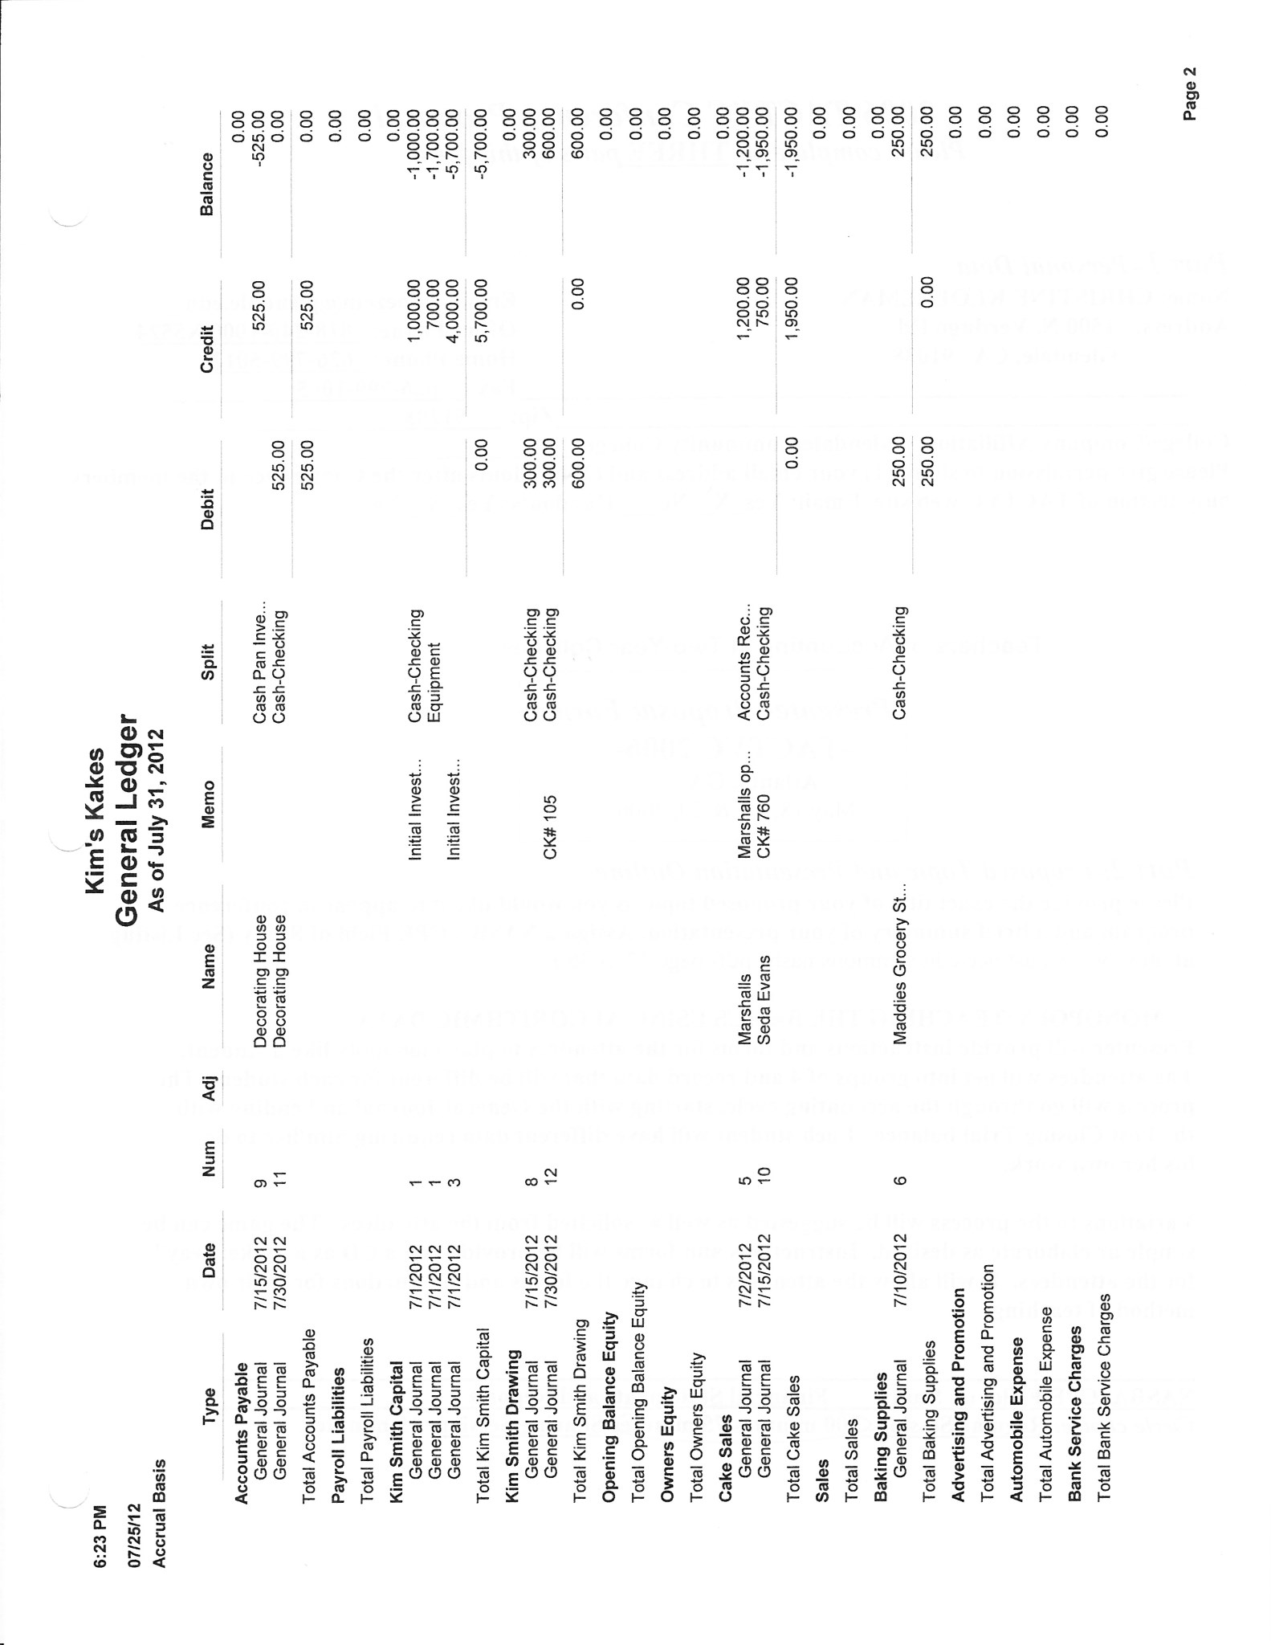

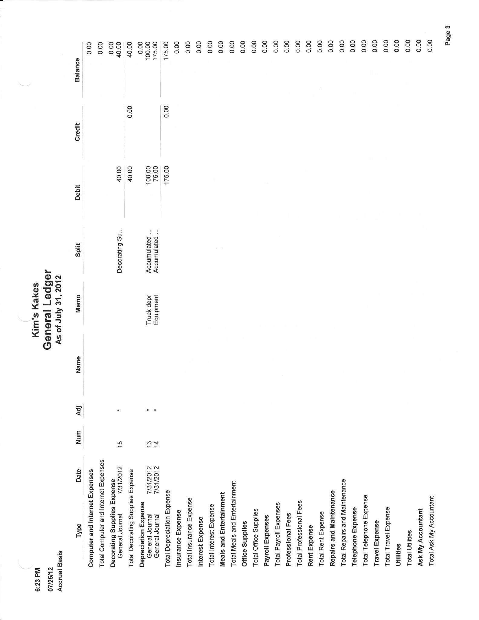

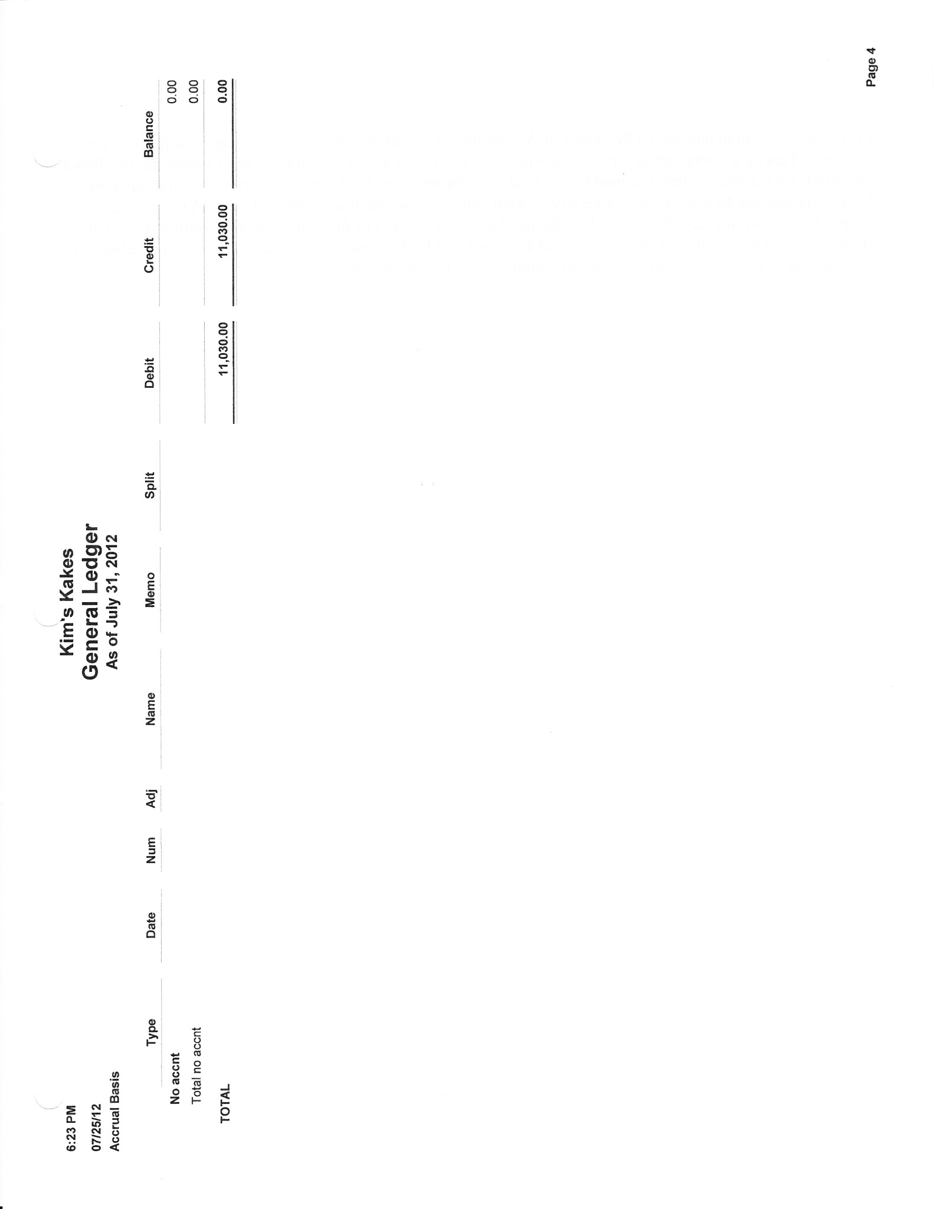

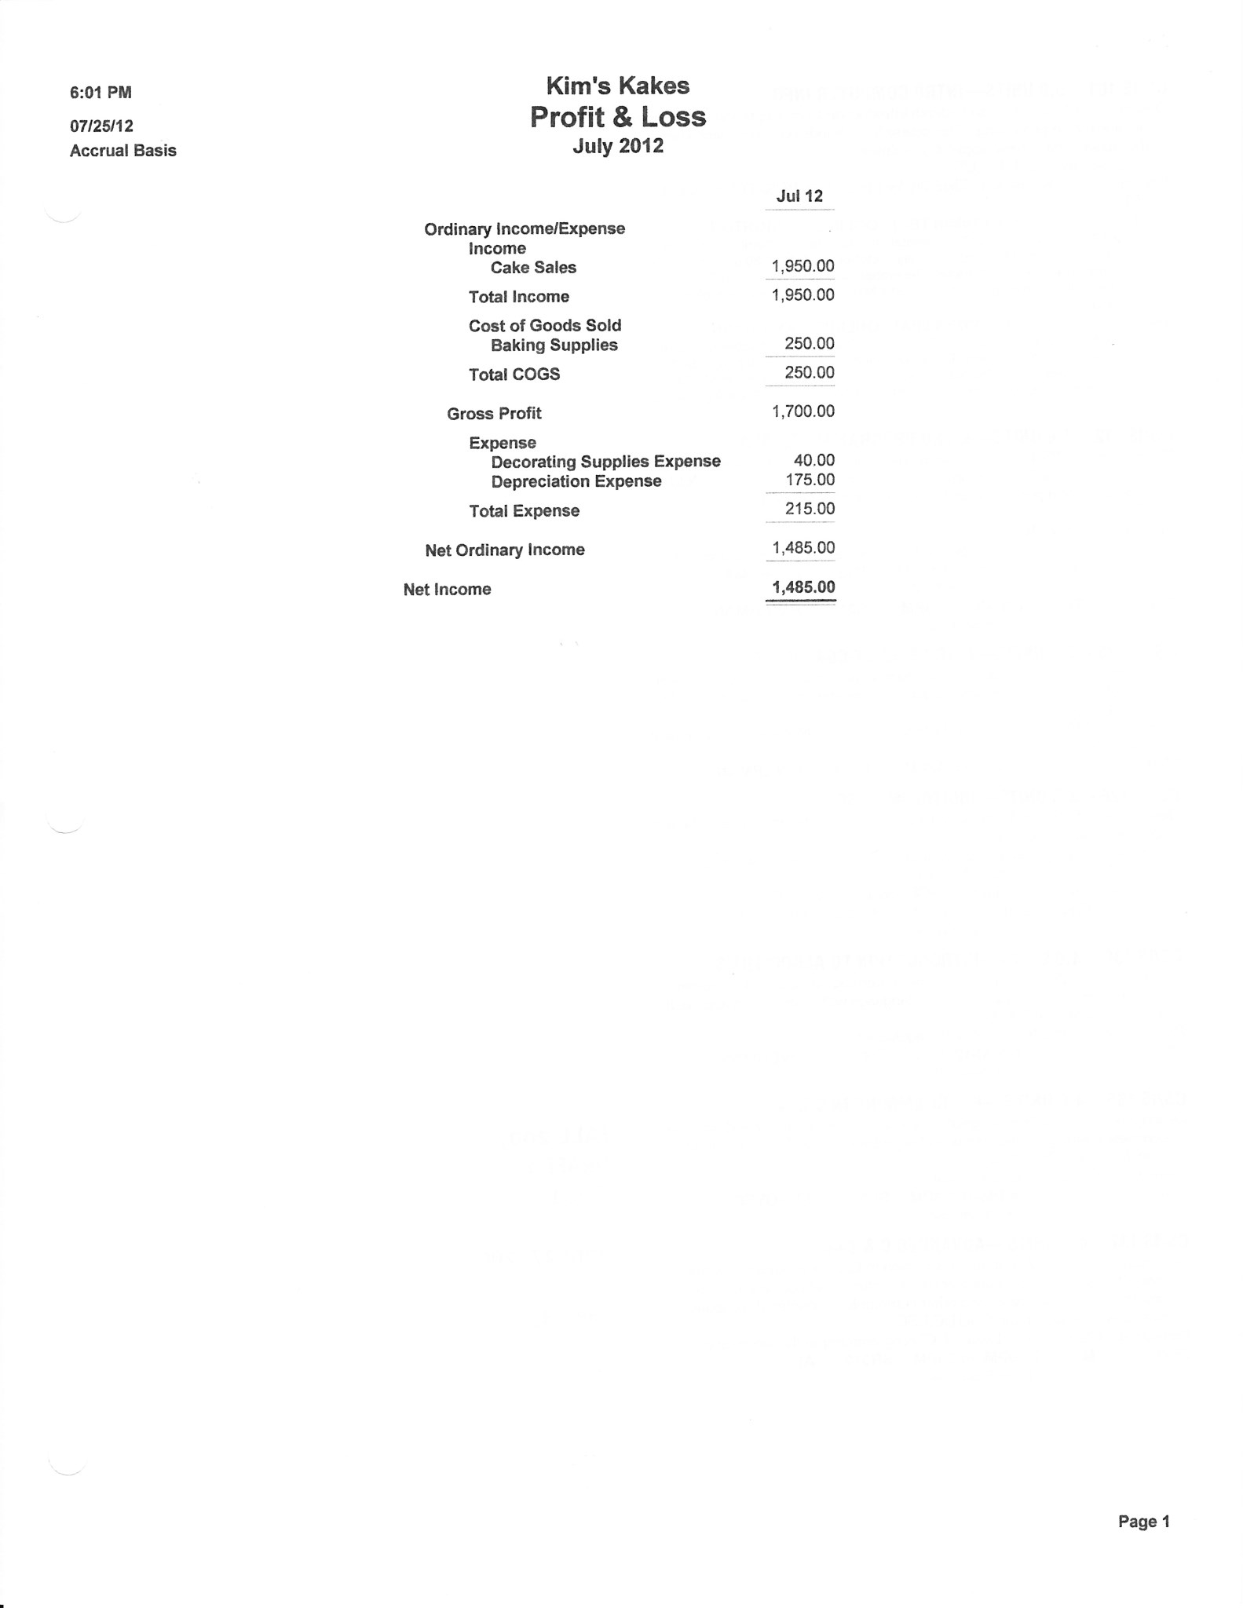

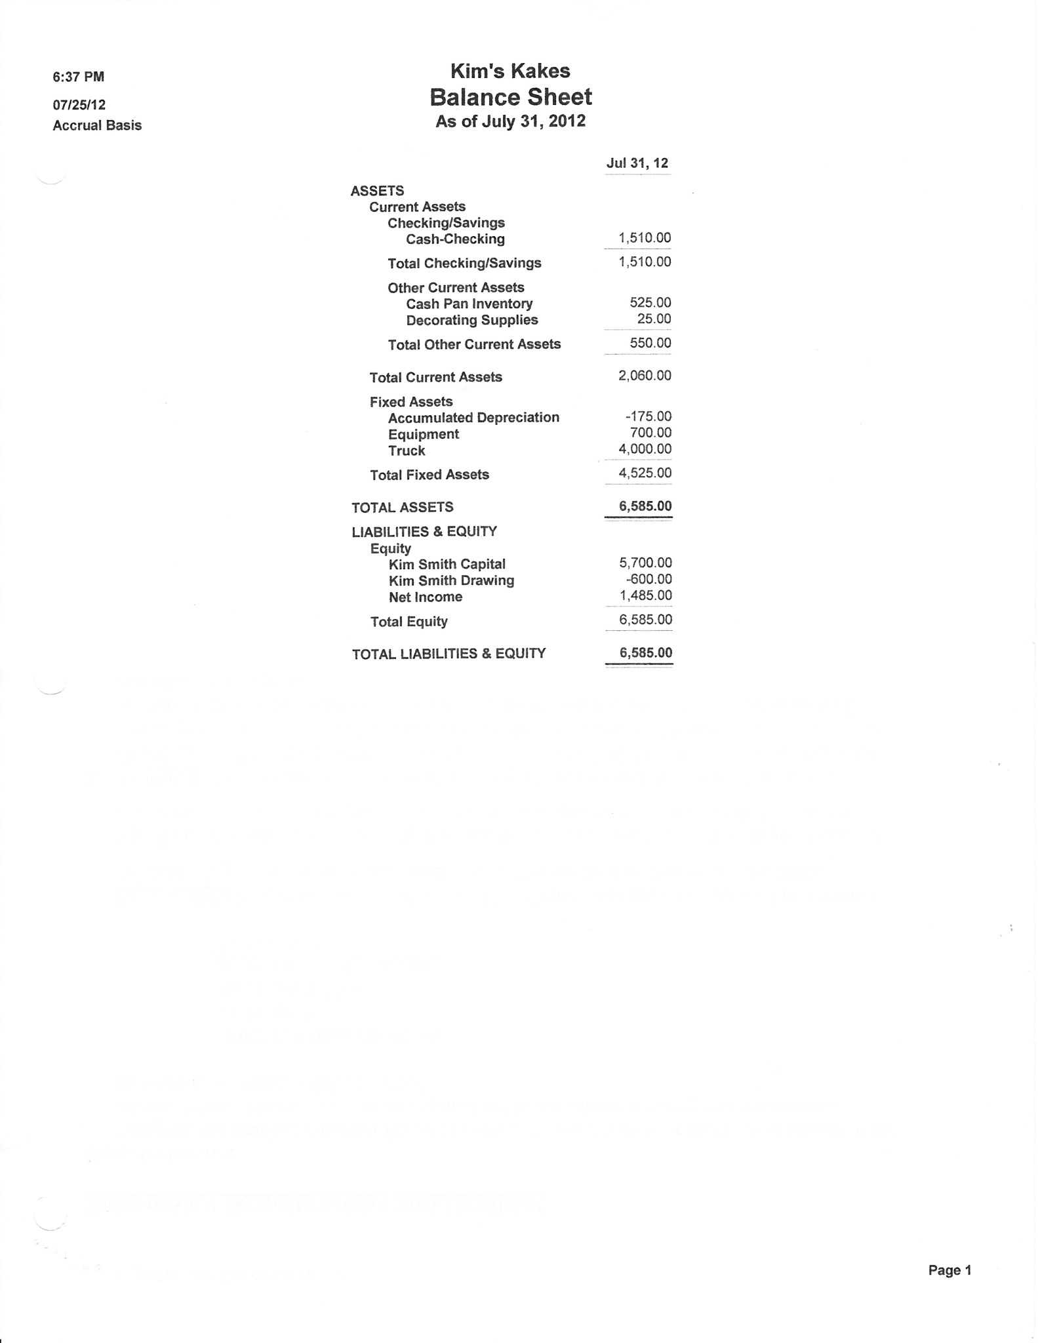

Accounts Receivable Generic Data

Customer Files

*Fred’s Farm, 145 Marsh St*, Your City, Your State, Zip 2/10 Net 30

*Little Rock School District, 80 River Ave,* Your City, Your State, Zip Net 30

*Bill Norman Design, 1441 Baget Street*, Your City, Your State, Zip 2/10 Net 30

*Mall's Stores, 3 West Place*, Your City, Your State, Zip Net 30

Items

Cupcakes $ 3.50 each Cake Pans $3.00 each

Sheet Cakes $40.00 each Layer Cakes $3.00 each

Mini cupcakes $ 1.00 each

Accounts Receivable Generic Data- Transactions

Please note that the source document number (Check#, JE#, Invoice #) may vary from the sample. Start invoices at 1000 and Credit Memos at 100. If information is needed on the invoice but is not stated, create your own data.

**Decorating supplies and Baking Supplies purchased on account**

a. August 1, 200X Purchased decorating supplies $123 and purchases $700 from *Decorating House*, $823. P.O. #995, 2/10 Net 30 (G/L) Add a new account “Purchases” and transfer the Baking Supplies balance.

**Create Invoice**

b. August 2, 200X Sold 100 cupcakes @$3.50 each to *Fred’s Farm, 145 Marsh St*, Your City, Your State, Zip. Inv #1000. 2/10 Net 30

**Create Sales Invoice with full Payment, add Customer and Item “on-the-fly”**

c. August 3, 200X *Little Rock School District, 80 River Ave,* Your City, Your State, Zip ordered 30 sheet cakes @ $40 each to P.O. #00576. Order to be picked up and paid on August

**Add New Item and Customer “on the fly”**

d. August 4, 200X Create invoice for 50 cake pans @ $3 each to *Bill Norman Design, 1441 Baget Street*, Your City, Your State, Zip. for party decorations, $150,

Inv # 1001 2/10 Net 30. UPS

**Record Check paid to Decorating House**

e. August 10, 200X Paid 8/1/0X *Decorating House* Invoice, CK #106, no discount $823 (G/L)

**Purchased Office Supplies on Account**

f. August 10, 200X Purchased on account office supplies from *Target Stores*, $200. Add account Office Supplies as a current asset. (G/L)

**Receive Payment from Customer with discount**

g. August 12, 200X Received check #1122 for $343 from *Fred’s Farm*. Invoice dated 8/2.

**Create Invoice with Multiple Items**

h. August 16, 200X Billed *Mall's Stores, 3 West Place*, Your City, Your State, Zip. for desserts for their Open House , P.O. 65432. Net 30, $840

Qty Description $each

5 3-layer cakes 100

6 Sheet cakes 40

100 Mini cupcakes 1

**Record Return Item**

i. August 17, 200X Two sheet cakes fell while delivering the order. Give Mall Stores credit for two returned sheet cakes from 8/16 invoice. Use Sales Return and Allowance

**Create Invoice – Sale on Account**

j. August 18, 200X Invoice Mall’s for 200 cupcakes @ $3.50 each. Net 30 days. Ship via delivered. No Freight. $700

**Cash Receipt for Mutliple Invoices and Sales Return and Allowance**

k. August 31, 200X Received CK # 191989 for $1190 from Mall’s for all of 8/16 invoice and 1/2 of 8/17 invoice.

**Record Bad Debt**

l. August 31, 200X Bill Norman was nowhere to be found. Declared his account to be uncollectible. Use Bad Debt Expense to remove his account from the A/R Ledger

**Paid for part-time help –Add account “on- the- fly”**

m. August 31, 200X Paid Karen Lee $500 for her part-time help. CK#107. Add account Wages Expense if needed. (G/L)

**Owner Withdrawal**

n. August 31, 200X Kim withdrew $1,000. Check #108. (G/L)

**Sales Invoice from Sales Order**

o. August 31, 200X Little Rock School District picked up and paid for the cakes ordered on August 3rd, $1200 CK#167898.

**Cash Deposit**

p. August 31, 200X Make a deposit of the cash receipt for the month. (Note for practice purpose deposits are made at the end of the month. Deposits should be made daily)

**Adjusting Entries - G/L**

p. August 31, 200X Truck Depreciation $100

q. August 31, 200X Equipment Depreciation $175

r. August 31, 200X Office Supplies ON HAND, $75 and Decorating Supplies on Hand $100 (Journal entry is calculated by subtracting on hand amount from the balance in office supplies and decorating supplies account)

Accounts Receivable Key

|  |  |  |  |  |
| --- | --- | --- | --- | --- |
|  | **General Journal** |  |  | Page ____ |
|  |  |  |  |  |
|  |  | **Post.** |  |  |
| **Date** | **Description/Account Name** | **Ref.** | **Debit** | **Credit** |
| a) | Purchases |  | 700 |  |
|  | Decorating Supplies |  | 123 |  |
|  | A/P-Decorating House |  |  | 823 |
|  |  |  |  |  |
|  | Purchases |  | 250 |  |
|  | Baking Supplies |  |  | 250 |
|  |  |  |  |  |
| b) | A/R - Fred Farms |  | 350 |  |
|  | Sales - Cupcakes |  |  | 350 |
|  |  |  |  |  |
| c) | A/R - Little Rock Schools |  | 1200 |  |
|  | Sales - Sheet Cakes |  |  | 1200 |
|  |  |  |  |  |
| d) | A/R - Bill Norman |  | 150 |  |
|  | Sales - Cake Pans |  |  | 150 |
|  |  |  |  |  |
| e) | A/P- Decorating House |  | 823 |  |
|  | Cash |  |  | 823 |
|  |  |  |  |  |
| f) | Office Supplies |  | 200 |  |
|  | A/P - Target |  |  | 200 |
|  |  |  |  |  |
| g) | Sales Discount |  | 7 |  |
|  | Cash |  | 343 |  |
|  | A/R - Fred Farms |  |  | 350 |
|  |  |  |  |  |
| h) | A/R - Mall's |  | 840 |  |
|  | Sales - Layer Cake |  |  | 500 |
|  | Sales - Sheet Cake |  |  | 240 |
|  | Sales - Mini cupcakes |  |  | 100 |
|  |  |  |  |  |
| i) | Sales Returns & Allowance |  | 80 |  |
|  | A/R - Mall's |  |  | 80 |
|  |  |  |  |  |
| j) | A/R - Mall's |  | 700 |  |
|  | Sales - Cupcakes |  |  | 700 |
|  |  |  |  |  |
| k) | Cash |  | 1190 |  |
|  | A/R- Mall's |  |  | 840 |
|  | A/R -Mall's |  |  | 350 |
|  |  |  |  |  |
| l) | Bad Debt Expense |  | 150 |  |
|  | A/R - Bill Norman |  |  | 150 |
|  |  |  |  |  |
| m) | Wages Expense |  | 500 |  |
|  | Cash |  |  | 500 |
|  |  |  |  |  |
| n) | Kim Smith, drawing |  | 1000 |  |
|  | Cash |  |  | 1000 |
|  |  |  |  |  |
| o) | Cash |  | 1200 |  |
|  | A/R - Little Rock School |  |  | 1200 |
|  |  |  |  |  |
| p) | Depreciation Expense |  | 100 |  |
|  | Accumulated Depr. |  |  | 100 |
|  |  |  |  |  |
|  |  |  |  |  |
| q) | Depreciation Expense |  | 75 |  |
|  | Accumulated Depr |  |  | 75 |
|  |  |  |  |  |
|  |  |  |  |  |
| r) | Office Supplies Expense |  | 125 |  |
|  | Decorating SuppliesExpense |  | 723 |  |
|  | Office Supplies |  |  | 125 |
|  | Decorating Supplies |  |  | 723 |
|  |  |  |  |  |
|  |  |  |  |  |

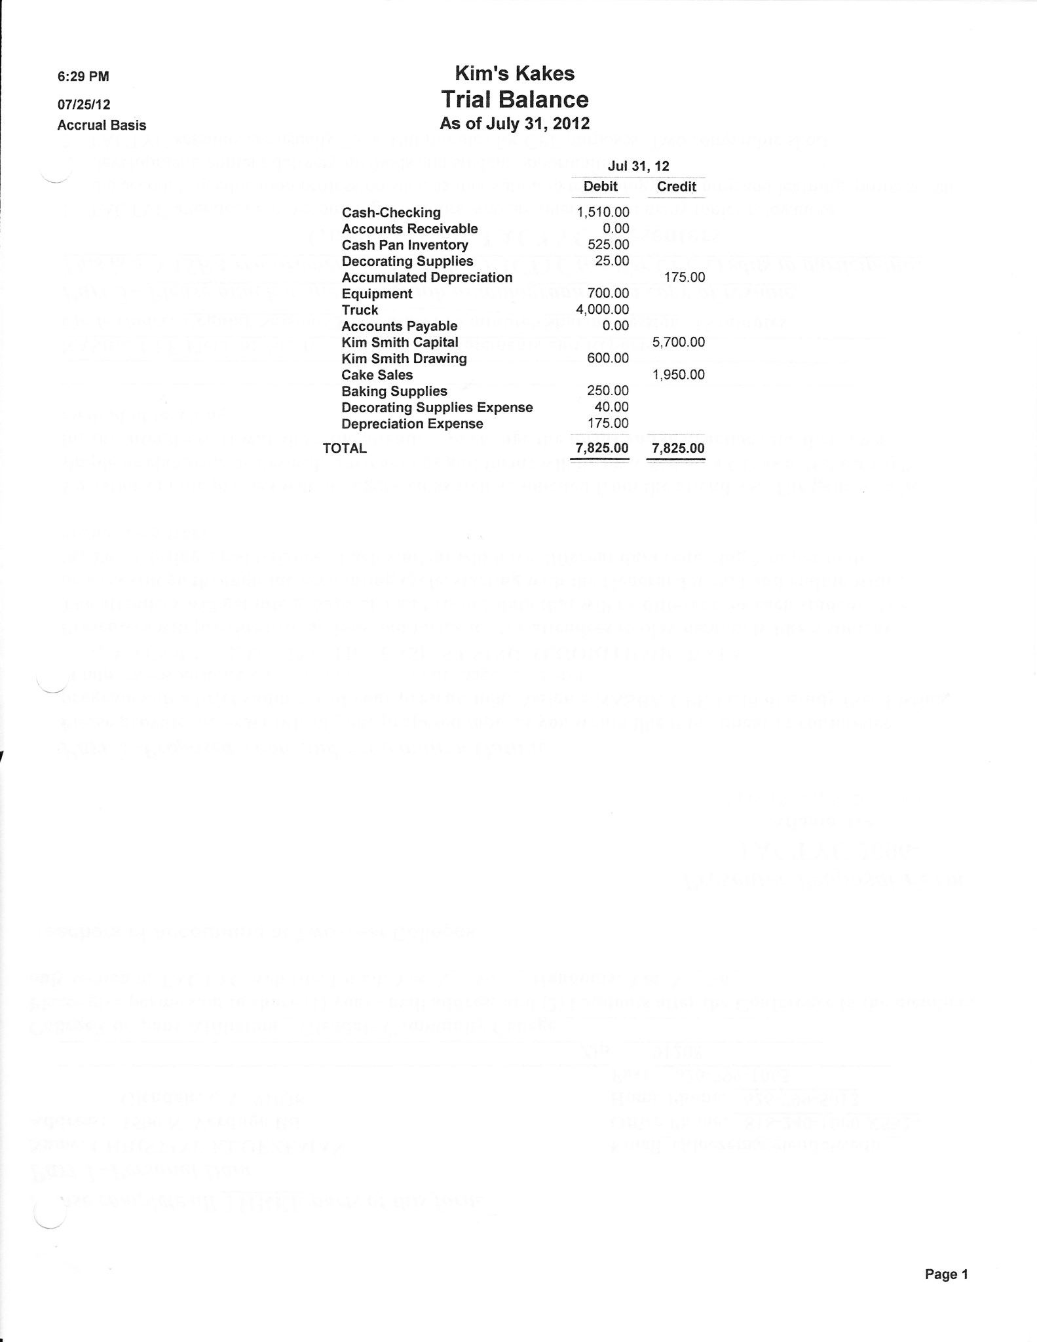

General Ledger - August

|  |  |  |  |  |  |  |  |  |  |  |
| --- | --- | --- | --- | --- | --- | --- | --- | --- | --- | --- |
| Cash | |  | Accounts Receivable | |  | Decorating Supplies | |  | Office Supplies | |
| 1510 | 823 |  | 350 | 350 |  | 25 | 48 |  | 200 | 125 |
| 343 | 500 |  | 1200 | 80 |  | 123 |  |  |  |  |
| 1190 | 1000 |  | 150 | 1190 |  |  |  |  | 75 |  |
| 1200 |  |  | 840 | 150 |  | 100 |  |  |  |  |
|  |  |  | 700 | 1200 |  |  |  |  |  |  |
| 1920 |  |  | 270 |  |  |  |  |  |  |  |
|  |  |  |  |  |  |  |  |  |  |  |
|  |  |  |  |  |  |  |  |  |  |  |
| Cake Pans | |  | Equipment | |  | Truck | |  | Accum Depr | |
| 525 |  |  | 700 |  |  | 4000 |  |  |  | 175 |
|  |  |  |  |  |  |  |  |  |  | 100 |
|  |  |  |  |  |  |  |  |  |  | 75 |
|  |  |  |  |  |  |  |  |  |  |  |
|  |  |  |  |  |  |  |  |  |  | 350 |
|  |  |  |  |  |  |  |  |  |  |  |
|  |  |  |  |  |  |  |  |  |  |  |
|  |  |  |  |  |  |  |  |  |  |  |
| A/P | |  | Kim's Capital | |  | Kim's Drawing | |  | Cake Sales | |
| 823 | 823 |  |  | 5700 |  | 600 |  |  |  | 1950 |
|  | 200 |  |  |  |  | 1000 |  |  |  |  |
|  |  |  |  |  |  |  |  |  |  |  |
|  | 200 |  |  |  |  | 1600 |  |  |  |  |
|  |  |  |  |  |  |  |  |  |  |  |
|  |  |  |  |  |  |  |  |  |  |  |
|  |  |  |  |  |  |  |  |  |  |  |
| Cupcake Sales | |  | Sheet Cakes | |  | Cake Pans | |  | Mini Cupcakes | |
|  | 350 |  |  | 1200 |  |  | 150 |  |  | 100 |
|  | 700 |  |  | 240 |  |  |  |  |  |  |
|  |  |  |  |  |  |  |  |  |  |  |
|  | 1050 |  |  | 1440 |  |  |  |  |  |  |
|  |  |  |  |  |  |  |  |  |  |  |
|  |  |  |  |  |  |  |  |  |  |  |
|  |  |  |  |  |  |  |  |  |  |  |
|  |  |  |  |  |  |  |  |  |  |  |
|  |  |  |  |  |  |  |  |  |  |  |
| Layer Cakes | |  | Sales Ret & Allow | |  | Sales Discount | |  | Purchases | |
|  | 500 |  | 80 |  |  | 7 |  |  | 250 |  |
|  |  |  |  |  |  |  |  |  | 700 |  |
|  |  |  |  |  |  |  |  |  |  |  |
|  |  |  |  |  |  |  |  |  | 950 |  |
|  |  |  |  |  |  |  |  |  |  |  |
|  |  |  |  |  |  |  |  |  |  |  |
|  |  |  |  |  |  |  |  |  |  |  |
|  |  |  |  |  |  |  |  |  |  |  |
|  |  |  |  |  |  |  |  |  |  |  |
| Wages Expense | |  | Office Supplies X | |  | Decorating Supplies X | |  | Baking Supplies X | |
| 500 |  |  | 125 |  |  | 40 |  |  | 250 | 250 |
|  |  |  |  |  |  | 48 |  |  |  |  |
|  |  |  |  |  |  |  |  |  |  |  |
|  |  |  |  |  |  | 88 |  |  |  |  |
|  |  |  |  |  |  |  |  |  |  |  |
|  |  |  |  |  |  |  |  |  |  |  |
|  |  |  |  |  |  |  |  |  |  |  |
|  |  |  |  |  |  |  |  |  |  |  |
|  |  |  |  |  |  |  |  |  |  |  |
|  |  |  |  |  |  |  |  |  |  |  |
| Depreciation Expense | |  | Bad Debt Expense | |  |  | |  |  | |
| 175 |  |  | 150 |  |  |  |  |  |  |  |
| 100 |  |  |  |  |  |  |  |  |  |  |
| 75 |  |  |  |  |  |  |  |  |  |  |
| 350 |  |  |  |  |  |  |  |  |  |  |
|  |  |  |  |  |  |  |  |  |  |  |
|  |  |  |  |  |  |  |  |  |  |  |
|  |  |  |  |  |  |  |  |  |  |  |
|  |  |  |  |  |  |  |  |  |  |  |
|  |  |  |  |  |  |  |  |  |  |  |
|  |  |  | Accounts Receivable Subsidiary Ledger | | | |  |  |  |  |
|  |  |  |  |  |  |  |  |  |  |  |
|  |  |  |  |  |  |  |  |  |  |  |
| Fred Farms | |  | Little Rock School | |  | Bill Norman | |  | Mall's | |
| 350 | 350 |  | 1200 | 1200 |  | 150 | 150 |  | 840 | 80 |
|  |  |  |  |  |  |  |  |  | 700 | 1190 |
|  |  |  |  |  |  |  |  |  |  |  |
|  |  |  |  |  |  |  |  |  | 270 |  |
|  |  |  |  |  |  |  |  |  |  |  |
|  |  |  |  |  |  |  |  |  |  |  |

|  |  |  |
| --- | --- | --- |
| ADJUSTED TRIAL BALANCE - August | |  |
|  |  |  |
| Account Name | Dr | Cr |
| Cash | 1920 |  |
| A/R | 270 |  |
| Decorating Supplies | 100 |  |
| Office Suppplies | 75 |  |
| Cake Pans | 525 |  |
| Equipment | 700 |  |
| Truck | 4000 |  |
| Accumulated Depr. |  | 350 |
| A/P |  | 200 |
| Kim's Capital |  | 5700 |
| Kim's Drawing | 1600 |  |
| Cake Sales |  | 1950 |
| Cupcake Sales |  | 1050 |
| Sheet Cakes |  | 1440 |
| Cake Pans |  | 150 |
| Layer Cakes |  | 500 |
| Mini cupcakes |  | 100 |
| Sales Ret and Allowance | 80 |  |
| Sales Discount | 7 |  |
| Purchases | 950 |  |
| Wages Expense | 500 |  |
| Baking Supplies X | 0 |  |
| Office supplies expense | 125 |  |
| Decorating Supplies X | 88 |  |
| Depreciation Expense | 350 |  |
| Bad Debt Expense | 150 |  |
|  | **11440** | **11440** |

|  |  |  |  |  |  |
| --- | --- | --- | --- | --- | --- |
|  |  |  |  |  |  |
|  |  |  |  |  |  |
| INCOME STATEMENT | | | |  |  |
|  |  |  |  |  |  |
|  | MTD | MTD | YTD | YTD |  |
| Revenue |  |  |  |  |  |
| Cake Sales |  |  | 1950 |  |  |
| Cupcake Sales | 1050 |  | 1050 |  |  |
| Sheet Cakes | 1440 |  | 1440 |  |  |
| Cake Pans | 150 |  | 150 |  |  |
| Layer Cakes | 500 |  | 500 |  |  |
| Mini cupcakes | 100 |  | 100 |  |  |
| total Revenue |  | 3240 |  | 5190 |  |
| less Sales R & A |  | 80 |  | 80 |  |
| less Sales Discount |  | 7 |  | 7 |  |
| NET SALES |  | 3153 |  | 5103 |  |
| EXPENSES |  |  |  |  |  |
| Purchases | 950 |  | 950 |  |  |
| Wages Expense | 500 |  | 500 |  |  |
| Baking Supplies X | -250 |  | 0 |  |  |
| Office supplies expense | 125 |  | 125 |  |  |
| Decorating Supplies X | 48 |  | 88 |  |  |
| Depreciation Expense | 175 |  | 350 |  |  |
| Bad Debt Expense | 150 |  | 150 |  |  |
| TOTAL EXPENSES |  | 1698 |  | 2163 |  |
|  |  |  |  |  |  |
| Net Income |  | 1455 |  | 2940 |  |
|  |  |  |  |  |  |
|  |  |  |  |  |  |
|  |  |  |  |  |  |
|  |  |  |  |  |  |
|  |  |  |  |  |  |
|  |  |  |  |  |  |
|  |  |  |  |  |  |
| BALANCE SHEET | | |  |  |  |
|  |  |  |  |  |  |
| Assets |  |  |  |  |  |
| Cash | 1920 |  |  |  |  |
| A/R | 270 |  |  |  |  |
| Decorating Supplies | 100 |  |  |  |  |
| Office Suppplies | 75 |  |  |  |  |
| Cake Pans | 525 |  |  |  |  |
| Equipment | 700 |  |  |  |  |
| Truck | 4000 |  |  |  |  |
| Accumulated Depr. |  | 350 |  |  |  |
| Total Assets |  |  | 7240 |  |  |
|  |  |  |  |  |  |
| LIABILITIES |  |  |  |  |  |
| A/P |  | 200 |  |  |  |
|  |  |  |  |  |  |
| OWNER'S EQUITY |  |  |  |  |  |
| Kim's Capital |  | 5700 |  |  |  |
| Kim's Drawing |  | -1600 |  |  |  |
| Net Income |  | 2940 |  |  |  |
| TOTAL OWNER'S EQUITY |  | 7040 |  |  |  |
|  |  |  |  |  |  |
| Total Liabilities and OE |  |  | 7240 |  |  |
|  |  |  |  |  |  |
|  |  |  |  |  |  |

Accounts Payable Generic Data

Vendors

BALLOONER'S SUPPLY 123 SPERRY ST.

GLENDALE, CA 91208

SUSAN CASEY

CONWIN CABONICS 145 SAN FERNANDO RD

LOS ANGELES, CA90032

STAR NEWS 800 MARENGO BLVD

ALTADENA, CA 91001

TARGET DEPARTMENT 9890 ATLANTIC AVE

ALHAMBRA, CA 91801

KAREN WILLIS 1941 MILAN AVE

LOS ANGELES, CA 90032

Accounts Payable Generic Data

Transactions

**Purchase of decorating supplies on Account - A/P**

a. Sept 1, 200X Purchased decorating supplies, P.O. 45678. Decorating House $900 2/10 Net 30, Inv 638..

**Sale on Account - A/R**

b. Sept 3, 200X Billed Lost Hills School District for 900 mini cupcakes @ $1.00 each Terms: 2/10 Net 30 P.O. 4532 Delivered, no sales tax.

**Cash Sales - A/R**

c. Sept 2, 200X Record cash sales 1000 cupcakes at $3.50 each from the cash register.

**Weekly Payments - A/P**

d. Sept 7, 200X Pay Decorating House invoice receiving a discount & August Target Inv

**Purchase on Account - A/P**

e. Sept 9, 200X Purchased 50 cake pans for resale from Smart and Final. Inv #639, $550, P.O. 12345. Terms: 2/10 Net 30

**Purchase for Cash with New Vendor and New Account - A/P Instant Check**

f. Sept 10, 200X Decided to go to a cooking conference. Need an immediate check for $300 to be included in registration. Artistic Cakes Association,1731 Hot Shot St., Glendale, CA 91208. 650-Conference Expense. Inv#640, P.O. #12346

**Purchase Returns - A/P**

g. Sept 11, 200X Returned 5 cake pans to Smart & Final that were defective. $150

**Sale on Account - A/R**

1. Sept 12, 200X Sold 40 sheet cakes @ 10.00 each to Marshall's to be

used at an open house at 502 Belmont, Anaheim, CA. Terms 2/10 Net 30. P.O. M51322. Taxable 10%. Delivery charge $50

**Receipt of Bill for expenses - A/P (record invoice)**

i. Sept 14, 200X Received a telephone bill from pacific Bell, 1220 E. Colorado, Glendale, CA Invoice #642, $75, Net 10 days P.O. Box #0999

**15th Payments on Accounts - A/P**

j. Sept 15, 200X Pay Smart & Final invoice

**Cash Receipts from Customer with Discount - A/R**

k. Sept 16, 200X Received Ck 52812 from Marshall's. $???? Inv # dated 9/12, discount.

**Purchase of Asset on Account with New Terms - A/P**

l. Sept 16, 200X Purchased new mixer from Conwin, $400. P.O. 12446. Inv. 643. Add term 2/10 Net 60

**24th Payments - A/P**

m. Sept 24, 200X Pay Conwin $400 for Invoice dated 9/16

Pay Telephone bill $75

**Purchase Expenses on Account - A/P**

n. Sept 27,200X Purchased an ad in the Star News, 800 Marengo Blvd, Pasadena, CA $110 for one week. Net 30 Inv 644.

**EOM Payments - September 30, 200X-**

o. Paid Employee Paid Joy Willis $500 for her part time help Inv #9/30/0X

p. Owner Withdrawal Kim Withdrew $1500, Inv #646

**Create a payments list and then the check**

q. Pay Target Pay 8/15 Target invoice

**Adjusting Entries - G/L September 30 ,200X**

1. Truck Depreciation $100
2. Equipment Depreciation $100
3. Supplies USED $50

|  |  |  |  |  |
| --- | --- | --- | --- | --- |
|  | **General Journal** |  |  | Page ____ |
|  |  |  |  |  |
|  |  | **Post.** |  |  |
| **Date** | **Description/Account Name** | **Ref.** | **Debit** | **Credit** |
|  | Decorating Supplies |  | 900 |  |
|  | A/P |  |  | 900 |
|  |  |  |  |  |
|  | A/R |  | 900 |  |
|  | Mini CupCakes |  |  | 900 |
|  |  |  |  |  |
|  | Cash |  | 3500 |  |
|  | Cupcake Sales |  |  | 3500 |
|  |  |  |  |  |
|  | A/P |  | 900 |  |
|  | Cash |  |  | 855 |
|  | Purchase Discount |  |  | 45 |
|  |  |  |  |  |
|  | Cake Pan Inventory |  | 550 |  |
|  | A/P |  |  | 550 |
|  |  |  |  |  |
|  | Conference Expense |  | 300 |  |
|  | Cash |  |  | 300 |
|  |  |  |  |  |
|  | A/P |  | 150 |  |
|  | Purchase Returns& Allow |  |  | 150 |
|  |  |  |  |  |
|  | A/R |  | 440 |  |
|  | Sales Tax Payable |  |  | 40 |
|  | Sheet Cake Sales |  |  | 400 |
|  |  |  |  |  |
|  | Utilities Expense |  | 75 |  |
|  | A/P |  |  | 75 |
|  |  |  |  |  |
|  |  |  |  |  |
|  | A/P |  | 400 |  |
|  | Cash |  |  | 400 |
|  |  |  |  |  |
|  | Sales Discount |  | 22 |  |
|  | Cash |  | 418 |  |
|  | A/R |  |  | 440 |
|  |  |  |  |  |
|  | Equipment |  | 400 |  |
|  | A/P |  |  | 400 |
|  |  |  |  |  |
|  |  |  |  |  |
|  | A/P |  | 400 |  |
|  | Purchase Discount |  |  | 40 |
|  | Cash |  |  | 320 |
|  |  |  |  |  |
|  | A/P |  | 75 |  |
|  | Cash |  |  | 75 |
|  |  |  |  |  |
|  | Advertising Expense |  | 110 |  |
|  | A/P |  |  | 110 |
|  |  |  |  |  |
|  | Wages Expense |  | 500 |  |
|  | Cash |  |  | 500 |
|  |  |  |  |  |
|  | Drawing, Kim |  | 1500 |  |
|  | Cash |  |  | 1500 |
|  |  |  |  |  |
|  | A/P- Target |  | 200 |  |
|  | Cash |  |  | 200 |
|  |  |  |  |  |
|  | Depreciation Expense |  | 100 |  |
|  | Accumulated Depr. |  |  | 100 |
|  |  |  |  |  |
|  |  |  |  |  |
|  | Depreciation Expense |  | 100 |  |
|  | Accumulated Depr. |  |  | 100 |
|  |  |  |  |  |
|  | Supplies Expense |  | 50 |  |
|  | Supplies |  |  | 50 |
|  |  |  |  |  |

|  |  |  |
| --- | --- | --- |
| ADJUSTED TRIAL BALANCE |  |  |
| Account Name | Dr | Cr |
| Cash | 1688 |  |
| A/R | 1170 |  |
| Decorating Supplies | 1000 |  |
| Office Supplies | 25 |  |
| Cake Pans | 1075 |  |
| Equipment | 1100 |  |
| Truck | 4000 |  |
| Accumulated Depr. |  | 550 |
| A/P |  | 110 |
| Sales Tax Payable |  | 40 |
| Kim's Capital |  | 5700 |
| Kim's Drawing | 3100 |  |
| Cake Sales |  | 1950 |
| Cupcake Sales |  | 4550 |
| Sheet Cakes |  | 1840 |
| Cake Pans |  | 150 |
| Layer Cakes |  | 500 |
| Mini cupcakes |  | 1000 |
| Sales Ret and Allowance | 80 |  |
| Sales Discount | 29 |  |
| Purchases | 950 |  |
| Purchases Ret & Allow |  | 150 |
| Purchase Discounts |  | 125 |
| Wages Expense | 1000 |  |
| Baking Supplies X | 0 |  |
| Office supplies expense | 175 |  |
| Decorating Supplies X | 88 |  |
| Depreciation Expense | 550 |  |
| Conference Expense | 300 |  |
| Advertising Expense | 100 |  |
| Utilities Expense | 75 |  |
| Bad Debt Expense | 150 |  |
|  | **16655** | **16665** |

General Ledger – August

|  |  |  |  |  |  |  |  |  |  |  |
| --- | --- | --- | --- | --- | --- | --- | --- | --- | --- | --- |
| Cash | |  | Accounts Receivable | |  | Decorating Supplies | |  |  | |
| 1920 | 855 |  | 270 | 440 |  | 100 |  |  |  |  |
| 3500 | 300 |  | 900 |  |  | 900 |  |  |  |  |
| 418 | 400 |  | 440 |  |  |  |  |  |  |  |
|  | 320 |  |  |  |  | 1000 |  |  |  |  |
|  | 75 |  |  |  |  |  |  |  |  |  |
|  | 500 |  | 1170 |  |  | Office Supplies | |  |  |  |
|  | 1500 |  |  |  |  | 75 | 50 |  |  |  |
|  | 200 |  |  |  |  | 25 |  |  |  |  |
| 1688 |  |  |  |  |  |  |  |  |  |  |
|  |  |  |  |  |  |  |  |  |  |  |
|  |  |  |  |  |  |  |  |  |  |  |
|  |  |  |  |  |  |  |  |  |  |  |
|  |  |  |  |  |  |  |  |  |  |  |
| Cake Pans | |  | Equipment | |  | Truck | |  | Accum Depr | |
| 525 |  |  | 700 |  |  | 4000 |  |  |  | 350 |
| 550 |  |  | 400 |  |  |  |  |  |  | 200 |
|  |  |  |  |  |  |  |  |  |  |  |
| 1075 |  |  | 1100 |  |  |  |  |  |  |  |
|  |  |  |  |  |  |  |  |  |  | 550 |
|  |  |  |  |  |  |  |  |  |  |  |
|  |  |  |  |  |  |  |  |  |  |  |
|  |  |  |  |  |  |  |  |  |  |  |
| A/P | |  | Sales Tax Payable | |  | Kim's Capital | |  | Kim's Drawing | |
| 900 | 200 |  |  | 40 |  |  | 5700 |  | 1600 |  |
| 150 | 900 |  |  |  |  |  |  |  | 1500 |  |
| 400 | 550 |  |  |  |  |  |  |  |  |  |
| 400 | 75 |  |  |  |  |  |  |  | 3100 |  |
| 75 | 400 |  |  |  |  |  |  |  |  |  |
| 200 | 110 |  |  |  | Cake Sales | |  |  |  |  |
|  | 110 |  |  |  |  | 1950 |  |  |  |  |
|  |  |  |  |  |  |  |  |  |  |  |
|  |  |  |  |  |  |  |  |  |  |  |
|  |  |  |  |  |  |  |  |  |  |  |
| Cupcake Sales | |  | Sheet Cakes | |  | Cake Pans | |  | Mini Cupcakes | |
|  | 1050 |  |  | 1440 |  |  | 150 |  |  | 100 |
|  | 3500 |  |  | 400 |  |  |  |  |  | 900 |
|  |  |  |  |  |  |  |  |  |  |  |
|  | 4550 |  |  | 1840 |  |  |  |  |  | 1000 |
|  |  |  |  |  |  |  |  |  |  |  |
| Layer Cakes | |  | Sales Ret & Allow | |  | Sales Discount | |  | Purchases | |
|  | 500 |  | 80 |  |  | 7 |  |  | 950 |  |
|  |  |  |  |  |  | 22 |  |  |  |  |
|  |  |  |  |  |  | 29 |  |  |  |  |
|  |  |  |  |  |  |  |  |  |  |  |
|  |  |  | Purchase Ret & All | |  | Purchase Discount | |  |  |  |
|  |  |  |  | 150 |  |  | 45 |  |  |  |
|  |  |  |  |  |  |  | 80 |  |  |  |
|  |  |  |  |  |  |  | 125 |  |  |  |
| Wages Expense | |  | Office Supplies X | |  | Decorating Supplies X | |  | Baking Supplies X | |
| 500 |  |  | 125 |  |  | 88 |  |  | 0 |  |
|  |  |  |  |  |  |  |  |  |  |  |
|  |  |  |  |  |  |  |  |  |  |  |
| Conference Expense | |  | Advertising Expense | |  | Utility Expense | |  |  |  |
| 300 |  |  | 110 |  |  | 75 |  |  |  |  |
|  |  |  |  |  |  |  |  |  |  |  |
|  |  |  |  |  |  |  |  |  |  |  |
|  |  |  |  |  |  |  |  |  |  |  |
|  |  |  |  |  |  |  |  |  |  |  |
|  |  |  |  |  |  |  |  |  |  |  |
| Depreciation Expense | |  | Bad Debt Expense | |  |  | |  |  | |
| 350 |  |  | 150 |  |  |  |  |  |  |  |
| 200 |  |  |  |  |  |  |  |  |  |  |
|  |  |  |  |  |  |  |  |  |  |  |
| 550 |  |  |  |  |  |  |  |  |  |  |
|  |  |  |  |  |  |  |  |  |  |  |
|  |  |  |  |  |  |  |  |  |  |  |
|  |  |  |  |  |  |  |  |  |  |  |
|  |  |  |  |  |  |  |  |  |  |  |
|  |  |  |  |  |  |  |  |  |  |  |
|  |  |  | **Accounts Receivable Subsidiary Ledger** | | | |  |  |  |  |
|  |  |  |  |  |  |  |  |  |  |  |
|  |  |  |  |  |  |  |  |  |  |  |
| Fred Farms | |  | Little Rock School | |  | Bill Norman | |  | Mall's | |
| 350 | 350 |  | 1200 | 1200 |  | 150 | 150 |  | 840 | 80 |
|  |  |  |  |  |  |  |  |  | 700 | 1190 |
|  |  |  |  |  |  |  |  |  |  |  |
|  |  |  |  |  |  |  |  |  | 270 |  |
| Lost Hills | |  | Marshalls | |  |  |  |  |  |  |
| 900 |  |  | 440 | 440 |  |  |  |  |  |  |
|  |  |  |  |  |  |  |  |  |  |  |

|  |  |  |  |  |  |  |  |  |  |  |
| --- | --- | --- | --- | --- | --- | --- | --- | --- | --- | --- |
|  |  |  |  | | | |  |  |  |  |
|  | **Accounts Payable Subsidiary Ledger** | | | |  |  |  |  |  |  |
| Target | |  | Decorating House | |  | Smart&Final | |  |  |  |
| 200 | 200 |  | 900 | 900 |  | 150 | 550 |  |  |  |
|  |  |  |  |  |  | 400 |  |  |  |  |
|  |  |  |  |  |  |  |  |  |  |  |
|  |  |  |  |  |  |  |  |  |  |  |
| Pacific Bell | |  | Conwin | |  | Star News | |  |  |  |
| 75 | 75 |  | 400 | 400 |  |  | 110 |  |  |  |
|  |  |  |  |  |  |  |  |  |  |  |
|  |  |  |  |  |  |  |  |  |  |  |