QUICKBOOKS 2012: Kim’s Cakes
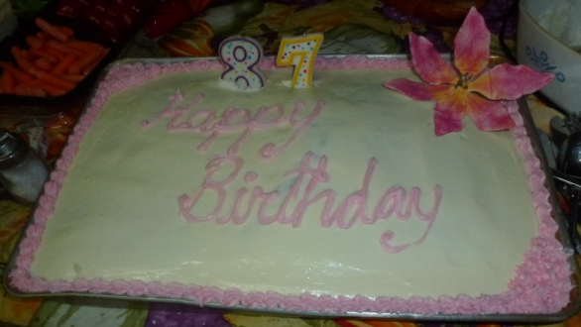
General Ledger Scenario 1
Kimberly Jackson is a Culinary Arts student. She has been making cakes for her friends for many years. Her friends have spread the word that she is fantastic and very creative. Because of this she is having a hard time filling cake requests while both working and going to school. She has calculated that selling three cakes a week would give her the same pay as her present job. As such, she has decided to quit her 20 hour per week low paying job and start her own cake decorating business. She also calculated that she will work in her home until she receives orders for 2 cakes per day, which is her beginning business level. Her address is 1900 Hope St, Pasadena, CA 91103. Her phone number is 626-796-4111. Once her beginning business level has been reached, she will search for a storefront on a busy street. Kim has decided to only use the General Ledger (Company) module of Quickbooks until her business improves.

Accounts Receivable Scenario 2
After a month of work, Kim feels that she made the right decision to start her own business. She is beginning to get return customers from the business community. Her business customers need invoices and to buy on credit. This is best recorded in the Customer or Accounts Receivable module. She is going to start with very basic invoices, which in later months will be more elaborate. Her friends tell her that cupcakes are very popular. She has decided to sell both large and mini cupcakes as well as her sheet cakes and layered cakes. She has accepted large orders and will need occasional help but does not yet have any employees.
Kimberly has found a company called Decorating House that has all the materials she needs to make her cakes. This is the only vendor she has, so she will continue to use handwritten checks, recording them in the general ledger.
No Sales Tax will be included in the invoices because it is Business to Business.

