- Create a new company
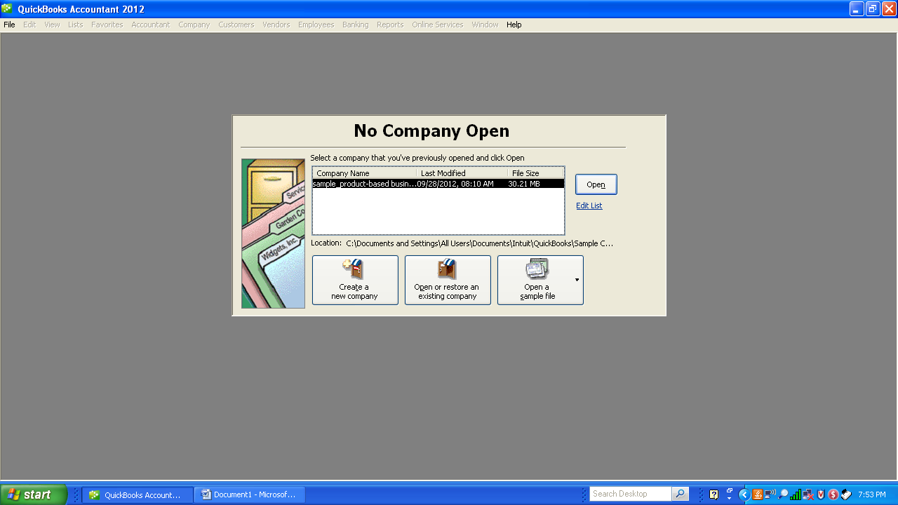

- Express Start-up
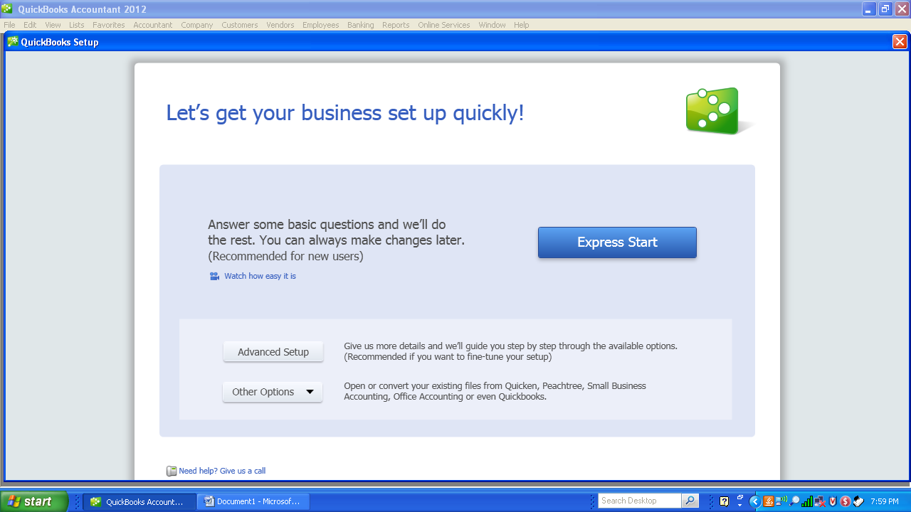

- Company Information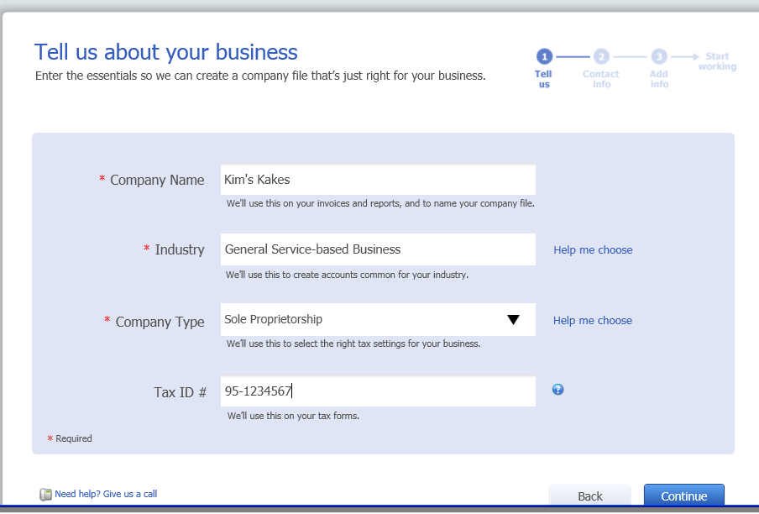

- Enter Contact Information
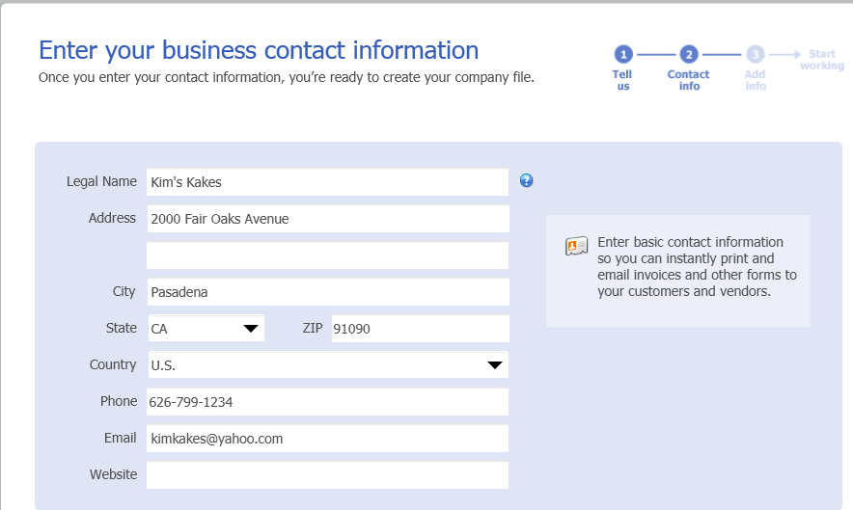

- No Need to add Customers, Products or Bank Accounts now. Just click on Start Working below Bank Accounts.
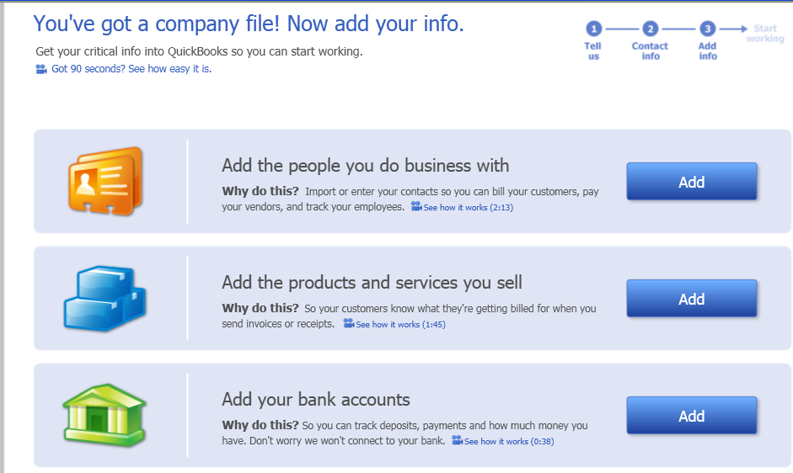

- Company files are created and the Menu screen appears.
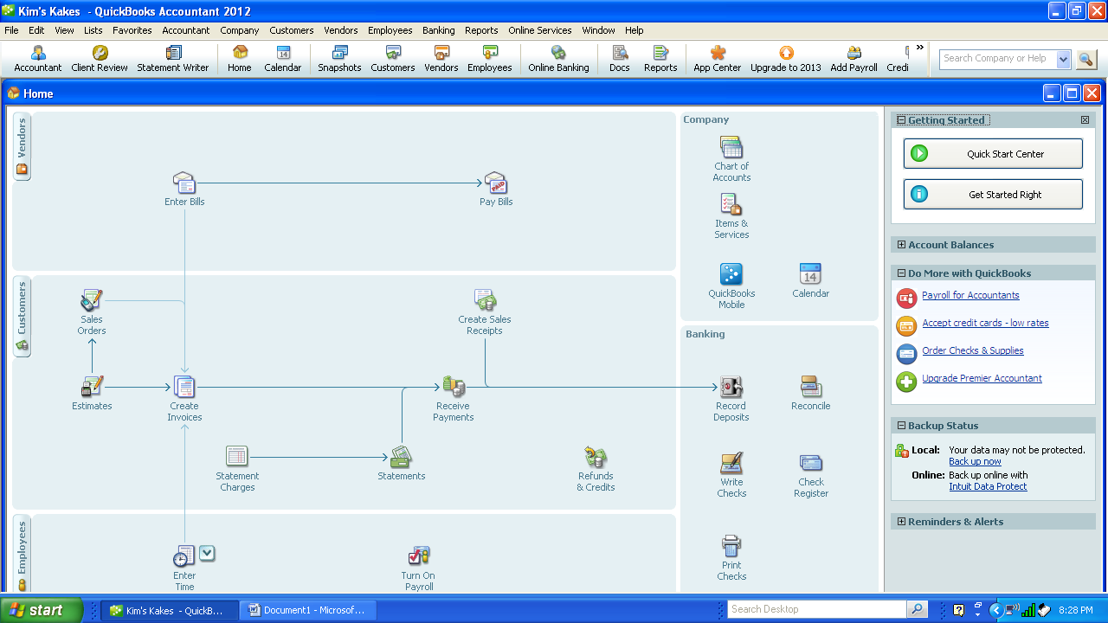

- Select Company-Chart of Accounts or the Chart of Accounts icon in Company square.
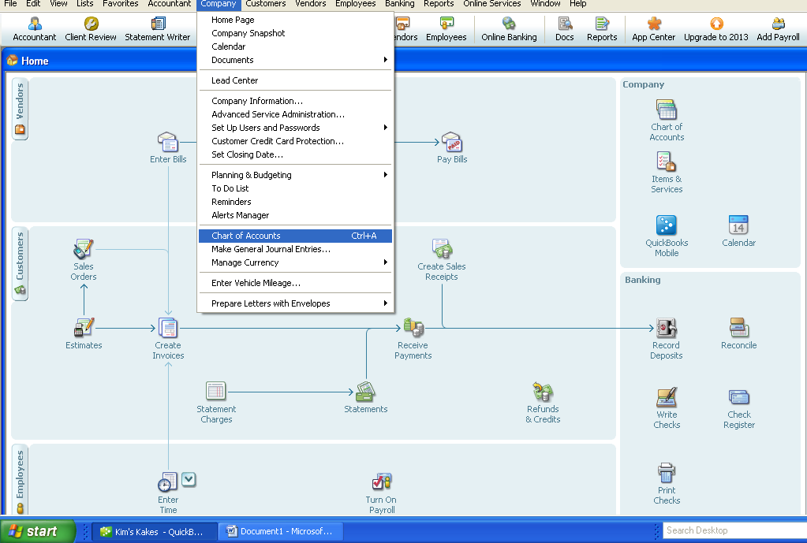

- Enter the Chart of Accounts starting with Cash. Select the radio button “Bank”. Select Continue.

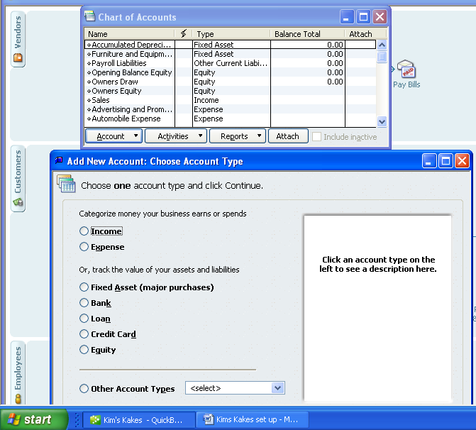

- Enter the remaining information for the Cash Account. Select Save & New.
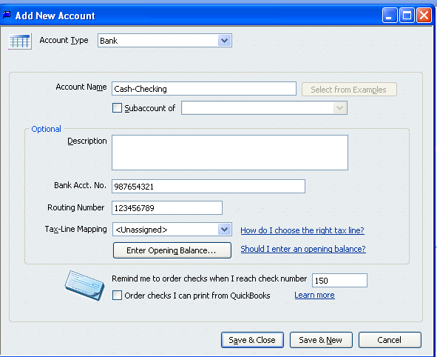

- Enter the remaining Chart of Accounts by clicking on Save and Next. After the last account select Save & Close.
- Print the Chart of Accounts by selecting the Chart of Accounts Icon or select the Chart of Accounts from the pull down menu “Lists”.
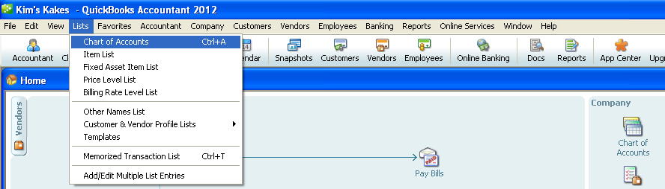
- Print the Chart of Accounts to verify the accounts that have been entered.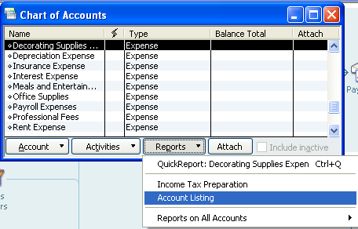

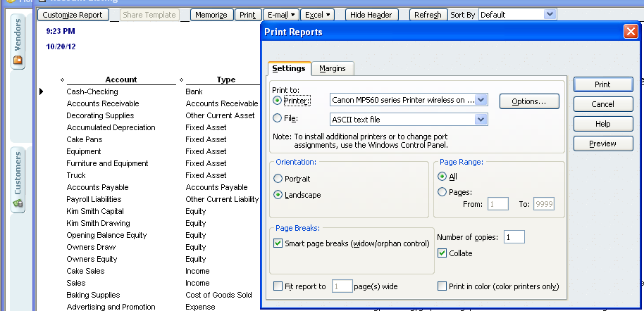
- Select Print from the Activity Menu at the top of the screen

