Accounting 101
Financial Accounting
10:45-11:55am Ticket # 1601
Instructor: Christy Kloezeman

Text: Financial Accounting Office:SR340
Spiceland, Thomas, Herrmann Phone: 240-1000 X5524
2nd Edition ISBN: 0078110823 Hours: MW Noon-12:45 TTH Noon-1:30
Website: www.mhhe.com/succeed e-mail:ckloezem@glendale.edu
Connect Fax: 626-799-1965
Website:glendale.edu/ckloezem

Week Date Subject to be Covered
===== ====== =========================
1 2/13 Class Orientation
Chapter 1- Acctg-Information & Decision Making

2 2/20 Chapter 2 –Accounting Information System( Measuring Bus Act, Dr, Cr,)
Start Monopoly Practice Set
Washington Birthday 2/20—No School
Deadline to Drop without a W – 2/25

3 2/27 Chapter 2 –Accounting Information System Con’t

4 3/5 Chapter 3 – Financial Reporting Process
TEST 1 (Chap 1-3)

5 3/12 Chapter 4 – Cash and Internal Controls

6 3/19 Chapter 5 - Receivables and Sales
Annual Report(Set One) Due

7 3/26 Chapter 6 – Inventory and Cost of Goods Sold
Monopoly Practice Set Due

8 4/2 TEST 2 (Chap 4-6)
Chapter 7 – Long Term Assets

4/9 – 4/14 SPRING BREAK

9 4/16 Chapter 8 Current Liabilities
No Class on 4/18 and 4/19

10 4/23 Chapter 9 – Long Term Liabilities

11 4/30 TEST 3 – Chapters 7-9
Annual Report(Set 2)

12 5/7 Chapter 10 – Stockholder’s Equity

13 5/14 Chapter 11 – Statement of Cash Flow
Deadline to drop with W -- 5/12

14 5/21 Chapter 12 – Financial Statement Analysis (if time)

15 5/28 Memorial Day 5/28 --No School
Review
Annual Report(Set 3)

6/4 10:30 Final

*You must come to class to get any changes to the schedule. It WILL change. Make the changes on this form.

Drop Policy

It is your responsibility to drop this class. Do not expect the instructor to drop you if you stop coming. However, you could be dropped due to lack of attendance, poor scores or disruptive behavior.

Calculators and Cell Phones
Please turn off all cell phones while class is in session. Especially, do not answer the phone in class. Cell phones cannot be used as calculators or opened at anytime during the tests. Calculators will be provided for all tests including the final.

Clickers
Clickers are a fun way to answers questions and get everyone involved in the class. The instructor will provide the pre numbered clickers to be picked up every day to record attendance and to answer short questions during our discussions. Universities and 4 year colleges are starting to use them more and more. They are the 2nd generation clicker so it should last for a while.

Talking Policy
The class has a very casual attitude but talking is very disruptive. Because of prior problems a policy has been required. When the instructor asks a question you are expected to answer. However, talking while the instructor is lecturing is rude and will not be tolerated. If talking, you will be warned once. After the 2nd time you will be asked to leave the class. If the disruptive behavior occurs again, you will not be given a warning but just asked to leave. If it occurs a third time you will be dropped from the class. If you don't understand something, please raise your hand and ask the teacher. Usually you are not the only one to have this question.
Glendale Community College Academic Dishonesty Policy

College study is the process of becoming an independent scholar. All students are expected to do their own work. All forms of cheating and plagiarism are absolutely forbidden. This is the official policy of Glendale Community College and the instructor of this course. Students found cheating will have their assignments marked 0 for failure and may receive a failing grade for the course.

Examples of cheating include, but are not limited to, the following:
*using unauthorized materials on exams
*copying other student exams
*submitting any assigned work not the student's own
*copying other written materials without proper credit to the original author
*downloading from computer networks
*purchasing papers

Incidents of academic dishonesty will be reported to the Vice President of Instruction and will become part of the student's Glendale College file.

GRADES/POINTS
YOU EARN YOUR GRADES-I MARK ONLY WHAT YOU HAVE EARNED

%
Quizzes 50 8
Tests 200 31 A = 90% 585 - 650
Final 100 15 B = 80% 520 - 584
Homework 50 8 C = 70% 455 - 519
AnnualRpt 100 15 D = 60% 390 - 454
Monopoly 100 15 F 0 - 389
LearnSmrt 50 8

TOTAL 650

Your grade will be available at the Glendale website usually 3 days after the last final. Grades can no longer be posted on my door. Do not ask for me to email your grade or call you back. Provide a grade postcard if you want to know the score on the final test.

QUIZZES (50 pts)

There will be a quick quiz after we finish each chapter. The quiz for some chapters may be skipped but only 10 quizzes will be counted for a total of 50 points. The purpose of these quizzes is to see if you understand the chapter. The quiz(es) with the lowest score will be dropped. The more quizzes we have the more you can drop. Each will be worth 5 points. NO MAKE UPS!!!

TESTS (300 pts)

Tests are multiple choice, matching and problems. They will be taken in class not on the computer. If you cannot make the test on the assigned date (it may change) it will be your responsibility to fit a makeup into the instructor’s schedule.

FINAL (100 pts)

The final will use a scantron format and cover all the theory and logic of Chapters 1-12 and Account Classifications. An F will be earned by anyone not taking the final. It is required, so you must make prior arrangements if you cannot attend the time given. You cannot get an A in this class if you flunk the final. No matter how much extra credit you have.

HOMEWORK (50 pts)

Homework is important. You must register for Connect to complete your homework. It is your way of learning the system and my way of knowing where I can help you. Your homework will be turned into Connect. It is best to print the homework from connect so you can see how it is formatted. Write up the homework on the printed copy then input it into the computer to check the answers. You can submit the homework several times and I will take the best score. It will provide the answers to your homework while you are working on the problem. Full 5 points will be earned when you turn the homework on time. Half points (2.5) will be earned if turned in before the test. No points will be earned after the test on the chapters.

Manual Project(100 pts)

You will be required to do a practice set starting in Chapter 2. This is a requirement of the course. We will be doing it using the Monopoly game. Plan to not miss any classes during this time as it will be difficult to make up the work. The project should take 4-6 hours. Further directions will be provided at a later date.

Annual Report Project (100 pts)

The 2nd week of class you need to obtain a 2011/2012 Annual Report. (How will be discussed later). An Annual Report prior to 2010 will not be accepted. If you have stock in a company you can use that annual report. It is best to select a Retail or Merchandising Company. Do not select Insurance, Banks, Oil or Investments companies since they do not have all the accounts and situations needed.

The Buckle Questions at the end of each chapter are to be answered for the company you have selected. Be sure to be in class since several questions will be changed.

You will be turning in the Annual report in sets. Your company's annual report will need to be submitted with each set. Set One is turned in after Chapter 3. (This will ensure the company is good.)

The next set will be turned in after Chapter 7. The last set (Chapters 8-11) will be turned in on the last day of class. The last set should include all three sets and show good organization. This is a good project to keep for future business classes.

SUPPLEMENTAL INSTRUCTION -Extra Credit
Supplemental Instruction is for additional study not tutoring. Each week, the Supplemental Instruction Instructor will help with homework, a case study, or a particular subject. The student will get 5 points for attending the entire hour S.I. This will be based on the signature page from each SI session. You can go several times a week but only one a week will be counted for the 5 points. This help is free. It is not to get someone to do your homework. It is just to discuss the concepts. Further details will be given the first week of class.

S.I. Workshops will be taught by students (S.I. Leader) that have taken my accounting class in previous semesters and have taken several other business classes. Some of the S.I.s can be set aside for review before a test if arrangements are made with the S.I. leader.

LEARN SMART

Connect has a tutorial program—Learn Smart. This program helps you understand the topics in each of the chapters. It is helpful to go through Learn Smart before reading the text or doing the homework.

TEGRITY

Tegrity is a component of CONNECT. It contains recorded instructor’s lectures. If you need to review what was discussed in class you can access it from the CONNECT website for the class. It is helpful in case you are ill and missed a class. It is not a replacement for attending class as only power point lectures will be recorded. The instructor sometimes forgets to setup the recording. If you find it helpful please REMIND her to record the lecture. The speed of the lecture can be increased or decreased as needed. You can also go to a certain part of the lecture.

EXTRA CREDIT
POINTS

Only 25 extra credit points can be applied to your total points. You cannot get a C in the class if you flunk all the tests no matter how many extra credit points you get.

All the extra credit will be turned in the last day of class, before the final. Only one submission will be accepted. Plan you work accordingly as you cannot do a lot of extra credit in two days.

Extra Credit Activities
Besides the S.I. Workshops, other extra credit activities are Additional Perspectives, Videos and Newspaper Articles.

Additional Perspecitives
The Cases are found after the Chapter Problems. If any cases are discussed in class, you cannot use them as extra credit.

You are to write an IOM discussing the case and answer the questions for that case(See IOM format). Write it as though it was an analysis in interoffice memo form to your boss. Logic, accounting knowledge, and interpreting accounting information need to be presented.

Keep it to one typewritten page. A score of up to 5 points can be earned for the IOM. It will be graded on 1)following the given format, 2)data provided and 3)discussion about the data. If these are not completed your grade usually will go down a point or two. They must be completed with thought not just scribbled for a few points.

VIDEO
Videos about accounting subjects can be viewed in the Learning Center on the 2nd floor Administration building. A list of 10 important points of the video needs to be turned in for 5 points. Please use full sentences and put a number for each point. The points must be business related and from the first as well as the last part of the video. You must watch for the entire video to get the 5 points.
A list of both the learning center videos and public videos can be obtained from the instructor's website.

NEWSPAPER BUSINESS ARTICLES
Write up a memo stating Who, What, When, Where and Why of the article. It should be a business issue not that Walmart stock price went up 5 cents or its net income is higher than estimated. The Who, What, When and Where should be short with a large paragraph or two on the why of the article.

PORTFOLIO

It is strongly suggested that you keep all your work organized in a notebook. This is called a portfolio. If your points are incorrect, you can have them changed by showing the corrected work to me. Suggested tabs are: Homework, Quizzes, Tests, Skills Development Exercises, Manual and Computer Project, Group Projects, Career Project, Annual Report Project, Extra Credit.

IOM Format
INTEROFFICE MEMO (IOM)
DATE:
TO:
FROM: Your Name

SUBJECT:

*ATTACHMENT: Required Journal Entries or tables
* This line may or may not be appropriate depending on the chapter you are doing.
(Brief Summary of the Case Problem)

I have analyzed .................. and find ............
..........

The details of this analysis are ...........
............

I would recommend ....................
Chapter Organization
Learning Objectives
Feature Story
Text by Learning Objectives by Part
Chapter Review of Learning Objectives with Key Points in light blue
Decision Points
Common Mistakes in Orange
Quick Quizzes in Lime green
Review Problem and Answer for each Part
International Financial Reporting Standards (IFRS)
Ethical Dilemma
Key Points by Learning Objectives
Glossary
Self Study Questions
Review Questions
Brief Exercises
Exercises
Problem Set A and Problem Set B
Additional Perspectives
Continuing Problem – Great Adventure
Financial Analysis
Buckle Questions
American Eagle Outfitters vs Buckle
Ethics
Internet Research Activity
Written Communications
101 Grade Sheet

Quizzes Tests
Syllabus ______ 5 Test One _____ 100
Chapter 1 ______ 5 Test Two _____ 100
Chapter 2 ______ 5 Test Three _____ 100
Chapter 3 ______ 5
Chapter 4 ______ 5
Chapter 5 ______ 5
Chapter 6 ______ 5
Chapter 7 ______ 5 FINAL _____ 100
Chapter 8 ______ 5
Chapter 9 ______ 5
Chapter 10 ______ 5 PROJECT
Chapter 11 ______ 5
Chapter 12 ______ 5 Manual Practice Set _____ 100

Total ______ 50 Extra Credit _____

Homework Annual Rpt Learn Smart
Chapter 1 _____________ ____________ _____________
Chapter 2 _____________ ____________ _____________
Chapter 3 _____________ ____________ _____________
Chapter 4 _____________ ____________ _____________
Chapter 5 _____________ ____________ _____________
Chapter 6 _____________ ____________ _____________
Chapter 7 _____________ ____________ _____________
Chapter 8 _____________ ____________ _____________
Chapter 9 _____________ ____________ _____________
Chapter 10 _____________ ____________ _____________
Chapter 11 _____________ ____________ _____________
Chapter 12 _____________ ____________ _____________

50 100 50

Total ______/650

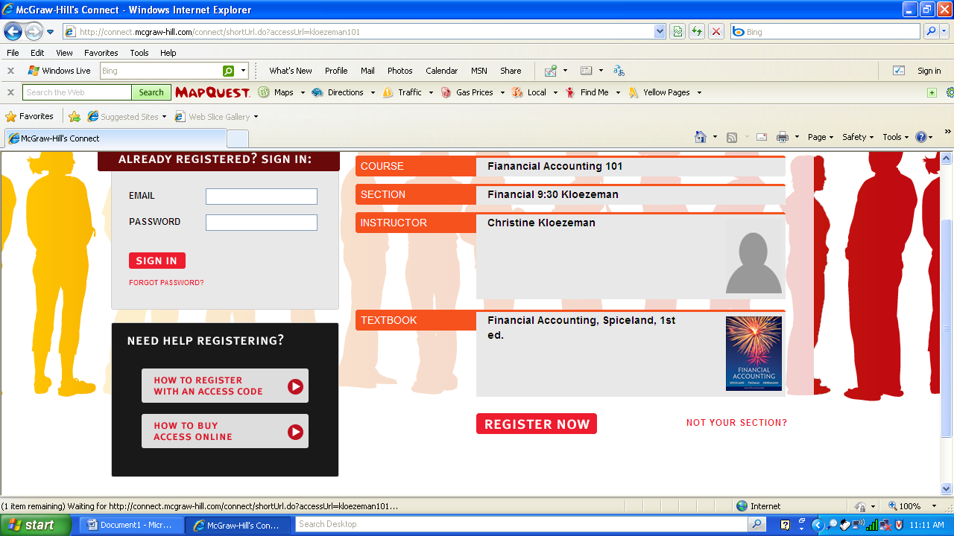
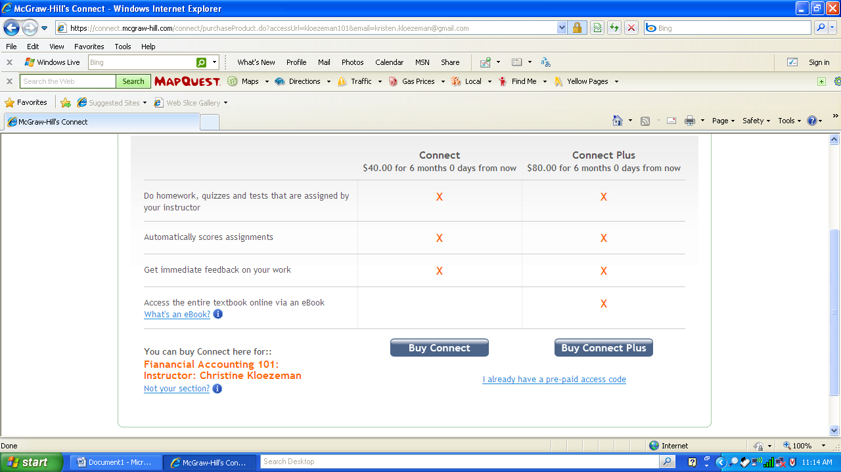
This is a unique address for
http://connect.mcgraw-hill.com/class/kloezeman1045

HOMEWORK
(All problems are the “A” problems)

Chapter One – Accounting Information and Decision Making
P1-2 Accounting Classifications
P1-3 Financial Statements
P1-4 Financial Statements
P1-6 Generally Accepted Accounting Principles
P1-7 Conceptual Framework

Chapter Two – Accounting Information System
P2-1 Accounting Equation
P2-2 Transactions
P2-3 Normal Balance
P2-7 Journal Entries
P2-9 Journal Entries and Financial Statements

Chapter Three – Financial Reporting Process
E3-7 Adjusting Journal Entries
E3-8 Adjusting Journal Entries
E3-10 Adjusting Journal Entries
E3-17 Closing Entries & Post Closing Trial Balance
E3-18 Closing Entries

Chapter Four – Cash and Internal Controls
E4-7 Bank Reconciliation
E4-8 Bank Reconciliation
E4-9 Petty Cash
E4-10 Petty Cash
P4-2 Bank Reconciliation & Cash Adjustments
P4-3 Bank Reconciliation & Cash Adjustments
P4-4 Cash Flow – Direct Method

Chapter Five – Receivables & Sales
P5-1 Revenue Recognition
P5-2 Credit Sales & Contra Revenue
P5-3 A/R Transactions
P5-4 Uncollectibles
P5-8 Long Term Notes & Interest Receivables

Chapter Six – Inventory
P6-1 Cost of Goods Sold- Periodic
P6-3 Transaction & Income Statement – Periodic
P6-4 Transaction & Income Statement – Perpetual
P6-6 FIFO/LIFO Lower Cost/Market
P6-8 Inventory Turnover, Gross Profit percentage
P6-9 LIFO/FIFO – Perpetual

Chapter Seven – Long Term Assets
P7-1 Acquisition Costs
P7-2 Acquisition Costs
P7-5 Depreciation
P7-6 Amortization
P7-9 Ratios

Chapter Eight - Current Liabilities
E8-3 Notes Payable
E8-4 Notes Receivable
E8-14 Warranties
P8-3 Payroll
P8-8 Ratios

Chapter Nine - Long Term Liabilities
P9-1 Bond Price & Amortization
P9-2 Bond Issue & Interest
P9-4 Amortization Table
P9-5 Leases
P9-6 Ratios

Chapter Ten - Stockholder’s Equity
P10-1 Terms
P10-2 Transactions
P10-4 Stockholder’s Equity Section
P10-5 Stockholder’s Equity Transaction
P10-7 Ratios

Chapter Eleven - Cash Flow
P11-1 Classifications
P11-3 Operating – Indirect
P11-4 Statement – Indirect
P11-5 Ratios
P11-7 Statement - Indirect

