Name __________________________ Date_____________
Susy's Balloon
Service
Cover Sheet-Chapter Four
Order of Reports to be attached :
Customer List
Journal Detail Report - Current Batch
Sales Journal with Invoices
Cash Receipt Journal
Adjustments and Credit Memo
Aged Invoice Listing
Statements
A/R Subsidiary Ledger
Adjusted Trial Balance
General Journal Report (Journal Detail Report)
Income Statement
Balance Sheet 8/31/0X
General Ledger
Income Statement date 9/01/0X

Did you make a back-up/archival copy?

Section 3: STUDENT APPLICATION

L.O 8 Accounts Receivable Susy's Balloon Service
AUGUST 200X
____________________________________________________________

OVERVIEW INSTRUCTIONS

Susan is starting to sell individual balloons and mylars (silver balloons). She is taking telephone cash orders for single balloons or bouquets that the customer will pick up. Also, several customers want a small present to be attached to the balloons. This increase in business will require a Purchases Account. The Balloon Accessories Expense Account will no longer be adequate, therefore the balance in this account must be transferred to Purchases with a Journal Entry.
Susan is still doing business out of her home. Her business has increased enough for her to hire a part-time employee.

Update the General Ledger
Step 1: Update the Chart of Accounts. Add the following accounts
- Bad Debt Expense
- Sales Returns & Allowance
- Sales Discount
- Purchases
- Wages Expense

Set up the Accounts Receivable
Step One: Create A/R Data File
Step Two: Maintain Payment Terms
Step Three: Maintain A/R Parameters
Step Four: Select A/R Forms
Step Five:Maintain Post Accounts
Step Six: Maintain Shipping Instructions
Step Seven: Sales Taxes - Maintain
Step Eight: Sales Account - Maintain
Step Nine: Standard Items-Maintain
Step Ten: Check your set-up. Select Utilities then Display A/R Status, Still in Set-up : YES
Step Eleven: Enter Customers
Step Twelve: Print Customer List

MAKE A BACK UP COPY AND LABEL IT A/R SETUP

Step Thirteen: Get out of Set-up Mode for Any Module

Enter Daily Transactions
Please note that the source document number (Check#, JE#, Invoice #) may vary from the sample. Start invoices at 1000 and Credit Memos at 100. If information is needed on the invoice but is not stated, create your own data.

a. August 1, 200X Purchased ballons & Accessories from Ballooner's Supply, $823. P.O. #995, 2/10 Net 30 (G/L)
b. August 5, 200X Sold 1000 laxtex balloons @$1.00 each to Derby Corp. Inv #1000. 2/10 Net 30
c. August 5, 200X Sold 33 "Welcome"mylar balloons @ $3.50 each to Lost Hills School District P.O. #00576. Received check #167850 dated 8/4 for one-half of invoice ($57.75) No discounts.
d. August 5, 200X Billed Norman Bell, 1441 Back Street, Glendale, CA 91208 for party decorations, $750, 2/10 Net 30. UPS
e. August 15, 200X Paid 8/1/0X Ballooner's Supply Invoice, CK #106, no discount $823 (G/L)
f. August 15, 200X Purchased on account decorating and office supplies from Target Stores, $200. Change 113 to Office/Décor Supplies (G/L)
g. August 15, 200X Received check #1122 for $980 from Derby. Invoice dated 8/5.
h. August 16, 200X Billed Marshall's for open House Balloons, P.O. 65432. Net 30, $880
Assorted Decorations:
Qty Description $each
5 Single Arch 100
12 Balloon Bouquet 25
Latex Balloons
80 Assorted Colors 1
i. August 17, 200X Lost Hills School District returned 15 defective mylar balloons from 8/5 invoice. Use Sales Return and Allowance
j. August 17, 200X Invoice Marshall for 200 mylars @ $3.50 each. Net 30 days. Ship via UPS. No Freight. $700
k. August 31, 200X Received CK # 191989 for $1230 from Marshall for all of 8/16 invoice and 1/2 of 8/17 invoice.
l. August 31, 200X Norman Bell was nowhere to be found. Declared his account to be uncollectible. Use Bad Debt Expense,.
m. August 31, 200X Paid Karen Willis $500 for her part-time help. CK#107. Add account 501 Wages Expense if needed. (G/L)
n. August 31, 200X Susy withdrew $1,000. Check #108. (G/L)
o. August 31, 200X Lost Hills School District paid their balance, $5.25 CK#167898.

ADJUSTING ENTRIES - G/L
p. August 31, 200X Truck Depreciation $100
q. August 31, 200X Equipment Depreciation $175
r. August 31, 200X Supplies ON HAND, $75 (Journal entry is calculated by subtracting $75 from the balance in supplies account)
______________________________________________________________
REPORTS

- Print the Journal entry detail report.
- Print the Sales Journal. Keep invoics with this report. Normally they would have been mailed to the customer.
- Print Cash Receipts Journal and any Credit memo Journal.

MONTH END ACTIVITIES

- Print Aging Report.
- Print Detail Report - Subsidiary Report
- Print Statements.
- Enter and post adjusting entries.
- Print Trial Balance- Summary
- Print Trial Balance-Detail
- Print Income Statement
- Print Balance Sheet
- Make an archival disk. Put aside should you need to restart from this point.
- Perform period end closing. Close Accounts Receivable the close General Ledger.
- Print Income Statement dated 9/30/0X showing no dollars in the current column. This indicates the previous month was closed.
- Compile all reports following the steps given in the lab work discussion in Chapter 2.

DETAIL INSTRUCTIONS
Set-up Detail

- Update the Chart of Accounts by adding the following accounts (G/L):
____________________________________
- Bad Debt Expense
- Sales Returns & Allowance
- Sales Discount
- Purchases
- Wages Expense
___________________________________

- Compare your Chart of Accounts to below report

Aug 1, 2002 Susy's Balloon Service - Chris
10:24 pm Chart of Accounts

Sub
Account # Account Description Account Type Type PSC-Through
========= =========================== ================ ==== ===========
111.00 CASH Current Assets P
112.00 ACCOUNTS RECEIVABLE Current Assets P
113.00 DECORATING SUPPLIES Current Assets P

150.00 EQUIPMENT Fixed Assets P
151.00 ACCUMULATED DEPR-EQUIPMENT Fixed Assets P
160.00 TRUCK Fixed Assets P
161.00 ACCUMULATED DEPR-TRUCK Fixed Assets P

211.00 ACCOUNTS PAYABLE Current Liabilities P

311.00 SUSAN CASEY, CAPITAL Equity P
312.00 SUSAN CASEY, DRAWING Equity P

399.00 RETAINED EARNINGS Retained Earnings P

411.00 INCOME FROM SERVICES Sales P

420.00 SALES RETURNS AND ALLOWANCE Sales Adjustments P
421.00 SALES DISCOUNT Sales Adjustments P

440.00 FREIGHT REVENUE Sales P

450.00 PURCHASES Cost of Goods Sold P

501.00 WAGES EXPENSE Expenses P
506.00 UTILITIES EXPENSE Expenses P
512.00 SUPPLIES EXPENSE Expenses P
601.00 ADVERTISING EXPENSE Expenses P
605.00 BALLOON ACCESSORIES EXPENSE Expenses P
615.00 DEPRECIATION Expenses P
620.00 Bad Debt Expense Expenses P

3. Set-up A/R- All commands are in the Utilities Pull Down menu
Step One: Create A/R Data File
1. Select A/R Icon,
2. Select Utilities
3. Select Create A/R Data Files (It's on the bottom of the list)
a. Note: Exclusive Option, Click OK
b. Note: This will destroy any existing A/R; Continue with option: Select Yes.
c.. Current A/R Month :August 2000
Last month of Fiscal Year: November
OK
4. Type the work CREATE, Select OK.
5. ➔ Creating data files
6. Note: Set-up Mode? OK

Step Two: Maintain Payment Terms
1. Select Utilities- Maintain Payment Terms
- Stay in A/R Set-up Mode? Yes
- Click on the next icon to see the terms: 1. Prepaid, 2. COD, 3. Net 30
- Change the fields in the term 4 by over writing what already exists.
Terms: 4
Discount Rate: 2.0%
Discount Period (# of days): 10
Due: 30 days
Description 2% 10 days Net 30
5. Save by clicking on disk
6. Add term 5
Terms: 5
Discount Rate 0
Day 5
Description Net 5
Save

Step Three: Maintain A/R Parameters
1. Stay in A/R Set-up Mode?, OK
2. Months to keep 12
Last Month November
Length of Aging 30 60 90
Model Customer Leave Blank
Allow for Future Posting Yes
Monthly Finance Charge 1.0%
Minimum Finance Charge $1.00 Select OK?
Grace Period 0 days
Minimum Balance $5.00
3. Select OK when finished.
November

Step Four: Select A/R Forms
1. Stay in A/R Set-up Mode?, Yes
2. Select Invoice Plain Paper Std A/R Invoices
3. Click on Close.
Step Five:Maintain Post Accounts
- Stay in A/R Set-up Mode?, Yes
- Enter the following accounts in each field, pressing enter after each field:
A/R 112 Finance Chg 445
Misc 411 Credit/Debit 420
Discounts 421 Bad Debt 620
Freight Chg 440 Deposits (Leave Blank)
Cash Acct 111
Invoice Preferences - leave in default mode

Step Six: Maintain Shipping Instructions
1. Enter the following
1. UPS
2. Next Day Air
3. USPS
Select OK?

Step Seven: Sales Taxes - Maintain
- Stay in A/R Set-up Mode?, YES
- Note: No SalesTax Information. Will be put in NEW mode.
- ID: CA
- Description: California Sales
- Account #: 212 (Add this account on the fly)
- Note: Account not currently on file. Add it now? Yes. Remember it is a current liability.
- Sales Tax Rate: 8.25%
- Save

Step Eight: Sales Account - Maintain
1. Stay in A/R Set-up Mode?, OK
2. Sales Account # 1
3. Description: Income from Services
4. GL Acct # 411, Save

Step Nine: Standard Items-Maintain
1. Add the following items:
Item ID LATEX MYLARS OTHER
Description Latex Balloons Mylar Balloons Assorted Decorations
Price A $1 $3.50 $0 (to be entered)
Sales Acct 1 1 1
Discount Amt Yes Yes Yes
Taxable Yes Yes Yes

Step Ten: Check your set-up. Select Utilities then Display A/R Status, Still in Set-up : YES

Step Eleven: Enter Customers
- Select customer from the pull down menu and select Maintain Customer.
- Stay in A/R Set-up Mode?, Yes
- No Customers. Put in New. OK
- Add each field for the three customers:
Customer ID# DERBY
Name Derby Corporation
Address: 305 Orange Grove
Address: Leave Blank
City, State Anaheim, CA
Zip 92806

5. Click on the INV/STMT Radio Box
Terms: 2/10 Net 30
Sales Rep: None
Sales Acct: 1
Print Statement: X
1st Sales Tax CA
Discount Rate 0

Sales Discount
Trade Discounts

6. Enter remaining two customers in the same manner as Derby:
Customer ID# MARSH
Name Marshall’s Corporation
Address: 344 Center Street
City, State Torrance, CA
Zip 90507
INV/STMT
Same as DERBY
Customer ID# LOSTHILL
Name Lost Hills School District
Address: 825 Marengo Ave
City, State Lost Hills, CA
Zip 93249
INV/STMT

Same as DERBY

Step Twelve: Print Customer List
- Select Customer Pull Down Menu
- Select Customer List.
- Bring to Screen. If correct click on print icon.

CUSTOMER LIST

Aug 1, 2002 Susy's Balloon Service - Chris 10:52 pm Customer List

Customer Name/Address/Phone/FAX Customer Information
============ ========================== ========= ==============================
DERBY Derby Corporation FinChgs: No CrLimit: None
305 Orange Grove Dunning:No HighBal: 0.00
Anaheim, CA 92806 Stments: Yes Balance: 0.00
Bal/Fwd: No Open Cr: 0.00
PriceLv: A FinChgs: 0.00
Note: None Deposit: 0.00
Disc: 0.000%
SalesTax: CA
Resale #:
Sls Acct: 1. Income from Services
Rep: None
Since: 07/06/03 Terms: 4. 2.00%-10 / Net 30
Phone: ( ) - Cat: None
FAX: ( ) - Comments:
-------------------------- --------- ------------------------------

LOSTHILL Lost Hills School Dist FinChgs: No CrLimit: None
825 Marengo Ave Dunning: No HighBal: 0.00
Lost Hills, CA 93249 Stments: Yes Balance: 0.00
Bal/Fwd: No Open Cr: 0.00
PriceLv: A FinChgs: 0.00
Note: None Deposit: 0.00
Disc: 0.000%
SalesTax: CA
Resale #:
Sls Acct: 1. Income from Services
Rep: None
Since: 07/06/03 Terms: 4. 2.00%-10 / Net 30
Phone: ( ) - Cat: None
FAX: ( ) - Comments:
-------------------------- --------- ------------------------------

MARSH Marshall's Corporation FinChgs: No CrLimit: None
344 Center Street Dunning: No HighBal: 0.00
Torrance, CA 90507 Stments: Yes Balance: 0.00
Bal/Fwd: No Open Cr: 0.00
PriceLv: A FinChgs: 0.00
Note: None Deposit: 0.00
Disc: 0.000%
SalesTax: CA
Resale #:
Sls Acct: 1. Income from Services
Rep: None
Since: 07/06/03 Terms: 4. 2.00%-10 / Net 30
Phone: ( ) - Cat: None
FAX: ( ) - Comments:

MAKE A BACKUP COPY AND LABEL IT A/R SETUP

Step Thirteen: Get out of Set-up Mode for Any Module
1. Select any option or Utilities; Display Status
2. Note: Still in Set-up Mode? Select NO
3. Type OK in box to get out of set up mode.
- You must get out of Setup to have the transactions intergrated to the General Ledger.

Enter Daily Transactions
Note that the source document number (Check#, JE#, Invoice #) may vary from the sample. Start invoices at 1000 and Credit Memos at 100. If information is needed on the invoice but is not stated, create your own data.

a. August 1, 200X Purchased balloons & Accessories from Ballooner's Supply, $823. P.O. #995, 2/10 Net 30 (G/L)
Debit 450 Credit 211

b. August 5, 200X Sold 1000 latex balloons @$1.00 each to Derby Corp. Inv #1000. 2/10 Net 30

Enter Sales-A/R Invoices
- Select transactions - invoices
- Use the down arrow to select the customer ID.
- Enter 1000 in the Invoice # field. The next invoice click on next and the program will add one to 1000.
- Enter the correct date
- Enter the description as the P.O. number.

Header
- Click on Header button. Terms should be Net 5
- Double Check information. If correct click on OK.

Line Item
1. Click on Line Item button.
2. Type is Item.
3. Item #: Latex or Mylar or Other
4. Ordered: Enter the amount of items ordered.
5. Shipped: Just press entered if it is the same as ordered.
6. Unit Price: Automatic from the Standard Items file.
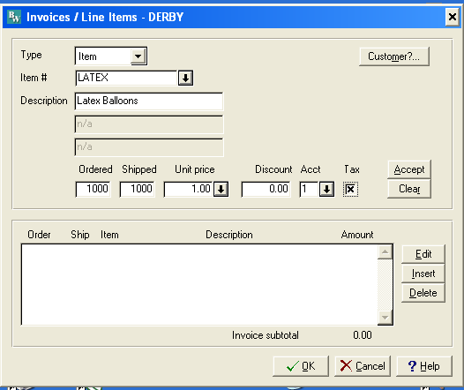

7. Account: 1 Income From Services
8. Accept
9. Double check the subtotal, then OK if correct.

Summary
1. Click on Summary button.
2. 0 for Misc, Discount & Freight.
3. Enter to accept sales tax.
4. Press enter when finished, click on OK.
5. Select print and post to print an invoice.
6. Close

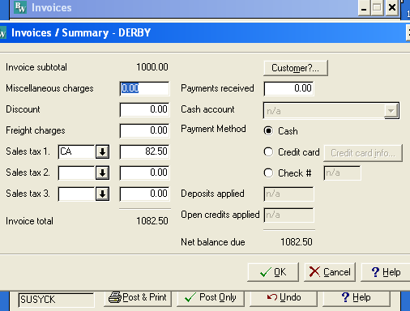

DERBY INVOICE

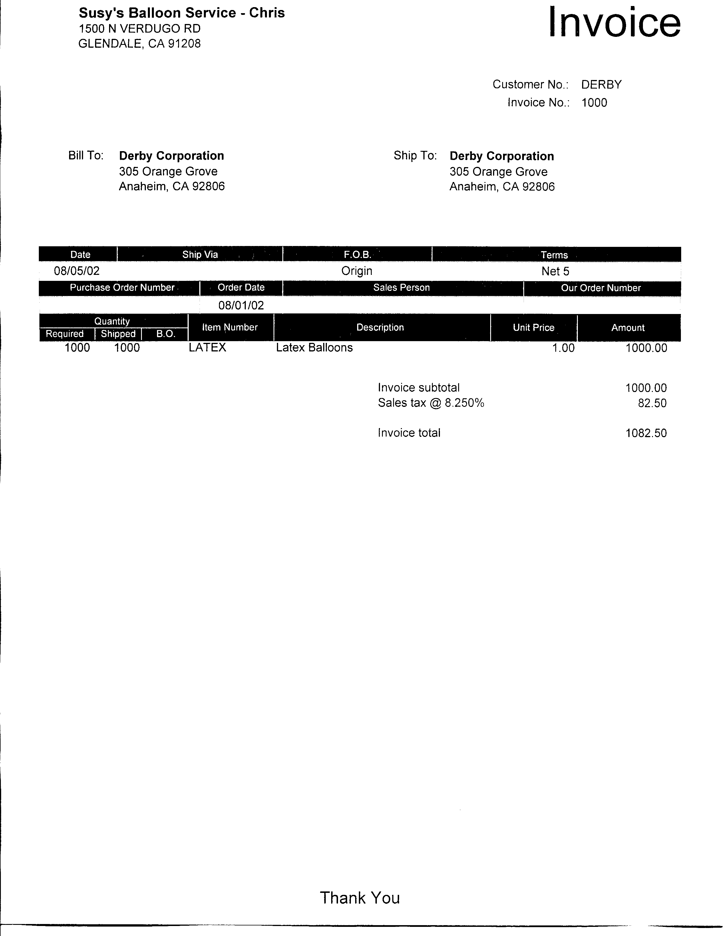

c. August 5, 200X Sold 33 "Welcome" mylar balloons @ $3.50 each to Lost Hills School District P.O. #00576. Received check #167850 dated 8/4 for one-half of invoice ($57.75) No Discounts.

- Enter in the same manner as the Derby invoice.
- To enter the prepayment, click on the summary button, enter the amount in Payment received.
- If a discount shows up simply highlight the field and replace it with 0.
- It will also show up on the first screen of the invoice entry.

d. August 5, 200X Billed Norman Bell, 1441 Back Street, Glendale, CA 91208 for party decorations, $750, 2/10 Net 30. UPS
- See the above instructions using the "Other" item.

e. August 15, 200X Paid 8/1/0X Ballooner's Supply Invoice, CK #106, no discount $823 (G/L)
Debit 211 Credit 111

f. August 15, 200X Purchased on account decorating and office supplies from Target Stores, $200. Change 113 to Office/Décor Supplies (G/L)
Debit 113 Credit 211

g. August 15, 200X Received check #1122 for $1062.50 from Derby. Invoice dated 8/5.

Enter Cash Receipts
1. Select A/R
2. Select Transaction
3. Select Post Receipts
4. Select Customer ID using the down arrow.
5. Select Check #.
6. Enter Reference, if any.
7. Enter amount. (You can come back and enter this amount after selecting the invoices.)
8. Enter the invoice # that is being paid, or use the down arrow. Press enter.
9. Accept full payment or enter or enter a partial payment.
10. Press enter to ignore discount or enter a discount.
11. Press enter to ignore write-off.
Distribution will automatically be entered.
- Select post.

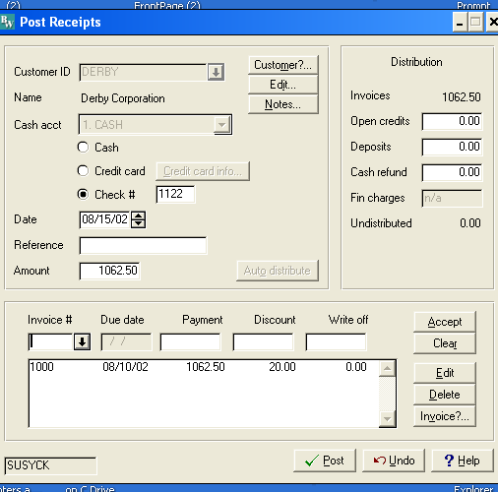

- Continue for the others.

h. August 16, 200X Billed Marshall's for open House Balloons, P.O. 65432. Net 30, $880
Assorted Decorations:
Qty Description $each
5 Single Arch 100
12 Balloon Bouquet 25
Latex Balloons 80 Assorted Colors 1
Enter in the same way as the Derby and Lost Hills invoices.

i. August 17, 200X Lost Hills School District returned 15 defective mylar balloons from 8/5 invoice. $52.50 Use Sales Return and Allowance

CREDIT MEMO
- Select Transactions - Credit Memo
- Enter the Customer
- Select Invoice to be adjusted.
- Enter the amount to be written off.
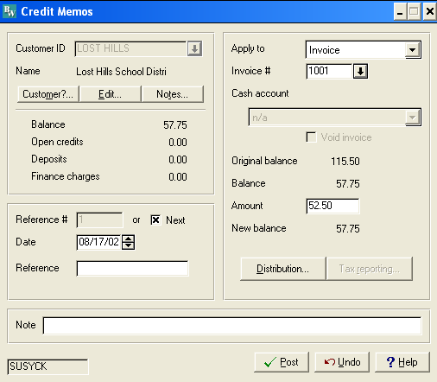
- Select Distribution.
- Check to make sure the amount was entered into the Sales Return and Allowance account. OK
- Post.
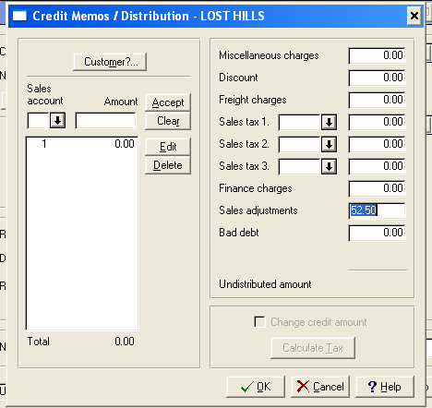

j. August 17, 200X Invoice Marshall for 200 mylars @ $3.50 each. Net 30 days. Ship via UPS. No Freight. $700
k. August 31, 200X Received CK # 191989 for $1230 from Marshall for all of 8/16 invoice and 1/2 of 8/17 invoice.
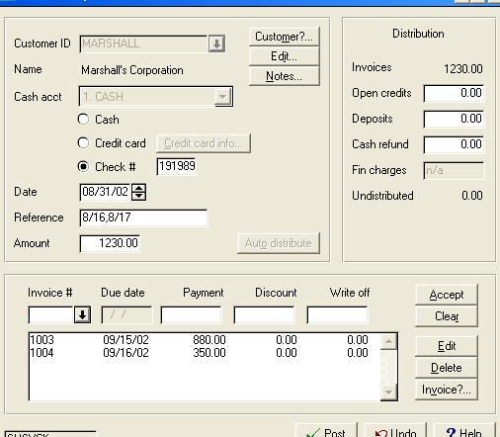

l. August 31, 200X Norman Bell was nowhere to be found. Declared his account to be uncollectible. Use Bad Debt Expense,.
(See August 17 Lost Hills Transactions for screen displays.)

- Select Transactions - Credit Memo
- Enter the Customer
- Select Invoice to be a write off.
- Enter amount to be written off.
- Select Distribution
- Enter the Amount in Bad Debt (This is the only difference from 8/17 transaction)
- Post
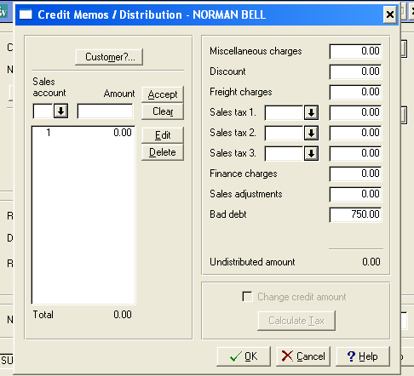

m. August 31, 200X Paid Karen Willis $500 for her part-time help. CK#107. Add account 501 Wages Expense if needed. (G/L)

n. August 31, 200X Susy withdrew $1,000. Check #108. (G/L)

o. August 31, 200X Lost Hills School District paid their balance, $5.25 CK#167898.
See August 15th Derby transactions.

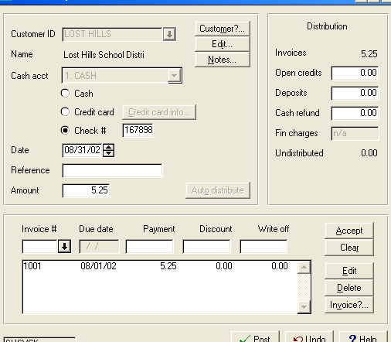

ADJUSTING ENTRIES - G/L
q. August 31, 200X Truck Depreciation $100
r. August 31, 200X Equipment Depreciation $100
s. August 31, 200X Supplies ON HAND, $75 (Journal entry is calculated by subtracting $75 from the balance in supplies account)

REPORTS

- Print the Journal entry detail report.
- Print the Sales Journal. Keep invoics with this report. Normally they would have been mailed to the customer.
- Print Cash Receipts Journal and any Credit memo Journal.

Journal Report
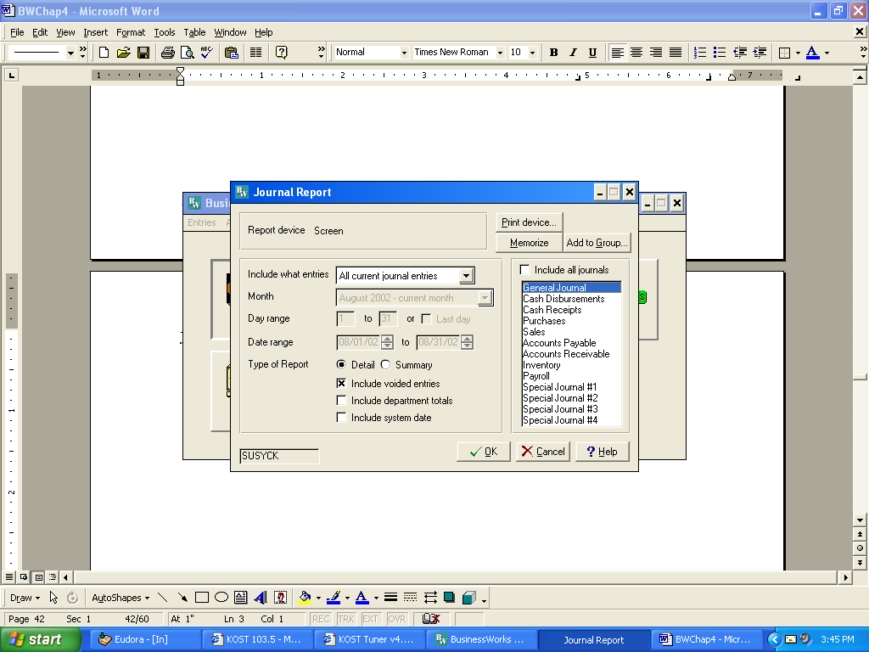
1.Select Reports
2.Select Journal Report
3.Click on Include all journals to remove the check
4.Click on General Journal.

Aug 31, 2002 Susy's Balloon Service -
3:48 pm Journal Detail Report

Post/Sys
Date Jnl Ref. No Description / Accounts Debit Credit

08/01/02 G/L 114 Ballooners Supply
PO box 995
605.00 BALLOON ACCESSORIES EXPENSE 823.00
211.00 ACCOUNTS PAYABLE 823.00

08/01/02 G/L 115 Ballooner's Invoice
CK#106
211.00 ACCOUNTS PAYABLE 823.00
111.00 CASH 823.00

08/15/02 G/L 116 Target Stores decorating
and office supplies
113.00 OFFICE/DECOR SUPPLIES 200.00
111.00 CASH 200.00

08/31/02 G/L 117 Karen Willis Wages
501.00 WAGES EXPENSE 500.00
111.00 CASH 500.00

08/31/02 G/L 118 Susy Withdrawal CK#108
312.00 SUSAN CASEY, DRAWING 1,000.00
111.00 CASH 1,000.00

08/31/02 G/L 119 truck depreciation
615.00 DEPRECIATION EXPENSE 100.00
161.00 ACCUMULATED DEPR-TRUCK 100.00

08/31/02 G/L 120 EQUIPMENT DEPR
615.00 DEPRECIATION EXPENSE 75.00
151.00 ACCUMULATED DEPR-EQUIPMENT 75.00

08/31/02 G/L 121 SUPPLIES BALANCE $225 ON HAND $75
512.00 SUPPLIES EXPENSE 150.00
113.00 OFFICE/DECOR SUPPLIES 150.00

***** Report Total 3,671.00 3,671.00

Sales Journal/Cash Receipts/Adjustments Journal
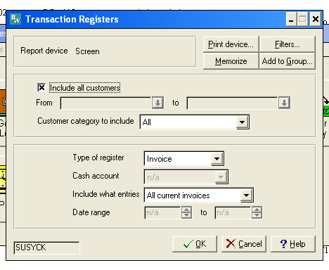
- Select Reports, Transaction Register
- Type of Register= invoices for the Sales Journal
- Type of Register =Cash Receipts for Cash Receipts
- Type of Register=adjustments for Sales Ret and Allowance
Sales Journal
Aug 1, 2002 Susy's Balloon Service - Chris
4:05 pm Accounts Receivable Invoice Register
All Current Invoices

Invoice
Inv # Customer Date Description Total Sales Tax Freight
1001 LOST HILLS 08/01 115.50 0.00 0.00
1002 NORMAN BELL 08/01 part decorations750.00 0.00 0.00
1000 DERBY 08/05 1082.50 82.50 0.00
1003 MARSHALL 08/16 880.00 0.00 0.00
1004 MARSHALL 08/17 700.00 0.00 0.00

Report Total 3528.00 82.50 0.00
Sales tax (CA) 82.50

Cash Receipts Journal
Aug 1, 2002 Susy's Balloon Service - Chris
4:10 pm Accounts Receivable Cash Receipts Register
All Current Cash Receipts

Inv # / Cash --- Distribution --
Chk # Reference Acct Customer Date Amount Apply to Amount
====== ============ ==== ============ ======== ========== ========
167850 1 LOST HILLS 08/01/02 57.75 1001 57.75
1122 1 DERBY 08/15/02 1062.50 1000 1062.50
191989 8/16,8/17 1 MARSHALL 08/31/02 1230.00 1004 350.00
1003 880.00
167898 1 LOST HILLS 08/31/02 5.25 1001 5.25
Report Total 2355.50
ADJUSTMENTS
Aug 1, 2002 Susy's Balloon Service - Chris
4:13 pm Accounts Receivable Adjustments Register
All Current Adjustments

Ref # Transaction Reference Customer SR Date Amount Applied to
====== =========== ============ ============ === ======== ========== ==========
1 Credit Memo LOST HILLS 08/17/02 52.50 1001
2 Credit Memo uncollect NORMAN BELL 08/31/02 750.00 1002
==========
Report Total Credit Memo 802.50
Debit Memos 0.00
Apply O/Cs 0.00
Apply Deps 0.00
Write offs 0.00

Applied to:
Open credits 0.00
Finance charges 0.00
Cash refunds 0.00
Deposits 0.00
Invoices 802.50

MONTH END ACTIVITIES
- Print Aging Report.
- Print Detail Report - Subsidiary Report
- Print Statements.
- Print Trial Balance- Summary
- Print Trial Balance-Detail
- Print Income Statement
- Print Balance Sheet
- Make an archival disk. Put aside should you need to restart from this point.
- Perform period end closing. Close Accounts Receivable the close General Ledger.
- Print Income Statement dated 9/30/0X shwoing no dollars in the current column. This indicates the previous month was closed.
- Compile all reports following the steps given in the lab work discussion in Chapter 2.

A/R Subsidiary Ledger (Detail Report)

Aug 1, 2002 Susy's Balloon Service - Chris
4:17 pm Accounts Receivable Detail Report
All Current Transactions

Original Current
Transaction Txn Date Description / Dist Amount Balance Balance
=============== ======== ==================== ========== =========== ===========
DERBY Derby Corporation
1000 08/05/02 1082.50 0.00
Pay -#1122 08/15/02 / 1000 1062.50
/ EP Dis 20.00
----------- -----------
Customer Total 1082.50 0.00

LOST HILLS Lost Hills School Distri
1001 08/01/02 115.50 0.00
Pay -#167850 08/01/02 / 1001 57.75
CR -#1 08/17/02 / 1001 52.50
Pay -#167898 08/31/02 / 1001 5.25
----------- -----------
Customer Total 115.50 0.00

MARSHALL Marshall's Corporation
1003 08/16/02 880.00 0.00
1004 08/17/02 700.00 350.00
Pay -#191989 08/31/02 8/16,8/17 1230.00
/ 1004 350.00
/ 1003 880.00
----------- -----------
Customer Total 1580.00 350.00

NORMAN BELL Norman Bell
1002 08/01/02 part decorations 750.00 0.00
CR -#2 08/31/02 uncollect / 1002 750.00
----------- -----------
Customer Total 750.00 0.00

=========== ===========
Report Total 3528.00 350.00

Aging Report,
Aug 1, 2002 Susy's Balloon Service - Chris
4:22 pm Accounts Receivable Aging Report - Detail Report
Aged by Due date

Inv # Due Date Current 1 to 30 31 to 90 91 to 180 Over 180 Balance
======== ======== ========== ========= ========= ========= ========= =========
MARSHALL Marshall's Corporation
1004 09/16/02 350.00 350.00
--------- --------- --------- --------- --------- ---------
Customer Total 350.00 0.00 0.00 0.00 0.00 350.00
100.0% 0.0% 0.0% 0.0% 0.0%

Report Total 350.00 0.00 0.00 0.00 0.00 350.00
Trial Balance
Aug 1, 2002 Susy's Balloon Service - Chris
4:24 pm Summary Trial Balance

Acct No Account Description Begin Bal Debits Credits Ending Bal
111.00 CASH 1335.00 2355.50 2523.00 1167.50

112.00 ACCOUNTS RECEIVABLE
0.00 3470.25 3120.25 350.00
113.00 OFFICE/DECOR SUPPLIES
25.00 200.00 150.00 75.00

150.00 EQUIPMENT 500.00 0.00 0.00 500.00

151.00 ACCUMULATED DEPR-EQUIPMENT
-75.00 0.00 75.00 -150.00

160.00 TRUCK 4000.00 0.00 0.00 4000.00

161.00 ACCUMULATED DEPR-TRUCK
-100.00 0.00 100.00 -200.00

211.00 ACCOUNTS PAYABLE 0.00 823.00 823.00 0.00

212.00 California Sales Tax
0.00 0.00 82.50 -82.50

311.00 SUSAN CASEY, CAPITAL
-5500.00 0.00 0.00 -5500.00

312.00 SUSAN CASEY, DRAWING
600.00 1000.00 0.00 1600.00

411.00 INCOME FROM SERVICES
-1750.00 0.00 3445.50 -5195.50

420.00 SALES RETURNS AND ALLOWANCE
0.00 52.50 0.00 52.50

421.00 SALES DISCOUNT 0.00 20.00 0.00 20.00

501.00 WAGES EXPENSE 0.00 500.00 0.00 500.00

512.00 SUPPLIES EXPENSE 40.00 150.00 0.00 190.00

605.00 BALLOON ACCESSORIES EXPENSE
750.00 823.00 0.00 1573.00

615.00 DEPRECIATION EXPENSE
175.00 175.00 0.00 350.00

620.00 Bad Debt Expense 0.00 750.00 0.00 750.00

***** Report Total 10319.25 10319.25
Income Statement,
Aug 1, 2002 Susy's Balloon Service - Chris
4:27 pm Income Statement

1 Month Ended 9 Months Ended
August 31, 2002 August 31, 2002
============ ======= ============ =======

Income
INCOME FROM SERVICES $3,445.50 102.1% $5,195.50 101.4%
------------ ------------
TOTAL Income 3,445.50 102.1% 5,195.50 101.4%
------------ ------------

Adjustments
SALES RETURNS AND ALLOWANCE (52.50) -1.6% (52.50) -1.0%
SALES DISCOUNT (20.00) -0.6% (20.00) -0.4%
------------ ------------
TOTAL Adjustments (72.50) -2.1% (72.50) -1.4%
------------ ------------
NET REVENUE 3,373.00 100.0% 5,123.00 100.0%
------------ ------------
GROSS PROFIT 3,373.00 100.0% 5,123.00 100.0%
------------ ------------

Expenses
WAGES EXPENSE 500.00 14.8% 500.00 9.8%
SUPPLIES EXPENSE 150.00 4.4% 190.00 3.7%
BALLOON ACCESSORIES EXPENSE 823.00 24.4% 1,573.00 30.7%
DEPRECIATION EXPENSE 175.00 5.2% 350.00 6.8%
Bad Debt Expense 750.00 22.2% 750.00 14.6%
------------ ------------
TOTAL Expenses 2,398.00 71.1% 3,363.00 65.6%
------------ ------------
OPERATING PROFIT 975.00 28.9% 1,760.00 34.4%
------------ ------------

NET PROFIT $975.00 28.9% $1,760.00 34.4%
Balance Sheet
Aug 1, 2002 Susy's Balloon Service - Chris
4:28 pm Balance Sheet

As of: August 31, 2002

ASSETS

Current Assets:
CASH $1,167.50
ACCOUNTS RECEIVABLE 350.00
OFFICE/DECOR SUPPLIES 75.00
--------------
TOTAL Current Assets $1,592.50

Fixed Assets:
EQUIPMENT 500.00
ACCUMULATED DEPR-EQUIPMENT (150.00)
TRUCK 4,000.00
ACCUMULATED DEPR-TRUCK (200.00)
--------------
TOTAL Fixed Assets 4,150.00
--------------
TOTAL ASSETS $5,742.50
==============

LIABILITIES

Current Liabilities:
California Sales Tax $82.50
--------------
TOTAL Current Liabilities $82.50
--------------
TOTAL LIABILITIES 82.50

CAPITAL

SUSAN CASEY, CAPITAL 5,500.00
SUSAN CASEY, DRAWING (1,600.00)
Year-to-Date Earnings 1,760.00
--------------
TOTAL CAPITAL 5,660.00
--------------

TOTAL LIABILITIES & CAPITAL $5,742.50
==============

