CHAPTER FOUR-
ACCOUNTS RECEIVABLE
TABLE OF CONTENTS

Learning Objectives. . . . . . . . . . . . . . . . . . . . . . . . . . . . . . . . . . . . . . 3
Introduction . . . . . . . . . . . . . . . . . . . . . . . . . . . . . . . . . . . . . . . . . . . . 3
Section 1: Receivable Accounting . . . . . . . . . . . . . . . . . . . . . . . . . . 3
Review and Computerized A/R Theory . . . . . . . . . . . . . . . . . . 3
Learning Objective 1: A/R Transactions . . . . . . . . . . . . . . . . 3
Sales. . . . . . . . . . . . . . . . . . . . . . . . . . . . . . . . . . . . . . . . 4
Cash Sale
Sales On Account
Sales Return & Allowances
Sales Discount
Payment Terms. . . . . . . . . . . . . . . . . . . . . . . . . . . . . . . . 5
Cash Receipts. . . . . . . . . . . . . . . . . . . . . . . . . . . . . . . . . 6
Payment from Customer on Account
Within Discount Period
Freight
Learning Objective 2: A/R Subsidiary Ledger. . . . . . . . . . . . . . 8
Learning Objective 3: Flow of Data. . . . . . . . . . . . . . . . . . . . . . 9
Learning Objective 4: Customer Types & Fields in Main File. .10
Open Item
Balance Forward
Automatic Billing
Main File
Fields
Beginning Balances
Learning Objective 5: Computerized A/R Transactions . . . . . 11
Invoice Entry Processing
Sales Invoicing. . . . . . . . . . . . . . . . . . . . . . . . . . . . . . . . 12
Types of Invoices
Invoice Structure. . . . . . . . . . . . . . . . . . . . . . . . . . 13
Header
Body
Total
Freight Charges
Printing

Sales Return and Allowances . . . . . . . . . . . . . . . . . . . . . 14
Credit Memo
Negative Invoice
Zero Check
Cash Receipts. . . . . . . . . . . . . . . . . . . . . . . . . . . . . . . . . 14
Sales Discount. . . . . . . . . . . . . . . . . . . . . . . . . . . . . . . . . 15
Bad Debt Uncollectible. . . . . . . . . . . . . . . . . . . . . . . . . . . 15
Finance Charge Basics . . . . . . . . . . . . . . . . . . . . . . . . . . 15
Sales Tax Basics. . . . . . . . . . . . . . . . . . . . . . . . . . . . . . . 16
Learning Objective 6: Reports . . . . . . . . . . . . . . . . . . . . . . . . . 16
Customer List
Subsidiary Ledger Report
Sales Journal
Cash Receipts Journal
Finance Charge Journal
Aged Ledger
Statements
Learning Objective 7: Posting to G/L. . . . . . . . . . . . . . . . . . . . . .17
Posting
End of Month Closing
Section 3: Student Application-Susy's Balloon Service . . . . . . . . . . . .18
Key Terms . . . . . . . . . . . . . . . . . . . . . . . . . . . . . . . . . . . . . . . . . . . . . . 45
Review Questions . . . . . . . . . . . . . . . . . . . . . . . . . . . . . . . . . . . . . . . . 45
Self Examination Questions. . . . . . . . . . . . . . . . . . . . . . . . . . . . . . . . . 45
Dr. Detail Phd. . . . . . . . . . . . . . . . . . . . . . . . . . . . . . . . . . . . . . . . . . . . 47
ABC Company . . . . . . . . . . . . . . . . . . . . . . . . . . . . . . . . . . . . . . . . . . .52

4
Accounts

Receivable

LEARNING OBJECTIVES

After completing this chapter the student will be able to:  1. List the standard accounting transactions that deal with the A/R account.  - State the difference between the A/R Subsidiary Ledger and the General Ledger. | - Identify how the data is processed from the initial invoice to the report.  - Describe the customer types and fields within the customer file.  - Describe the special characteristics of transactions within the A/R module. | - List the reports contained in the A/R module.  - Perform the steps in the accounting cycle using the A/R module  - Enter the data for particular problems using the techniques learned in this chapter.

The Accounts Receivable module deals with any transaction that has a debit or credit to Accounts Receivable, such as Sales on Account, Customer Payment on Account. Sales Discount, Sales Returns and Allowances. All these transactions occur in the master file of the customer file.  The Accounts Receivable account is primarily a holding account. It contains the amount customers owe the company. It is increased by sales on account and decreased by cash payments, and sales returns and allowances. The following is a brief discussion of the transactions that affect the Accounts Receivable account. | INTRODUCTION

The accounts that affect the Accounts Receivable module are:  ASSETS  Cash  Accounts Receivable  Allowance for Uncollected Accounts  Liabilities  Sales tax Payable | SECTION 1:  RECEIVABLE ACCOUNTING ---REVIEW AND COMPUTERIZED A/R THEORY  -----------------------

Transactions  ------------------------  L.O. 1  SALES  CASH SALE  SALES ON ACCOUNT | Revenue  Sales or Income from Services  Sales Returns and Allowances  Sales Discount  Freight Revenue/Freight Out  Expense  Bad Debt Expense  Freight Out  Freight IN  The standard Accounts Receivable transactions are discussed here.  A cash sale is when the customer pays for the sale at the time of receipt of the product or service. The payment can be in the form of cash, check or credit card.  The accounting entry to record a cash sale is a debit to the cash account and a credit to the revenue account. The transaction in journal entry form is shown below.  Cash  Sales or Income from Service  This entry can be recorded in three ways:  - As a journal entry in the general journal.  - As a cash receipt in the cash receipts journal with a credit to the revenue account.  - By creating an invoice for a customer called CASH, then recording a cash receipt or recording a receipt of a check at the same time as the creation of the invoice if the accounting software has that capability.  A sale or service on account is when a customer receives the product or service with a promise to pay at later time based on the agreed-upon terms. The most common terms are:  - Net 30 – the full amount is due in 30 days.  - 2/10 Net 30 – the customer receives a discount of 2% of the amount of the invoice if paid in 10 days or full amount is due if paid in 30 days.  To record a sale on account, the Accounts Receivable account is increased with a debit and the Revenue account is increased with a credit. The transaction in journal entry form is shown below:  Account receivable  Sales or Income from Services  This transaction can be recorded in the sales journal in a single-column format if there is no sales tax or in multiple columns if sales tax is included.

Whenever a product is sold there is always a chance the product is defective, requiring its return by the customer for full credit or a reduction in the invoice price given. Instead of just reducing the sales, the company may want to keep a record of how much is returned in an account called Sales Returns and Allowances.  The transaction in journal entry form is given below:  Sales Return and Allowances  Account receivable  This transaction has a particular characteristic. Because the transactions in the Accounting Receivable module are integrated to the General Ledger, this transaction must be recorded in the Accounts Receivable module—not as a journal entry in the General Journal. The total of all the customer’s balances (the detail or subsidiary ledger) must always equal the Accounts Receivable account in the General Ledger (the summary or controlling)  The transaction can be recorded in two ways:  - As a credit memo if the program has a special command that creates the credit memo separate from the invoicing.  - As a negative invoice (the total cost is a negative number) with the account number for sales being the sales return and allowance number, or by creating an inventory item called sales return and allowances.  Note that a credit memo is the same as a negative invoice.  A Sales Discount occurs when the invoice is paid within the discount period. The discount period is determined by the payment terms on the invoice, such as 2/10 Net 30. This means that the buyers can take a 2% reduction in the amount owed on the invoice if paid within 10 days, or the full amount is due in 30 days. Note that it is 2% of the sale, not including the freight. Sales Returns and Allowances should also be taken into consideration. A discount cannot apply to items that have been returned.  In some accounting programs the discount amount is calculated automatically based on the date of the invoice and the current date or the date of the cash receipt.  Payment terms relate to when an invoice is due and when and the amount of discount can be taken if paid ahead of time. Terms can be any arrangement the buyer and seller agree on. The structure of payment terms is:  2 / 10 Net 30  A B C  - discount rate  - pay within number of days to get discount.  - Full amount to be paid within number of days  Examples of payment terms are:  2/10 Net 30 = 2% discount if paid within 10 days, the full amount due in 30 days.  1/10 Net 25 = 1% discount if paid within 10 days, the full account due by the 25th day. | SALES RETURNS AND ALLOWANCES  CUSTOMER  RETURN MERCHANDISE  SALES DISCOUNT  PAYMENT TERMS

CASH RECEIPTS  PAYMENT FROM  CUSTOMER ON  ACCOUNT  PAYMENT FROM  CUSTOMER WITHIN  DISCOUNT PEDIOD  FREIGHT (KNOWN AT TIME OF INVOICE) | 1/10 Net EOM = 1% discount if paid by 10th of the month, full amount by end of the month.  Immediate or Due Upon receipt = Paying at same time of invoice or when the item is delivered.  Cash = Will pay for the invoice when picking up products.  When the customer sends the payment of the invoice, whether full or partial, Cash is increased with a debit and Accounts Receivable is decreased with a credit. The transaction in journal entry form is shown below.  Cash  Accounts Receivable  This transaction is recorded in the cash receipts journal.  If the terms of the invoice include a discount and the customer pays the invoice within the indicated terms, a discount is given. No discount is given until the payment is received.  There are some customers who like to take “lost discounts” or discounts not deserved. In other words, the customer would write a check less the discount even though the check would be received after the discount date. Although not an ethical procedure, it does occur in business. The company needs to set a policy concerning the handling of these “lost discounts.” If the company does not want to accept the lost discount, a balance would be left in the customer’s account.  This transaction is recorded in the cash receipts journal. To record a customer’s payment within the discount period, the cash account would be increased (debit) by the amount of the check. Accounts Receivable would be decreased (credit) by the amount of the invoice (less any sales returns/allowances), and the difference would be a debit to sales discounts. The transaction in journal entry form is shown below:  Cash  Sales discount  Accounts receivable  Freight in is the cost of bringing the product purchased into the business. Freight revenue is the process of sending the product out to the customer. If the freight is designated as FOB(Free On Board) Destination, the seller pays the freight. If the freight is designated as FOB Shipping Point, the customer should pay the freight. Many times the vendor will pay the freight as a convenience to the customer. The sales invoice will reflect the predetermined freight cost. The customer will pay the freight at the same time as payment of the sales invoice.  The transactions journal entry form are given below:  Invoice to Customer  Accounts receivable  Sales  Freight Revenue

Company’s Payment to Freight Company
Freight Out
Cash

Shipping and handling can be considered revenue since the actual cost can be less than the amount billed to the customer. In this case, freight revenue is used for the amount billed to the customer and freight-out, a cost of goods sold account, is used for the actual cost. The difference (profit) will be reflected in the gross profit calculation.
If the freight is unknown, it is paid separately once the customer receives the merchandise and the freight company has sent a bill to the customer.
The journal entry form of the transactions in this situation is shown below:

Company Customer

Invoice to Customer
A/R
Sales
Payment to Freight Company—by customer
Freight In
Cash
Payment from Customer
Cash
A/R

A/R Subsidiary  Ledger  L.O.2  Flow of Data  L.O.3 | The Accounts Receivable Subsidiary Ledger, a supplement to the General Ledger, contains only the transactions that affect the Accounts Receivable account. It contains the general information about the customer (name, address, phone number, sales year-to-date, credit terms, etc.) and detail information about the activity of the customer (sales, cash receipts, sales returns/allowances). This information can be kept by date or by invoice number, depending on the number of customers and transactions.  The total of the balances of all the customer’s accounts should equal the balance in the Accounts Receivable control account in the General Ledger. A report listing the customer balances is necessary to show this equality. This report is sometimes called the Schedule of Accounts Receivable. It can also be called the Aged Accounts Receivable if it includes the age or how many days from the date of the invoice to the current date.  In the manual accounting system an invoice would be printed, then recorded in the sales journal: a check would be deposited, then recorded in the cash receipt journal; and a credit memo for sales returns printed and recorded in the General Journal and the subsidiary ledger. Each transaction would be posted to the appropriate customer in the subsidiary ledger. This process is a very time-consuming and tedious task.  Using a computerized system the transaction is recorded in the appropriate journal. A simple command telling the system to post the transaction will record it in both the General Ledger and the appropriate customer account in the subsidiary ledger.  The data in the subsidiary ledger can be accumulated in two ways:  - Maintaining all invoices and payments for the entire year. At the end of the year the invoice will be cleared by the cash payments, leaving only the unpaid invoices. The advantage of this method is that every transaction for every customer is shown for the entire year. Purchases and cash payment activity are shown in detail. This will help to decide to give the customer additional credit or extended time to pay.  - Clearing invoice paid with cash payment at the end of each month. This method keeps the information contained on the computer memory to a minimum, requiring less room on the hard drive. It also leaves the customer’s account in the subsidiary ledger uncluttered.  Knowing how the information gets from one part of the system to the other will speed the error-correction process.  In the Accounts Receivable module the transaction is recorded in the appropriate journal. While the transaction is being recorded three areas are accessed; the Chart of Accounts in the General Ledger, the customer file in the Accounts Receivable module, and the items file in the Inventory module. The same inventory data is used for the A/R, A/P, and Inventory modules. If this information is incorrect or the file does not exist an error will occur.  A sales invoice puts a debit into the subsidiary ledger for the customer and enters a credit to sales and a debit to the A/R account in the General Ledger.

A sales invoice puts a debit into the subsidiary ledger for the customer and enters a credit to sales and a debit to the A/R account in the General Ledger.
Customer
Information
U
P
D
A
T
E
S
A cash receipt will need to match the check received to the correct invoice(s). By matching the invoice with a cash receipt, the system makes the invoice balance $0.
Once the transaction has been entered it will be either immediately posted to the general and subsidiary ledgers if it is real-time processing or posted to the ledgers with a command to post. Another command is entered to remove the $0 balance or clear invoices.
The Accounts Receivable account is never closed because it is a permanent account. Figure 4.1 shows the A/R data flow. _________________
CUSTOMER
FILE MAINTENANCE
___________________
_____________ _______________
CASH INVOICE-
RECEIPTS (Real Time)
Entry __________________ Customer ------------------------
___________ Information PRINT/ POST
CUSTOMER ------------------------
SUBSIDIARY
LEDGER ____________ _________
---------------------- Sales
CASH Journal INVOICE
RECEIPTS _________________ -------------------- ---------------
LISTING
#1,#2,#3 ________ __________ --------------------
--------------------- Cash
POST State- Aged Receipts
ment Ledger ------------------
_____________ ------------- ----------------
Cash ___________
Receipts Customer
Journal List
--------------------- -----------------
_________________
GENERAL
LEDGER
__________________
_____________ _______________
Cash
Receipts Sales Journal
Period End Period End
Close close
-------------------- --- ----------------------
_____________ _________________

Cash
Receipts Sales Journal
Journal o
O
----------------------- ---------------------------

Customer Types and Fields of Main File L.O. 4

There are three methods used in accounting for customer transactions:
Open Item, Balance Froward, Automatic Billing

Open Item and Balance Forward deal with how the accounting program handles data at month end and how it appears at the beginning of the next month.
OPEN ITEM  BALANCE FORWARD  AUTOMATIC BILLING | For an open item customer, the detail for each invoice (issuance, payment, return/ allowance) for that customer is carried (kept) in the customer’s account until the invoice is paid in full. The invoice is considered an open item (invoice) until its balance is $0. There are many variations of this type of customer depending on the characteristics of the computer and the individual company. For example, Smith Brothers Co. has the following information listed in its file:  DATE INV# INV$ CK# PAYMENT BALANCE  6/17 4567 1,500 1,500  6/25 4689 300 1,800  6/27 4567 586 1,000 800  6/30 4689 596 300 500  In Smith Brothers’ situation Invoice #4689 is 0 at the end of the month and therefore will not appear in the July data. However, both invoice #4567 and the partial payment will appear in July because the invoice balance is $500 not $0.  For a true open item customer, all the detail for invoice #4567 will remain until the invoice balance equals $0 or the invoice is purged or removed from the system. Keeping this amount of detail requires a great deal of memory. If there is a problem with limited memory, choosing a system with a modified open item customer option could be useful. In a modified open item method only the balance of the invoice will appear. If there are two or more invoices the balance of each invoice will be listed.  A true open item customer would be useful to companies that have several customers who have several invoices with full payment made within 30 days. A modified open item is useful for the companies that have several customers but limited invoices that are paid on time.  For a balance forward customer, the details of invoice, payments, and returns/allowances are kept for the month in which they occurred. However, in the next month only the balance the customer owes is provided. The balance is the amount due for the customer and is not listed by invoice number. This method requires the minimum amount of memory. It is best used for service—type companies (plumbers, electricians, carpenters) who deal with a customer only every few months.  Consider the previous example of Smith Brothers Co. During the month all the data is provided; however, after the end of the month and at the beginning of the next month the following will appear in the customer file:  DATE INV# INV$ CK# PAYMENT BALANCE  7/1 500  Notice this shows only the customer’s balance due or the amount carried forward, thus a balance forward customer. Tracing any errors or answering customer’s inquiries is more difficult using this approach.  Automatic billing deals with the invoicing of the customers, not how the data is kept in the customer file. A customer could be both automatic billing and balance forward. It is just a quick way of doing the monthly billing.

An automatic billing customer has the same amount billed to him/her every month. This billing is performed by setting up a list for the computer to use each month. It is modified as required. Selecting the command to process automatic billing will enter or create invoices based on the data in the list.  This method is useful for lawyers who have many clients on retainer or a company that rents appliances by the month. This method is useful any time several customers of the company have the same amount billed to them each month.  The customers are required to rent appliances for a minimum of three months. When entering the customer in the accounting records the monthly amount is entered into a list. For example, Mr. Kent rents a TV from Allstate at $30 a month. At the end of the month the accountant will process the automatic billing list and Mr. Kent will have a bill sent to him for $30. The first of the next month a bill will be printed by simply processing the automatic billing accounts. A bill of $30 will be printed out each month. The list is changed only if there is a change in the amount or Mr. Kent is no longer a customer.  The most common customer fields are the Customer Code, Customer Name, Address, and Beginning Balance. Other fields are (1) Type—Balance Forward, Open Item or Automatic Billing, (2) Credit Limit—how much is this customer allowed to buy on credit, (3) Last Sale date, (4) Last Payment date, and (5) Years-to-Date Sales. The last three fields are helpful in making management decisions—Should this customer receive additional credit? Should they get a reduced selling price? How much do you allow this customer to buy?  The contents in the fields can be changed, deleted, and viewed except for those fields that are automatically entered such as last sale date, last payment date, and sales year-to-date.  The customer’s beginning balances represent invoices that have not been paid or have been partially paid. Depending on the type of customer the beginning balance can be entered as a total dollar amount (balance forward) or by the unpaid invoice number, date, and amount (open item). The beginning balances can be checked by printing out an aged Accounts Receivable. The total open invoices should be the same amount as the Accounts Receivable controlling account in the General Ledger.  There are two types of invoice entry processing (1) point of sale and (2) order entry.  The point of sale is an invoice written with the customer present or at the point of sale. Usually a cash invoice is created and the cash receipt is recorded at the same time. Many retail stores use this method.  Order entry is an invoice written as a result of a purchase order. These invoices are usually on account, not paid for at the time of the receipt of the merchandise. Wholesalers primarily use this method because the customer is not present when the order is places and sent. | EXAMPLE: ALLSTATE APPLIANCE CO.  Main File  FIELDS  BEGINNING  BALANCE  Transactions  L.O.5  --------  INVOICE ENTRY  PROCESSING

SALES INVOICING  TYPE OF INVOICES  INVOICE STRUCTURE | There are three basic methods used to write the data to the Accounts receivable file.  - Invoice by invoice. As the invoice is completed it is entered into the customer file. Order entry programs usually use this method.  - Automatically. The program enters all the invoices when you end the Sales Invoice module. All invoices are entered to the appropriate customer at the same time.  - A special command to post the invoices that have been entered is used to write the data. “Post Invoices” gives the control of when to post. A high-end program will list all invoices that have been written and state which ones have been posted.  Knowing when the invoice data is written to the customer’s account in the Accounts receivable module will help locate the invoice should an error occur. Such errors as incorrect customer, duplicate invoice, and omitted invoices can be corrected by knowing whether to look in the Sales Invoicing module or the Accounts Receivable module. For example, a duplicate invoice could appear as a single invoice: an invoice has been written to the customer in the Accounts Receivable module and an identical invoice has been entered but not posted in the Sales Invoicing module.  An invoice represents a customer’s order. At the end of the month, a statement showing all the invoices and the customer payments is sent out to show the balance in each account.  There are three basic types of invoices: Service, Retail, and Resale/Wholesale/Manufacturing. The type of invoice to use depends on the customer and what is being sold.  Service  On a service invoice the majority of the bill is labor charge with no sales tax charged. There can be inventory items included but usually the items are limited. The inventory items would have sales tax applied.  Service companies, accountants, plumbers, electricians, and carpenters would be the users of this type of invoice.  Retail  If large quantities are purchased for the purpose of resale, no sales tax is applied and lower prices (trade discounts) are used. Wholesale invoices are used even if larger quantities are purchased for sale only to limited customers. These also would have no sales tax applied.  In a manufacturing invoice, items purchased by the customer are put together to create one or more products. These items are not taxed.  An invoice has three main parts: the header, the body, and the total.  Header  The header contains the customer’s name, address, and the ship to name and address. The terms and any other detail information such as the purchase order number, the salesperson, the freight amount, and the carrier can also be included.

The header also contains the company name and address. This could be with preprinted invoices and numbers or printed from the system configuration for the particular customer.

Body
The body of the invoice contains the inventory item number, description, quantity, unit price, and line total price. Each item purchased will have a separate line or sequence number.

Total
The total portion f the invoice will include the tax, should it be applied, the amount of freight, any prepayment, and the total of the invoice. This total is the amount that will be carried for this particular invoice into the accounts receivable ledger.
Figure 4.2 is an example of a computer-generated Sales Invoice. The three parts of an invoice are shown.

Figure 4.2
Three Parts of
An invoices
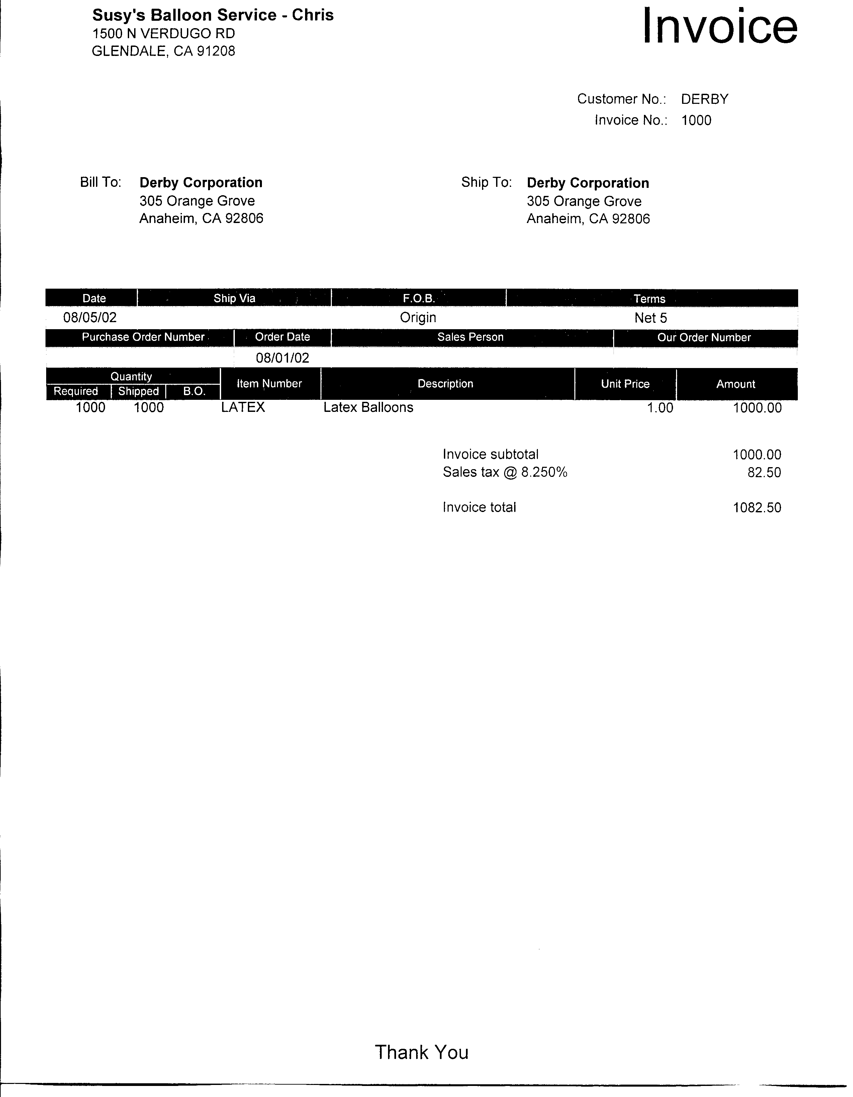

HEADER

B ODY

TOTAL

The payment of freight charges depends on the FOB (Free on Board) point. If the freight is FOB Destination, the seller is responsible for paying the freight. If it is shipping Point, the buyer is responsible for paying the freight. The seller might pay the freight for the buyer on FOB shipping. Point as a convenience. The charge is then added to the invoice and increases the customer’s account. If it is FOB destination, the freight cost is not added to the invoice.  A separate account should be kept for freight cost so it will not be included in net sales.  Every sales invoice should have a separate section in which to place the cost of the freight and the freight account should be included in the General Ledger account. | FREIGHT CHARGES

PRINTING  SALES RETURNS AND ALLOWANCES  CREDIT MEMO  NEGATIVE INVOICE  ZERO CHECK  CASH RECEIPTS | If the system uses real time processing for invoices, after entering the information for the invoice it must be posted. The invoice cannot be changed once it is printed. It must be voided and reentered if it is incorrect.  Some programs require the invoice to be printed as each section or part of the invoice is complete. If this is the case, it is hard to correct because you must make corrections to it before printing that section.  Other programs allow you to enter data for several invoices. Once the information for all the invoices are entered they can be printed as a group. Before the group of invoices is printed, an individual invoice can be changed. These programs can also print more than one copy of the invoice. This method gives the user more control over when and how to print.  Credit memos are written by the seller to indicate when a return or an allowance has been given. Many programs have special commands that allow the user to enter credit memos in the same manner as sales invoices.  The credit memo should offset the sales invoice so that it will disappear after the end-of-month closing. This can be accomplished by a field in the credit memo asking for the invoice number, which will have this credit memo applied to it.  If the program does not have a special command for Credit Memos (Sales returns and allowance or Bad Debt and Adjustments), a creative way to handle these types of transactions must be performed. This method is to create a negative invoice with the item number. The quantity is listed as a negative number to void the positive invoice.  A Negative invoice is matched to the original invoice by entering a zero cash receipt. A zero cash receipt is a check received that has no dollar amount and is used only to match the cash receipt for the positive invoice to the negative. The net effect is $0, thus zeroing of the invoices. It is cleared at end-of-month closing.  Cash receipts are entered as a batch and require the user to match the cash receipt to the customer's sales invoice. This is accomplished by entering the amount of the cash received. An accounting system will automatically know this is a debit to cash and a credit to A/R. What the system does NOT know is the aging period (0-30, 31-60, 61-90,90+-- balance forward system) or what invoice (open-item system) to which to apply this cash receipt.  For a balance-forward customer, the accounting system will list the aging periods and the user will place the dollar amount to be applied to each accounting/aging period. For the open-item customer, the user will need to enter the invoice(s) to which this cash receipt is applied.  Each day’s cash receipts should be entered and posted as a batch and be deposited in the bank. This will aid the user when reconciling the bank account.  During the month invoices and payments against invoices (cash receipts) are shown on the aged Accounts Receivable report. This is the detail for the month. After the end-of-month closing the invoices with matching cash receipts will be dropped from the system since they no longer represent an outstanding account receivable. Preserving this monthly detail is a good reason an archival disk (backup disk for storage) should be make before closing the month.

Sales discount is given at the item of payment, not when the invoice is issued. There should be a field for entering a discount amount or percentage in the cash receipt entry screen. Some accounting systems can calculate the amount automatically. This amount is based on three fields:  - the date of payment  - the date of the invoice  - the payment terms  Some systems do not automatically calculate sales discount. If the system does a calculation, the user is expected to input the necessary data from the check received.  NOTE: Date of Cash Receipt is based on the postmark, not the check date or invoice receipt date. Because this is a special field and the user does not enter the account number, the sales discount account number must be entered in the G/L Integration Accounts.  Some accounting programs have a special entry option for adjustments. It allows the user to enter a journal entry with a debit or credit to A/R and the opposite to another account, such as bad debt expense, plus specify the particular customer and invoice to which it is applies. It also allows the user to increase or decrease a customer’s account without writing a debit/credit memo. The Bad Debt Expense account number must be included in the G/L Offset Accounts.  If the software program does not have a Special Adjustment command, bad debt adjustments must be accomplished using Sales Invoice and Cash Receipt entries. To write off an account, a negative invoice must be created with the credit account number as bad debt expense instead of sales. Then a cash receipt of a $0 check must be entered to match the invoice with the negative invoice. This will clear the invoice from the A/R and will record it as a bad debt.  A finance charge is the dollar amount that a company charges customers for not paying invoices within the agreed time frame. To apply a finance charge to customers’ balances, the standard steps in a majority of accounting software programs are:  - Set up or configure your company by entering  - The control account where you want the finance charge to accumulate.  In Business Works, select Utilities-Posting Accounts.  - The percentage to be applied. Note whether the program uses an annual rate or monthly percentage. In Business Works it is Utilities-A/R Parameters  - Enter YES into the field “ Finance Charge applied? In the customer file.  In Business Works, select Customer/Maintain customer/ Inv/State  The user should understand how the program calculates the finance charge amount. First, for each customer the program locates the open items or unpaid balance for all aging brackets, beginning with the bracket specified in the setup. Next, the specified rate from the setup is applied to the open balance. The finance charge is then added to the customer’s balance and is accumulated in the YTD finance charge field. Finally, the finance charge applied is listed in the Finance Charge Journal. Some software programs have an option to apply the finance charge to only the unpaid invoice balance rather than the balance plus accumulated finance charges. | SALES DISCOUNT  BAD DEBT  (UNCOLLECTIBLE)  ACCOUNTS AND ADJUTMENTS  FINANCE CHARGE  BASICS

SALES TAX BASICS  Reports  L.O.6  --------  CUSTOMER LIST  SUBSIDIARY LEDGER  REPORT  SALES JOURNAL | There are special options you can use with a finance charge command:  Remove all finance charges. This option would be used if the percentage that is applied is incorrect or a major error for all customers was discovered.  Reenter finance charges, This option allows the user to reenter a finance charge if it was entered and removed.  Add a specific customer’s finance charge. If a finance charge is to be applied to only one customer because of an arrangement made between the customer and the company, this option would be used.  Every invoicing program should have the ability to calculate and store sales tax that is applied. The steps to apply sales tax are described below.  - Enter the company setup or configuration information:  - Set the G/L control account or integration account to the account you want to use to accumulate the sales tax collected from the customer. The account usually is to Sales Tax Payable. There can be several accounts if you have many states in which you do business. In Business Works select Maintain Sales Tax.  - Enter the percentage for each state. In Business Works select Customer-Maintain Customer- Inv/State  - State that sales tax is to be applied in a field in the Customer file.  - To include sales tax in the invoice, as each customer invoice is entered specify the line item on invoice or total invoice as taxable. The taxable amount should be able to be overwritten should the calculated tax be incorrect. In Business Works, select utilities, maintain standard items.  The A/R reports are varied and are basically: Customer List, Subsidiary Ledger, Sales Journal, Cash Receipt journal, Finance Charge journal, Aged Ledger, and Statements. These reports can be printed based on a series of date options: Current Month, One period back, last year and etc.  The purpose of the Customer List report is to provide the user with the code, name, and address of the current customers. The list should always be updated when a new customer is added and when a customer is deleted and no longer deals with the company. Some programs allow “temporary” customers. These programs will automatically delete the customer when the customer’s balance is zero. This is useful in situations when the company makes a “one-time” sale, i.e., a one-time overseas special shipment.  The Customer List report should contain the customer code or number that will be used by the A/R data entry clerk. A customer code will be easier to remember if it is an abbreviation of a customer name instead of a number. Having the list readily available will make the data entry go faster.  The Subsidiary Ledger report lists the customer’s open invoice from the previous month plus all the activity from the current month. The Subsidiary Ledger must always equal the Accounts receivable account in the General Ledger.  This report is useful to monitor the customer’s sales and payment activity and will show the open balance for the customer by the individual invoice. Also the information for the statements is the same as that listed on the subsidiary Ledger report.  The name of this subsidiary report can vary from program to program.  The Sales Journal report is the listing of all the invoices that have been printed or entered for the month. The Sales Journal can list this information by date, by invoice number, or by date and invoice number within that date. The preferred method is to list the information by invoice number.

The Cash Receipts Journal report lists the cash that was received from customers to pay off the open invoices. It is important to include the customer’s check number in the data entry and the invoice number. This information should be listed by date and/or deposit. This information is helpful to the individual doing the bank reconciliation and for data reentry or correspondence relating to returned checks.  The Finance Charge Journal report is used only if the company charges a finance charge. The journal lists those customers with a finance charge and indicates the amount of the charge. This is a helpful report if the company charges some customers and not others.  The purpose of this report is to list, by customer, open invoices and the number of days each has been outstanding. This listing could be used to gather the information to apply finance charges. The total amount of this report should be the balance in the Accounts Receivable account.  Statement s are individual reports for each customer. A statement includes a beginning balance, all the activity for the month, and an ending balance. Most accounting systems optionally print out all, some, or a single statement.  Statements can be used to bill or remind the customer to pay. Just write a note on the invoice that says “Pay from Statement.” Mailing out statements will help keep the accounting records accurate since customers will generally inform you of any errors.  .  Posting refers to the process of transferring data from the journals or modules to the General Ledger. Some programs post the individual transactions to the General Ledger at the same time as they are posted to the module. In other accounting software programs the transactions are posted to the General Ledger during the month-end closing procedures.  End-of-month closing clears all the current month transactions in the journals, leaving only balances. If the General Ledger is not updated when the individual transactions are posted, the end-of month closing will create a summary journal entry. The summary journal entry totals the amount of debits and credits of all transactions for each of the accounts, | CASH RECEIPTS  JOURNAL  FINANCE CHARGE  JOURNAL  AGED LEDGER  STATEMENTS  L.O. 7 Posting to the General Ledger  Posting  End-of-Month  Closing

Name __________________________ Date_____________
Susy's Balloon
Service
Cover Sheet-Chapter Four
Order of Reports to be attached :
Customer List
Journal Detail Report - Current Batch
Sales Journal with Invoices
Cash Receipt Journal
Adjustments and Credit Memo
Aged Invoice Listing
Statements
A/R Subsidiary Ledger
Adjusted Trial Balance
General Journal Report (Journal Detail Report)
Income Statement
Balance Sheet 8/31/0X
General Ledger
Income Statement date 9/01/0X

Did you make a back-up/archival copy?

Section 3: STUDENT APPLICATION

L.O 8 Accounts Receivable Susy's Balloon Service
AUGUST 200X
____________________________________________________________

OVERVIEW INSTRUCTIONS

Susan is starting to sell individual balloons and mylars (silver balloons). She is taking telephone cash orders for single balloons or bouquets that the customer will pick up. Also, several customers want a small present to be attached to the balloons. This increase in business will require a Purchases Account. The Balloon Accessories Expense Account will no longer be adequate, therefore the balance in this account must be transferred to Purchases with a Journal Entry.
Susan is still doing business out of her home. Her business has increased enough for her to hire a part-time employee.

Update the General Ledger
Step 1: Update the Chart of Accounts. Add the following accounts
- Bad Debt Expense
- Sales Returns & Allowance
- Sales Discount
- Purchases
- Wages Expense

Set up the Accounts Receivable
Step One: Create A/R Data File
Step Two: Maintain Payment Terms
Step Three: Maintain A/R Parameters
Step Four: Select A/R Forms
Step Five:Maintain Post Accounts
Step Six: Maintain Shipping Instructions
Step Seven: Sales Taxes - Maintain
Step Eight: Sales Account - Maintain
Step Nine: Standard Items-Maintain
Step Ten: Check your set-up. Select Utilities then Display A/R Status, Still in Set-up : YES
Step Eleven: Enter Customers
Step Twelve: Print Customer List

MAKE A BACK UP COPY AND LABEL IT A/R SETUP

Step Thirteen: Get out of Set-up Mode for Any Module

Enter Daily Transactions
Please note that the source document number (Check#, JE#, Invoice #) may vary from the sample. Start invoices at 1000 and Credit Memos at 100. If information is needed on the invoice but is not stated, create your own data.

a. August 1, 200X Purchased balloons & Accessories from Ballooner's Supply, $823. P.O. #995, 2/10 Net 30 (G/L)
b. August 5, 200X Sold 1000 latex balloons @$1.00 each to Derby Corp. Inv #1000. 2/10 Net 30
c. August 5, 200X Sold 33 "Welcome" mylar balloons @ $3.50 each to Lost Hills School District P.O. #00576. Received check #167850 dated 8/4 for one-half of invoice ($57.75) No discounts.
d. August 5, 200X Billed Norman Bell, 1441 Back Street, Glendale, CA 91208 for party decorations, $750, 2/10 Net 30. UPS
e. August 15, 200X Paid 8/1/0X Ballooner's Supply Invoice, CK #106, no discount $823 (G/L)
f. August 15, 200X Purchased on account decorating and office supplies from Target Stores, $200. Change 113 to Office/Décor Supplies (G/L)
g. August 15, 200X Received check #1122 for $980 from Derby. Invoice dated 8/5.
h. August 16, 200X Billed Marshall's for open House Balloons, P.O. 65432. Net 30, $880
Assorted Decorations:
Qty Description $each
5 Single Arch 100
12 Balloon Bouquet 25
Latex Balloons 80 Assorted Colors 1
i. August 17, 200X Lost Hills School District returned 15 defective mylar balloons from 8/5 invoice. Use Sales Return and Allowance
j. August 17, 200X Invoice Marshall for 200 mylars @ $3.50 each. Net 30 days. Ship via UPS. No Freight. $700
k. August 31, 200X Received CK # 191989 for $1230 from Marshall for all of 8/16 invoice and 1/2 of 8/17 invoice.
l. August 31, 200X Norman Bell was nowhere to be found. Declared his account to be uncollectible. Use Bad Debt Expense,.
m. August 31, 200X Paid Karen Willis $500 for her part-time help. CK#107. Add account 501 Wages Expense if needed. (G/L)
n. August 31, 200X Susy withdrew $1,000. Check #108. (G/L)
o. August 31, 200X Lost Hills School District paid their balance, $5.25 CK#167898.

ADJUSTING ENTRIES - G/L
p. August 31, 200X Truck Depreciation $100
q. August 31, 200X Equipment Depreciation $175
r. August 31, 200X Supplies ON HAND, $75 (Journal entry is calculated by subtracting $75 from the balance in supplies account)
______________________________________________________________
REPORTS

- Print the Journal entry detail report.
- Print the Sales Journal. Keep invoics with this report. Normally they would have been mailed to the customer.
- Print Cash Receipts Journal and any Credit memo Journal.

MONTH END ACTIVITIES

- Print Aging Report.
- Print Detail Report - Subsidiary Report
- Print Statements.
- Enter and post adjusting entries.
- Print Trial Balance- Summary
- Print Trial Balance-Detail
- Print Income Statement
- Print Balance Sheet
- Make an archival disk. Put aside should you need to restart from this point.
- Perform period end closing. Close Accounts Receivable the close General Ledger.
- Print Income Statement dated 9/30/0X showing no dollars in the current column. This indicates the previous month was closed.
- Compile all reports following the steps given in the lab work discussion in Chapter 2.

DETAIL INSTRUCTIONS
Set-up Detail

- Update the Chart of Accounts by adding the following accounts (G/L):
____________________________________
- Bad Debt Expense
- Sales Returns & Allowance
- Sales Discount
- Purchases
- Wages Expense
___________________________________

- Compare your Chart of Accounts to below report

Aug 1, 2002 Susy's Balloon Service - Chris
10:24 pm Chart of Accounts

Sub
Account # Account Description Account Type Type PSC-Through
========= =========================== ================ ==== ===========
111.00 CASH Current Assets P
112.00 ACCOUNTS RECEIVABLE Current Assets P
113.00 DECORATING SUPPLIES Current Assets P

150.00 EQUIPMENT Fixed Assets P
151.00 ACCUMULATED DEPR-EQUIPMENT Fixed Assets P
160.00 TRUCK Fixed Assets P
161.00 ACCUMULATED DEPR-TRUCK Fixed Assets P

211.00 ACCOUNTS PAYABLE Current Liabilities P

311.00 SUSAN CASEY, CAPITAL Equity P
312.00 SUSAN CASEY, DRAWING Equity P

399.00 RETAINED EARNINGS Retained Earnings P

411.00 INCOME FROM SERVICES Sales P

420.00 SALES RETURNS AND ALLOWANCE Sales Adjustments P
421.00 SALES DISCOUNT Sales Adjustments P

440.00 FREIGHT REVENUE Sales P

450.00 PURCHASES Cost of Goods Sold P

501.00 WAGES EXPENSE Expenses P
506.00 UTILITIES EXPENSE Expenses P
512.00 SUPPLIES EXPENSE Expenses P
601.00 ADVERTISING EXPENSE Expenses P
605.00 BALLOON ACCESSORIES EXPENSE Expenses P
615.00 DEPRECIATION Expenses P
620.00 Bad Debt Expense Expenses P

3. Set-up A/R- All commands are in the Utilities Pull Down menu
Step One: Create A/R Data File
1. Select A/R Icon,
2. Select Utilities
3. Select Create A/R Data Files (It's on the bottom of the list)
a. Note: Exclusive Option, Click OK
b. Note: This will destroy any existing A/R; Continue with option: Select Yes.
c.. Current A/R Month :August 2000
Last month of Fiscal Year: November
OK
4. Type the work CREATE, Select OK.
5. ➔ Creating data files
6. Note: Set-up Mode? OK

Step Two: Maintain Payment Terms
1. Select Utilities- Maintain Payment Terms
- Stay in A/R Set-up Mode? Yes
- Click on the next icon to see the terms: 1. Prepaid, 2. COD, 3. Net 30
- Change the fields in the term 4 by over writing what already exists.
Terms: 4
Discount Rate: 2.0%
Discount Period (# of days): 10
Due: 30 days
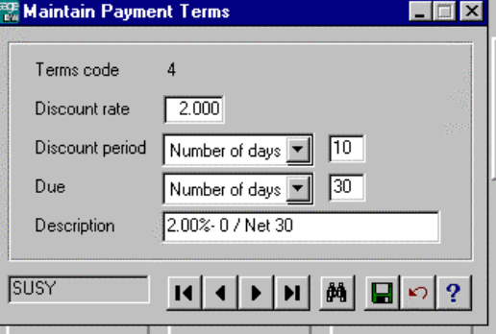 Description 2% 10 days Net 30
5. Save by clicking on disk
6. Add term 5
Terms: 5
Discount Rate 0
Day 5
Description Net 5
Save

Step Three: Maintain A/R Parameters
1. Stay in A/R Set-up Mode?, OK
2. Months to keep 12
Last Month November
Length of Aging 30 60 90
Model Customer Leave Blank
Allow for Future Posting Yes
Monthly Finance Charge 1.0%
Minimum Finance Charge $1.00 Select OK?
Grace Period 0 days
Minimum Balance $5.00
3. Select OK when finished.
November
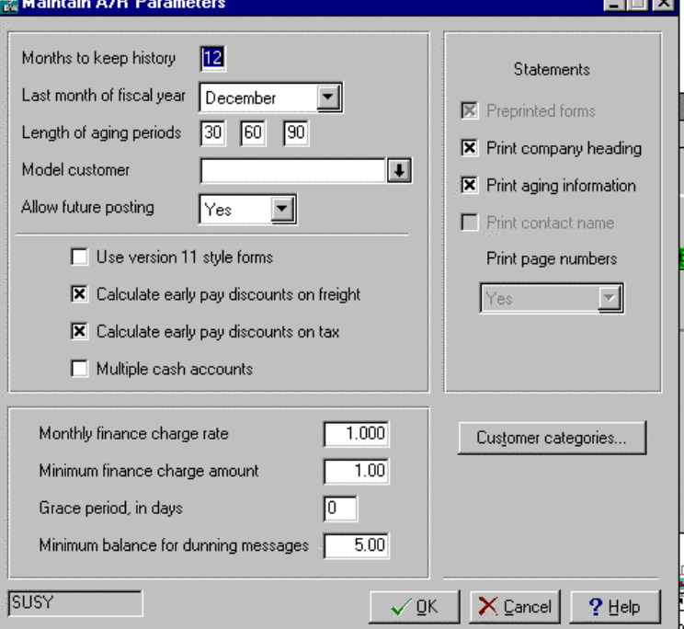

Step Four: Select A/R Forms
1. Stay in A/R Set-up Mode?, Yes
2. Select Invoice Plain Paper Std A/R Invoices
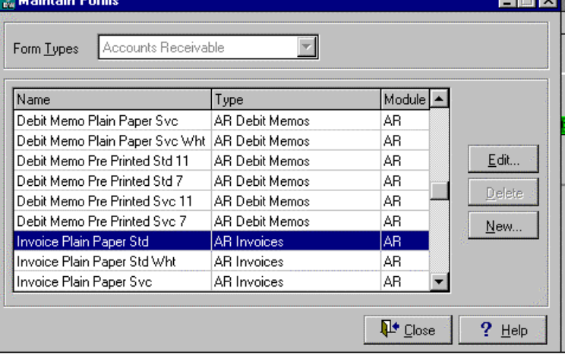3. Click on Close.
Step Five:Maintain Post Accounts
- Stay in A/R Set-up Mode?, Yes
- Enter the following accounts in each field, pressing enter after each field:
A/R 112 Finance Chg 445
Misc 411 Credit/Debit 420
Discounts 421 Bad Debt 620
Freight Chg 440 Deposits (Leave Blank)
Cash Acct 111
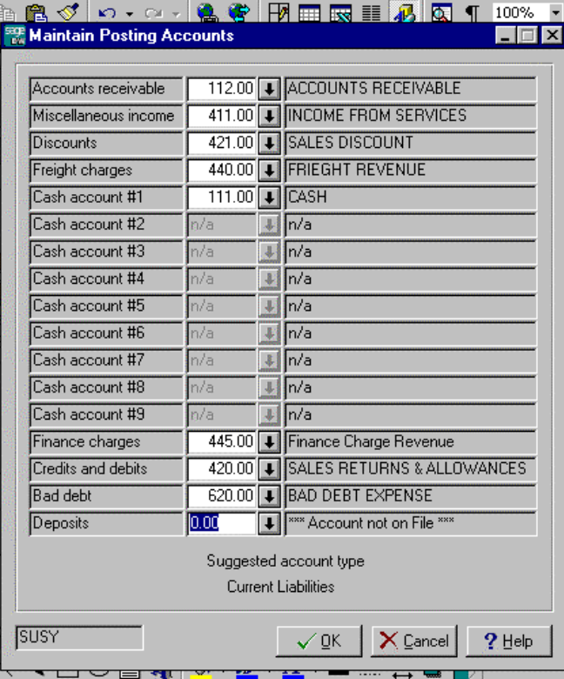
Invoice Preferences - leave in default mode

Step Six: Maintain Shipping Instructions
1. Enter the following
1. UPS
2. Next Day Air
3. USPS
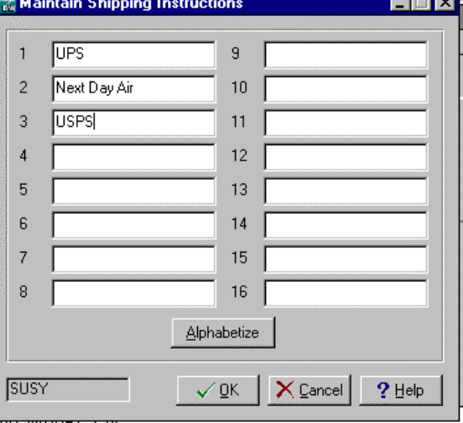 Select OK?

Step Seven: Sales Taxes - Maintain
- Stay in A/R Set-up Mode?, YES
- Note: No SalesTax Information. Will be put in NEW mode.
- ID: CA
- Description: California Sales
- Account #: 212 (Add this account on the fly)
- Note: Account not currently on file. Add it now? Yes. Remember it is a current liability.
- 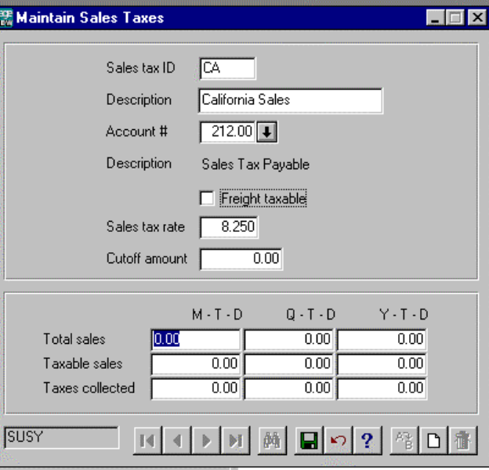Sales Tax Rate: 8.25%
- Save

Step Eight: Sales Account - Maintain
1. Stay in A/R Set-up Mode?, OK
2. Sales Account # 1
3. Description: Income from Services
4. GL Acct # 411, Save
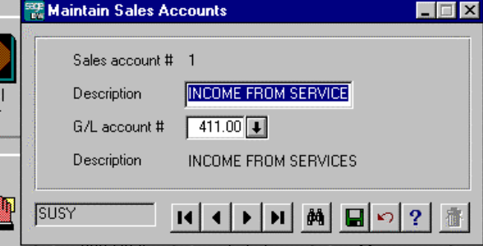

Step Nine: Standard Items-Maintain
1. Add the following items:
Item ID LATEX MYLARS OTHER
Description Latex Balloons Mylar Balloons Assorted Decorations
Price A $1 $3.50 $0 (to be entered)
Sales Acct 1 1 1
Discount Amt Yes Yes Yes
Taxable Yes Yes Yes
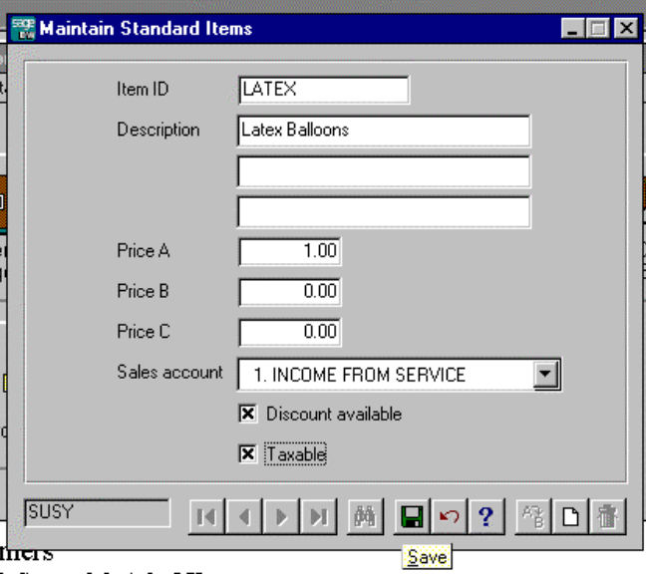

Step Ten: Check your set-up. Select Utilities then Display A/R Status, Still in Set-up : YES

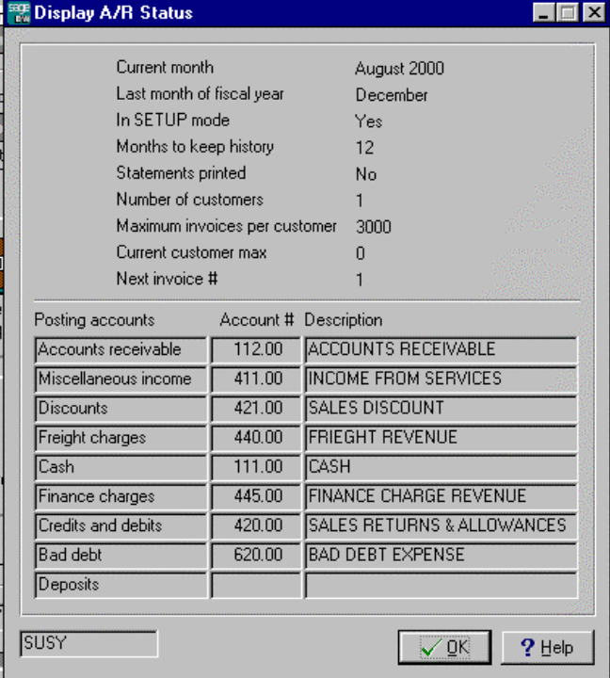

Step Eleven: Enter Customers
- Select customer from the pull down menu and select Maintain Customer.
- Stay in A/R Set-up Mode?, Yes
- No Customers. Put in New. OK
- Add each field for the three customers:
Customer ID# DERBY
Name Derby Corporation
Address: 305 Orange Grove
Address: Leave Blank
City, State Anaheim, CA
Zip 92806

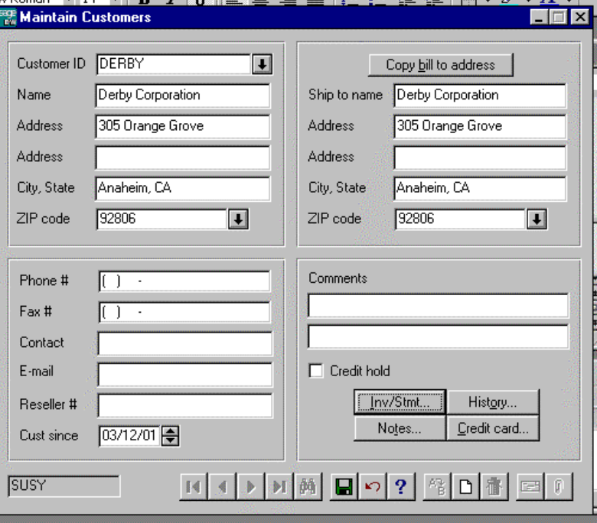5. Click on the INV/STMT Radio Box
Terms: 2/10 Net 30
Sales Rep: None
Sales Acct: 1
Print Statement: X
1st Sales Tax CA
Discount Rate 0

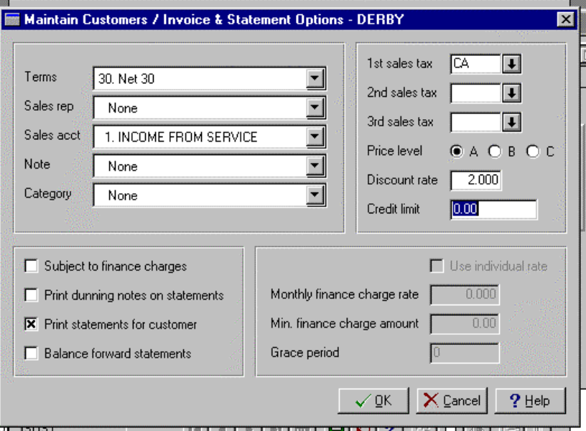
Sales Discount
Trade Discounts

6. Enter remaining two customers in the same manner as Derby:
Customer ID# MARSH
Name Marshall’s Corporation
Address: 344 Center Street
City, State Torrance, CA
Zip 90507
INV/STMT
Same as DERBY
Customer ID# LOSTHILL
Name Lost Hills School District
Address: 825 Marengo Ave
City, State Lost Hills, CA
Zip 93249
INV/STMT

Same as DERBY

Step Twelve: Print Customer List
- Select Customer Pull Down Menu
- Select Customer List.
- Bring to Screen. If correct click on print icon.

CUSTOMER LIST

Aug 1, 2002 Susy's Balloon Service - Chris 10:52 pm Customer List

Customer Name/Address/Phone/FAX Customer Information
============ ========================== ========= ==============================
DERBY Derby Corporation FinChgs: No CrLimit: None
305 Orange Grove Dunning:No HighBal: 0.00
Anaheim, CA 92806 Stments: Yes Balance: 0.00
Bal/Fwd: No Open Cr: 0.00
PriceLv: A FinChgs: 0.00
Note: None Deposit: 0.00
Disc: 0.000%
SalesTax: CA
Resale #:
Sls Acct: 1. Income from Services
Rep: None
Since: 07/06/03 Terms: 4. 2.00%-10 / Net 30
Phone: ( ) - Cat: None
FAX: ( ) - Comments:
-------------------------- --------- ------------------------------

LOSTHILL Lost Hills School Dist FinChgs: No CrLimit: None
825 Marengo Ave Dunning: No HighBal: 0.00
Lost Hills, CA 93249 Stments: Yes Balance: 0.00
Bal/Fwd: No Open Cr: 0.00
PriceLv: A FinChgs: 0.00
Note: None Deposit: 0.00
Disc: 0.000%
SalesTax: CA
Resale #:
Sls Acct: 1. Income from Services
Rep: None
Since: 07/06/03 Terms: 4. 2.00%-10 / Net 30
Phone: ( ) - Cat: None
FAX: ( ) - Comments:
-------------------------- --------- ------------------------------

MARSH Marshall's Corporation FinChgs: No CrLimit: None
344 Center Street Dunning: No HighBal: 0.00
Torrance, CA 90507 Stments: Yes Balance: 0.00
Bal/Fwd: No Open Cr: 0.00
PriceLv: A FinChgs: 0.00
Note: None Deposit: 0.00
Disc: 0.000%
SalesTax: CA
Resale #:
Sls Acct: 1. Income from Services
Rep: None
Since: 07/06/03 Terms: 4. 2.00%-10 / Net 30
Phone: ( ) - Cat: None
FAX: ( ) - Comments:

MAKE A BACKUP COPY AND LABEL IT A/R SETUP

Step Thirteen: Get out of Set-up Mode for Any Module
1. Select any option or Utilities; Display Status
2. Note: Still in Set-up Mode? Select NO
3. Type OK in box to get out of set up mode.
- You must get out of Setup to have the transactions intergrated to the General Ledger.

Enter Daily Transactions
Note that the source document number (Check#, JE#, Invoice #) may vary from the sample. Start invoices at 1000 and Credit Memos at 100. If information is needed on the invoice but is not stated, create your own data.

a. August 1, 200X Purchased balloons & Accessories from Ballooner's Supply, $823. P.O. #995, 2/10 Net 30 (G/L)
Debit 450 Credit 211

b. August 5, 200X Sold 1000 latex balloons @$1.00 each to Derby Corp. Inv #1000. 2/10 Net 30

Enter Sales-A/R Invoices
- Select transactions - invoices
- Use the down arrow to select the customer ID.
- Enter 1000 in the Invoice # field. The next invoice click on next and the program will add one to 1000.
- Enter the correct date
- Enter the description as the P.O. number.

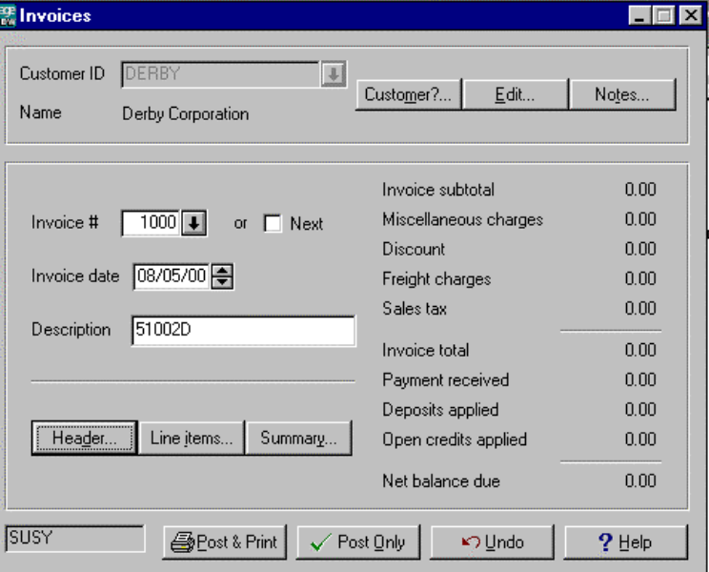

Header
- Click on Header button. Terms should be Net 5
- Double Check information. If correct click on OK.

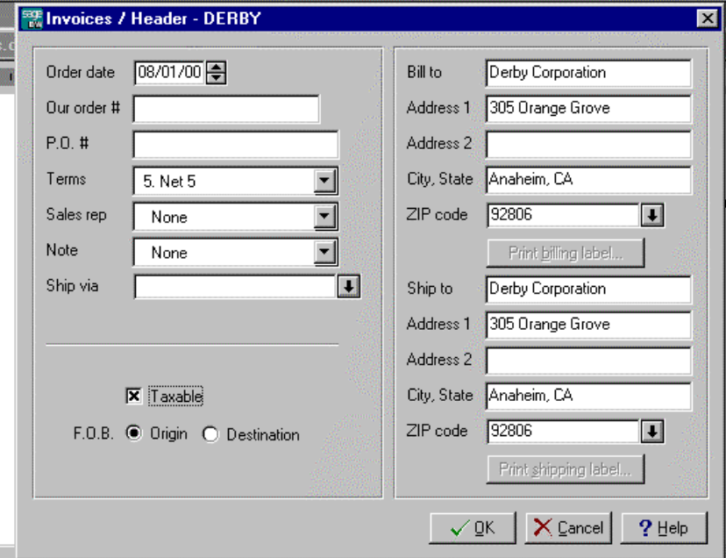Line Item
1. Click on Line Item button.
2. Type is Item.
3. Item #: Latex or Mylar or Other
4. Ordered: Enter the amount of items ordered.
5. Shipped: Just press entered if it is the same as ordered.
6. Unit Price: Automatic from the Standard Items file.
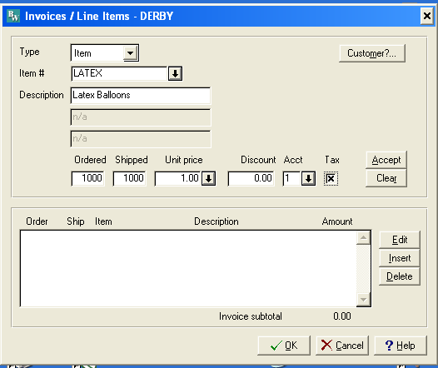

7. Account: 1 Income From Services
8. Accept
9. Double check the subtotal, then OK if correct.

Summary
1. Click on Summary button.
2. 0 for Misc, Discount & Freight.
3. Enter to accept sales tax.
4. Press enter when finished, click on OK.
5. Select print and post to print an invoice.
6. Close

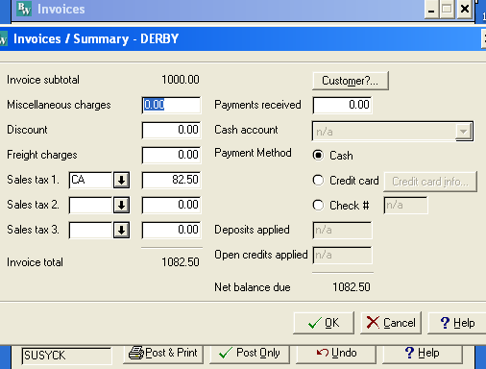

DERBY INVOICE

c. August 5, 200X Sold 33 "Welcome" mylar balloons @ $3.50 each to Lost Hills School District P.O. #00576. Received check #167850 dated 8/4 for one-half of invoice ($57.75) No Discounts.

- Enter in the same manner as the Derby invoice.
- To enter the prepayment, click on the summary button, enter the amount in Payment received.
- If a discount shows up simply highlight the field and replace it with 0.
- It will also show up on the first screen of the invoice entry.
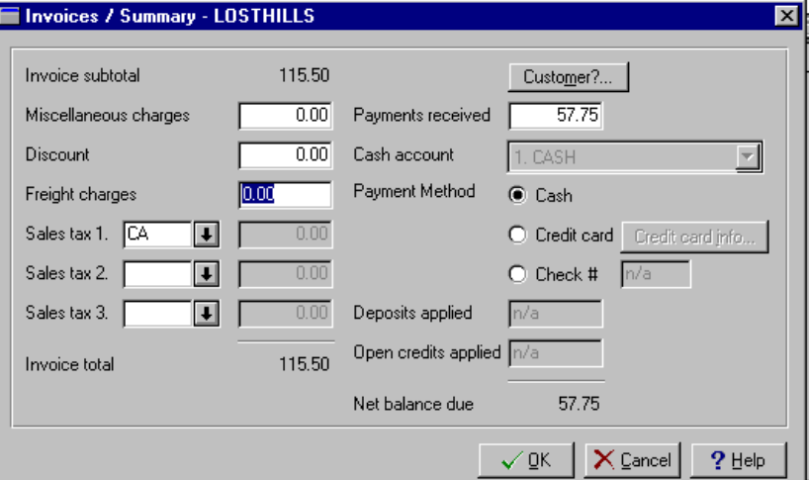

d. August 5, 200X Billed Norman Bell, 1441 Back Street, Glendale, CA 91208 for party decorations, $750, 2/10 Net 30. UPS
- See the above instructions using the "Other" item.

e. August 15, 200X Paid 8/1/0X Ballooner's Supply Invoice, CK #106, no discount $823 (G/L)
Debit 211 Credit 111

f. August 15, 200X Purchased on account decorating and office supplies from Target Stores, $200. Change 113 to Office/Décor Supplies (G/L)
Debit 113 Credit 211

g. August 15, 200X Received check #1122 for $1062.50 from Derby. Invoice dated 8/5.

Enter Cash Receipts
1. Select A/R
2. Select Transaction
3. Select Post Receipts
4. Select Customer ID using the down arrow.
5. Select Check #.
6. Enter Reference, if any.
7. Enter amount. (You can come back and enter this amount after selecting the invoices.)
8. Enter the invoice # that is being paid, or use the down arrow. Press enter.
9. Accept full payment or enter or enter a partial payment.
10. Press enter to ignore discount or enter a discount.
11. Press enter to ignore write-off.
Distribution will automatically be entered.
- Select post.

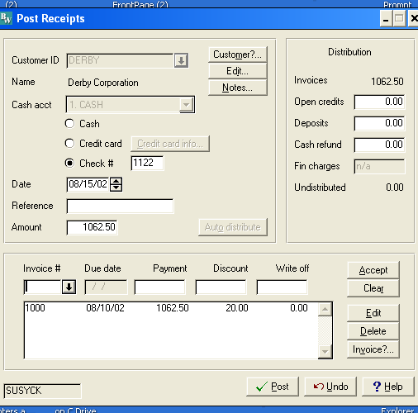

- Continue for the others.

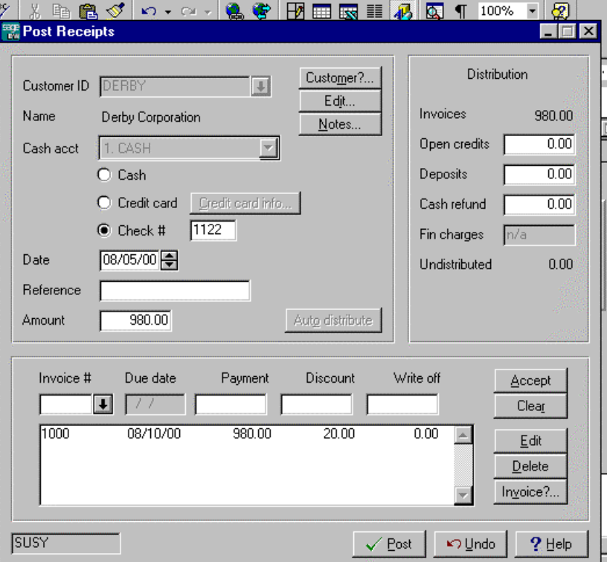
h. August 16, 200X Billed Marshall's for open House Balloons, P.O. 65432. Net 30, $880
Assorted Decorations:
Qty Description $each
5 Single Arch 100
12 Balloon Bouquet 25
Latex Balloons 80 Assorted Colors 1
Enter in the same way as the Derby and Lost Hills invoices.

i. August 17, 200X Lost Hills School District returned 15 defective mylar balloons from 8/5 invoice. $52.50 Use Sales Return and Allowance

CREDIT MEMO
- Select Transactions - Credit Memo
- Enter the Customer
- Select Invoice to be adjusted.
- Enter the amount to be written off.
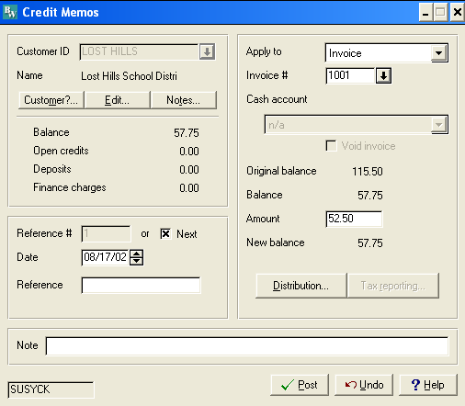
- Select Distribution.
- Check to make sure the amount was entered into the Sales Return and Allowance account. OK
- Post.
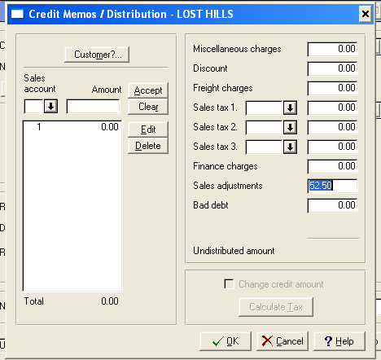

j. August 17, 200X Invoice Marshall for 200 mylars @ $3.50 each. Net 30 days. Ship via UPS. No Freight. $700
k. August 31, 200X Received CK # 191989 for $1230 from Marshall for all of 8/16 invoice and 1/2 of 8/17 invoice.
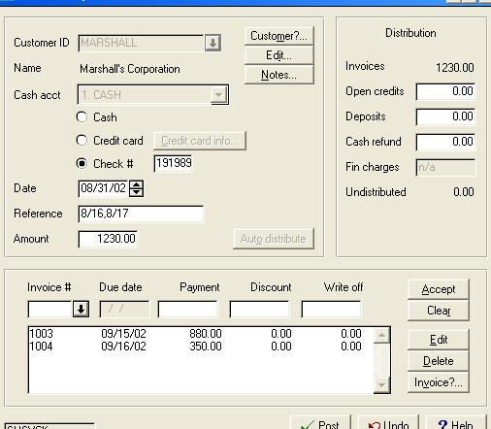

l. August 31, 200X Norman Bell was nowhere to be found. Declared his account to be uncollectible. Use Bad Debt Expense,.
(See August 17 Lost Hills Transactions for screen displays.)

- Select Transactions - Credit Memo
- Enter the Customer
- Select Invoice to be a write off.
- Enter amount to be written off.
- Select Distribution
- Enter the Amount in Bad Debt (This is the only difference from 8/17 transaction)
- Post
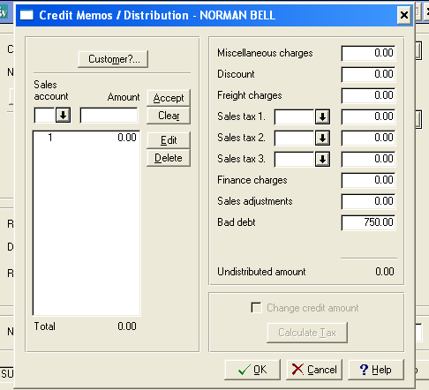

m. August 31, 200X Paid Karen Willis $500 for her part-time help. CK#107. Add account 501 Wages Expense if needed. (G/L)

n. August 31, 200X Susy withdrew $1,000. Check #108. (G/L)

o. August 31, 200X Lost Hills School District paid their balance, $5.25 CK#167898.
See August 15th Derby transactions.

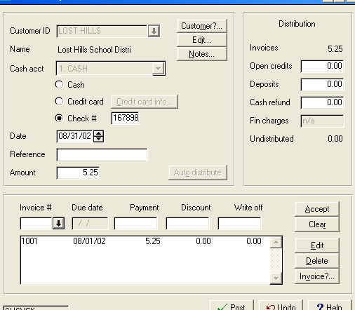

ADJUSTING ENTRIES - G/L
q. August 31, 200X Truck Depreciation $100
r. August 31, 200X Equipment Depreciation $100
s. August 31, 200X Supplies ON HAND, $75 (Journal entry is calculated by subtracting $75 from the balance in supplies account)

REPORTS

- Print the Journal entry detail report.
- Print the Sales Journal. Keep invoics with this report. Normally they would have been mailed to the customer.
- Print Cash Receipts Journal and any Credit memo Journal.

Journal Report
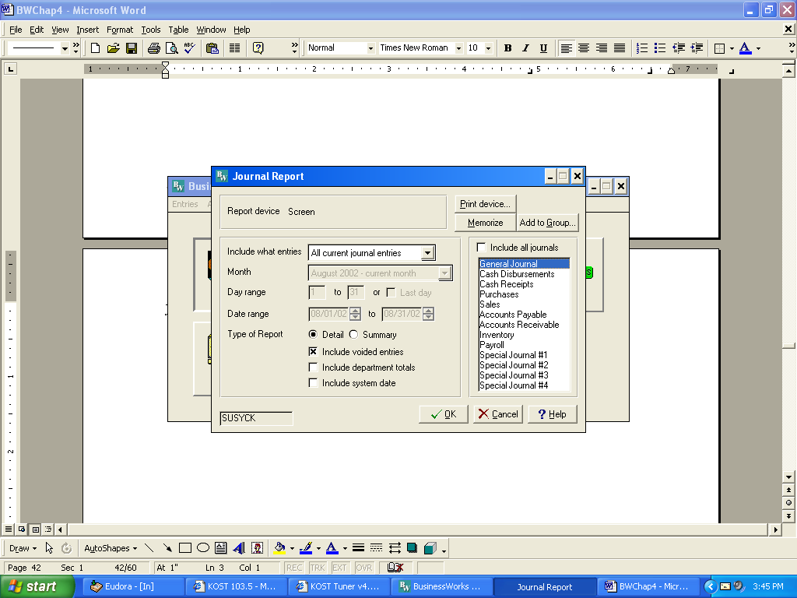
1.Select Reports
2.Select Journal Report
3.Click on Include all journals to remove the check
4.Click on General Journal.

Aug 31, 2002 Susy's Balloon Service -
3:48 pm Journal Detail Report

Post/Sys
Date Jnl Ref. No Description / Accounts Debit Credit

08/01/02 G/L 114 Ballooners Supply
PO box 995
605.00 BALLOON ACCESSORIES EXPENSE 823.00
211.00 ACCOUNTS PAYABLE 823.00

08/01/02 G/L 115 Ballooner's Invoice
CK#106
211.00 ACCOUNTS PAYABLE 823.00
111.00 CASH 823.00

08/15/02 G/L 116 Target Stores decorating
and office supplies
113.00 OFFICE/DECOR SUPPLIES 200.00
111.00 CASH 200.00

08/31/02 G/L 117 Karen Willis Wages
501.00 WAGES EXPENSE 500.00
111.00 CASH 500.00

08/31/02 G/L 118 Susy Withdrawal CK#108
312.00 SUSAN CASEY, DRAWING 1,000.00
111.00 CASH 1,000.00

08/31/02 G/L 119 truck depreciation
615.00 DEPRECIATION EXPENSE 100.00
161.00 ACCUMULATED DEPR-TRUCK 100.00

08/31/02 G/L 120 EQUIPMENT DEPR
615.00 DEPRECIATION EXPENSE 75.00
151.00 ACCUMULATED DEPR-EQUIPMENT 75.00

08/31/02 G/L 121 SUPPLIES BALANCE $225 ON HAND $75
512.00 SUPPLIES EXPENSE 150.00
113.00 OFFICE/DECOR SUPPLIES 150.00

***** Report Total 3,671.00 3,671.00

Sales Journal/Cash Receipts/Adjustments Journal
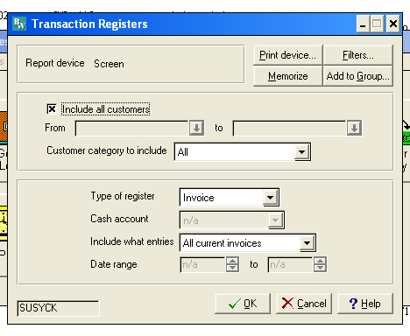
- Select Reports, Transaction Register
- Type of Register= invoices for the Sales Journal
- Type of Register =Cash Receipts for Cash Receipts
- Type of Register=adjustments for Sales Ret and Allowance
Sales Journal
Aug 1, 2002 Susy's Balloon Service - Chris
4:05 pm Accounts Receivable Invoice Register
All Current Invoices

Invoice
Inv # Customer Date Description Total Sales Tax Freight
1001 LOST HILLS 08/01 115.50 0.00 0.00
1002 NORMAN BELL 08/01 part decorations750.00 0.00 0.00
1000 DERBY 08/05 1082.50 82.50 0.00
1003 MARSHALL 08/16 880.00 0.00 0.00
1004 MARSHALL 08/17 700.00 0.00 0.00

Report Total 3528.00 82.50 0.00
Sales tax (CA) 82.50

Cash Receipts Journal
Aug 1, 2002 Susy's Balloon Service - Chris
4:10 pm Accounts Receivable Cash Receipts Register
All Current Cash Receipts

Inv # / Cash --- Distribution --
Chk # Reference Acct Customer Date Amount Apply to Amount
====== ============ ==== ============ ======== ========== ========
167850 1 LOST HILLS 08/01/02 57.75 1001 57.75
1122 1 DERBY 08/15/02 1062.50 1000 1062.50
191989 8/16,8/17 1 MARSHALL 08/31/02 1230.00 1004 350.00
1003 880.00
167898 1 LOST HILLS 08/31/02 5.25 1001 5.25
Report Total 2355.50
ADJUSTMENTS
Aug 1, 2002 Susy's Balloon Service - Chris
4:13 pm Accounts Receivable Adjustments Register
All Current Adjustments

Ref # Transaction Reference Customer SR Date Amount Applied to
====== =========== ============ ============ === ======== ========== ==========
1 Credit Memo LOST HILLS 08/17/02 52.50 1001
2 Credit Memo uncollect NORMAN BELL 08/31/02 750.00 1002
==========
Report Total Credit Memo 802.50
Debit Memos 0.00
Apply O/Cs 0.00
Apply Deps 0.00
Write offs 0.00

Applied to:
Open credits 0.00
Finance charges 0.00
Cash refunds 0.00
Deposits 0.00
Invoices 802.50

MONTH END ACTIVITIES
- Print Aging Report.
- Print Detail Report - Subsidiary Report
- Print Statements.
- Print Trial Balance- Summary
- Print Trial Balance-Detail
- Print Income Statement
- Print Balance Sheet
- Make an archival disk. Put aside should you need to restart from this point.
- Perform period end closing. Close Accounts Receivable the close General Ledger.
- Print Income Statement dated 9/30/0X shwoing no dollars in the current column. This indicates the previous month was closed.
- Compile all reports following the steps given in the lab work discussion in Chapter 2.

A/R Subsidiary Ledger (Detail Report)

Aug 1, 2002 Susy's Balloon Service - Chris
4:17 pm Accounts Receivable Detail Report
All Current Transactions

Original Current
Transaction Txn Date Description / Dist Amount Balance Balance
=============== ======== ==================== ========== =========== ===========
DERBY Derby Corporation
1000 08/05/02 1082.50 0.00
Pay -#1122 08/15/02 / 1000 1062.50
/ EP Dis 20.00
----------- -----------
Customer Total 1082.50 0.00

LOST HILLS Lost Hills School Distri
1001 08/01/02 115.50 0.00
Pay -#167850 08/01/02 / 1001 57.75
CR -#1 08/17/02 / 1001 52.50
Pay -#167898 08/31/02 / 1001 5.25
----------- -----------
Customer Total 115.50 0.00

MARSHALL Marshall's Corporation
1003 08/16/02 880.00 0.00
1004 08/17/02 700.00 350.00
Pay -#191989 08/31/02 8/16,8/17 1230.00
/ 1004 350.00
/ 1003 880.00
----------- -----------
Customer Total 1580.00 350.00

NORMAN BELL Norman Bell
1002 08/01/02 part decorations 750.00 0.00
CR -#2 08/31/02 uncollect / 1002 750.00
----------- -----------
Customer Total 750.00 0.00

=========== ===========
Report Total 3528.00 350.00

Aging Report,
Aug 1, 2002 Susy's Balloon Service - Chris
4:22 pm Accounts Receivable Aging Report - Detail Report
Aged by Due date

Inv # Due Date Current 1 to 30 31 to 90 91 to 180 Over 180 Balance
======== ======== ========== ========= ========= ========= ========= =========
MARSHALL Marshall's Corporation
1004 09/16/02 350.00 350.00
--------- --------- --------- --------- --------- ---------
Customer Total 350.00 0.00 0.00 0.00 0.00 350.00
100.0% 0.0% 0.0% 0.0% 0.0%

Report Total 350.00 0.00 0.00 0.00 0.00 350.00
Trial Balance
Aug 1, 2002 Susy's Balloon Service - Chris
4:24 pm Summary Trial Balance

Acct No Account Description Begin Bal Debits Credits Ending Bal
111.00 CASH 1335.00 2355.50 2523.00 1167.50

112.00 ACCOUNTS RECEIVABLE
0.00 3470.25 3120.25 350.00
113.00 OFFICE/DECOR SUPPLIES
25.00 200.00 150.00 75.00

150.00 EQUIPMENT 500.00 0.00 0.00 500.00

151.00 ACCUMULATED DEPR-EQUIPMENT
-75.00 0.00 75.00 -150.00

160.00 TRUCK 4000.00 0.00 0.00 4000.00

161.00 ACCUMULATED DEPR-TRUCK
-100.00 0.00 100.00 -200.00

211.00 ACCOUNTS PAYABLE 0.00 823.00 823.00 0.00

212.00 California Sales Tax
0.00 0.00 82.50 -82.50

311.00 SUSAN CASEY, CAPITAL
-5500.00 0.00 0.00 -5500.00

312.00 SUSAN CASEY, DRAWING
600.00 1000.00 0.00 1600.00

411.00 INCOME FROM SERVICES
-1750.00 0.00 3445.50 -5195.50

420.00 SALES RETURNS AND ALLOWANCE
0.00 52.50 0.00 52.50

421.00 SALES DISCOUNT 0.00 20.00 0.00 20.00

501.00 WAGES EXPENSE 0.00 500.00 0.00 500.00

512.00 SUPPLIES EXPENSE 40.00 150.00 0.00 190.00

605.00 BALLOON ACCESSORIES EXPENSE
750.00 823.00 0.00 1573.00

615.00 DEPRECIATION EXPENSE
175.00 175.00 0.00 350.00

620.00 Bad Debt Expense 0.00 750.00 0.00 750.00

***** Report Total 10319.25 10319.25
Income Statement,
Aug 1, 2002 Susy's Balloon Service - Chris
4:27 pm Income Statement

1 Month Ended 9 Months Ended
August 31, 2002 August 31, 2002
============ ======= ============ =======

Income
INCOME FROM SERVICES $3,445.50 102.1% $5,195.50 101.4%
------------ ------------
TOTAL Income 3,445.50 102.1% 5,195.50 101.4%
------------ ------------

Adjustments
SALES RETURNS AND ALLOWANCE (52.50) -1.6% (52.50) -1.0%
SALES DISCOUNT (20.00) -0.6% (20.00) -0.4%
------------ ------------
TOTAL Adjustments (72.50) -2.1% (72.50) -1.4%
------------ ------------
NET REVENUE 3,373.00 100.0% 5,123.00 100.0%
------------ ------------
GROSS PROFIT 3,373.00 100.0% 5,123.00 100.0%
------------ ------------

Expenses
WAGES EXPENSE 500.00 14.8% 500.00 9.8%
SUPPLIES EXPENSE 150.00 4.4% 190.00 3.7%
BALLOON ACCESSORIES EXPENSE 823.00 24.4% 1,573.00 30.7%
DEPRECIATION EXPENSE 175.00 5.2% 350.00 6.8%
Bad Debt Expense 750.00 22.2% 750.00 14.6%
------------ ------------
TOTAL Expenses 2,398.00 71.1% 3,363.00 65.6%
------------ ------------
OPERATING PROFIT 975.00 28.9% 1,760.00 34.4%
------------ ------------

NET PROFIT $975.00 28.9% $1,760.00 34.4%
Balance Sheet
Aug 1, 2002 Susy's Balloon Service - Chris
4:28 pm Balance Sheet

As of: August 31, 2002

ASSETS

Current Assets:
CASH $1,167.50
ACCOUNTS RECEIVABLE 350.00
OFFICE/DECOR SUPPLIES 75.00
--------------
TOTAL Current Assets $1,592.50

Fixed Assets:
EQUIPMENT 500.00
ACCUMULATED DEPR-EQUIPMENT (150.00)
TRUCK 4,000.00
ACCUMULATED DEPR-TRUCK (200.00)
--------------
TOTAL Fixed Assets 4,150.00
--------------
TOTAL ASSETS $5,742.50
==============

LIABILITIES

Current Liabilities:
California Sales Tax $82.50
--------------
TOTAL Current Liabilities $82.50
--------------
TOTAL LIABILITIES 82.50

CAPITAL

SUSAN CASEY, CAPITAL 5,500.00
SUSAN CASEY, DRAWING (1,600.00)
Year-to-Date Earnings 1,760.00
--------------
TOTAL CAPITAL 5,660.00
--------------

TOTAL LIABILITIES & CAPITAL $5,742.50
==============

AUDIT TEST
Chapter 4 - Accounts Receivable
SUSY'S BALLOON SERVICE

1. How much cash was brought into the company? __________

2. How much cash did the company pay out? ____________

3. What is the balance in A/R? ____________

4. What is the balance in A/P? ____________

5. What is the balance in Owner's Equity? ____________

6. What is the total Revenue for the month? ____________

7. What is the total Revenue for the year? ____________

8. What is the net income for the month? ____________

9. What is the net income for the year? ____________

10. What is the amount spent on advertising? ____________

11. What is the amount in the Sales Return& Allowance ____________

- What company has any A/R open items:
List the item # and $ ______________________________
______________________________
______________________________

13. What is the total expense for the year? ____________

14. Any other revenue and other expenses? ____________
KEY TERMS
__________________________________________________________________________

Automatic Billing Finance Charge Payment Terms
Bad Debt Expense Freight In Sales Discount
Balance Forward Freight Out Sales Invoice
Cash Receipts Header Sales On Account
Cash Sales Invoice Structure Sales Journal
Customer Types Inventory Items Sales Returns & Allowances
Credit Memo Modified Open Item Sales Tax
Discount Period Negative Invoice Statements
End of Month Closing Open Item Subsidiary Ledger
_________________________________________________________________________________

CHAPTER 4 REVIEW QUESTIONS
- Name the three customer types.
- What is the Main File of Accounts Receivable?
- Name three types of invoices.
- Name the three parts of an invoice.
- Describe the difference between real-time posting and batch posting of invoices.
- Name the two ways a Sales Return and Allowance can be entered.
- The total of a Cash Receipt batch should equal the same amount of a ___________.
- When is a sales discount given?
- What are the three steps that must be check to make sure finance charges are applied correctly?
- What are the three steps to make sure sales tax is applied correctly?
- What activity should always be performed before printing your invoice?
- What two reports can help find open item errors?

__________________________________________________________________

SELF EXAMINATION QUESTIONS

TRUE OR FALSE

____ 1. Make a journal entry in the General Ledger to record a Sales Return and Allowance>
____ 2. The original checks received should be the source document if cash receipts are entered once a week.
____ 3. An archival disk is a backup copy of your data before closing that will be placed into storage.
____ 4. The system will automatically calculate the total of the invoice.

MATCHING
5. How are the following transactions processed? Real Time or batch processing.
Invoices ________ Cash Receipts _________

- Identify the type of error for each situation
- Account distribution error
- Open Item error

Wrong date and P.O. # _________
Wrong customer entered _________
Wrong G/L account number _________
Wrong Invoice amount _________

- State where the following information would appear.

1.Payment terms A. Sales Journal
2.CashBalance B. Aged Invoice Listing
3.Open invoices for 1 customer C. Cash Receipt
4.Open Invoices D. Customer List
5. Customer Address E. General Ledger
- 6. Total cash received F. General Journal
- 7. Tot al Sales G. Statements
- 8. Total journal entries H. System Manager
- 9. Age of an invoice I. Trial Balance
- 10. Amount owed by a customer J. Inventory List
- 11. Discount applied K. Detail Report
- 12. Quantity of items purchased

- What information must be entered before an invoice can be printed?
DON’T USE THIS DATA YET____
Name _______________________ Date __________
 DR. DETAIL, PHd
Cover Sheet Chapter 4
ACCOUNTS RECEIVABLE
Order of Report to be attached:
Customer List
Journal Detail Report- Current Batches
Sales Journal - Invoices
Cash Receipts Journal
Adjustments and Credit Memos
Aged Invoices
Statements
A/R Subsidiary Ledger
Adjusted Trial Balance
General Journal
Income Statement
Balance Sheet
General Ledger Flash Report
General Ledger
Income Statement date 9/01/0X

Did you make your archival disk and a backup disk?
SET UP ACCOUNTS RECEIVABLE

- Update the Chart of Accounts by adding the following accounts:

2012 Sales Tax Payable Liability
4200 Sales Returns & Allowances Revenue
4210 Sales Discount Revenue
4250 Freight Revenue Revenue
6200 Bad Debt Expense Expense

- Print a new Chart of Accounts.
- Add the following customers. Determine your own code.

*All Used Cars Corp, Home Office, 351 Auto Row, Carson, NY
*Peppermill Police Dept, 100 King Drive, Peppermill, NY
*Peppermill Counry Club, 100 Country Club Dr., Peppermill, NY
*Transfer Funeral Home, 50 Dead End Street, Ventura, NY
*World Wide Corp., 752 Space Street, New York, NY

- Print Customer List.
- Enter Standard Items (Inventory). All items are non taxable and use 4010 as the sales account. The price is for Price A.
Small Car $ 50
Medium Car 75
Large Car 100
Van 150

- Print Standard Items List.

DAILY TRANSACTIONS

- Enter daily transactions in eith ther accounts receivable or general ledger module.
- Print the Journal entry detail report.
- Print the Sales Journal. Keep invoics with this report. Normally they would have been mailed to the customer.
- Print Cash Receipts Journal and any Credit memo Journal.

MONTH END ACTIVITIES
- Print Aging Report.
- Print Detail Report - Subsidiary Report
- Print Statements.
- Enter and post adjusting entries.
- Print Journal Report.
- Print Trial Balance- Summary
- Print Trial Balance-Detail
- Print Income Statement
- Print Balance Sheet
- Print General Ledger Flash Report
- Make an archival disk. Put aside should you need to restart from this point.
- Perform period end closing. Close Accounts Receivable the close General Ledger.
- Print Income Statement dated 9/30/0X shwoing no dollars in the current column. This indicates the previous month was closed.
- Compile all reports following the steps given in the lab work discussion in Chapter 2.

Dr. Detail PhD - August Transactions
August 1, 200X Billed Peppermill Police 2/10 Net 30 P.O.# AUGUST
Invoice starts at 4000.
10 Large Cars and 2 vans

August 1, 200X Purchased cleaning supplies from Target Stores with Cash $200

August 4, 200X Paid Rent on Pager. $25/month Check #1008

August 9, 200X Weekly Cash Sales Receipts $3000

Enter Cash Sales
1. Select A/R
2. Select Transaction.
3. Enter Cash as a customer. It is an automatic feature in the program. The program will automatically enter it as a cash sale and record the debit in the cash account instead of A/R.
4. Follow the instructions for the Header, line items, and summary from A/R Invoices instructions.
- To edit a line item, double click on line item. This will put this line in the entry line.
Note: because this is a cash sale no partial payment can be entered for a cash sale
August 9, 200X Robert detailed 2 small cars for Taleen Vezina who paid by check # 105. $100, Terms: Cash With Order. She needs an invoice for her records.
August 9, 200X Purchased a high-pressure Washer to wash cars without using customer's water from Equipment Masters on account $1000 Change Vacuum Cleaner and Accumulated Depreciation account to Equipment and Accum Depr-Equipment.
August 11,200X Billed Peppermill Police Dept., for 12 large cars, 3 vans 2/10 Net 30
P.O. August1
August 17, 200X Billed All Used Cars Corp. -Home Office for detailing cars
5 Vans, 6 Medicum Cars, 7 Large Cars, Net 30, P.O. 678
August 17, 200X Paid Equipment Masters on account, $500 Check #1009
August 19, 200X Billed Peppermill Country Club for 3 large cars, Net 30, P.O.817
August 21, 200X J. R. Domingo of the Peppermill Country Club called saying he did not like the job that was done. Send a credit memo invoice
August 21, 200X Received Check #14001 date 8/19 from Peppermill Police for $1900 to be applied to August 11 invoice first and the rest to August 1 invoice. Don't forget the discount.
August 21, 200X Billed Transfer Funeral Home for 6 vans, Net 10 days P.O. T6459
August 29, 200X Received CK #7201 dated 8/28 from Transder for $900, payment in full.
August 31, 200X Called All Used Cars Corp--Received a message that they had gone out of business and had no money to pay any invoices. Record the invoice as uncollectible.
August 31, 200X Paid Joe Gevorkyan $1000 for part-time help for the month. K# 1010
August 31, 200X Robert withdrew $1000. Check #1011

Adjusting Entries
August 31, 200X Truck Depreciation $50
August 31, 200X Equipment Depreciation, $75 ( includes both vacuum cleaner and high pressure washer)
August 31, 200X Cleaning Supplies on hand $110 (Adj. $755)
Office Supplies Used $400

AUDIT TEST
Chapter 4 - Accounts Receivable
Dr. Detail

1. How much cash was brought into the company? __________

2. How much cash did the company pay out? ____________

3. What is the balance in A/R? ____________

4. What is the balance in A/P? ____________

5. What is the balance in Owner's Equity? ____________

6. What is the total Revenue for the month? ____________

7. What is the total Revenue for the year? ____________

8. What is the net income for the month? ____________

9. What is the net income for the year? ____________

10. What is the amount spent on advertising? ____________

11. What is the amount in the Sales Return& Allowance ____________

- What company has any A/R open items:
List the item # and $ ______________________________
______________________________
______________________________

13. What is the total expense for the year? ____________

14. Any other revenue and other expenses? ____________
Name __________________________ Date________

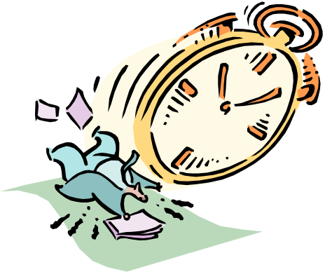
A B C
COMPANY

COVER SHEET
Chapter Four
ACCOUNTS RECEIVABLE
Order of Reports to be attached:
Customer List
Journal Detail Report-Current Batches
Sales Journal- Invoices
Cash Receipts Journal
Adjustments and Credit Memo
Aged Invoice Listing
A/R Subsidiary Ledger
Statements
General Journal Report
Adjusted Trial Balance
Profit and Loss Statement
Statement of Financial Position
General Ledger
General Ledger Flash Report
Profit and Loss Statement dated 9/01/0X

Did you make an archival disk and a back-up copy?

Set up Accounts Receivable

1. Update the Chart of Accounts: Add account 6200 Bad Debt Expense
2. Add customers. All customers have Net 30 as the terms. Invoices start at 1066 for the month of August. Open Item invoices are entered in the same manner as a normal invoice except it is entered before the user gets out of setup. As long as you are in setup it does not intergrate to the General Ledger.

date inv# P.O.# Balance
BENSON NURSING HOME
800 Prospect Manor 6/7 1060 B120 $1,500
Los Angeles, CA 90032

IMPORTS 6/1 1058 56600 2,553
320 E. Bradway
Glendale, CA 91028

MOBILE PRODUCTS
1 Oil Drive 6/15 1065 12 1,050
Alhambra, CA 91801

PERSONS PRODUCTS
77 Sunset St 4/02 1003 7001 7,000
Hollywood, CA

TOGETHER GIFTS
83 Mary Drive 4/13 1005 BB01 900
Pasadena, CA 90023

UNUSUAL GIFTS
9160 Manor Dr 4/29 1040 123456 1,500
Glendale, CA 91208

JONES, SUSY
6190 Severin
Los Angeles, CA 90042

DAY, DEBRA
1135 Diamond
Alhambra, CA 91801 ________
$14,503.00

3. Print Customer List.
- Enter the Beginning Balances using the Transaction--invoice command before you get out of setup.
- Print a subsidiary ledger which is the Detail report. It should be equal to $14,503.

- Enter the standard items
G/L #
Africian Products 4013
Japanese Products 4012
Korean Products 4011

- Print Standard item list.

Daily Transactions
- Enter the daily transactions. Enter the transactions either in Accounts Receivable or General Ledger.
- Print the Journal Report for all the journal entries.
- Print the Journals --- Cash Receipts and Sales . Keep invoices with the Sales Journal.

Month End Activites
- Print Aging Report.
- Print Detail Report - Subsidiary Report
- Print Statements.
- Enter and post adjusting entries.
- Print Journal Report.
- Print Trial Balance- Summary
- Print Trial Balance-Detail
- Print Income Statement
- Print Balance Sheet
- Print General Ledger Flash Report.
- Make an archival disk. Put aside should you need to restart from this point..
- Perform period end closing. Close Accounts Receivable the close General Ledger.
- Print Income Statement dated 9/30/0X shwoing no dollars in the current column. This indicates the previous month was closed.
- Compile all reports following the steps given in the lab work discussion in Chapter 2.

DAILY TRANSACTIONS- ABC COMPANY

a. August 1, 200X Received order from Benson Nursing Home for decorating items,
2/10 Net 30, UPS Shipping $10, No Sales Tax, P.O. 8972.

Description Qty $EA Total
Korean Masks 10 50. 500.
Korean Silk Paint 10 105. 1050.
Japanese Woodcraft 10 200. 2000.
$ 3550.

b. August 1, 200X Purchased items for Benson Nursing Home at 1/2 selling price, on account, from International Sales. G/L

c. August 1, 200X Invoice tenants to remind them their rent is due on the 15th.
Susy Jones $1000, Debra Day $1000

d. August 1, 200X Paid phone bill $155, CK #5206

e. August 1, 200X Purchased office supplies $105, CK #5207

f. August 15, 200X Received rent from both tenants, $1,800
Day ---CK# 456, $1000
Jones--CK#1234, $800, will pay rest on 31st.
g. August 15, 200X Received payment in full from the following customers:
Mobile Inv dated 6/15 $1050 CK#6783
Benson Inv dated 6/7 1500
Inv dated 8/1 3560 CK#456 $5,060
Together Inv dated 4/9 900 CK#234

h. August 15, 200X Received purchase order #73 from John Smith, a new customer.
Address: 1414 Hunt St., Los Angeles, CA 90032

- Africian Shrunken Heads @ $50 each

He prepaid $375 CK#6201 on 8/13. The remaining has terms Net 30.

Deliver by UPS - FOB Destination for:
Mother-in Law Gifts, 83 Hope Dr, La Mesa,CA 92041

i. August 15, 200X Ordered from Mombasa Co. the 15 shrunken heads on account at half the selling price.

j. August 15, 200X Made mortgage payment $2,000. CK # 5208
Interest: $550, Principle: $1450

k. August 25, 200X Received P.O. #8706 from Mobile Products for
25 Africian Wrist Rings @ $15 each = $375
UPS $5 Net 30. Prepaid CK#4201 dated 8/23 $380
ABC Transactions - page 2

l. August 25, 200X Ordered and paid for 25 wrist rings @ $7.50 each from Sula Supplies. CK#5209

m. August 25, 200X Imports ordered 500 Japanese hats @ .50 each = $250, 2/10 Net 30 UPS-FOB Destination P.O. 56713

n. August 25, 200X Purchases 500 Japanese Hats @ .25 each from International Sales, $125,
2/10 Net 30

o. August 25, 200X Imports returned 250 hats as defective.

p. August 29, 200X Returned 250 hats to International Sales.

q. August 30, 200X Paid post office for Buil Mailing of advertising leaflets $145, CK#5210

r. August 31, 200X Imports paid their account in full receiving a discount, CK #502, $2,675.50

s. August 31, 200X John Smith's attorney sent out a letter dated 8/31 saying Mr. Smith had died leaving no assets to sell to pay his debts. Write off the balance. $375

Adjusting Entries (August 31,200X)
- Supplies on hand--- $150
- Ppd Insurance Expired $100
- Depreciation - Bldg $555
AUDIT TEST
Chapter 4 - Accounts Receivable
ABC COMPANY

1. How much cash was brought into the company? __________

2. How much cash did the company pay out? ____________

3. What is the balance in A/R? ____________

4. What is the balance in A/P? ____________

5. What is the balance in Owner's Equity? ____________

6. What is the total Revenue for the month? ____________

7. What is the total Revenue for the year? ____________

8. What is the net income for the month? ____________

9. What is the net income for the year? ____________

10. What is the amount spent on advertising? ____________

11. What is the amount in the Sales Return& Allowance ____________

- What company has any A/R open items:
List the item # and $ ______________________________
______________________________
______________________________

13. What is the total expense for the year? ____________

14. Any other revenue and other expenses? ____________

