Chapter 13
Cost Management and Decision Making

ANSWERS to Review Questions
  - See the list of terms at the end of the chapter and the glossary for definitions.
  - The five stages of the decision making framework are:
- Setting goals and objectives – selecting a goal or goals and specifying tangible objectives
- Gathering information – creating useful information and generating feasible alternative solutions
- Evaluating alternatives – anticipating the future outcomes of each alternative action and choosing the best alternative
- Planning and implementation – planning resources and activities and implementing the best alternative rapidly and efficiently
- Obtaining feedback – Evaluating actual outcomes and improving future decisions and implementations
  - An organization’s goals are the reasons why the organization exists. Goals are aspirations and motivators. Tangible objectives are observable or measurable reflections of goals, which tend to be abstract. For example, a common business goal is generation of competitive returns for stockholders. A tangible objective that reflects that goal might be above-average stock price returns for the industry. A goal of a charitable organization might be to provide food and shelter for the homeless. A tangible objective that reflects these goals might be fully meeting demand on winter nights.
  - The target price is the amount customers are willing to pay for a product or service with specified features and functions. The target cost is the target price less the required return. If the target price is insufficient to generate the required return given current costs, (a) costs must be reduced to the target cost, and/or (b) the price must be increased, or (c) the product should be abandoned.

  - Ideal information is accurate, timely, relevant, and inexpensive. In most cases, achieving ideal levels of each information characteristic is impossible and at least one ideal must be sacrificed or may be less important. For example, opportunity cost is almost always relevant to decisions, but obtaining an accurate measure of opportunity cost in a timely and inexpensive way can be very difficult. Thus, decision makers may rely on historical costs which are readily available at low cost.
  - Relevant information must differ between alternatives and must occur in the future. Otherwise, the information does not affect the choice between alternatives.
  - The result of a quantitative analysis is that one alternative is preferred over the next-best alternative by some numerical amount. The amount by which the best alternative dominates the second-best alternative establishes a “price” on the qualitative characteristics. Suppose, for example, that a hospital’s board of directors is considering a new outpatient clinic in one of two communities: A or B. A quantitative analysis suggests that site A will be more cost effective than site B. Assume that the annual cost of running the clinic at site A will be $50,000 less than the annual cost at site B. Now suppose that the board feels that various qualitative considerations indicate that it would be preferable to locate the clinic at site B. For example, B might be an economically depressed area, where it is important to bring better quality health care to the community. If the board believes that the qualitative benefits at site B outweigh the $50,000 quantitative advantage at site A, then the clinic should be located at B.
  - Sunk costs are past costs that have already been incurred. Such amounts are irrelevant for decision making because they have no bearing on the future. Typical examples might include the cost of inventory that is held by a firm, the book value of existing equipment, and research and development costs that were incurred in prior years. Past costs might be useful, however, to help estimate future costs.
  - This situation occurs because year-end performance appraisals are often based on numbers produced by an organization’s financial accounting system, which takes gains and losses into account. With an asset disposal, for instance, the gain or loss is typically computed as the difference between sales price and book value, the latter of which is sunk. A manager may opt to reject a new asset that is profitable in the long run for fear of looking bad in the short term from a loss on the disposal of existing equipment.

  - Outsourcing refers to the acquisition of goods or services from a source that is external to an organization. Considerations other than cost of goods and services include quality, reliability, and impacts on other operations.
  - An opportunity cost is the benefit given up when the choice of one action precludes the choice of a different action. For example, one opportunity cost associated with getting a college education is the student’s forgone wages from a job that might have been held during the educational period. Another example is the return on alternative investments that is forgone by a company having funds tied up in inventory that is sitting in a warehouse.
  - Four influences on pricing decisions are:
- Customers: Management must consider customer demand, as demand reflects the prices that customers are willing to pay.
- Competitors: Management must consider the likely pricing decisions and product-design decisions of competing firms.
- Costs: Cost is another consideration. No organization or industry can price its product below total cost indefinitely.
- Legal, political, and image-related issues: Management must consider the way the public perceives the firm and must adhere to certain laws when setting prices.
  - In most industries, market forces and cost considerations jointly influence prices. No organization can price its products or services below cost for an indefinite period of time. On the other hand, no company can set prices at cost plus a markup without keeping an eye on the market. The product or service must be sold at a price that customers are willing to pay.
  - A target price is determined through market research that studies the price at which a good or service will sell. An acceptable profit margin is then subtracted from the target price to yield the maximum allowable (i.e., target) cost.

  - Companies should consider a product’s life cycle in the process of determining selling prices. Many costs unrelated to sales, production, and customer service (e.g., those attributable to upstream activities) have a significant bearing on a firm’s bottom line. The outlays related to all value-chain activities over the life cycle must be taken into account in pricing decisions.

  - Price discrimination relates to the practice of quoting different prices to different customers for the same products, with an intent to harm competition. Predatory pricing, on the other hand, involves temporarily setting a price below cost to broaden demand and injure competition. In the future, as supply is restricted and a firm gains control of the market, prices are raised. Both price discrimination and predatory pricing are illegal.

answers TO CRITICAL ANALYSIS
  - To a profit-seeking firm, benefits often mean “revenues’. It is more likely that a non-profit organization has objectives to create non-financial benefits, such as Bootstrap’s objective to create quality jobs for disabled persons. However, even profit-seeking firms have non-financial objectives, such as employee satisfaction, product quality, and reputation. As discussed in Chapter 20, profit-seeking firms often pursue non-financial objectives because they are leading indicators of financial performance. In contrast, non-profit organizations might pursue non-financial objectives, such as employment, as ends in themselves; financial performance is more likely to be a constraint than a goal. Despite differences in the types of goals or objectives, both types of organizations should approach benefit-cost analysis the same way: identify all relevant benefits and costs – financial and non-financial, quantitative and qualitative.
  - It is possible that firms in an industry, which does not have significant competition, could rely on costs as the basis for pricing. They could get complacent and allow costs to become excessive for the value of the product or service. If, however, new competition arises quickly either within or outside the industry to provide more value at a lower price, as happened in consumer electronics, the old companies may not learn quickly enough to price competitively or to improve their processes so that they can be profitable at lower prices. The new entrants to the industry could capture a large proportion of the market and cause old companies to leave the industry. Developing competitive prices requires understanding of both customer needs and competitors’ offerings. Comparing currently feasible costs with market prices (as target costing does) should give strong signals about which products are competitive and which need improvement to be competitive.
  - The manager is correct. Past costs are sunk and should not be considered when choosing among decision alternatives. Remember, relevant costs must have a bearing on the future. Another consideration: future costs must differ among alternatives, and not all future costs possess this characteristic (e.g., future promotional outlays of $4 million may be incurred regardless of which new products are selected for entry into the marketplace).

  - In most organizations, financial performance is the result of decision-making processes (as outlined in this chapter). Following a good decision-making process and making good decisions increases chances for good financial performance. It might be possible to monitor the decision-making process qualitatively to improve the chances that good decisions will be made. For example, one qualitative characteristic of a decision-making process is the degree to which all knowledgeable parties are involved. An optimal amount of involvement probably exists, but it would be difficult to measure quantitatively. A reliable qualitative indicator might be an observation of whether the “right” people are involved.
  - The CEO appears to be concerned about the personal repercussions of the decision to sell an unprofitable business unit. The sale might signal to stockholders that the CEO made poor decisions in the past. Reduced earnings (perhaps from a loss on sale or write-off of assets) might affect the CEO’s and other executives’ bonuses that are based on earnings. The CEO should realize that the stock price might be depressed now because of the unprofitable operation, and it might not drop on the news of the sale of unprofitable operations. In contrast, the stock price can rise if stockholders now expect the company to be more profitable in the future as a result.
  - Justifying investments in information systems and technology on financial grounds is difficult because it is difficult to accurately quantify the benefits of improved information in dollar terms. Some firms have invested heavily in information systems because they expect observable improvements in decision-making or because competitors have upgraded and may have a competitive edge. Unfortunately, little reliable evidence exists to demonstrate financially justifiable investments in information systems. In fact, some evidence exists to the contrary, but it is difficult to say whether unprofitable investments in information systems are caused by bad decisions, implementation, or luck. This is embarrassing so don’t assign this question unless you want to stimulate discussion about pre- and post-justifying IT investments or research that can definitively detect impacts of IT investments.

  - This municipal decision-making problem occurred in the city of Boulder, Colorado and was unresolved for three consecutive winters. Finally, the shelter was sited at the outskirts of town. Undoubtedly, problems of locating homeless shelters, jails, or drug treatment centers have been repeated in other locations. The problem stems from affected parties having different goals, which are difficult to reconcile. For example, property owners want to protect property values, and social organizations want to provide needed services. Municipal officials are caught in the difficult situation of trying to do the “right thing,” of which there is little agreement. The result can be endless analysis, during which property values are uncertain and services are not provided. Sometimes the legal system intervenes to force a decision, but a political alternative is to involve all affected parties in a process that specifies a decision must be made (e.g., before the next winter). Each party should identify feasible alternative locations and the costs and benefits of each location. Other parties should challenge the alternatives on clearly identified quantitative and qualitative grounds. Eventually a decision will emerge.
  - This is the typical “cost accounting” attitude that cost management seeks to change. Organizations can change every cost if it really wants to. Changing the cost structure itself may be prohibitively costly, in which case the company is in the wrong business, and the argument is correct. However, until this determination, the organization should seek cost reductions, perhaps using the method of target costing.
  - Possible benefits can include: cost reduction, access to increased expertise and, in the case of data processing, state-of-the-art technology, freedom to concentrate added time and resources on core activities, improved employee efficiency, better access to information, and improved legal/regulatory compliance. Possible costs can include reduced quality of services, loss of sensitive information, lack of contact with employees and customers, and higher costs of services.
  - The manager’s remark has some validity. Full cost is defined to include variable cost plus a share of the organization’s fixed costs. Over time, all costs must be covered in order for an entity to remain viable and financially sound. Furthermore, other customers may expect discounted prices, too. In the short term, however, it is a different story. Many fixed or committed costs are not relevant to short-run decisions, as these amounts will not change in upcoming months. Accordingly, such amounts need not be considered in special-order pricing decisions. This is particularly true if a company has some idle productive capacity, in which case any amounts received in excess of a special order’s variable cost (and directly traceable fixed cost) will provide a positive contribution toward profit.

  - The airline appears to be focusing on its customers and marketplace when setting ticket prices. More than likely, the cost to fly Nancy and others is the same regardless of when the flight takes place.
Nancy had a business trip and was eager to return home. Businesspeople with rigid (and meeting-filled) schedules will pay just about any price for the flight. With a leisure or vacation traveler, however, it is an entirely different story. Such passengers are typically budget conscious, and they will not travel if the fares are too high. Additionally, many of their trips are discretionary in nature and they often want to stay at their destinations longer (e.g., over a weekend), thus qualifying for a “Saturday-night stay.” The carrier is simply using two different prices to take advantage of its market.
The airline would not be accused of price discrimination—at least in the legalistic sense. The Robinson-Patman Act applies to products, not services, and the carrier is not trying to harm competition.

Solutions to exercises
  - (15 min) Decision Making: Spending and part-time work. Many solutions are feasible. Following is an example using the chapter’s decision-making framework.
- Setting goals and objectives: Goal = economically feasible and enjoyable school year. Objective = balance between cash available from all sources and expenditures.
- Gathering information: Measure cash available from summer job and allowance from parents. Investigate part-time job opportunities. Measure required expenditures for school and living expenses. Identify alternatives: a) status quo (no increased earnings or decreased spending), b) reduced spending, c) increased earnings, and d) reduced spending and increased earnings.
- Evaluating alternatives: Estimate the quantitative and qualitative costs and benefits of each of the alternatives and choose the best: a) Can the status quo result in meeting obligations and a feasible lifestyle? b) Can some spending be reduced, such as eliminating the need for a car by riding a bicycle or taking public transportation? c) Can a part-time job fill monetary needs while allowing enough time for study and entertainment? d) Is some combination of reduced spending and part-time work feasible?
- Planning and implementation: Assume that c) part-time job is the best option. Research job opportunities in the classified section of the newspaper and the student center. Ask friends who work to recommend jobs and to give recommendations to employers. Prepare for interviews by consulting with the school’s placement center. Interview for part-time jobs and select the best opportunity.
- Obtaining feedback: If the initial job search is unsuccessful, ask interviewers for feedback on what would have made the interviews more successful. Consult again with the placement center to improve interview skills and identify matches between jobs and experience.
  - (15 min) Decision Making: Outsourcing internal auditing. Many solutions are feasible. Following is an example using the chapter’s decision-making framework.
- Setting goals and objectives: Goal = efficient internal auditing services. Objectives = a) high quality review of internal operations, b) high-quality pre-audit compliance work, c) control of cost and quality of internal audit services, d) management training

- Gathering information: Determine the levels and types of internal auditing and management training services needed and available internally or externally. Alternatives = a) keep internal auditing, b) outsource internal auditing, c) keep some and outsource some internal auditing (may be multiple combinations possible). Determine the outcomes of each alternative.
- Evaluating alternatives: Compare the costs and benefits of each of the alternatives and choose the best based on both quantitative and qualitative information. Costs include out-of-pocket expenditures for the internal and external services and transition of own employees, loss of control of service and information, reduced responsiveness, loss of management training through internal auditing. Benefits include reduced costs, increased expertise and objectivity, more effective management training programs.
- Planning and implementation: Assume the decision is to outsource internal auditing. Develop a schedule to retrain or out-place employees. Develop schedule and contract with outsourced service provider to obtain needed services. Develop controls to assure the quality and cost of internal auditing services. Develop alternative management training program.
- Obtaining feedback: Regularly or as needed evaluate the quality and cost of the outsourced service and new management training program. If either is unsatisfactory, make needed changes, which can include a return to the status quo (some companies now are doing just that).
  - (15 min) Decision Making: Outsource maintenance and cleaning services. Many solutions are feasible. Following is an example using the chapter’s decision-making framework.
- Setting goals and objectives: Goal = efficient cleaning and maintenance services. Objectives = a) high quality maintenance and b) high-quality cleaning.
- Gathering information: Determine the levels and types of cleaning and maintenance services needed and available internally or externally. Alternatives = a) keep cleaning and maintenance, b) outsource cleaning and maintenance, c) keep some and outsource some cleaning and maintenance (may be multiple combinations possible). Determine the outcomes of each alternative.

- Evaluating alternatives: Compare the costs and benefits of each of the alternatives and choose the best based on both quantitative and qualitative information. Costs include out-of-pocket expenditures for the internal and external services and transition of own employees, loss of control of service, and reduced responsiveness. Benefits include reduced costs and paperwork and increased employment of disabled workers or continued employment of own employees.
- Planning and implementation: Assume the decision is to keep internal cleaning and maintenance. Develop a schedule to improve training of employees. Develop controls to assure the quality and cost of internal cleaning and maintenance services.
- Obtaining feedback: Regularly or as needed evaluate the quality and cost of the cleaning and maintenance services. If either is unsatisfactory, make needed changes, which can include a re-evaluation of outsourcing the services.

13.31 (45 min per manager interviewed plus travel time) Answers will vary among teams. Memos or emails should address the issues raised.
- Relative significance of customers, costs, competitors, cost-plus formulas, and target costing in the firms’ pricing methods
- Approach used when the good or service is new, unique, and untested in the marketplace
- Approach used when there is little knowledge on which to base a decision
- The manager’s biggest success and failure in pricing

13.32 (15 min) Information dimensions.
 | Example of information at:
Information attribute | Very high level | Very low level
Subjectivity | Individual preference for color of automobile | Audited financial statement
Accuracy | Time of day measured by the atomic clock at the National Institute of Standards and Technology | Distance between mountain tops estimated without maps or instruments
Timeliness | Pressure gauge reading on steam boiler | Last year’s measure of net income used for today’s product decisions
Cost | Customers’ current intentions to buy a product or service | Financial summaries available at Hoovers.com or Yahoo!.com
Relevance | Proceeds from sale of assets to be replaced | Historical cost of assets to be replaced

13.33 (40 min) Leasing Decision--Field Study. Answers will vary among teams. Issues that students typically cite include the difference between lease payments and loan payments, the overall cost of leasing versus the cost of buying (short-term and long-term), mileage allowances, estimation of residual value, up-front down payments, how long an individual keeps a car, an individual’s attitude about always making payments, and the attractiveness of driving newer vehicles

13.34 (15 min) Relevant costs
Decision to: | Cost
Accept a special order ___a, b, c _______ | a. Internal unit-level manufacturing cost
Close a plant __a, b, c, e, h____ | b. Cost to buy externally
Launch a new product __a, b, c, e, f___ | c. Opportunity cost of alternative use
Make or buy a product component _a, b, c, e, f, g, h_ | d. Cost paid for parts on hand
Outsource a business activity _b, c, f, g, h__ | e. Lease cost for facility
 | f. Loss of quality reputation
 | g. Loss of control
 | h. Loss of employee trust
13.35 (15 min) Relevant costs
Decision to: | Cost
Accept a special order _a, c, e, f, g__ | a. $15 internal unit-level manufacturing cost
Close a plant _a, b, c, e, g, h_ | b. Increased employee turnover
Launch a new product __a, c, e, f, g__ | c. $20,000 opportunity cost of alternative use
Make or buy a product component __a, b, c, e, f, g, h_ | d. $20 cost paid for parts on hand
Outsource a business activity __b, c, e, g, h___ | e. Reduced ability to guarantee deliveries
 | f. Increased warranty and repair expense
 | g. $25 cost to buy externally
 | h. $50,000 penalty to break annual lease for facility

13.36 (20 min) Decision tree.

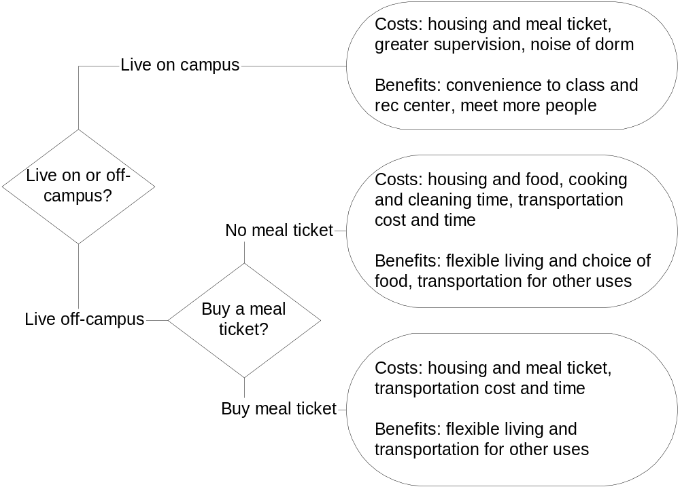
13.37 (20 min) Decision tree
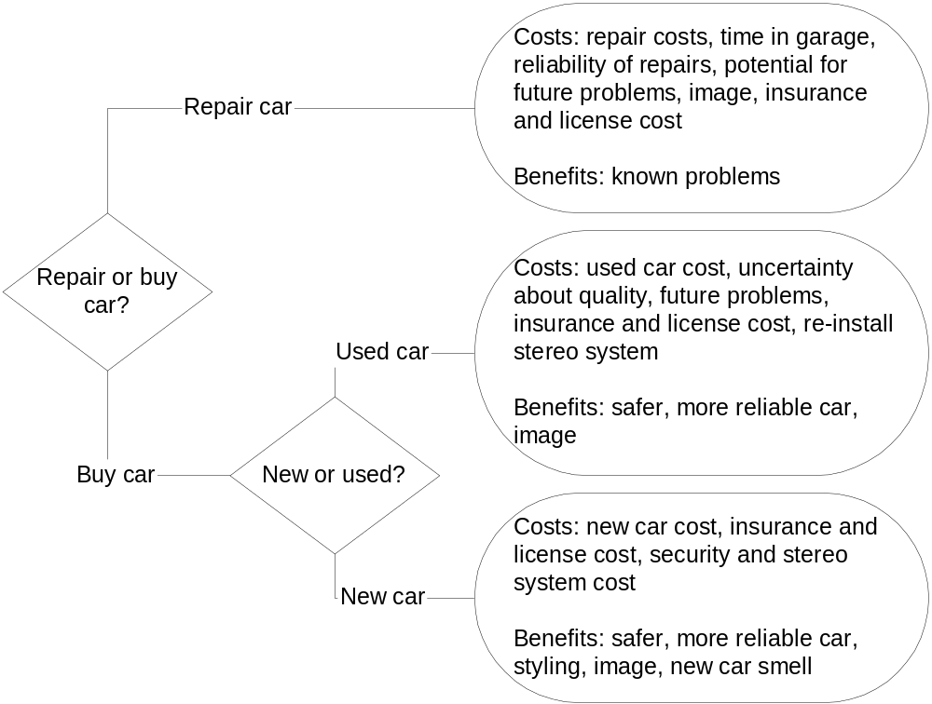

13.38 (10 min) Quantitative and qualitative factors.
Cost or benefit | Status quo | Alternative
Revenues | $50,000 | $50,000
Costs | 30,000 | 40,000
Profit | $20,000 | $10,000
Quality | Medium | Very high
Meets production schedules | Medium | High
The profit difference between the alternatives is $10,000 in favor of the status quo. If the alternative is judged to be more attractive, the improved quality and meeting production schedules must be worth at least $10,000.

13.39 (10 min) Quantitative and qualitative factors.
Cost or benefit | Alternative 1 | Alternative 2
Cost savings | $20,000 | $30,000
Flexibility | High | Medium
Quality | Very high | Medium
Meets delivery schedules | High | Medium
The cost-saving and profit difference between the alternatives is $10,000 in favor of alternative 2. If alternative 1 is judged to be more attractive, the improved flexibility, quality and meeting delivery schedules must be worth at least $10,000.
13.40 (30 min) Outsourcing Decision.
- The basic reasons for outsourcing have been: cost savings, a lowering of product cost, reducing the need for capital investment, lack of in-house skills, access to state-of-the-art skills, an overall improvement in the quality of service, and an increased ability to focus on core competencies.
- Outsourcing concerns include a decrease in service quality and a risk that the outsource provider would not understand the company’s business.

- Firms typically outsource payroll and tax. These areas generally require expensive software and subject matter expertise. Other functions include internal auditing, benefits administration, along with special projects, accounts payable, and investment management, among others.

13.41 (20 min) Pricing
 | A | B | C | D | E
Unit-level cost | $12 | $20 | $32 | $8 | $60
Product-level cost, per unit | 6 | 22 | 12 | $16 | 24
Facility-level cost, per unit | 15 | 16 | $7 | 3 | 16
Mark-up percentage | 25% | 50% | 40% | 100% | 75%
Price per unit | $41.25 | $87.00 | $71.40 | $54.00 | $175.00

13.42 (15 min) Relevant Costs: SDC
- The $1,525,000 expended to date is a past cost. Accordingly, it is sunk and not relevant to the decision at hand. Regardless of what the firm decides to do, it will have already incurred these construction outlays.
- The proper decision involves a comparison of the relevant costs and benefits of each of the three proposals.
 | Do | Sell at | Sell at
 | Nothing | $1,400,000 | $1,600,000
Relevant benefits | $ 0 | $1,400,000 | $1,600,000
Relevant costs | 0 | 0 | 160,000
Net benefit | $ 0 | $1,400,000 | $1,440,000
San Diego should finish and sell the residence at $1,600,000 because this option produces the greatest net benefit to the firm. The difference is relatively small, however, and the decision might hinge on how confident SDC is about the two sales prices. If the higher price for the completed house is much less certain than the “as is” price, the firm might choose to sell now and avoid the risk of not getting the higher price later. Notice that if the past cost of $1,525,000 were included in the analysis, it would be included for all three options and thus have no effect on the decision.

13.43 (20 min) Relevant cost: CDM.
- Olmec’s compensation is computed on the basis of company profitability. It is likely that he will take actions (i.e., make decisions) that will help boost his year-end bonus, not reduce it. As shown in part (b), a conflict arises in this situation because the action that is in the best long-term interest of the firm will decrease his immediate compensation. Olmec’s performance evaluation is based on annual profitability. Despite above average performance for much of the year, he might not survive to see the long-term benefits of replacing the equipment, having been replaced by a successor because of poor performance at year-end.
- The old equipment has a book value of $400,000 and a selling price of only $250,000, which produces a $150,000 loss on disposal. This loss could threaten Olmec’s year-end bonus. However, the $400,000 book value is a sunk cost. Although he will take a “hit” on his year-end bonus, Olmec should be persuaded to purchase the new machine because the company will benefit with a substantial cost savings over the next 10 years (savings of $1,800,000 over 10 years compared with a net outlay for the new machine of $1,250,000 (= $1,500,000 – 250,000).

solutions to problems
13.44 (20 min) Cost reduction: MST. Note: this problem assumes that students have studied target costing.
a. Computation of the cost reduction.
Input data
Expected market price | $175
Required return on sales | 25%
Product life, years | 3
Currently feasible cost | $45,000,000
Expected average annual sales | 90,000
Expected cost reduction | 18%
Target costing analysis
Sales price | $175
Return on sales | x 25%
Dollar return on sales | $ 43.75
Target cost per unit ($175 – $43.75) | $ 131.25
Product lifecycle sales (3 x 90,000) | 270,000
Total target cost ($131.25 x 270,000) | $35,437,500
Currently feasible cost | $45,000,000
Cost reduction | $9,562,500

b. If MST expects to be able to reduce costs by 18 percent, its expected cost reduction is 0.18 x $45,000,000 = $8,100,000. This is less than the required cost reduction of $9,562,500, so unless further cost reductions are possible or the price can be raised, this is not a feasible product.
EXCEL SOLUTIONS ARE FOUND IN EXCEL SOLUTIONS FILE

13.45 (20 min) Cost reduction. Mercy Hospital. The following spreadsheet computes the target cost and cost reduction required for part “a” and the return on charges after process improvements required for part “b.”
 | A | B
1 | Expected charge reimbursement (sales price) | $25,000
2 | Required return on charges (return on sales) | 30%
3 | Current average cost per hip replacement | $22,000
4 | Expected cost reduction | $8,000
5 | a) Target cost [(1-B2)*B1] | $17,500
6 | Target cost reduction (B3 – B5) | $4,500
7 | b) Return on charges after procedure improvements {[B1-(B3-B4)]/B1} | 44%
EXCEL SOLUTIONS ARE FOUND IN EXCEL SOLUTIONS FILE
  - Currently, the hip replacements are not viable because a cost reduction of $4,500 per procedure is required to earn the necessary return of 30 percent.
  - The expected cost reduction is more than sufficient to make the procedure financially viable. The expected return of 44 percent exceeds the required return of 30 percent.

13.46 (15 min) Make or Buy: Black Diamond
a. | Internal | Outsourced
Quantity of # 10541 | 5,000 | 5,000
Unit-level cost | $ 40 | $ 48
Facility-level cost per unit | 15 | 0
Total cost per unit | $ 55 | $ 48
Facility cost savings |  | 33.3%
Analysis of outsourcing decision | Internal | Outsourced | Difference
Quantity | 5,000 | 5,000 | -
Unit-level cost | $ 40.00 | $ 48.00 | $ (8.00)
Unit-level cost, total | $ 200,000 | $ 240,000 | (40,000)
Facility-level cost, total | 75,000 | 50,000 | 25,000
Total cost | $ 275,000 | $ 290,000 | $ (15,000)
a. Black Diamond should make the part internally.
b. Because the outsourcing (buy) alternative costs $15,000 more than the internal (make) alternative, Black Diamond must make at least $15,000 profit on the new product, RAC.
c. Other considerations include the quality and reliability of the outsourced supplier.

13.47 (20 min) Dropping a Product Line: Chapman & Tracy
 | Auditing | Tax | Consulting | Total
Sales………………….. | $300,000 | $500,000 | $600,000 | $1,400,000
Service-level cost……… | 250,000 | 300,000 | 350,000 | $900,000
Shared facility cost.…… | 50,000 | 60,000 | 80,000 | $190,000
Operating income (loss) | $0 | $140,000 | $170,000 | $310,000
 | Keep auditing | Drop auditing | Increase tax | Net effects
Sales | $ 1,400,000 | $(300,000) | $ 200,000 | $1,300,000
Service-level cost | 900,000 | (250,000) | 120,000 | 770,000
Facility-level cost | 190,000 | (15,000) | 0 | 175,000
Operating income (loss) | $ 310,000 | $ (35,000) | $ 80,000 | $ 355,000
a. The analysis shows that Chapman & Tracy should drop its auditing activities and increase its tax work.
b. The analysis assumes that eliminating auditing has no adverse effect on either existing or new consulting or tax work. Often one type of required business, such as auditing (or tax) leads to other types of business. Current regulations, however, may restrict auditors of publicly traded firms from offering certain types of consulting (e.g., internal control and systems).
EXCEL SOLUTIONS ARE FOUND IN EXCEL SOLUTIONS FILE

13.48 (15 min) Product-Line Closure: Buy-U Deli
Ice Cream Counter | Original analysis | Change | Revised analysis
Sales | $45,000 | - | $45,000
Less: Cost of food | 20,000 | - | $20,000
Gross profit | $25,000 | $0 | $25,000
Less: Operating expenses
Wages of counter personnel | $12,000 |  | $12,000
Paper products (e.g., napkins) | 4,000 | - | $4,000
Utilities (based on percent of sales) | 2,900 | - | $2,900
Depreciation of counter equipment and furnishings | 3,000 | (3,000) | $0
Depreciation of building (based on percent of sales) | 5,000 | (5,000) | $0
Deli manager’s salary (based on percent of time spent on ice cream | 6,000 | (6,000) | $0
Total operating expenses | 32,900 | (14,000) | 18,900
Income (loss) on ice cream counter | ($7,900) | ($14,000) | $6,100

a. The revised analysis assumes that closing the ice-cream counter has the following implications: a) personnel, paper products, and utilities will decrease but b) depreciation charges and the allocation of the deli manager’s salary are irrelevant to the decision. The revised analysis shows that closing the ice-cream counter is likely to cause annual profits to decrease by $6,100.
b. Other factors to consider include whether ice-cream sales are related to other sales such that dropping ice cream might reduce other sales and whether excess equipment could be sold.
EXCEL SOLUTIONS ARE FOUND IN EXCEL SOLUTIONS FILE
13.49 (20 min) Opportunity Cost: Marlene Judd
2-year analysis | Keep job | MBA | Opportunity cost
Beginning salary | $ 48,000
Annual raise | 2% | 5%
Year 1 salary + tuition | 48,960 | 40,000 | (88,960)
Year 2 salary + tuition | 49,939 | 40,000 | (89,939)
Living costs (2 years) | (60,000) | (60,000) | -
Year 3 salary | 50,938 | 80,000 | 29,062
Year 4 salary | 51,957 | 84,000 | 32,043
Year 5 salary | 52,996 | 88,200 | 35,204
Year 6 salary | 54,056 | 92,610 | 38,554
Year 7 salary | 55,137 | 97,241 | 42,104
Cumulative difference |  |  | $ (1,932)

- Yes, an opportunity cost does arise in this situation. By going to graduate school on a full-time basis, Marlene will not be able to earn her teaching salary. The salary for next year would be $48,960 ($48,000 x 1.02). The following year’s salary would amount to $49,939 ($48,960 x 1.02), producing a total opportunity cost of $98,899, before discounting to consider the time value of money.
- The “true” cost of the degree is $178,899 [$98,899 + ($40,000 x 2 years)], or the sum of the opportunity cost and tuition. Living costs are not considered here because the amounts would be incurred regardless of whether she returned to school or continued in teaching.
- Possible actions include attending a less prestigious (and cheaper) university, obtaining a scholarship, continuing to teach and going to school part time, and working part time while enrolled in school.
- Marlene is 55 years old, meaning that she will earn the increased salary for a relatively short period of time. At the expected salaries and annual increases, the higher salary will pay back the opportunity and tuition costs about seven years after graduation. However, there are other factors to consider, such as whether she will face age discrimination or be happier in a new job.
EXCEL SOLUTIONS ARE FOUND IN EXCEL SOLUTIONS FILE

13.50 (25 min) Special Order
 | Normal | Special order change
Sales quantity | 120,000 | 40,000 | units
Unit-level costs | $ 360,000 | -20% | per unit
Facility-level costs | 600,000 | 80,000 | setup
Total costs | $ 960,000 | $ 1,136,000
Total cost per unit | $ 8.00 | $ 7.10
Capacity usage | 75%
Analysis of special order
Practical capacity | 160,000
Current production | 120,000
Unused capacity | 40,000
Special order | 40,000
Excess capacity | 0 | OK
Special order price | $ 6.00
Unit-level cost | 2.40
Contribution margin per unit | $ 3.60
Total contribution margin | 144,000
Change in facility costs | 80,000
Profit from special order | $ 64,000
a. The analysis indicates that the special order should be accepted. The company is operating at 75 percent of capacity and as long as the unit-level costs and incremental facility costs of the order are covered, Intermountain will benefit. However, the special order does exhaust available capacity, so this should be the most profitable use of the remaining capacity. The order from Scott Corporation will boost profitability by $64,000 (40,000 units x $3.60 - $80,000).
- Other factors to consider include effects on current customers who have paid and expected to pay regular prices, which one assumes cover full absorption costs. Will all customers expect discounted prices in the future?
EXCEL SOLUTIONS ARE FOUND IN EXCEL SOLUTIONS FILE

13.51 (30-45 min) Decision making. Genetically modified plants. Although the setting seems non-traditional, it has great implications for businesses such as Monsanto, which has invested greatly in the development of genetically modified plants. It also has implications for governments, farmers, consumers, and ecosystems worldwide. Presentations will vary, but they should cover the following points:
a. Decision making framework
I. Setting goals and objectives – Identify “acceptable risks” and manage risk properly.
II. Gathering information – Assemble knowledge on observed and expected impacts of genetically modified plants: gene flow, insect resistance, non-target/ecosystem damage, pesticide use. Also identify what is not known.
III. Evaluating alternatives – Change current regulatory approach. Adopt holistic management approach, rather than piece-meal focus on single plant in single settings. Set risk levels to evaluate both types of errors: Type 1: falsely rejecting a harmless plant (the effect must be large enough to be judged significant) and Type 2: not rejecting a harmful plant (the test must be powerful enough to detect harmful effects if they exist). Estimate social costs and benefits of introductions (e.g., social benefits will be lower if GM plant merely reduces production cost of subsidized crops).
IV. Planning and implementation – Be careful, especially with regard to type 2 errors. Need effective, powerful tests of the effects of GM plants. Be especially careful when mixing genes among species (e.g., inserting fish genes into plants).
V. Obtaining feedback – Answer questions about “acceptable risk,” social costs and benefits of precautionary approaches.

13.52 (45 min) Decision tree and benefit-cost analysis. Maytag. Solutions will vary, but should reflect the following:
a. Decision making.
I. Setting goals and objectives – Stay competitive. Minimize costs of production, transportation and assembly of appliances.

II. Gathering information – Identify qualitative and long-term effects of decision. Relative labor, materials, quality, reliability, and transportation costs: U.S. versus Mexico. Identify alternatives, including locations, suppliers, etc.
III. Evaluating alternatives –Choose the overall lowest cost alternative.
IV. Planning and implementation – Plan and time so as to not adversely affect current production (controversial?).
V. Obtaining feedback – Periodically monitor and evaluate cost effectiveness of decision. Repatriate if cost savings do not materialize?
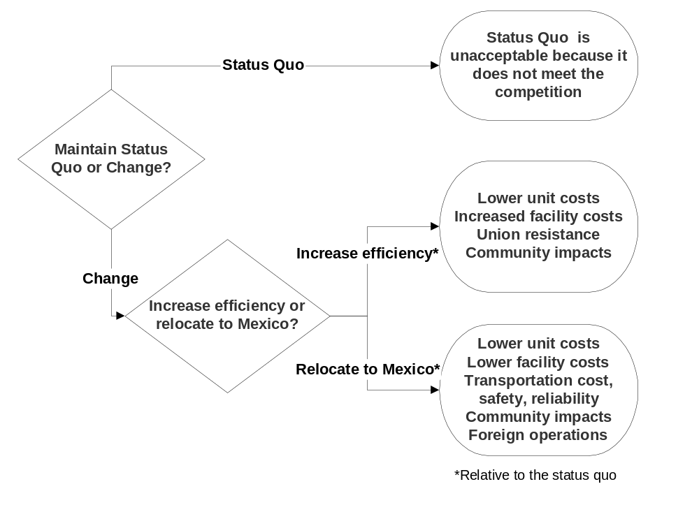b. Decision trees will vary, but might look like:

13.53 (45 – 60 min) Benefit-cost analysis. TGIF Financial.
a. Quantitative factors include: settlement costs, payment discount, contract length, settlement transfer fee, earnings rates from charges, revenues. Annual customer charges, interest income, late fees, and operating costs are assumed to be equal across alternatives, but are they? Qualitative factors include: customer and merchant acceptance of cards, reputation costs of challenging settlement fee, long-term relations with Visa, Mastercard, merchants, and customers.
b. Calculations based on the spreadsheet (part c) follow.
Input data | Visa |  | MasterCard
Visa settlement ……………………………. | $2,000,000,000
TGIF's pro rata share of settlement …… | $ 70,000,000
Discount for early payment …………….. | 6% | of pro rata share
Transfer service fee ……………………… | 3% | of annual volume
Annual debit card revenue ……………… | $ 60,000,000 |  | $ 54,000,000
Retailer payment rate (net)……………….. | 2% |  | 1.8%
Annual debit card operating expenses | $ 40,000,000 |  | $ 40,000,000
Contract length …………………………… | 10 | years | 10 | years
 | Pay settlement now | Pay settlement later | Switch to MasterCard
Ten-year revenues ………………………… | $ 600,000,000 | $ 600,000,000 | $ 540,000,000 | *
Settlement share…………………………… | (65,800,000) | (70,000,000)
Transfer service fee……………………….. | - | - | (90,000,000)
Ten-year net revenues …………………… | $ 534,200,000 | $ 530,000,000 | $ 450,000,000
* (1.8% ÷ 2%) x $600,000,000
The calculations indicate that TGIF should pay the settlement early and not switch to MasterCard.
EXCEL SOLUTIONS ARE FOUND IN EXCEL SOLUTIONS FILE
c. The revised solution after using Solver follows:
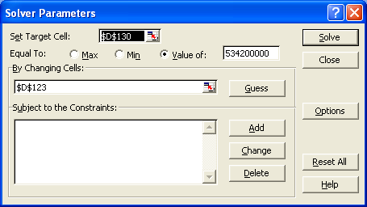

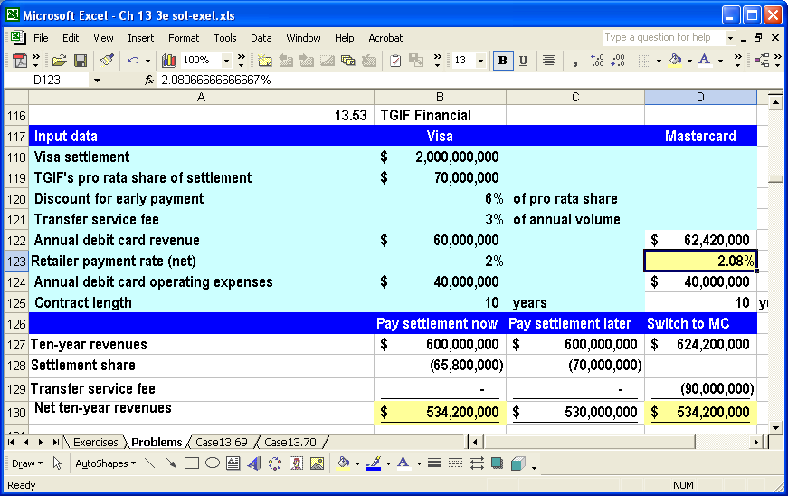

It seems unlikely that MasterCard would increase its payout rate from 1.8% to 2.1% (or more) to member banks, but TGIF and others might convince MasterCard to do so by promising to switch from Visa. The solution also can be found algebraically as follows:
R = the unknown payout rate
$ 534,200,000 = $ 600,000,000 (R / 0.02) – $ 90,000,000
R = (534,200,000 + 90,000,000)x(0.02) ÷ 600,000,000 = 0.0208 = 2.08% rounded

13.54 (60 min) Decision making. World trade. Solutions will vary, but should reflect the following:
a. Decision making.
I. Setting goals and objectives – all countries benefit from open trade, make progress on liberalizing trade between developed and developing countries, keep negotiations on track, don’t lose precious time.
II. Gathering information – who is affected and by how much, which trade barriers are most restrictive, how do politics affect economic issues, what are the most contentious issues.
III. Evaluating alternatives – expand general agreements by cutting tariffs and subsidies worldwide, expand bilateral agreements and/or regional free trade areas, increase protectionism.
IV. Planning and implementation – commit to renewed negotiations to the framework adopted in the earlier meeting at Doha, Qatar:
- Substantial cuts in domestic and export subsidies for each major product sector from actual subsidy disbursements over the period 2000-02,
- The Doha objective of "reductions, with a view to phasing out, all forms of export subsidies".
- Sharply reducing high tariffs with no levies above a two-digit negotiated cap, and major expansion of tariff-rate quotas.
- Specific measures to tackle the problems of the least-developed cotton-exporting countries in the agriculture agreement.
V. Obtaining feedback – commitments would give trade negotiators the political impetus needed to restart the Doha round.

b. The major factors that impeded the talks included: agenda complexity, presidential elections in the U.S., European Union enlargement, unwillingness for agricultural reform by developed countries, alternative free trade area agreements
c. Measuring benefits and costs of actions such as eliminating agricultural subsidies is a complex social, political, economic exercise. The goal of improved trade and economic development is based on economic theory of efficient use of resources. “In the real world, politics intervenes” to create protective tariffs and subsidies, particularly of agricultural products (manufacturing, e.g., steel, is also subject to political manipulation). Theoretically, restricted trade has large opportunity costs, particularly for least developed countries, but practically speaking removing restrictions means rearranging economic activities. For example, tariffs on imported sugar protect sugar growers in the U.S. and restrict development of countries such as the Dominican Republic, where sugar can be grown more efficiently. The global economy should benefit from elimination of those tariffs, but that would mean less sugar would be grown in the U.S. and more in the Dominican Republic. Domestic politics usually works to prevent that redistribution of activity and income.
d. The status of decision making at the end of the Cancun talks was undefined, with the real possibility of stalled talks for several years – and increased foregone opportunities.
e. Not available at press time, but a keyword search on “world trade” or “globalization” will generate current sources.

13.55 (30 min) Cost reduction
at 200,000 units | This year | Change | Next year
Sales price per unit | $700 | $ (120) | $580
Product costs per unit
Materials
Computer chip | $77.00 | $ (29.00) | $48.00
Motor | $60.00 | 0 | 60.00
Housing unit | $50.00 | -18% | 41.00
Mechanical parts | $86.00 | 0% | 86.00
Miscellaneous parts | $22.00 | -18% | 18.04
Total materials | $295.00 |  | $253.04
Labor
Assembly labor | $90.00 | -20% | 72.00
Testing labor | 60.00 | -20% | 48.00
Total labor | $150.00 |  | $ 120.00
Equipment and facilities
Specific to Sergzig | 70.00 | -20% | 56.00
General administrative | 80.00 | 0 | 80.00
Total equip & facilities | 150.00 |  | 136.00
Total product costs | 595.00 |  | 509.04
Profit per unit | $ 105.00 |  | $ 70.96
Return on sales | 15.0% |  | 12.2%
a. Advantages include: the long-term contract, which can insulate Sayre from price increases and guarantee quality; reductions in the costs of components, labor and facility costs. Disadvantages include: the long-term contract, which can prevent Sayre from using multiple, competing suppliers. Risks involve the reliability of the supplier; the quality of the cheaper chips; perceived or actual reductions in quality of cheaper components.
b. The analysis shows that Sayre cannot meet its target return on sales with the planned changes.
c. A further price reduction will require significant cost reductions to meet the target return on sales, as follows.
EXCEL SOLUTIONS ARE FOUND IN EXCEL SOLUTIONS FILE

Sales, Units | 200,000
Sales price per unit | $ 540.00
Return on sales | 15%
Profit per unit | $ 81.00
Target cost per unit | $ 459.00
Total target cost | $91,800,000
Currently feasible costs
Product costs per unit | $ 509.04
Currently feasible costs | $101,808,000
Cost reduction target | $10,008,000

13.56 (45 min) Target cost
Below is the basic spreadsheet. The shaded cells contain input data, and all other cells contain formulas. Changing each of the shaded cells, as indicated by the problem, creates the solutions that follow.
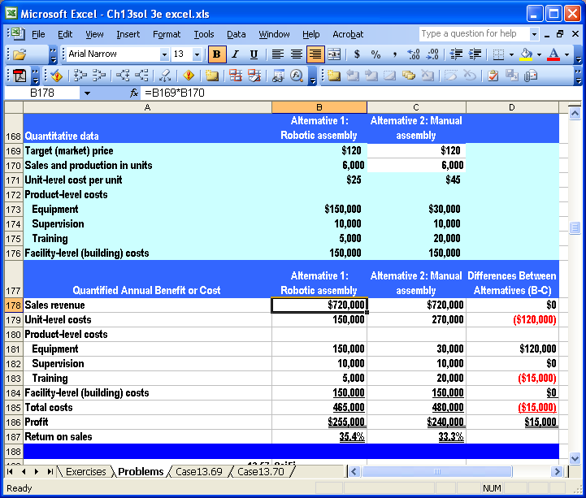
EXCEL SOLUTIONS ARE FOUND IN EXCEL SOLUTIONS FILE
13.56 a. Market price = $120
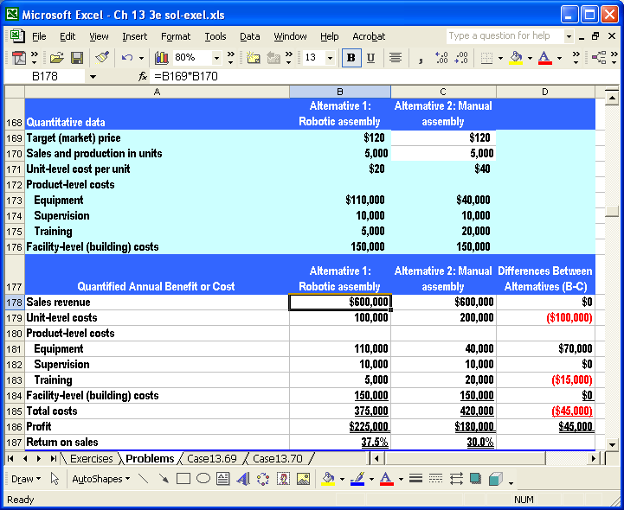
13.56 b. Unit level costs = $25, $45
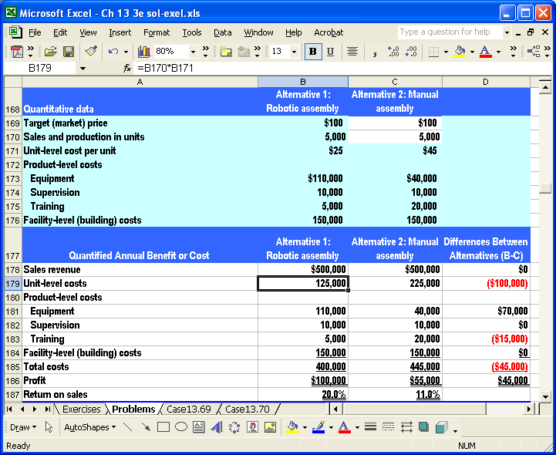
13.56 c. Equipment costs = $150,000, $30,000
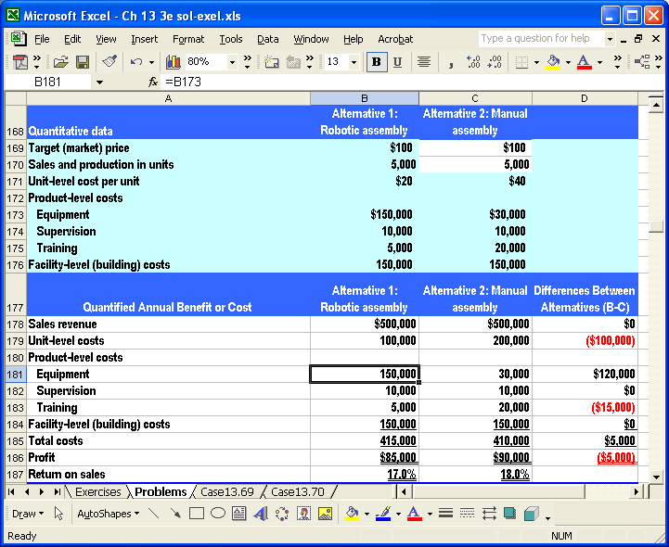
13.56 d. Sales volume increases 20% to 6,000 units
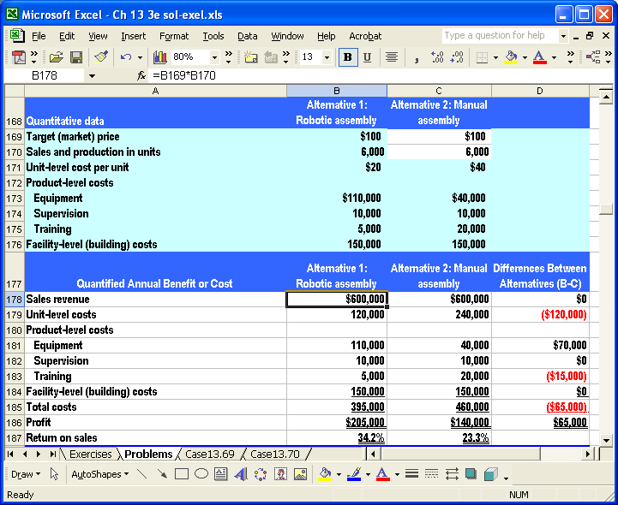
13.56 e. Combine parts a to d.
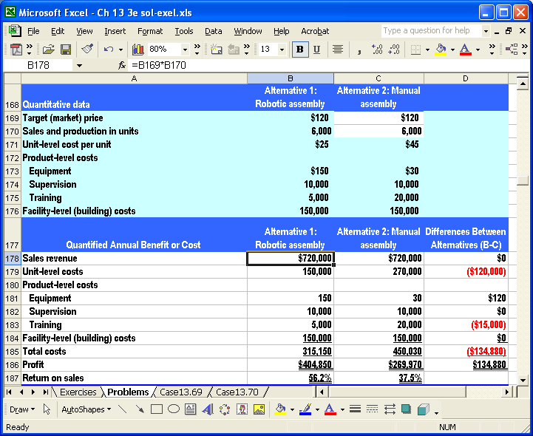
f. Your natural skepticism should focus on the likelihood of each of the changes, alone and in combination. Four of the five alternatives quantitatively favor the robotic assembly process, but this may be misleading majority support if most of those alternatives are not likely to occur or if other equally likely alternatives that favor the manual assembly process were not modeled. Choosing alternatives is just as important as modeling the effects of decision choices because one could bias the analysis toward one outcome by choosing only those alternatives that favor it.

13.57 Cost reduction. Sci-Fi
Input data | a. Original | b. Expected changes | Revised
Price per book | $ 15 | -5% | $ 14.25
Purchase cost per book | $ 8 | 20% | $ 9.60
Handling cost per book | $ 1 | 60% | $ 1.60
Committed cost per year | $ 500,000 | 15% | $ 575,000
Required return on sales | 20% | 0% | 20%
Sales quantity per year | 200,000 | -12% | 176,000
Product life, years | 1 | 0% | 1
Costing analysis | Original |  | Revised
Sales price | $ 15.00 |  | $ 14.25
Return on sales | 20% |  | 20%
Dollar return on sales | $3.00 |  | $2.85
Target cost per unit | $12.00 |  | $11.40
Product lifecycle sales | 200,000 |  | 176,000
Total target cost | $2,400,000 |  | $2,006,400
Currently feasible cost | $2,300,000 |  | $2,546,200
Projected income | $700,000 |  | ($38,200)
Return on sales | 23% |  | -2%
Cost reduction required | ($100,000) |  | $539,800

c. In competitive situations, clinging to the status quo usually means forgoing innovations and improvements that competitors seek out and adopt. As shown in part b, this can result in declining sales prices and market share. This also can mean lack of improvements in processes and incentives for workers to improve their efficiency.

EXCEL SOLUTIONS ARE FOUND IN EXCEL SOLUTIONS FILE
13.58 (25 min) Alternative processes
 | Basic | Deluxe
Sales price (product) | $ 30.00 | $ 30.00
Sales commission | 5% | 5%
Shipping per unit | $ 8.00 | $4.00
Facility cost, per year | $ 500,000 | $780,000
Sales quantity | 50,000 | 50,000
Revenue | $1,500,000 | $ 1,500,000
Expenses
Sales commissions | $ 75,000 | $ 75,000
Shipping cost | 400,000 | 200,000
Facility cost | 500,000 | 780,000
Total expenses | 975,000 | 1,055,000
Operating profit | $ 525,000 | $ 445,000
Indifference level | 70,000 | units

a. The analysis above shows that the Basic system is more profitable at 50,000 units per year by $80,000 (= $525,000 – 445,000). The lower facility cost per year of the Basic system more than offsets its higher unit-level shipping cost at this level of operation.
b. Because revenues and sales commissions are equal under both alternatives, only the differences in shipping and facility costs drive the difference in profits. The point at which the two alternatives “break even” can be found by equating their shipping costs and solving for the unknown quantity shipped, Q, as follows:
$8 Q + $500,000 = $4 Q + $ $780,000
$4 Q = $280,000
Q = 70,000 units
c. If the company chooses the Deluxe system, it must value improved service by at least $80,000 per year, the difference in annual profits. The company might be expecting that improved services will increase demand for the product and allow the company to “grow into” its new distribution system. Beyond 70,000 units shipped, the Deluxe system is more profitable because its lower unit-level cost more than offsets its higher facility cost.
EXCEL SOLUTIONS ARE FOUND IN EXCEL SOLUTIONS FILE

13.59 (20 min) Make or buy: Xyon Co.
 | Cost if make | Cost if buy
Quantity required per month | 10,000
Components | $ 270,000
Assembly labor | 290,000
Facility costs per month | 640,000 | 640,000
Total production cost | 1,200,000
Alternative use of the facility (opportunity cost) | 150,000
Purchase cost |  | $ 88
Make or buy analysis | Make | Buy | Difference
Purchase cost per month |  | $ 880,000 | $ (880,000)
Internal cost per month
Components | $270,000 | - | 270,000
Assembly labor | 290,000 | - | 290,000
Facility costs (irrelevant) | 640,000 | 640,000 | -
Alternative use of the facility (opportunity cost) | 150,000 |  | 150,000
Total cost | $ 1,350,000 | $ 1,520,000 | $ (170,000)

a. The revised analysis shows that Xyon is not financially better off buying the pumps. The company’s original analysis erroneously did not include the monthly facility cost for both alternatives, which appears to be a committed cost that will be incurred even if the pumps are purchased. Xyon has an alternative use for the facility. Although it does not change the outcome of the analysis, the opportunity cost should be counted as a cost of making or a benefit of buying the pumps.
b. Benefits of outsourcing the pumps to Kobec include the reliability and expertise of the supplier. Xyon admits that it has little experience with the products it currently buys from Kobec, and its inexperience might cost the company more than the $170,000 extra per month it spends. In other words, Xyon’s costs of making the pumps might be understated. Problems of outsourcing include possible adverse impacts if Kobec does not meet its obligations of quality and timeliness.
EXCEL SOLUTIONS ARE FOUND IN EXCEL SOLUTIONS FILE
13.60 (20 min) Drop a service: Melville College
 | Keep Botany | Drop Botany | Net Outcome
Program revenues | $ 320,000 | $ (195,000) | $ 125,000
Program operating expenses
Salaries | 215,000 | (170,000) | 45,000
Supplies | 10,000 | (7,500) | 2,500
Facility costs | 175,000 | (55,000) | 120,000
Total expenses | 400,000 | (232,500) | 167,500
Operating profit | $ (80,000) | $ 37,500 | $ (42,500)
a. If Melville drops the botany program, its reduced expenses will exceed its lost revenues by $37,500 annually (excluding the one-time $1,100 cost of moving equipment). On this criterion alone, the college should drop the botany program. However, the college will not avoid all of the loss left by the program, which will be ($42,500)
b. Numerous other factors may be important to this decision. For example, if the program is dropped, careful consideration should be given to the academic implications of the decision such as a loss of accreditation. Dropping the program may have an impact on Melville’s reputation as a “quality” institution of higher learning. If the college drops botany, the donor who is interested in botany might change her will to exclude the college. Transferring botany equipment to fine arts might increase savings (net of the $1,100 moving cost) if that transfer eliminated a planned equipment purchase by fine arts.. Finally, there may be some additional financial effects, namely, those associated with running an improved varsity athletic program (e.g., added gate receipts and concession sales, a larger student body, and so on). It is unclear whether improved athletic teams will result in greater contributions to more than offset the costs of the new facility and the lost bequest.
c. Melville might seek salary reductions through personnel layoffs or cheaper help (graduate teaching assistants, part-time instructors, student office workers, and temps); increased enrollments through aggressive marketing programs; cooperative instructional ventures with other colleges and universities; larger class sizes; and distance learning options. Other options include downsizing the botany department to match resources to students served, encouraging the department (and all departments) to attract outside funding, and extending the fiscal requirement to all programs in the college. These are sure to be politically difficult decisions.

13.61 (60 min) Replace equipment: Bootstrap
a. A screen-shot of the financial model follows. See the instructor’s CD for the model.
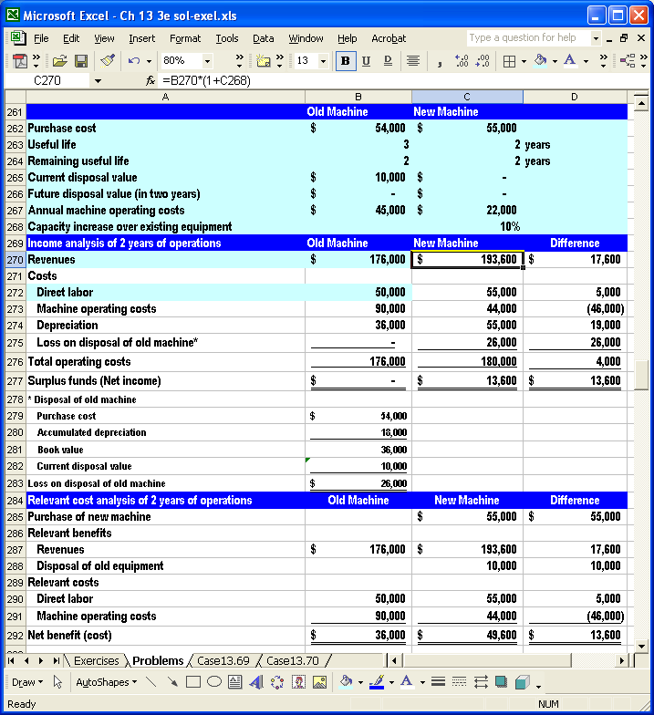
EXCEL SOLUTIONS ARE FOUND IN EXCEL SOLUTIONS FILE

b. The models after using the Solver wizard follow. First, the two-year sales growth, cell C268. The new equipment would have to have less capacity and sales (-1%, rounded) than the old equipment. This seems unlikely.
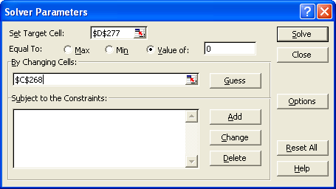

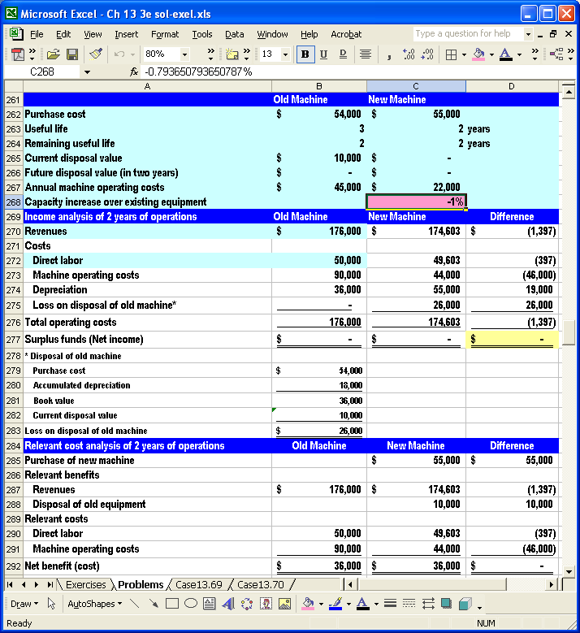

Next, the level of new operating costs, cell C267. The new equipment would have to have increased annual operating costs ($28,800 vs. $22,000). This could be likely and should be investigated further.
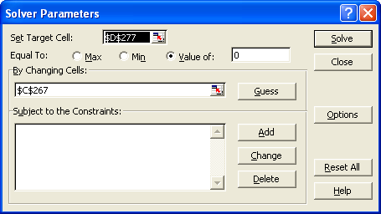

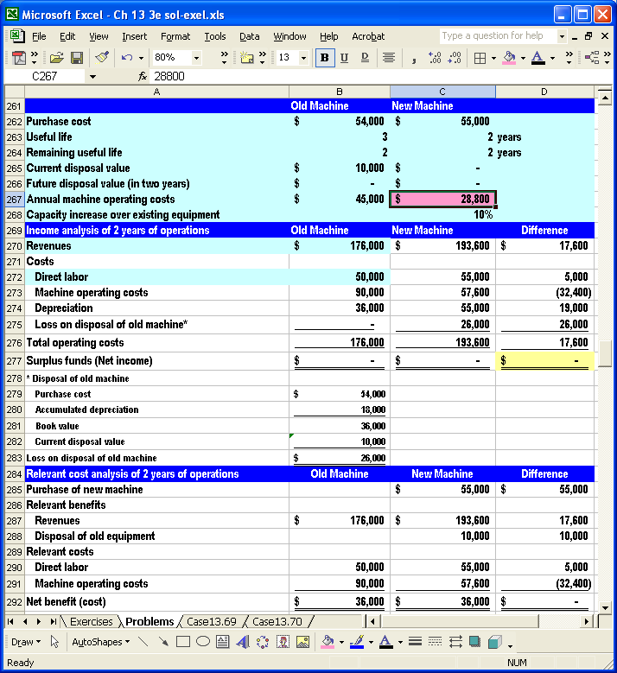

c. A manager might be reluctant to replace the equipment before the end of is expected life because doing so might indicate faulty decision making when the existing equipment was purchased. Also the manager might not want to create a loss on the sale of the old equipment.

13.62 (60 min) Equipment replacement – Community Hospital.
a. A screen-shot of the financial model follows. See the instructor’s CD for the model.
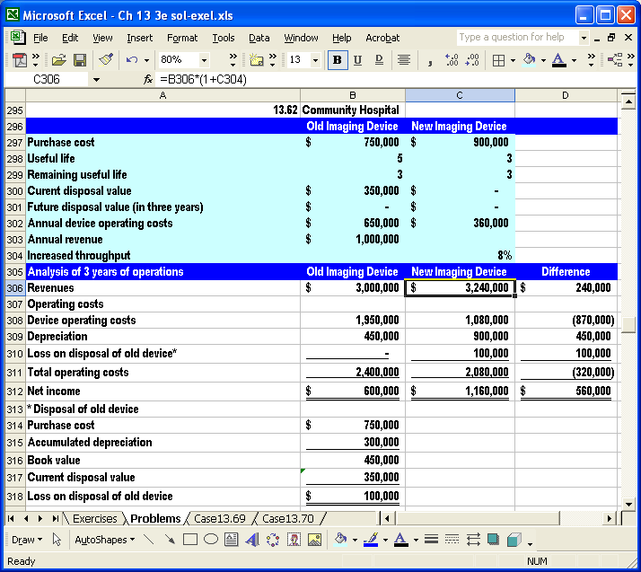
EXCEL SOLUTIONS ARE FOUND IN EXCEL SOLUTIONS FILE

b. The models after using the Solver wizard follow. First the percentage change in throughput, cell C304. Throughput would have to be 11% (rounded) less than the old imaging device, which seems unlikely.
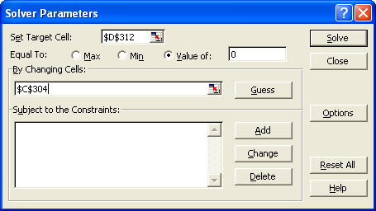

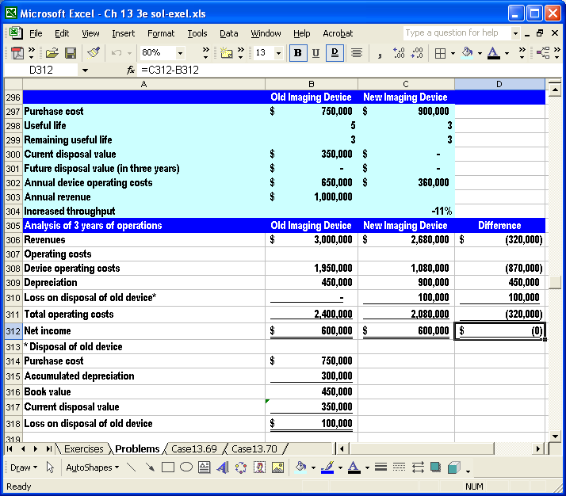

b. Next the new operating costs, cell C302.The new imaging device’s operating costs would have to be much higher than advertised (nearly $547,000 rather than $360,000), which seems unlikely.
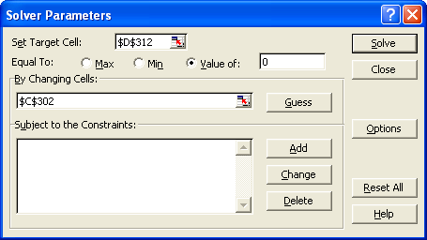

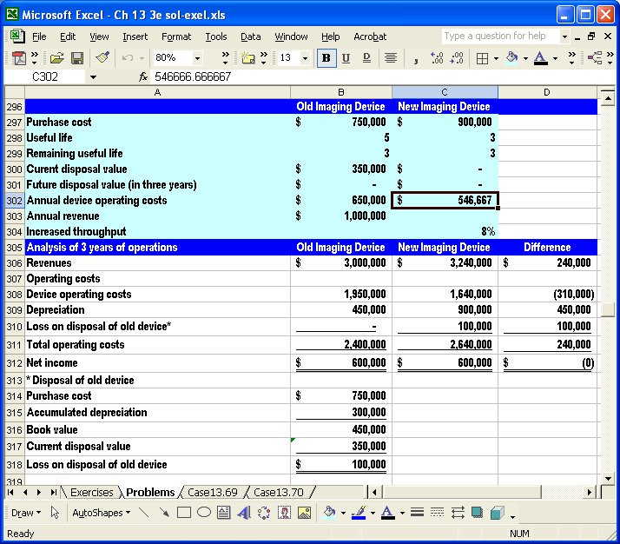
c. A manager might be reluctant to replace the equipment before the end of is expected life because doing so might indicate faulty decision making when the existing equipment was purchased. Also the manager might not want to create a loss on the sale of the old equipment.

13.63 (35 min) Special order: Cosmos.
a. Special order | 1,100
over | 3 | months
Needed to meet special order | 367 | per month
Capacity | 3,000 | per month
Capacity use | 80%
Normal volume | 2,400 | per month
Unused capacity | 600 | per month
 | Normal | Per unit | Change
b. Selling price | $ 36.00 | $ 31.00 | $ (5.00)
Unit-level costs | $28,560 | 11.90 | $ -
Facility-level costs per month
Manufacturing | 96,000 |  | $ (96,000)
Marketing | 78,000 |  | $ (78,000)
Consulting | - |  | $ 5,500
Analysis of special order | fill in 2 months | fill in 3 months
Revenues | $ 34,100 | $ 34,100
Relevant costs
Unit-level costs | 13,090 | 13,090
Consulting | 11,000 | $ 16,500
Total costs | 24,090 | 29,590
Profit on special order | $ 10,010 | $ 4,510

The special order is more profitable if it can be filled in 2 months rather than 3.
c. Cosmos should be concerned about effects on its future prices. It cannot cover all of its costs if it must discount its prices to obtain business. Cosmos also should be concerned about entering the global market without experience; it should establish the credibility and reliability of its consultant, who appears to be committing only several days per month.

d. Perhaps, yes. Possibly. Cosmos may believe that a short-term loss may lead to long-term benefits and profits. Somewhat akin to the marketing concept known as a “loss leader,” the company may be willing to take a loss just to get its foot in the door and establish a presence in Japan. Whether Cosmos is taking a loss depends on how one treats facility costs. In the short-run, the special order appears to be profitable. In the long run, the company must cover all of its costs. It appears that the global market is more competitive than Cosmos’ normal markets, and if Cosmos can learn to be competitive globally it will have great advantages against its normal competitors, too.
13.64 (35 min) Special order: Framar
Capacity use | 75% | Tax rate | 40%
Sales commission rate | 10%
Sales revenue | $ 25,000,000
Less sales commission | 2,500,000
Net sales | 22,500,000
Expenses
Unit-level costs | 15,750,000
Facility-level costs | 2,250,000 | 14.2857143% of unit-level costs
Total costs | 18,000,000
Income before tax | 4,500,000
Taxes | 1,800,000 | at 40%
Net income | $ 2,700,000
a. Special order (rounded numbers) |  | b. Counter offer
Materials | $ 29,200 | Sales price | $ 127,000
Labor | 56,000 | Sales commission | $ 12,700
Unit-level costs | 85,200 | Unit-level costs | 85,200
Facility-level cost @14.2857143% | 12,171 | Contribution margin | $ 29,100
Total costs before sales comm. | 97,371 | Tax @40% | $ 11,640
Add markup @25% | 24,343 | Profit after tax | $ 17,460
Price before sales commission | 121,714
Price after sales commission (÷ 0.9) | $ 135,238
Less relevant costs

Unit-level costs | 85,200
Sales commission @10% | 13,524
Contribution margin | $ 36,514
Tax @ 40% | 14,606
Profit after tax | $ 21,908
EXCEL SOLUTIONS ARE FOUND IN EXCEL SOLUTIONS FILE
13.64 (continued)
a. Assuming that facility costs are committed and will not change if the order is accepted, Framar will experience an increase of $21,908 after-tax profit.
b. As shown above and assuming that facility costs are irrelevant to the decision, the counter offer also is profitable.
c. The breakeven price just covers sales commissions and unit-level costs, as follows:
Let P = the unknown price
0 = P - 0.1P – 85,200
0.9P = 85,200
P = $94,667 (note that taxes are irrelevant at breakeven)
d. Profits will likely fall. Framar originally used a full-cost pricing formula to derive a $135,238 bid price. A drop in selling price to $127,000 signifies that the firm is now pricing its orders at less than full cost, which would depress profitability.
Reduced prices could lead to an increase in income if the firm is able to generate additional volume. This situation will not occur here: problem data state that Framar has operated and will continue to operate at 75 percent of practical capacity.
13.65 (90 min) Pricing of Special Order, Ethics, Target Costing
a. Decision tree
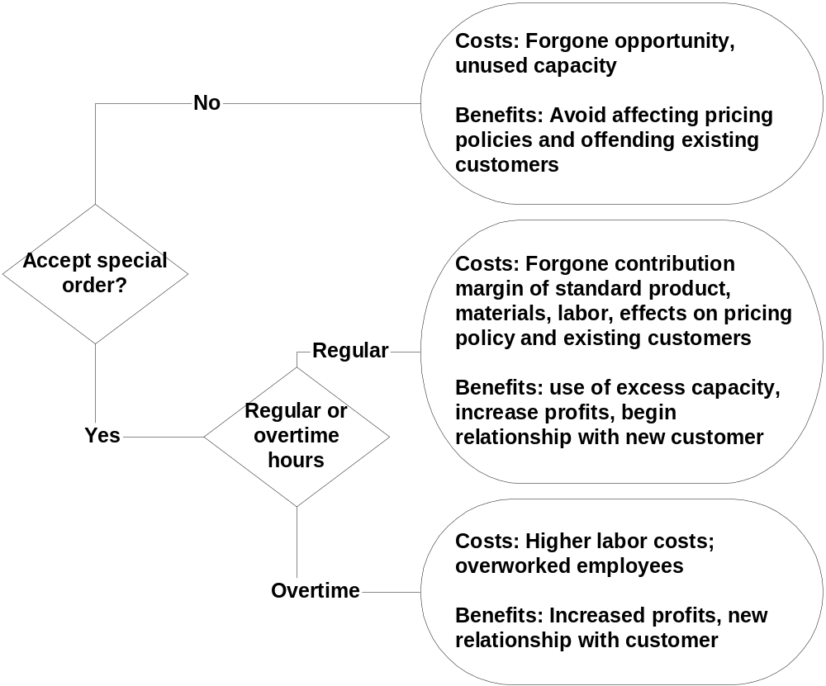

b. Alternative bids
 | Regular |  | Overtime
Labor rate | $ 20.00 | per hour | $ 30.00 | per hour
Facility cost rate | $ 13.60 | per hour | $ 13.60 | per hour
Standard product
Labor hours | 250
Sales price | $ 15,000
Labor | 5,000
Materials | 2,500
Facility | 3,400
Markup rate on custom orders | 50%
Special order | All Regular hrs |  | All Overtime hrs
Labor hours | 3,000 |  | 3,000
Materials | $ 56,000 |  | $ 56,000
Labor @ $20, $30 | 60,000 |  | 90,000
Facility-cost @ $13.60 | 40,800 |  | 40,800
Total cost | $ 156,800 |  | $ 186,800
Markup @ 50% | $ 78,400 |  | $ 93,400
Bid price | $ 235,200 |  | $ 280,200
Less relevant costs
Materials | $ 56,000 |  | $ 56,000
Labor | 60,000 |  | 90,000
Foregone standard contribution margin
Sales quantity* | 12
Revenue | $ 180,000
Expenses
Labor | 60,000
Materials | 30,000
Foregone contribution margin | 90,000
Total relevant costs | $ 206,000 |  | $ 146,000
Profit | $ 29,200 |  | $ 134,200

* (3,000 total hrs ÷ 250 hrs per unit)
c. Minimum bids under each alternative will cover relevant costs, which using normal or overtime hours are:
 | Normal hours | Overtime hours
Materials | $56,000 | $56,000
Labor | 60,000 | 90,000
Foregone CM | 90,000 | - 0 -
Total | $206,000 | $146,000
d. Lyan Company’s employee is not acting ethically. The details of the bid submitted by Hamilton are confidential between Hamilton and Lyan. It is unfair and unethical to give this information to Hamilton’s competitor. If Lyan Company had wanted competing bids on the specialized equipment, the bids should have been solicited at the same time from the relevant set of manufacturers. Each competing firm should receive the same specifications on the customized equipment and be given the same time frame in which to complete the bid. Moreover, the competing firms should be made aware that more than one bid is being solicited.
e. Hamilton is using a cost-plus approach to pricing, summing its full production costs and then adding a markup. Target costing begins with an assessment of a likely market price. The technique next subtracts the firm’s target profit to yield the target manufacturing cost. Cost analysts, engineers, production personnel, and others then work together in a process to achieve the target cost. Achieving a target cost is really the result of a variety of continuous improvement techniques. A relatively short cycle time severely limits the opportunity for continuous improvement over time, meaning that most cost reduction must occur in a product or service’s development phase.
13.66 (60 min) Lifecycle costs – Greenacres Construction
Purchase cost | $135,000
Resale cost at replacement | 47,250
Useful life, years | 7
Operating hours per year | 1,200
Opportunity cost of capital | 16%
Annual insurance cost | $768
Annual property tax | $1,145
Fuel consumption per hour, gallons | 5
Fuel cost per gallon | $1.25
Annual scheduled maintenance cost | $7,344
Annual repair cost | $5,400
Hourly operator cost (wage + benefits) | $20.00
a. Backhoe equipment hourly costs
Useful life in years | 7
Hours of use per year, total | 1,200
Ownership cost
Purchase cost, total | $ 135,000
Salvage value | 47,250
Recoverable value | $ 87,750
Hourly purchase cost | $ 10.45
Opportunity cost
Average investment cost over equipment life (1/2 of the $135,000 purchase costs) | $ 67,500
Desired rate of return on investments | 16%
Annual opportunity cost | 10,800
Hourly opportunity cost | $ 9.00
Insurance cost
Annual insurance cost | $ 768
Hourly insurance cost | $ 0.64
Property tax & license cost
Annual property tax & license | $ 1,145
Hourly property tax & license cost | $ 0.95
Total hourly ownership cost | $ 21.04

Operating cost
Fuel cost
Fuel cost per gallon | $1.25
Fuel per hour at normal speed, gallons | 5
Fuel cost per hour | $6.25
Scheduled maintenance cost
Annual scheduled maintenance | $ 7,344
Hourly maintenance cost | $ 6.12
Repair costs
Average annual repairs | $ 5,400
Hourly repair cost | $ 4.50
Total hourly operating cost | $ 16.87
Total hourly ownership and operating cost | $ 37.91

b. Analysis of construction job costs
Direct labor hours | 600
Direct labor hourly rate (wage + benefits) | $18.40
Equipment (backhoe) hours | 120
Construction materials | $5,500
Overhead rate per direct labor hour | $9.80
Overhead rate per equipment hour | $7.75
Target rate of return on sales | 25%
Direct labor cost | $ 11,040.00
Backhoe cost (equipment + operator, $37.91 + $20) x 120 | 6,949.27
Construction materials | 5,500.00
Direct-labor based overhead | 5,880.00
Equipment based overhead | 930.00
Total construction job costs | $ 30,299.27
Bid price at required ROS | $ 40,399.03
EXCEL SOLUTIONS ARE FOUND IN EXCEL SOLUTIONS FILE

c. Revised job costs
Revised hourly equipment cost ($37.91 – 9.00) | $ 28.91
Revised rate of return on sales | 10%
Direct labor cost | 11,040
Backhoe cost (equipment + operator, ($28.91 + 20)x120 | $ 5,869.27
Construction materials | 5,500.00
Revised construction job costs | $ 22,409
Bid price at revised ROS | $ 24,889.19
This tactic might win the job and might keep employees on jobs. However, one needs to be careful of setting a pricing precedent that the customer might expect in the future. This approach does not cover the lifecycle costs of the equipment used for the job, which means the company is not generating sufficient income from the job to meet its required return or to operate the equipment profitably. However, if times are tough, this approach is probably preferable to losing the bid and possibly shutting down.

13.67 Lifecycle costs. – Quantorus Data Storage
Purchase cost | $250,000
Resale cost at replacement | 40,000
Useful life, years | 3
Operating hours per year | 4,000
Opportunity cost of capital | 12%
Annual insurance cost | $1,500
Annual property tax | $445
Energy consumption per hour, kilowatt-hours (kwh) | 50
Energy cost per kwh | $0.0125
Annual scheduled maintenance cost | $10,440
Annual repair cost | $24,110
Hourly operator cost (wage + benefits) | $35.00
a. Robotic assembly equipment hourly costs
Useful life in years | 3
Hours of use per year, total | 4,000
Ownership cost
Purchase cost, total | $ 250,000
Salvage value | 40,000
Recoverable value | $210,000
Hourly purchase cost | $ 17.50
Opportunity cost
Average investment cost over equipment life (1/2 of the $250,000 purchase cost) | $ 125,000
Desired rate of return on investments | 12%
Annual opportunity cost | 15,000
Hourly opportunity cost | $ 3.75
Insurance cost
Annual insurance cost | $ 1,500
Hourly insurance cost | $ 0.38
Property tax & license cost
Annual property tax & license | $ 445
Hourly property tax & license cost | $ 0.11
Total hourly ownership cost | $ 21.74

Operating cost
Energy cost
Energy cost per kwh | $0.0125
Energy consumption per hour, kilowatt-hours (kwh) | 50
Energy cost per hour (rounded) | $0.63
Scheduled maintenance cost
Annual scheduled maintenance | $ 10,440
Hourly maintenance cost | $ 2.61
Repair costs
Average annual repairs | $24,110
Hourly repair cost | $ 6.03
Total hourly operating cost | $ 9.26
Total hourly ownership and operating cost | $ 31.00
b. Analysis of batch costs
Units of product per batch | 400
Direct labor hours | 200
Direct labor hourly rate (wage + benefits) | $28.40
Assembly equipment hours | 80
Direct materials | $45,500
Overhead rate per direct labor hour | $19.80
Overhead rate per equipment hour | $72.75
Direct labor cost | $ 5,680
Assembly equipment cost | 2,480
Direct materials | 45,500
Direct-labor based overhead | 3,960
Equipment based overhead | 5,820
Total batch costs | $ 63,440
Cost per unit of product | $ 158.60
c. Revised batch costs
Revised hourly equipment cost | $ 27
Direct labor cost | $ 5,680
Equipment cost | 2,180
Direct materials | 45,500

Revised batch costs | $ 53,360
Revised cost per unit | $ 133.40
This tactic might win market share. However, one needs to be careful of buying market share by setting a pricing precedent that customers will expect in the future. This approach does not cover the lifecycle costs of the equipment used for manufacturing, which means the company is not generating sufficient income from the job to meet its required return or to operate processes profitably. All of the omitted costs must be covered by operations at some time.
EXCEL SOLUTIONS ARE FOUND IN EXCEL SOLUTIONS FILE
SOLUTIONS TO CASES
13.68 (30 - 40 min) Benefit-cost analysis – Grand Coulee Dam.
This might seem an unlikely context for a cost management text, but few projects have the impact on business, communities, and the environment as large dams. The cited article about Grand Coulee Dam in Washington State is very interesting reading. Benefits and costs have not been borne by the same entities or individuals. Currently some of the adversely affected groups (e.g., Native Americans and sport and commercial fishermen) are working toward reparations of past damages. The impacts on businesses and farms in the region could be immense. The World Bank has been a frequent supporter of these projects, but has been criticized for focusing on benefits while ignoring costs.
    - Based on 70 years of experience with the Grand Coulee Dam, one can expect the following benefits and costs:
Benefits | Quantifiable?
Increased crop production……………………………………… | Yes
Increased electrical power……………………………………. | Yes
Economic development……………………………………….. | Yes
Flood protection………………………………………………… | Yes
Flat water recreation and transportation……………………. | Yes
Costs
Opportunity costs of financiers………………………………. | Yes
Loss of traditional lands, fishing, transportation, culture by native peoples………………………………………………… | Yes to quantity, but not easily for $ value
Loss of livelihood by commercial fishermen………………... | Yes
Loss of sport fishing……………………………………………. | Yes to quantity, but not easily for $ value
Displacement of non-native people, housing, businesses | Yes
Losses by farmers and businesses who do not benefit and have relative disadvantages…………………………….. | Yes to quantity, but not easily for $ value

b. If the experience of Grand Coulee Dam is instructive, one should expect intense lobbying for the project by farmers, businesses, other economic and political interests who stand to benefit most from the project. As it turns out, these were the only parties to the decision making about the Grand Coulee Dam. It’s likely that including the other affected parties, like those that bore most of the uncompensated cost before, will extend the decision making and will raise the cost of the project greatly. Not that this is a bad thing, but large new dam projects will have a much more difficult time gaining approval than before.
c. Each of the categories of predicted benefits and costs should be audited on a more timely basis than was the case for the Grand Coulee Dam.

13.69 (30 – 45 min) Benefit-cost analysis - Diesel vs. solar power in Brazil.
Photovoltaic (PV) power plants are clean and efficient in converting solar energy, but very expensive. The Brazilian government is developing its frontier areas in the Amazon region and has mandated 24-hour electrical service to that region. Villages and small towns have relied on diesel-powered generators, which are dirty and noisy. Furthermore, the transport and storage of diesel fuel is expensive and environmentally damaging. Hence, the investigation of completely or mostly PV plants. The cited article is interesting reading but might be a bit difficult for the non-technical. The essence of the article is distilled in the case.
a. Qualitative and quantitative considerations include:
Financial | Non-financial
Costs of equipment (purchase, transport, installation, maintenance) | Noise
Cost of diesel fuel | Environmental damage from spilled and burned fuel, discarded batteries
Cost per kilowatt-hour | Population served
Trade and currency exchange exposure for foreign purchases of PV plants | Reliability of equipment and power supply
b. One way to analyze the data is to plot the cost per megawatt-hour (MWH) versus the plant power range (which is a proxy for average population served) or the type of power plant. Sample plots follow.

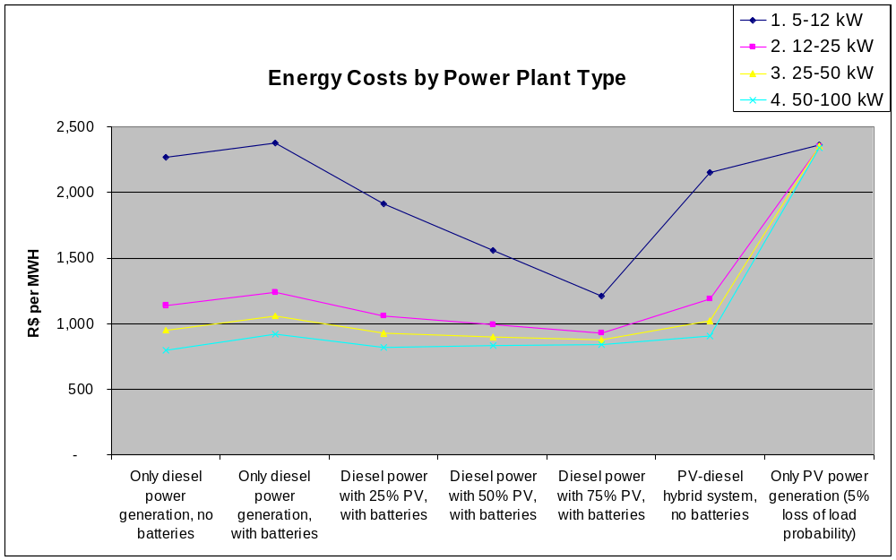

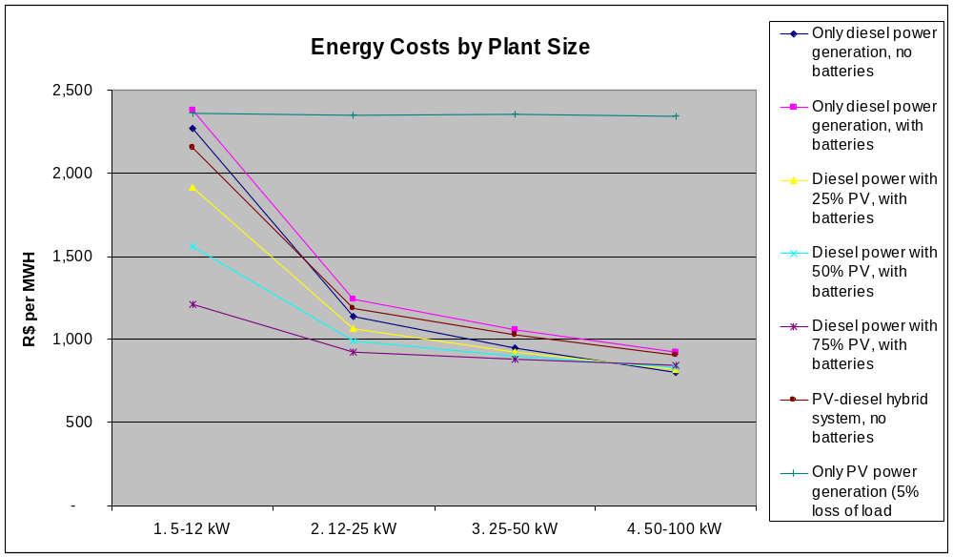
Abandoning stand-alone diesel power plants probably is impractical, but the graphs indicate that no new stand-alone plants should be installed, and any replacements should be PV-diesel hybrid plants. Except for the largest plants, 50-100 kW serving about 750 people each, diesel-only plants are the highest cost, without considering environmental factors. PV-only plants are usually the most costly alternatives, and hybrid systems are always cheaper. Although the PV-only plants are the cleanest alternative, at this time they do not appear to be economically viable.
c. The most efficient plants for nearly all sizes are hybrids with 75% PV power arrays. The only exception is that diesel-only plants are the most efficient for the largest plant size. However, the difference is not great between diesel-only and the 75%-hybrid plants: $R44 per megawatt-hour. Environmental damages from diesel-only systems might be more than that.
d. I would recommend going with 75% PV-diesel hybrids for all new and replacement power plants. It is possible that standardizing the plants could result in purchase, installation, and maintenance cost savings that have not been incorporated into the analysis.
13.70 (60 – 75 min) Benefit-cost analysis – Social benefits and the CPI

a. Articles abound, particularly regarding the problem of the aging population in Europe, caused by low fertility and restrictive immigration policies. The U.S. also has problems with paying for future social security benefits, but not as severe. Most articles conclude that some combination of the following are needed to meet future obligations: higher taxes and reduced benefits, neither of which is politically popular. Indexing benefits and taxes to the CPI is part of the problem and modifying the indexing seems like an easy fix – unless one is concerned about preserving the purchasing power of the elderly who depend on social security benefits and of current taxpayers who must forego private uses of their income when they pay taxes.
b & c. Projecting all the impacts on social security benefits and tax collections affected by the CPI is an extremely complex actuarial and econometric problem. Surprisingly, straightforward analysis of the simple numbers in the case yield results that are similar in magnitude to the much more complex modeling reported in academic and government analyses. One such analysis follows on the next pages. This analysis is best done with a spreadsheet.
EXCEL SOLUTIONS ARE FOUND IN EXCEL SOLUTIONS FILE

 | A | B | C | D | E | F | G
1 |  |  | Base annual growth | Most likely error | Largest error | Smallest error
2 | Annual increase in the CPI |  | 3.0% | 0.50% | 1.50% | 0.20%
3 | Working population | 150,000,000 | 1.0%
4 | Social security beneficiaries | 30,000,000 | 2.0%
5 | Average annual social security benefit | $ 15,000
6 | Personal exemption (reduction in taxable income) | $ 2,500
7 | Average tax rate on earnings and social security benefits | 20%
8 | Year | Total (undiscounted) | 1 | 2 | 3 | 4 | 5
9 | No assumed errors
10 | Total social security benefits | $ 5,963,129,925,905 | $472,770,000,000 | $496,692,162,000 | $521,824,785,397 | $548,229,119,538 | $575,969,512,987
11 | Total reduction in taxes from personal exemption | 1,931,905,695,993 | 156,817,500,000 | 163,948,833,750 | 171,408,626,628 | 179,212,193,496 | 187,375,571,549
12 | Most likely error
13 | Total social security benefits | 5,794,762,160,745 | 470,475,000,000 | 491,881,612,500 | 514,262,225,869 | 537,661,157,146 | 562,124,739,796
14 | Total reduction in taxes from personal exemption | 1,877,716,144,927 | 156,056,250,000 | 162,360,960,938 | 168,924,482,565 | 175,757,601,878 | 182,871,561,821
15 | Largest error
16 | Total social security benefits | 5,473,063,751,107 | 465,885,000,000 | 482,330,740,500 | 499,357,015,640 | 516,984,318,292 | 535,233,864,727
17 | Total reduction in taxes from personal exemption | 1,774,156,447,256 | 154,533,750,000 | 159,208,395,938 | 164,028,429,931 | 168,998,490,562 | 174,123,367,738
18 | Smallest error
19 | Total social security benefits | 5,895,165,573,104 | 471,852,000,000 | 494,765,133,120 | 518,790,927,984 | 543,983,415,447 | 570,399,250,101
20 | Total reduction in taxes from personal exemption | 1,910,032,060,850 | 156,513,000,000 | 163,312,757,400 | 170,412,067,348 | 177,824,303,076 | 185,563,442,316
21 | Savings over 10 years (undiscounted)
22 | Most likely error | $222,557,316,227
23 | Largest error | 647,815,423,536
24 | Smallest error | 89,837,987,944
25
26 | Formulas in year 1 that are copied to subsequent years

27 | Total social security benefits (no error, row 10) | =($B$5*(1+$C$2)^C$8)*($B$4*(1+$C$4)^C$8)
28 | Total reduction in taxes from personal exemption (no error, row 11) | =($B$6*(1+$C$2)^C$8)*(($B$3*(1+$C$3)^C$8)*($B$7)+$B$4*(1+$C$4)^C$8)
29 | Total social security benefits (most likely error, row 13) | =($B$5*(1+$C$2-$D$2)^C$8)*($B$4*(1+$C$4)^C$8)
30 | Total reduction in taxes from personal exemption (most likely error, row 14) | =($B$6*(1+$C$2-$D$2)^C$8)*(($B$3*(1+$C$3)^C$8)*($B$7)+$B$4*(1+$C$4)^C$8)
Formulas are copied out to ten years – additional columns not shown. See instructor’s CD for model. Incorporation of other errors uses similar formulas.

d. Letters will vary, but they should touch on the impacts of indexing and take a cautious approach to including very likely errors in the CPI. Current workers and retirees will be hit by changes in indexing – the take-home pay of current workers is increased by higher personal exemptions but decreased by higher social security taxes. Retired workers benefit from higher personal exemptions but more so from higher social security benefits. It is unclear whether the letter writer should favor current or retired workers in this debate. This is an interesting and timely issue.

