Chapter 8
Process-Costing Systems

ANSWERS to Review Questions
  - Equivalent units are computed in process costing because it enables companies to assign costs to whole units rather than partial units. Equivalent units represent the amount of work actually performed on products not yet complete translated to the work required to complete an equivalent number of whole units. For example, four units were started at the beginning of a month and each was 25 percent complete at the end of the month. The work performed would be considered equivalent to the work performed to complete one whole unit. This calculation allows companies to assign costs to one whole unit rather than four partially completed units.
  - Using the basic cost flow equation, rearrange the terms to solve for the unknown beginning inventory. From BB + TI – TO = EB, we have:
Beginning Inventory + Transfers In – Transfers Out = Ending Inventory.
Rearranging yields:
Beginning Inventory = Transfers Out + Ending Inventory – Transfers In
8.3 With FIFO costing, the units in the beginning inventory are transferred out first. These beginning inventory units carry with them the costs incurred in a previous period plus the costs incurred this period to complete the beginning inventory. Units started and completed during the period are charged out using all current period costs. While such a distinction is made by the department transferring the units out, the department receiving the units usually ignores the distinction in costs incurred in the prior department.
8.4 Under FIFO costing, the equivalent units represent only the work done in the current period. Under weighted-average costing, the equivalent units represent the work associated with all of the costs charged to work in process regardless of the period in which those costs were incurred (i.e., including costs from prior periods that are in beginning inventory).
8.5 Prior department costs behave the same as direct materials, which are typically added at the start of production. They are treated separately because they represent the accumulation of costs from previous departments rather than the receipt of materials from the stores area. It is helpful to separate prior department costs from other costs because the manager of the department receiving the transferred units has no control over the costs incurred in prior departments. Thus, the prior department costs are not useful for evaluating the performance of the manager of the department receiving the units.
8.6 Using the basic cost flow equation, rearrange the terms to solve for the unknown transfers out. From BB + TI – TO = EB, we have:
Beginning Inventory + Transfers In – Transfers Out = Ending Inventory.
Rearranging yields:
Transfers Out = Beginning Inventory + Transfers In – Ending Inventory
8.7 Process costing typically separates the costs of spoiled units from the costs of other outputs of the period. Some process costing systems classify spoiled goods under two categories:
1) Normal spoilage, where the spoiled good is treated as a natural outcome of an imperfect process and is counted as a normal cost of good units produced. This approach is in some disfavor as it can be interpreted as tolerance of spoilage.
2) Abnormal spoilage, where the spoiled good was not expected and is treated as a cost of the period.
8.8 Spoilage costs are similar to underapplied overhead because they are both costs in excess of what was expected.
8.9 Relative costs and benefits of weighted-average vs. FIFO costing:
Weighted-average costing
Benefits | Costs
- Easier to learn and apply in practice  - More appropriate than FIFO when costs per unit do not materially differ from one period to the next | - Numbers are not reflective of current year activity  - Can hide signals that process costs are changing

FIFO costing
Benefits | Costs
- Units are based on current period activity  - More accurate at matching actual costs to the period of production  - Can signal process cost changes which can warrant other changes such as the pricing of products | - Requires detailed information  - Complicated to calculate

8.10 Operation costing is a hybrid of job costing and process costing by adding customized materials to a continuous process. The accounting is similar in that costs of materials are assigned separately to jobs, like job costing. Conversion costs are assigned equally over each operation.

ANSWERS to CRITICAL ANALYSIS
8.11 To assign costs to specific lots of cereal or similarly mass-produced items requires a lot of recordkeeping. Assuming products are all the same, a process costing system provides sufficient information for control purposes. Recordkeeping is simplified since all costs in a given month are accumulated in one account and assigned at the end of the period.
8.12 a. Certainly, LIFO process costing is possible. This just means that cost of goods completed exhausts all of current costs applied before dipping into beginning WIP costs. Ending WIP, therefore, could contain mostly costs from beginning WIP. Though this does not mirror most production process flows, it would be possible to measure costs this way so that cost of goods completed (and cost of goods sold) reflects current costs more accurately.
b. MeadWestvaco, Corporation, a large paper producer, reports in its Form 10-Ks a mix of inventory costing methods: “Cost is determined using the last-in, first-out (LIFO) method for raw materials, finished goods and certain production materials, where allowed for U.S. federal income tax purposes. Cost of all other inventories is determined by the first-in, first-out (FIFO) or average cost method.”
8.13 b. If there is no beginning WIP inventory, all costs assigned to cost of goods completed (and ending WIP) are current costs. Therefore, both weighted-average and FIFO process costing always will generate the same cost of goods manufactured.
8.14 a. Total equivalent units would be understated. (A lower percentage completion multiplied by the number of physical units results in lower equivalent units.)
b. Costs per equivalent unit would be overstated. (Fewer equivalent units divided into the same costs results in higher costs per equivalent unit.)
c. Costs assigned to cost of goods transferred out for the period would be overstated. (Higher costs per unit result in over-costing.)
8.15 b. Weighted average costing considers both current costs and costs in beginning WIP inventory.
8.16 e. None of these answers is correct. Answer “a” is incorrect because it ignores different degrees of completion. “b” is incorrect because it double-counts units started that are still in ending WIP. “c” is incorrect because units in ending WIP should be multiplied by the amount of work done this period, not the amount necessary to complete them (in the future). “d” is incorrect because it defines weighted average equivalent units and repeats the error of “c.”
8.17 No process is 100 percent error-free, and some spoilage is inevitable. Moreover, the optimal level of spoilage usually is not zero – the cost of eliminating the last spoiled unit may be prohibitively high. However, treating spoilage as a normal cost of production runs the risk of approving higher levels of spoilage than would be achieved with less tolerance. Reporting spoilage separately is a step toward recognizing the magnitude of an organization’s spoilage problem. The next step is to determine the costs and benefits of reducing spoilage.
8.18 Some organizations classify spoilage into normal and abnormal categories. The rate of normal spoilage usually is based on historical experience and is considered a normal cost of production. Any amount of spoilage above that amount would be treated as an extraordinary cost of the period. This treatment of spoilage, unfortunately, could result in complacency about higher than necessary levels of spoilage. Other organizations may be able to reduce spoilage and its wasted resources and gain a cost advantage.
8.19 If you overstate degrees of completion of ending WIP, you also will overstate the amount of equivalent units of work done overall. This will lead to a lower cost per equivalent unit, and, if completed units are sold, cost of goods sold will be lower than it should be (and the period’s income higher). Relatively more cost will be retained in ending WIP than justified. In future periods, either more than normal cost will be added to actually complete these units in ending WIP, or the cost of ending WIP will be restated to reflect actual degrees of completion. In either event, these costs, once buried in ending WIP, will be expensed eventually. If the individual wishes to play this game, each period ending WIP must be overstated even more, until there is almost no more overstating to do. The units may be shown as nearly complete, but an audit would reveal otherwise, unraveling the whole scheme.

SOLUTIONS to eXERCISES

8.20 (20 min) Equivalent units computation, weighted-average method
 | Physical units | Degree of Completion |  | Equivalent Units
Flow of units |  | Materials | Conversion | Materials | Conversion
Units to account for:
Beginning WIP | 1,000
Units started | 12,000
Total units to account for | 13,000
Units accounted for:
Completed and transferred out | 9,000 | 100% | 100% | 9,000 | 9,000
Ending WIP* | 4,000 | 10% | 20% | 400 | 800
Total units accounted for | 13,000 |  |  | 9,400 | 9,800
 |  |  |  | (a) | (b)
* EI = 1,000 + 12,000 – 9,000 = 4,000
EXCEL SOLUTIONS ARE FOUND IN EXCEL SOLUTIONS FILE

8.21 (30 min) Equivalent units computation, FIFO method (Appendix A)
 | Physical units | Degree of Completion |  | Equivalent Units
Flow of units |  | Materials | Conversion | Materials | Conversion
Units to account for:
Beginning WIP | 1,000 | 20% | 15% | 200 | 150
Units started | 12,000
Total units to account for | 13,000
Units accounted for:
Completed and transferred out:
From beginning inventory | 1,000 | 80% | 85% | 800 | 850
Started and completed | 8,000 | 100% | 100% | 8,000 | 8,000
Units in ending WIP* | 4,000 | 10% | 20% | 400 | 800
Total units accounted for | 13,000
Current period equivalent units |  |  |  | (a) 9,200 | (b) 9,650
* EI = 1,000 + 12,000 - 9,000 = 4,000
EXCEL SOLUTIONS ARE FOUND IN EXCEL SOLUTIONS FILE

8.22 (20 min) Equivalent units computed, weighted-average method
 | Physical units | Degree of Completion |  | Equivalent Units
Flow of units |  | Materials | Conversion | Materials | Conversion
Units to account for:
Beginning WIP* | 7,000
Units started | 25,000
Total units to account for | 32,000
Units accounted for:
Completed and transferred out | 22,000 | 100% | 100% | 22,000 | 22,000
Ending WIP | 10,000 | 20% | 10% | 2,000 | 1,000
Total units accounted for | 32,000 |  |  | (a) 24,000 | (b) 23,000
*BI = 22,000 + 10,000 – 25,000 = 7,000
EXCEL SOLUTIONS ARE FOUND IN EXCEL SOLUTIONS FILE

8.23 (30 min) Equivalent units computed, FIFO method (Appendix A)
 | Physical units | Degree of Completion |  | Equivalent Units
Flow of units |  | Materials | Conversion | Materials | Conversion
Units to account for:
Beginning WIP* | 7,000 | 55% | 70% | 3,850 | 4,900
Units started | 25,000
Total units to account for | 32,000
Units accounted for:
To complete beginning WIP | 7,000 | 45% | 30% | 3,150 | 2,100
Started and completed** | 15,000 | 100% | 100% | 15,000 | 15,000
Ending WIP | 10,000 | 20% | 10% | 2,000 | 1,000
Total units accounted for | 32,000
Current period equivalent units |  |  |  | 20,150 | 18,100
*BI = 10,000 + 22,000 – 25,000
**15,000 units started and completed = 22,000 total transferred out – 7,000 transferred out that was in beginning inventory
EXCEL SOLUTIONS ARE FOUND IN EXCEL SOLUTIONS FILE
8.24 (20 min) Equivalent units computed, weighted- average method
 | Physical units | Degree of Completion |  | Equivalent Units
Flow of units |  | Materials | Conversion | Materials | Conversion
Units to account for:
Beginning WIP | 6,000
Units started | 40,000
Total units to account for | 46,000
Units accounted for:
Completed and transferred out | 30,000 | 100% | 100% | 30,000 | 30,000
Ending WIP | 16,000 | 100% | 40% | 16,000 | 6,400
Total units accounted for | 46,000 |  |  | (a) 46,000 | (b) 36,400

EXCEL SOLUTIONS ARE FOUND IN EXCEL SOLUTIONS FILE

8.25 (30 min) Equivalent units computed, FIFO (Appendix A)
 | Physical units | Degree of Completion |  | Equivalent Units
Flow of units |  | Materials | Conversion | Materials | Conversion
Units to account for:
Beginning WIP | 250 | 100% | 40% | 250 | 100
Units started | 1,000
Total units to account for | 1,250
Units accounted for:
Completed and transferred out:
From beginning inventory | 250 | 0% | 60% | 0 | 150
Started and completed | 800 | 100% | 100% | 800 | 800
Ending inventory | 200 | 100% | 70% | 200 | 140
Total units accounted for | 1,250
January equivalent units |  |  |  | 1,000 | 1,090

EXCEL SOLUTIONS ARE FOUND IN EXCEL SOLUTIONS FILE
8.26 (20 min) Costs per equivalent unit computed, weighted average method
Flow of units | Physical units | Percent completeMaterials | Equiv. Units  Materials
Units to account for:
Beginning WIP | 60,000
Units started | 160,000
Total units to account for | 220,000
Units accounted for:
Completed and transferred out | 170,000 | 100% | 170,000
Ending WIP | 50,000 | 100% | 50,000
Total units accounted for | 220,000 |  | 220,000
Costs to account for |  |  | Materials
Costs in beginning WIP |  |  | $ 13,200
Current period costs |  |  | 35,200
Total costs to account for |  |  | $ 48,400
Cost per equivalent unit |  |  | $ 0.22*
* $0.22 = $48,400 ÷ 220,000 EU
EXCEL SOLUTIONS ARE FOUND IN EXCEL SOLUTIONS FILE
8.27 (30 min) Equivalent units computed, FIFO (Appendix A)
Flow of units | Physical units | Degree of Completion | Equivalent Units
Units to account for:
Beginning WIP | 40,000 | 60% | 24,000
Units started | 700,000
Total units to account for | 740,000
Units accounted for:
Beginning WIP | 40,000 | 40% | 16,000
Started and completed* | 620,000 | 100% | 620,000
Ending WIP | 80,000 | 20% | 16,000
Total units accounted for | 740,000
April equivalent units |  |  | 652,000
* 620,000 units started and completed = 660,000 total transferred out – 40,000 transferred out that was in beginning inventory
EXCEL SOLUTIONS ARE FOUND IN EXCEL SOLUTIONS FILE
8.28 (40 min) Cost per equivalent unit with spoilage, weighted average method
 | Physical units | Degree of Completion |  | Equivalent Units
Flow of units |  | Materials | Conversion | Materials | Conversion
Units to account for:
Beginning WIP | 150
Units started | 1,000
Total units to account for | 1,150
Units accounted for:
Completed and transferred out | 750 | 100% | 100% | 750 | 750
Spoilage | 100 | 100% | 100% | 100 | 100
Ending WIP | 300 | 40% | 20% | 120 | 60
Total units accounted for | 1,150 |  |  | 970 | 910
Costs to account for | Total Costs |  |  | Materials | Conversion
Costs in beginning WIP | $ 624 |  |  | $ 488 | $ 136
Current period costs | 9,042 |  |  | 5,720 | 3,322
Total costs to account for | 9,666 |  |  | 6,208 | 3,458
Cost per equivalent unit | $ 10.20 |  |  | $ 6.40* | $ 3.80**
* $6.40 = $6,208 ÷ 970 EU
** $3.80 = $3,458 ÷ 910 EU

EXCEL SOLUTIONS ARE FOUND IN EXCEL SOLUTIONS FILE
8.29 (30 min) Cost assignment to units transferred out, spoilage, and ending inventory (using costs from exercise 8.28), weighted-average
 | Physical units | Degree of Completion |  | Equivalent Units
Flow of units |  | Materials | Conversion | Materials | Conversion
Units to account for:
Beginning WIP | 150
Units started | 1,000
Total units to account for | 1,150
Units accounted for:
Completed and transferred out | 750 | 100% | 100% | 750 | 750
Spoilage | 100 | 100% | 100% | 100 | 100
Ending WIP | 300 | 40% | 20% | 120 | 60
Total units accounted for | 1,150 |  |  | 970 | 910
Costs to account for | Total Costs |  |  | Materials | Conversion
Costs in beginning WIP | $ 624 |  |  | $ 488 | $ 136
Current period costs | 9,042 |  |  | 5,720 | 3,322
Total Costs to account for | 9,666 |  |  | 6,208 | 3,458
Cost per equivalent unit | $ 10.20 |  |  | $ 6.40 | $ 3.80
Costs assigned | Total Costs |  |  | Materials | Conversion
Completed and transferred out | $ 7,650 |  |  | $ 4,800ª | $ 2,850^{b}
Spoilage | 1,020 |  |  | 640^{c} | 380^{d}
Ending WIP | 996 |  |  | 768e | 228^{f}
Total costs assigned | $ 9,666 |  |  | $ 6,208 | $ 3,458
ª $4,800 = $6.40 x 750 E.U.
^{b} $2,850 = $3.80 x 750 E.U.
^{c} $640 = $6.40 x 100 E.U.
^{d} $380 = $3.80 x 100 E.U.
^{e} $768 = $6.40 x 120 E.U.
^{f} $228 = $3.80 x 60 E.U.

Costs for units completed and transferred out total $7,650, spoilage costs total $1,020, and ending inventory costs total $996.
EXCEL SOLUTIONS ARE FOUND IN EXCEL SOLUTIONS FILE
8.30 (30 min) Costs per equivalent unit (with spoilage) computed, weighted average
a.
 | Physical units | Degree of Completion |  | Equivalent Units
Flow of units |  | Materials | Conversion | Materials | Conversion
Units to account for:
Beginning WIP | 8,000
Units started | 14,000
Total units to account for | 22,000
Units accounted for:
Completed and transferred out | 17,000 | 100% | 100% | 17,000 | 17,000
Spoilage | 500 | 100% | 50% | 500 | 250
Ending WIP | 4,500 | 80% | 40% | 3,600 | 1,800
Total units accounted for | 22,000 |  |  | 21,100 | 19,050
Costs to account for | Total Costs |  |  | Materials | Conversion
Costs in beginning WIP | $ 98,260 |  |  | $ 31,400 | $ 66,860
Current period costs | 895,240 |  |  | 390,600 | 504,640
Total costs to account for | $993,500 |  |  | 422,000 | 571,500
Cost per equivalent unit | $ 50 |  |  | $ 20* | $ 30**
* $20 = $422,000 ÷21,100 E.U.
** $30 = $571,500 ÷19,050 E.U.

EXCEL SOLUTIONS ARE FOUND IN EXCEL SOLUTIONS FILE

8.31 (40 min) Cost assignment to units transferred out, spoilage, and ending inventory (using costs from exercise 8.30), weighted average
Note: Answers might differ due to rounding the cost per equivalent unit calculation.

 | Physical units | Degree of Completion |  | Equivalent Units
Flow of units |  | Materials | Conversion | Materials | Conversion
Units to account for:
Beginning WIP | 8,000
Units started | 14,000
Total units to account for | 22,000
Units accounted for:
Completed and transferred out | 17,000 | 100% | 100% | 17,000 | 17,000
Spoilage | 500 | 100% | 50% | 500 | 250
Ending WIP | 4,500 | 80% | 40% | 3,600 | 1,800
Total units accounted for | 22,000 |  |  | 21,100 | 19,050
Costs to account for | Total Costs |  |  | Materials | Conversion
Costs in beginning WIP | $ 98,260 |  |  | $ 31,400 | $ 66,860
Current period costs | 895,240 |  |  | 390,600 | 504,640
Total costs to account for | $993,500 |  |  | 422,000 | 571,500
Cost per equivalent unit | $ 50 |  |  | $ 20 | $ 30
Costs assigned | Total Costs |  |  | Materials | Conversion
Completed and transferred out | $ 850,000 |  |  | $340,000ª | $ 510,000^{b}
Spoilage | 17,500 |  |  | 10,000^{c} | 7,500^{d}
Ending WIP | 126,000 |  |  | 72,000e | 54,000^{f}
Total costs assigned | $ 993,500 |  |  | $ 422,000 | $ 571,500
ª $340,000 = $20 x 17,000 E.U.
^{b} $510,000 = $30 x 17,000 E.U.
^{c} $10,000 = $20 x 500 E.U.
^{d} $7,500 = $30 x 250 E.U.
^{e} $72,000 = $20 x 3,600 E.U.
^{f} $54,000 = $30 x 1,800 E.U.
Costs for units completed and transferred out total $850,000, spoilage costs total $17,500, and ending inventory costs total $126,000.
EXCEL SOLUTIONS ARE FOUND IN EXCEL SOLUTIONS FILE

8.32 (60 min) Assign costs to products, operation costing (Appendix B)
a. Dirt Touring Wheelchairs
Number of units produced 240 80 50

Costs:
Direct materials* $ 72,000 $16,000 $40,000
Conversion costs–Basic Ass’y** 24,000 8,000 5,000
Conversion costs-Special Ass’y*** 9,600 0 10,000
Total Product Costs $105,600 $24,000 $55,000
Cost per Unit (total costs/units) $440 $300 $1,100

* Equals number of units produced times the cost of direct materials per unit: for Dirt bikes, $72,000 = $300 x 240 units
** Equals number of units produced times $100 per unit: for Dirt bikes, $24,000 = $100 x 240 units
*** Equals number of units produced times cost per unit for special assembly: for Dirt bikes, $9,600 = $40 x 240 units
b.

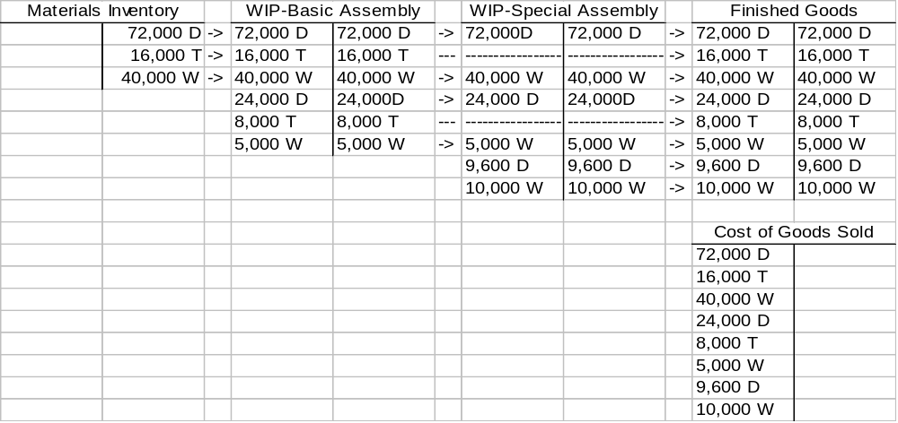

D = Dirt Bike
T = Touring Motorcycle
W = Motorized Wheelchair
8.32 (continued)
c. South Central West
Revenue $90,000 $80,000 $80,000
Costs
Dirt¹ 17,600 44,000 44,000
Touring² 24,000
Wheelchairs³ 44,000 11,000
Profits $28,400 $12,000 $25,000

¹ Equals $440 (from part a above) x units produced and sold to customer: for South, $17,600 = $440 x 40 units

² Equals $300 (from part a above) x units produced and sold to customer: for Central, $24,000 = $300 x 80 units

³ Equals $1,100 (from part a above) x units produced and sold to customer: for South, $44,000 = $1,100 x 40 units
8.33 (60 min) Assign costs to products, operation costing (Appendix B)
a. Nicholson Pitt J. Dean
Number of coats produced 250 140 60

Costs:
Direct materials* $ 50,000 $42,000 $30,000
Conversion costs–Basic Ass’y** 25,000 14,000 6,000
Conversion costs-Special Fin.*** 0 7,000 2,400
Total Product Costs $75,000 $63,000 $38,400
Cost per Unit (total costs/units) $300 $450 $640

* Equals number of units produced times the cost of direct materials per unit: for Nicholson coat, $72,000 = $200 x 250 units
** Equals number of units produced times $100 per unit: for Nicholson coat, $25,000 = $100 x 250 units
*** Equals number of units produced times cost per unit for special finishing: for Pitt coat, $7,000 = $50 x 140 units

8.33 (continued)
b.
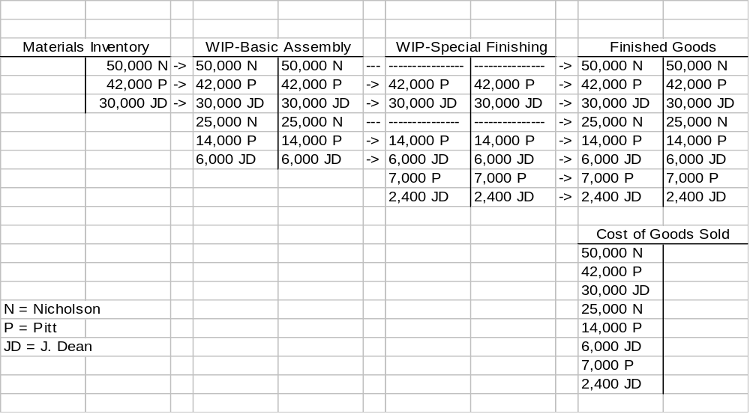

Solutions to problems
8.34 (45 min) Production cost report, weighted-average method
a.

Gates Company
Production Cost Report
Month Ending March 31
 | Physical units | Degree of Completion |  | Equivalent Units
Flow of units |  | Materials | Conversion | Materials | Conversion
Units to account for:
Beginning WIP | 22,000
Units started | 12,000
Total units to account for | 34,000
Units accounted for:
Completed and transferred out | 28,000 | 100% | 100% | 28,000 | 28,000
Ending WIP | 6,000 | 80% | 60% | 4,800 | 3,600
Total units accounted for | 34,000 |  |  | 32,800 | 31,600
Costs to account for | Total Costs |  |  | Materials | Conversion
Costs in beginning WIP | $ 49,800 |  |  | $22,360 | $27,440
Current period costs | 33,800 |  |  | 17,000 | 16,800
Total Costs to account for | 83,600 |  |  | 39,360 | 44,240
Cost per equivalent unit |  |  |  | $ 1.20 | $ 1.40
Costs assigned | Total Costs |  |  | Materials | Conversion
Completed and transferred out | $72,800 |  |  | $ 33,600ª | $ 39,200^{b}
Ending WIP | 10,800 |  |  | 5,760^{c} | 5,040^{d}
Total costs assigned | $ 83,600 |  |  | $ 39,360 | $ 44,240
ª $33,600 = $1.20 x 28,000 E.U.
^{b} $39,200 = $1.40 x 28,000 E.U.
^{c} $5,760 = $1.20 x 4,800 E.U.
^{d} $5,040 = $1.40 x 3,600 E.U.

b. Cost flows
Finished Goods Inventory $72,800
WIP Inventory $72,800

To transfer costs from Work-in-Process inventory to Finished Goods Inventory.

EXCEL SOLUTIONS ARE FOUND IN EXCEL SOLUTIONS FILE

8.35 (60 min.) Production cost report, FIFO method (Appendix A)

Note: Answers might differ because of rounding.

Production Cost Report (FIFO)
Month ending March 31
Mat. Conv Costs EU: Mat EU: Conv costs
Units to account for
Beg. WIP 22,000
Units started 12,000
Total to account for 34,000
Units to account for
Work to complete Beg Inv 22,000 25% 30% 5,500 6,600
Started and completed 6,000 100% 100% 6,000 6,000
Units in End Inv 6,000 80% 60% 4,800 3,600
Total units accounted for 34,000 16,300 16,200

Flow of Costs
Costs to be accounted for
Costs in Beg Inv $49,800 $22,360 $27,440
Current period costs 33,800 17,000 16,800
Total to be accounted for $83,600 $39,360 $44,240
Costs per EU* $1.04294 $1.03704
Costs accounted for
Costs transferred out:
From Beg Inv $49,800 $22,360 $27,440
To complete Beg Inv** 12,580 5,736 6,844
Started and completed*** 12,480 6,258 6,222
Total costs transferred out 74,860 34,354 40,506
Costs in End Inv**** 8,739 5,006 3,733
Total costs accounted for $83,600# $39,360 $44,240#
8.35 (continued)
Footnotes to table
* Cost per EU (equivalent unit) equals current period costs divided by equivalent units of work done in the current period: $1.04294 = $17,000/16,300; $1.03704= $16,800/16,200.
** Costs to complete beginning inventory equal equivalent units to complete beginning inventory times cost per EU: $5,666 = 5,500 x $1.04294; $6,855 = 6,600 x $1.03704.
*** Costs of units started and completed equals units started and completed times cost per EU: $6,258 = 6,000 x $1.04294; $6,222 = 6,000 x $1.03704.
**** Costs in ending inventory equal number of equivalent units in ending inventory times cost per EU: $5,006 = 4,800 x $1.04294; $3,733 = 3,600 x $1.03704.

# Numbers do not add to total because of rounding. (Totals are correct.)

b. The FIFO approach is helpful when costs fluctuate significantly over time. A case can be made for using the FIFO method for the company because this method tracks costs by period, and helps identify increasing or decreasing costs by period. Using the FIFO approach would help the managers of this company see that it had lower costs in the current period than in the previous period.
EXCEL SOLUTIONS ARE FOUND IN EXCEL SOLUTIONS FILE
8.36 (45 min) Production cost report, weighted-average method
a. Note: Answers might differ somewhat due to rounding the cost per equivalent unit

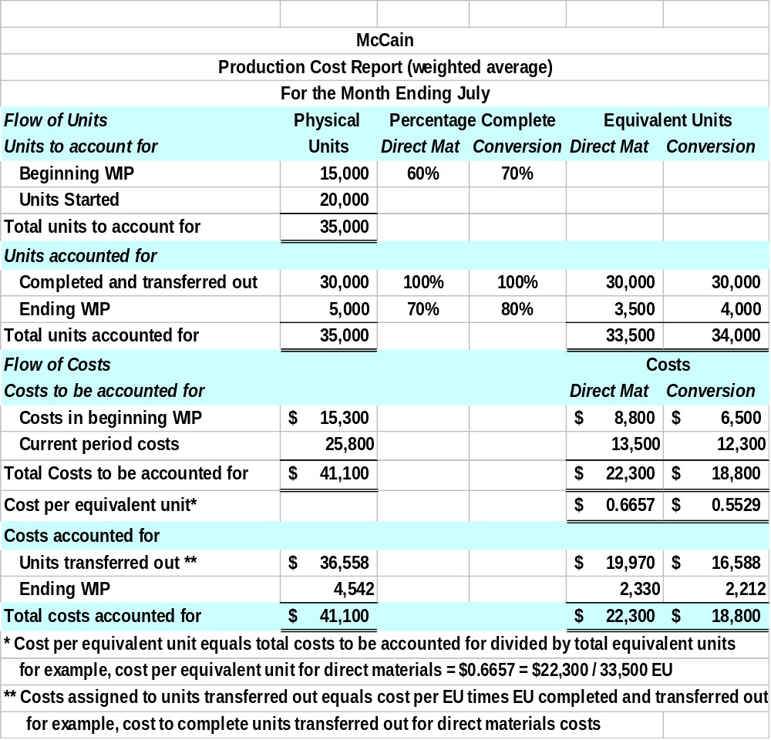
EXCEL SOLUTIONS ARE FOUND IN EXCEL SOLUTIONS FILE

b.

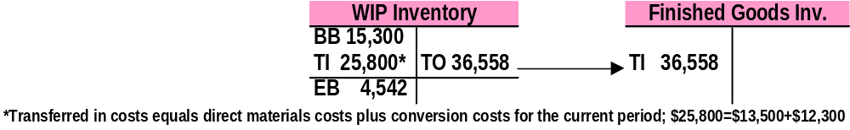

8.37 (45 min) Production cost report, weighted-average

a. Note: Answers might differ due to rounding the cost per equivalent unit calculation.
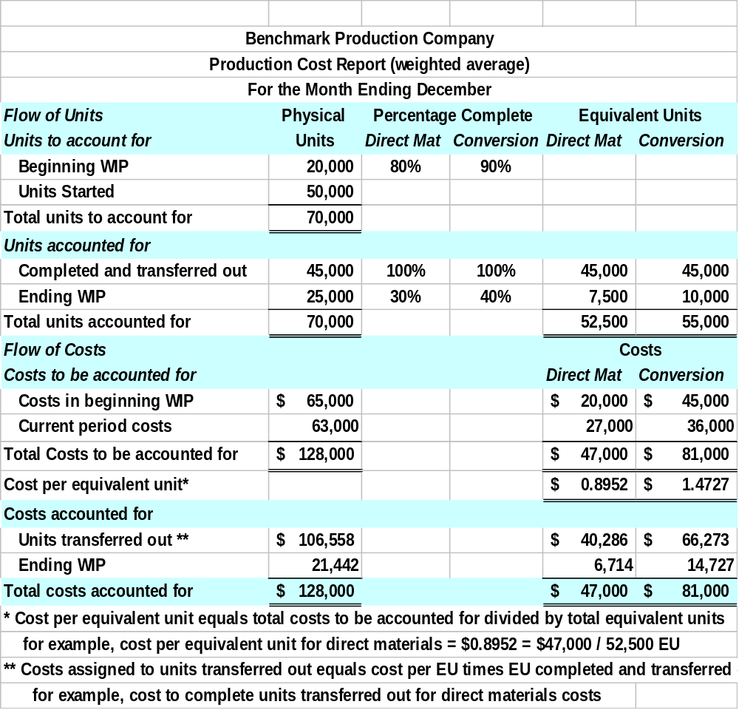

EXCEL SOLUTIONS ARE FOUND IN EXCEL SOLUTIONS FILE

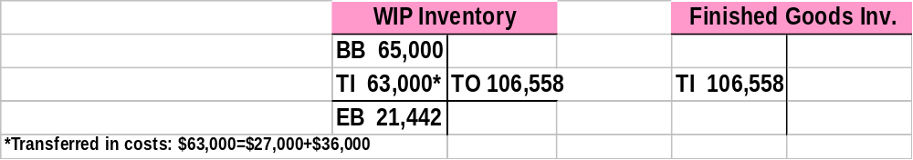b.

8.38 (60 min) Production cost report, FIFO (Appendix A)
a. Note: Answers might differ due to rounding the cost per equivalent unit calculation.

EXCEL SOLUTIONS ARE FOUND IN EXCEL SOLUTIONS FILE

8.38 (continued)
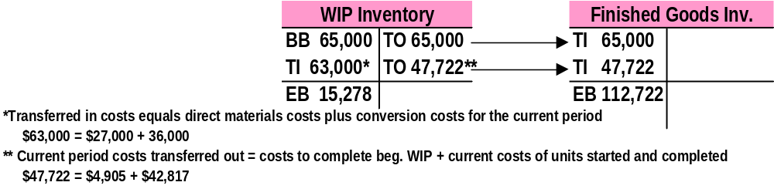b.

c. Using weighted-average costing, ending WIP Inventory was $21,442. Using the FIFO costing approach, ending WIP Inventory was $15,278. The difference is attributable to a lower current cost per equivalent unit using FIFO, which is ultimately assigned to ending WIP Inventory (and the most recent completed inventory transferred out). The FIFO approach is helpful when costs fluctuate significantly over time. A case can be made for using the FIFO method for Needles Production Company because this method tracks costs by period, and helps identify increasing or decreasing costs by period. Using the FIFO approach would help the company identify that it had lower costs in the current period.

8.39 (40 min) Solving for unknowns—weighted-average

a. Answer: 4,350 units.
Start with the formula: transferred out (TO) = beginning inventory (BI) + transferred in (TI) – ending inventory (EI).

TO = 4,100 + 3,500 – 3,250

TO = 4,350

b. Answer: $53,300.
First compute the cost per equivalent unit from ending inventory:
$4,500/(6,000 x .2) = $3.75
Next, multiply the cost per equivalent unit by the total equivalent units for the period to derive the total costs (including BI costs):

$3.75 x 18,000 = $67,500.

Finally, subtract the BI costs from the total costs to derive the materials costs incurred this period:
$67,500 - $14,200 = $53,300.

c. Answer: 200 equivalent units
First, compute the cost of ending inventory:
EI = BI + TI – TO
EI = $1,900 + $18,100 - $19,200
= $800
Next compute the cost per equivalent unit:
$19,200 costs TO/4,800 units TO
= $4
Finally: $800/$4 = 200 equivalent units
d. Answer: 1,200 units in the ending inventory

First, find the cost per equivalent unit:

$3,360 TO/1,600 units TO = $2.10

Next, find the equivalent units for materials costs in EI:

$630/$2.10 = 300 equiv. units

Finally, if these units are 25% complete, then the total number of units in EI
must be 1,200 (1,200 = 300/.25)
8.40 (60 min) Production cost report, weighted average
a. Note: Answers might differ due to rounding the cost per equivalent unit calculation.

Flow of Units |  | Degree of Completion |  |  |  | Equivalent Units
Units to be accounted for | Physical units | Trans. In | Mat'ls | Conv. | Trans. In | Materials | Conversion
Beginning WIP | 1,000 | 100% | 60% | 75% | 1,000 | 600 | 750
Units Transferred In | 6,000
Total units to account for | 7,000
Units accounted for
Completed and transferred out* | 4,300 | 100% | 100% | 100% | 4,300 | 4,300 | 4,300
Ending WIP | 2,700 | 100% | 80% | 45% | 2,700 | 2,160 | 1,215
Total units accounted for | 7,000 |  |  |  | 7,000 | 6,460 | 5,515
Equivalent units |  |  |  |  | 7,000 | 6,460 | 5,515
Costs to be accounted for |  |  |  |  |  | Costs
 |  |  |  |  | Trans. In | Materials | Conversion
Costs in beginning WIP | $ 8,120,000 |  |  |  | $ 7,100,000 | $ 600,000 | $ 420,000
Current period costs | 52,175,000 |  |  |  | 43,200,000 | 2,500,000 | 6,475,000
Total Costs to be accounted for | $ 60,295,000 |  |  |  | $ 50,300,000 | $ 3,100,000 | $ 6,895,000
Cost per equivalent unit |  |  |  |  | $ 7,185.71 | $ 479.88 | $ 1,250.23
Costs accounted for
Completed and Transferred out | $ 38,338,014 |  |  |  | $ 30,898,571 | $ 2,063,467 | $ 5,375,975
Ending WIP | 21,956,986 |  |  |  | 19,401,429 | 1,036,533 | 1,519,025
Total costs accounted for | $ 60,295,000 |  |  |  | $ 50,300,000 | $ 3,100,000 | $ 6,895,000
* 4,300 = 7,000 - 2,700
EXCEL SOLUTIONS ARE FOUND IN EXCEL SOLUTIONS FILE

8.40 (continued)
b. WIP
BB 8,120,000
TI 52,175,000* | TO 38,338,014
EB 21,956,986

* Transfers-in cost represents the total of shredding process costs, direct material costs, and conversion costs; $52,175,000 = $43,200,000 + $2,500,000 + $6,475,000
8.41 (60 min) Production cost report, weighted-average
a.
 |  | Degree | Of Completion |  |  |  |  |  | Equivalent | units
Units to be accounted for | Physical Units | Transferred In | Materials | Labor | Overhead | Transferred In |  |  | Materials | Labor | Overhead
Beginning WIP | 1,000 | 100% | 100% | 60% | 50% | 1,000 |  |  | 1,000 | 600 | 500
Units transferred In | 5,000
Total units to account for | 6,000
Units accounted for
Completed & transferred | 4,000 | 100% | 100% | 100% | 100% | 4,000 |  |  | 4,000 | 4,000 | 4,000
Ending WIP | 2,000 | 100% | 90% | 70% | 35% | 2,000 |  |  | 1,800 | 1,400 | 700
Total units accounted for | 6,000 |  |  |  |  | 6,000 |  |  | 5,800 | 5,400 | 4,700
Costs to be accounted for |  |  |  |  |  |  |  | Costs
Costs in beginning WIP | $ 64,700 |  |  |  |  | $ 32,000 |  |  | $ 20,000 | $ 7,200 | $ 5,500
Current period costs | 310,000 |  |  |  |  | 160,000 |  |  | 96,000 | 36,000 | 18,000
Total costs to account for | $ 374,700 |  |  |  |  | $ 192,000 |  |  | $ 116,000 | $ 43,200 | $ 23,500
Cost per equivalent unit |  |  |  |  |  | $ 32.00 |  |  | $ 20.00 | $ 8.00 | $ 5.00
Costs accounted for
Completed & transferred out | $ 260,000 |  |  |  |  | $ 128,000 |  |  | $ 80,000 | $ 32,000 | $ 20,000
Ending WIP | 114,700 |  |  |  |  | 64,000 |  |  | $ 36,000 | $ 11,200 | $ 3,500
Total costs accounted for | $ 374,700 |  |  |  |  | $ 192,000 |  |  | $ 116,000 | $ 43,200 | $ 23,500

b. The weighted-average production analysis indicates that the assembling department has met its material cost target and beat its labor cost target. However, it has not met its overhead cost target of $4.50 (versus $5.00 actual cost).
EXCEL SOLUTIONS ARE FOUND IN EXCEL SOLUTIONS FILE
8.42 (45 min) Production cost report (with spoilage), weighted-average
a. Note: Answers might differ due to rounding the cost per equivalent unit calculation.

Flow of Units | Physical units | Degree of Completion |  | Equivalent Units
Units to be accounted for |  | Materials | Conversion | Materials | Conversion
Beginning WIP | 11,000 | 75% | 70%
Units Started | 6,000
Total units to account for | 17,000
Units accounted for
Completed and transferred | 13,800 | 100% | 100% | 13,800 | 13,800
Spoilage | 200 | 100% | 100% | 200 | 200
Ending WIP | 3,000 | 80% | 60% | 2,400 | 1,800
Total units accounted for | 17,000 |  |  | 16,400 | 15,800
Costs to be accounted for |  |  |  | Costs
Costs in beginning WIP | $ 4,650 |  |  | $ 3,200 | $ 1,450
Current period costs | 31,800 |  |  | 16,000 | 15,800
Total Costs to account for | 36,450 |  |  | 19,200 | 17,250
Cost per equivalent unit |  |  |  | $1.171 | $ 1.092
Costs accounted for
Completed and Transferred out | $ 31,222 |  |  | $ 16,156 | $ 15,066
Spoilage | 453 |  |  | 234 | 219
Ending WIP | 4,775 |  |  | 2,810 | 1,965
Total costs accounted for | $ 36,450 |  |  | $ 19,200 | $ 17,250

b.
 | WIP
 | BB 4,650
 | TI 31,800 | TO 31,222
 |  | Spoilage 453
 | EB 4,775

EXCEL SOLUTIONS ARE FOUND IN EXCEL SOLUTIONS FILE
8.43 (45 min) Production cost report (with spoilage), weighted-average
a. Note: Rounding is due to rounding the cost per equivalent unit calculation.

Flow of Units | Physical units | Degree of Completion |  | Equivalent Units
Units to be accounted for |  | Materials | Conversion | Materials | Conversion
Beginning WIP | 13,000 | 70% | 60%
Units Started | 17,000
Total units to account for | 30,000
Units accounted for
Completed and transferred | 22,500 | 100% | 100% | 22,500 | 22,500
Spoilage | 1,500 | 75% | 60% | 1,125 | 900
Ending WIP | 6,000 | 60% | 55% | 3,600 | 3,300
Total units accounted for | 30,000 |  |  | 27,225 | 26,700
Costs to be accounted for |  |  |  | Costs
Costs in beginning WIP | $ 18,500 |  |  | $ 6,500 | $ 12,000
Current period costs | 31,800 |  |  | 16,000 | 15,800
Total Costs to account for | $ 50,300 |  |  | $ 22,500 | 27,800
Cost per equivalent unit |  |  |  | $ 0.8264 | $ 1.0412
Costs accounted for
Completed and Transferred out | $ 42,021 |  |  | $ 18,594 | 23,427
Spoilage | 1,868 |  |  | 931 | 937
Ending WIP | 6,411 |  |  | 2,975 | 3,436
Total costs accounted for | $ 50,300 |  |  | $ 22,500 | $ 27,800

b.
 | WIP
 | BB 18,500
 | TI 31,800 | TO 42,021
 |  | Spoilage 1,868
 | EB 6,411

EXCEL SOLUTIONS ARE FOUND IN EXCEL SOLUTIONS FILE

8.44 (30 min) Transfer from Prior Department, Weighted Average
a.
Flow of Units | Physical units | Degree of Completion |  | Equivalent Units
Units to be accounted for |  | Materials | Conversion | Materials | Conversion
Beginning WIP | 25,000 | 0% | 40%
Units transferred In | 120,000
Total units to account for | 145,000
Units accounted for
Completed & transferred | 132,500 | 100% | 100% | 132,500 | 132,500
Ending WIP | 12,500 | 100% | 30% | 12,500 | 3,750
Total units accounted for | 145,000 |  |  | 145,000 | 136,250

b.
Flow of Units | Physical units | Degree of |  | Completion | Equivalent Units
Units to be accounted for |  | Transferred In | Materials | Conversion | Transferred In | Materials | Conversion
Beginning WIP | 50,000 | 100% | 0% | 80%
Units Transferred In | 320,000
Total units to account for | 370,000
Units accounted for
Completed & transferred | 330,000 | 100% | 100% | 100% | 330,000 | 330,000 | 330,000
Ending WIP | 40,000 | 100% | 0% | 90% | 40,000 | - | 36,000
Total units accounted for | 370,000 |  |  |  | 370,000 | 330,000 | 366,000

solutions to cases

8.45 (60 min) Public policy and process costing
a. $000 omitted
Balance | Finished goods | WIP
BB (given) | $ 24, 832* | $ 13,868*
TI = EB + TO – BB* | 330,361 | 335,713
TO = BB + TI – EB** | 329,748* | 330,361
EB (given) | 25,445* | 19,220*
* Given in the case.
** TO is CGS for Finished Goods Inventory. TO for WIP is the TI to Finished Goods Inventory.

b. Process costs per unit. Start by computing product line costs.
Operating profit = Net sales – SG&A – COGS.
So, COGS = Net sales – SG&A – Operating profit.
$000 omitted.
Product line | Net sales | % sales | SG&A* | Operating profit | CGS
Timber products | $ 79,045 | 21.83% | $7,053 | $ 37,309 | $ 34,683
Paper and paperboard | 92,433 | 25.52% | 8,247 | (11,842) | 96,028
Converted products | 190,677 | 52.65% | 17,013 | (25,373) | 199,037
Total | $ 362,155 | 100% | $ 32,313 | $ 94 | $ 329,748
* Allocated to product line based on the product line’s percent of total sales.
For example, $7,053 = $79,045/$362,155 x $32,313.

EXCEL SOLUTIONS ARE FOUND IN EXCEL SOLUTIONS FILE

8.45 (continued)
The following table answers both questions b and c:
Product area | CGS | Sales quantity | Year 2 cost per unit | Year 1 cost per unit | % change
Timber products | $ 34,683,000 | 144,000,000 | $ .24 | $ .23 | 4%
Paper and paperboard | 96,028,000 | 177,000 | 542.53 | 502.01 | 8%
Converted products | 199,037,000 | 255,000 | 780.54 | 789.59 | -1%
Total | $329,748,000

The results in the last column are consistent with reduced conversion costs for converted products – despite increased material costs converted product costs have declined. It does not appear, however, that the company has reduced its conversion costs for timber or paper sufficiently to offset increased material prices. This demonstrates the cost squeeze experienced by Longview Fibre and others that depend on more expensive, local timber. Some companies, such as Weyerhaeuser, have secured long-term supplies from private lands in Canada and have entered joint ventures to grow and harvest timber in New Zealand and South America.

8.46 (60 min) Choosing between job and process costing
Answers will vary. Some large companies that have both commercial and governmental customers include such defense contractors as Boeing, General Electric and Honeywell. Many consulting firms, including the Big 5 accountancy firms, service both governmental and commercial customers. Many firms that provide IT, food and maintenance services have both governmental and commercial customers. Some universities offer programs for governmental employees, such as people in the military services, and nongovernmental students. (Note that governmental is not limited to national governments, but includes local, county and state/provincial governmental units.)
Governmental contracts sometimes require cost-plus fees, which necessitate job costing. Companies with governmental customers sometimes find that the profit margins are smaller on governmental work, thus increasing the benefits of close cost control that job costing provides. Governments might require job costing because they are subject to scrutiny by citizens who want to know how much is spent on particular jobs or projects.

8.47 (60 min.) Spoilage costs, weighted-average

a. Normal vs abnormal spoilage: The issue is whether any spoilage should be regarded as normal. Many feel that this label implies that spoilage is acceptable, and that this attitude is not competitive these days. Normal spoilage of 300 jackets at the first inspection (4.1% of those inspected = 300 / (8,160 – 900)) seems quite high for most industries. Presumably, the company will seek to eliminate the sources of the abnormal spoilage, but why not seek to eliminate it all? Although the optimal amount of spoilage (or defects) may be greater than zero, “normal” spoilage implies historical levels of spoilage that people have gotten used to.
b. Production analysis
Flow of Units |  | Degree of | Completion |  |  | Equivalent | Units
Units to be accounted for | Physical units | Material #1 | Material #2 | Conversion | Material #1 | Material #2 | Conversion
Beginning WIP | 560 | 100% | 0% | 25%
Units started | 7,600
Total units to be accounted for | 8,160
Units accounted for
Completed | 6,600 | 100% | 100% | 100% | 6,600 | 6,600 | 6,600
Spoilage - 1st insp | 460 | 100% | 0% | 70% | 460 | - | 322
Spoilage - 2nd insp | 200 | 100% | 100% | 100% | 200 | 200 | 200
Ending WIP | 900 | 100% | 0% | 50% | 900 | - | 450
Units accounted for | 8,160 |  |  |  | 8,160 | 6,800 | 7,572
Costs to be accounted for
Beginning WIP | $ 17,006 |  |  |  | $12, 500 | $ - | $ 4,506
Current period costs | 605,220 |  |  |  | 252,700 | 74,120 | 278,400
Costs to be accounted for | $622,226 |  |  |  | $ 265,200 | $ 74,120 | $ 282,906
Cost per equiv. unit |  |  |  |  | $ 32.50 | $ 10.90 | $ 37.36
Costs accounted for
Completed | $533,030 |  |  |  | $ 214,500 | $ 71,940 | $ 246,590
Spoilage - 1st insp | 26,981 |  |  |  | 14,950 | - | $ 12,031
Spoilage - 2nd insp | 16,152 |  |  |  | 6,500 | 2,180 | $ 7,472
Ending WIP | 46,063 |  |  |  | 29,250 | - | 16,813
Costs accounted for | $622,226 |  |  |  | $ 265,200 | $ 74,120 | $ 282,906
EXCEL SOLUTIONS ARE FOUND IN EXCEL SOLUTIONS FILE
8.47 (continued)
c. Required return on sales = (125 - 75) / 125 = 40%. Current costs per unit equal $80.76 (= $32.50 + $10.90 + $37.36).
P = $80.76 / (1 - .40)
P = $134.60
The target cost reduction = $80.76 – $75 = $5.76 per unit.

8.48 (60 min.) Ethics – Increasing Production to Boost Profit

a. Knowing that any units started in the last half of March will remain in WIP Inventory at the end of the month, management is attempting to allocate a higher proportion of fixed costs (primarily overhead costs) to ending WIP Inventory. This in turn reduces the proportion of costs allocated to goods transferred out to Finished Goods Inventory. Since all goods transferred out during March were sold by March 31, fewer costs would ultimately be assigned to Cost of Goods Sold for the month. Lower Cost of Goods Sold results in higher net income.

b. The revised production cost report appears below. Amounts may vary slightly due to rounding.
8.48 cont.
Unit Information
Units
(board
feet)
Direct
materials
Direct
labor
Overhead
Units in beginning WIP Inventory (all completed this period)
250,000

n/a
n/a
n/a
Units started and completed during the period
140,000

100%
100%
100%
Units started and
partially
completed during the period
225,000

80%
85%
90%
Cost Information
Direct
materials
Direct
labor
Overhead
Costs in beginning WIP Inventory
$76,000
$90,000
$150,000
Costs incurred during the period
$95,000
$102,000
$150,000
Step 1: Summary of Physical Units and Equivalent Unit Calculations

Units to be accounted for
Physical
Units
Units in beginning WIP Inventory
250,000

Units started during the period
365,000

Total units to be accounted for
615,000

Units accounted for
Physical
Units
Direct
materials
Direct
labor
Overhead
Units completed and transferred out
390,000

390,000

390,000

390,000

Units in ending WIP Inventory
225,000

180,000

191,250

202,500

Total units accounted for
615,000

570,000

581,250

592,500

check: total units to be accounted for = total units accounted for? If so, amount = 0 ---->
0
Step 2: Summary of Costs to be Accounted for

Costs to be accounted for
Direct
materials
Direct
labor
Overhead
Total
Costs in beginning WIP Inventory
$76,000
$90,000
$150,000
$316,000
Costs incurred during the period
95,000
102,000
150,000
347,000
Total costs to be accounted for
$171,000
$192,000
$300,000
$663,000
check: total costs to be accounted for = total costs accounted for? If so, amount = $0 ---->
$0
Step 3: Calculation of Cost per Equivalent Unit
Direct
materials
Direct
labor
Overhead
Total
Total costs to be accounted for (a)
$171,000
$192,000
$300,000
Total equivalent units accounted for (b)
570,000
581,250
592,500
Cost per equivalent unit (a) / (b)
$0.3000
$0.3303
$0.5063
$1.1367
Step 4: Assign Costs to Units Transferred Out and Units in Ending WIP Inventory
Direct
materials
Direct
labor
Overhead
Total
Costs assigned to units transferred out*
$117,000
$128,826
$197,468
$443,294
Costs assigned to ending WIP Inventory*
54,000
63,174
102,532
219,706
Total costs accounted for
$663,000
Month Ending March 31
Equivalent Units
Percent Complete
Data Entry Section
Pacific Siding Incorporated
Preliminary
Production Cost Report

*These costs = cost per EU x EU transferred out or in ending inventory.

c. The last section of the report (Step 4) clearly identifies the impact of increasing production. Specifically, comparing the costs assigned to units transferred out from the Controller’s initial estimate to the revised report prepared in part b will identify the impact on profit. Since all units transferred out were sold by March 31, the costs assigned to these units are ultimately included in Cost of Goods Sold on the income statement as of March 31. Thus, if these costs decrease, Cost of Goods Sold decreases, and net income (profit) increases.
Profit is estimated to increase by $98,327 as a result of boosting production at the end of March (this amount may vary slightly due to rounding). This is calculated as follows:
Costs assigned to units transferred out (no increase
in production) $541,621
Costs assigned to units transferred out (with increase
in production) 443,294
Increase in Profit $ 98,327

The primary reason for this increase is that more overhead costs, most of which are fixed, are allocated to units remaining in ending WIP Inventory at March 31.

d. The request made by the CEO and CFO is not ethical if the only motivation is to increase profit. The case clearly states that Pacific Siding does not expect an increase in sales. Absent any additional customer demand, it appears that the only reason to boost production is to manipulate profit. This action places the company in a precarious position starting the next fiscal year as inventory levels will reach excessive levels.

