Enter Daily Transactions

Please note that the source document number (Check#, JE#, Invoice #) may vary from the sample. Start invoices at 1000 and Credit Memos at 100. If information is needed on the invoice but is not stated, create your own data.

**Decorating supplies and Baking Supplies purchased on account**

a. August 1, 200X Purchased decorating supplies $123 and purchases $700 from *Decorating House*, $823. P.O. #995, 2/10 Net 30 (G/L) Add a new account “Purchases” and transfer the Baking Supplies balance.

**Create Invoice**

b. August 2, 200X Sold 100 cupcakes @$3.50 each to *Fred’s Farm, 145 Marsh St*, Your City, Your State, Zip. Inv #1000. 2/10 Net 30

**Create Sales Invoice with full Payment, add Customer and Item “on-the-fly”**

c. August 3, 200X *Little Rock School District, 80 River Ave,* Your City, Your State, Zip ordered 30 sheet cakes @ $40 each to P.O. #00576. Order to be picked up and paid on August

**Add New Item and Customer “on the fly”**

d. August 4, 200X Create invoice for 50 cake pans @ $3 each to *Bill Norman Design, 1441 Baget Street*, Your City, Your State, Zip. for party decorations, $150,

Inv # 1001 2/10 Net 30. UPS

**Record Check paid to Decorating House**

e. August 10, 200X Paid 8/1/0X *Decorating House* Invoice, CK #106, no discount $823 (G/L)

**Purchased Office Supplies on Account**

f. August 10, 200X Purchased on account office supplies from *Target Stores*, $200. Add account Office Supplies as a current asset. (G/L)

**Receive Payment from Customer with discount**

g. August 12, 200X Received check #1122 for $343 from *Fred’s Farm*. Invoice dated 8/2.

**Create Invoice with Multiple Items**

h. August 16, 200X Billed *Mall's Stores, 3 West Place*, Your City, Your State, Zip. for desserts for their Open House , P.O. 65432. Net 30, $840

Qty Description $each

5 3-layer cakes 100

6 Sheet cakes 40

100 Mini cupcakes 1

**Record Return Item**

i. August 17, 200X Two sheet cakes fell while delivering the order. Give Mall Stores credit for two returned sheet cakes from 8/16 invoice. Use Sales Return and Allowance

**Create Invoice – Sale on Account**

j. August 18, 200X Invoice Mall’s for 200 cupcakes @ $3.50 each. Net 30 days. Ship via delivered. No Freight. $700

**Cash Receipt for Mutliple Invoices and Sales Return and Allowance**

k. August 31, 200X Received CK # 191989 for $1190 from Mall’s for all of 8/16 invoice and 1/2 of 8/17 invoice.

**Record Bad Debt**

l. August 31, 200X Bill Norman was nowhere to be found. Declared his account to be uncollectible. Use Bad Debt Expense to remove his account from the A/R Ledger

**Paid for part-time help –Add account “on- the- fly”**

m. August 31, 200X Paid Karen Lee $500 for her part-time help. CK#107. Add account Wages Expense if needed. (G/L)

**Owner Withdrawal**

n. August 31, 200X Kim withdrew $1,000. Check #108. (G/L)

**Sales Invoice from Sales Order**

o. August 31, 200X Little Rock School District picked up and paid for the cakes ordered on August 3rd, $1200 CK#167898.

**Cash Deposit**

p. August 31, 200X Make a deposit of the cash receipt for the month. (Note for practice purpose deposits are made at the end of the month. Deposits should be made daily)

**Adjusting Entries - G/L**

p. August 31, 200X Truck Depreciation $100

q. August 31, 200X Equipment Depreciation $175

r. August 31, 200X Office Supplies ON HAND, $75 and Decorating Supplies on Hand $100 (Journal entry is calculated by subtracting on hand amount from the balance in office supplies and decorating supplies account)

**STEP BY STEP INSTRUCTIONS:**

**Decorating supplies and Baking supplies (Purchases) purchased on Account**

a. August 1, 200X Purchased decorating supplies $123 and purchases $700 from *Decorating House*, Total $823. P.O. #995, 2/10 Net 30 Add a new account “Purchases” and transfer the Baking Supplies balance. (G/L)

1. Add new account “Purchases” when adding the journal entry to transfer Baking Supplies to Purchases. Purchases is an “Other Account Type: Cost of Goods Sold”.

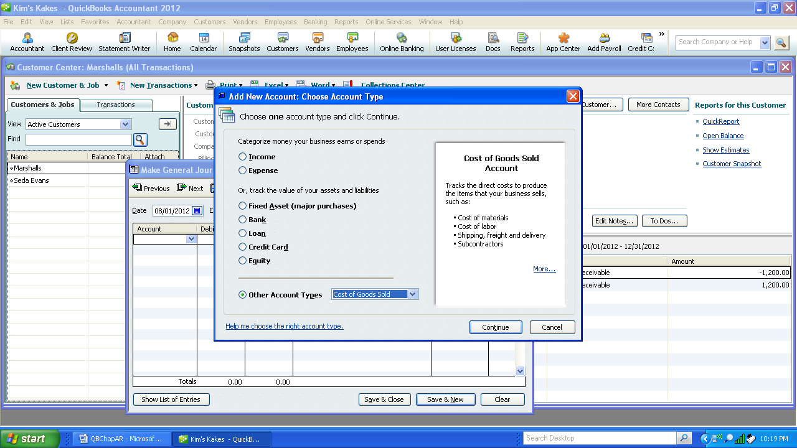

1. Add New Account—enter Purchases as the name of the account. Select Save and Close.

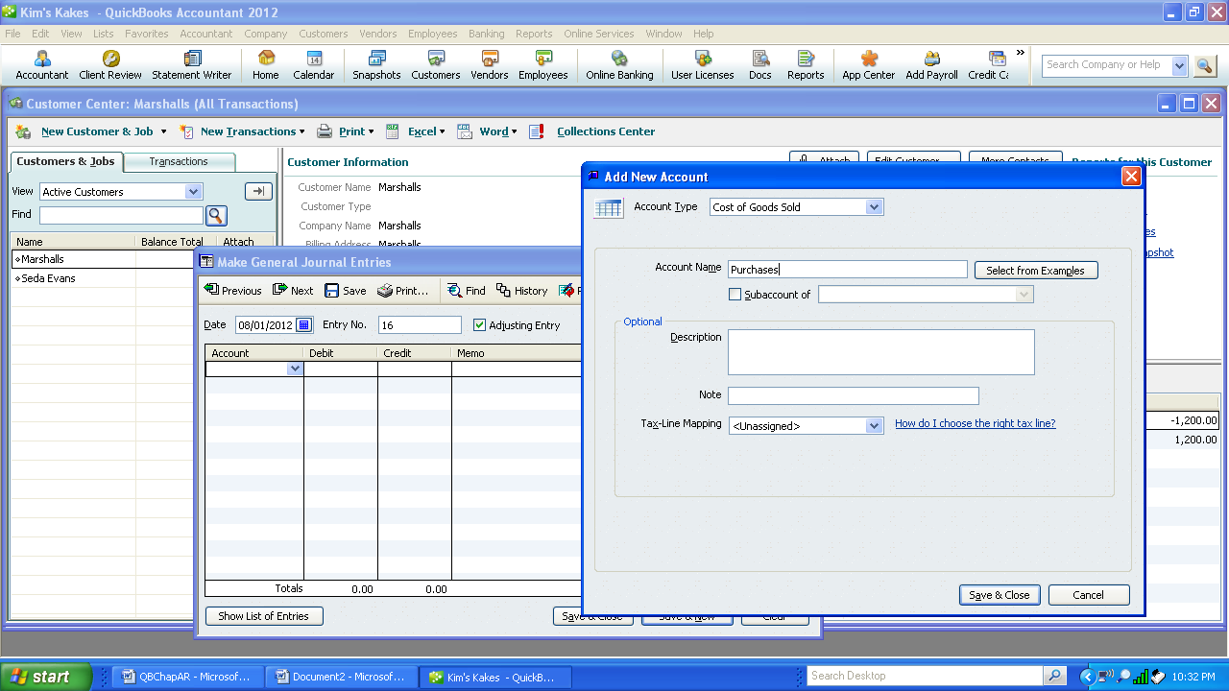

1. Enter $250 as a debit to Purchases and select account Baking Supplies as a $250 credit. This will transfer the amount in Baking Supplies to Purchases. Select Save & Close to enter the next transaction.

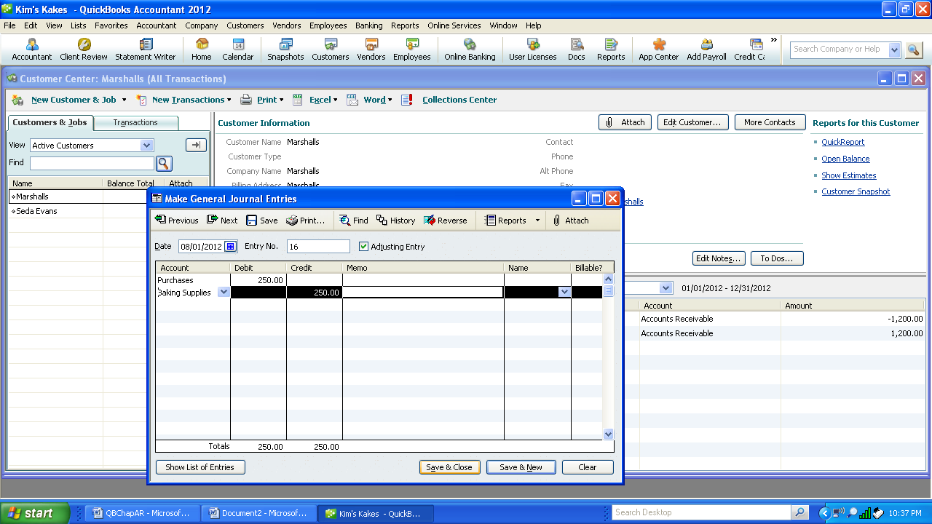

4. Select Company, Make Journal Entry

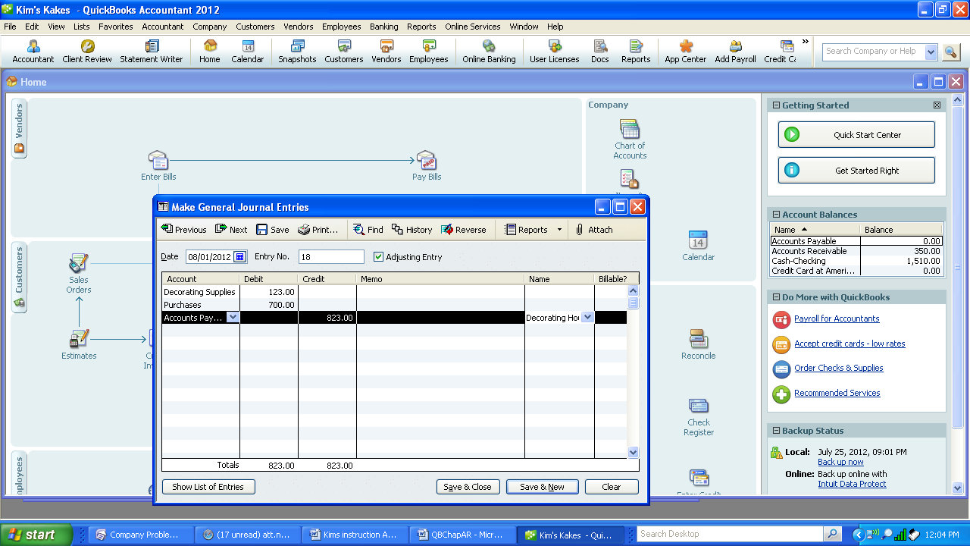

2. Select Save & Close.

**Create Invoice**

b. August 2, 200X Sold 100 cupcakes @$3.50 each to *Fred’s Farm, 145 Marsh St*, Your City, Your State, Zip. Inv #1000. 2/10 Net 30

1. From the Home screen, select Create Invoices from the Customer area or Choose Customer drop down menu and select Create Invoices Icon

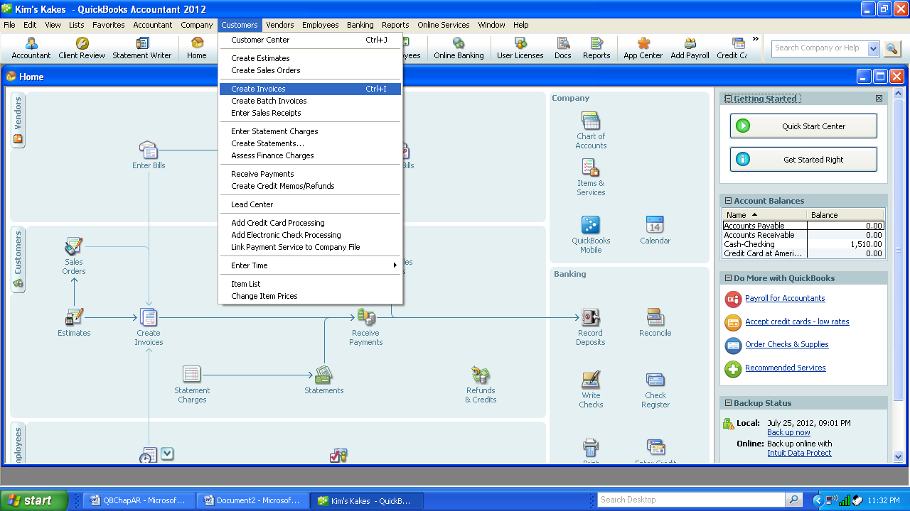

2. Select Customer: Job Field and Add new. Enter the information into the New Customer Screen. Then click OK.

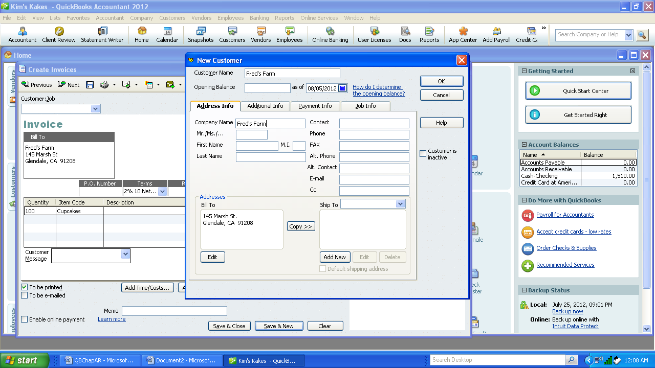

3. Enter the invoice # as 1000 and double check the date. Select 2/10 Net 30 from the Terms pull down menu

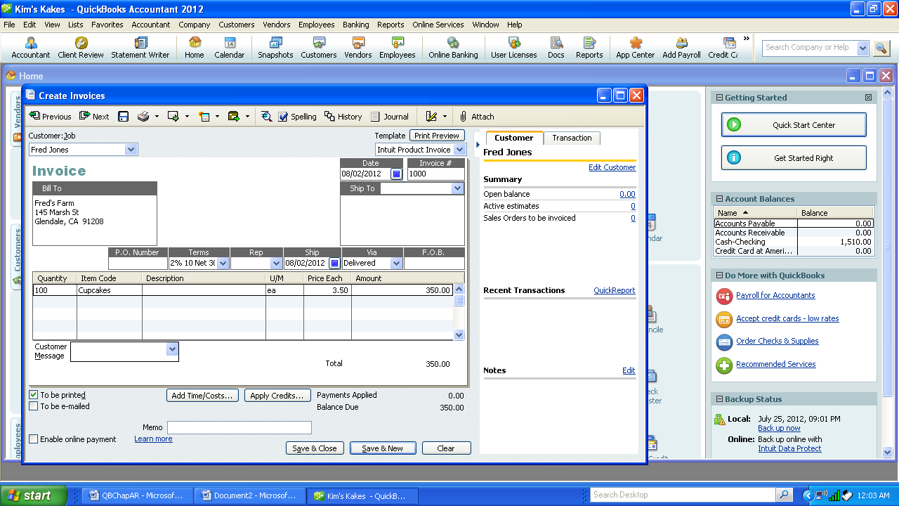

1. Add “Delivered” as a new type of freight. Select VIA and add new, enter delivered

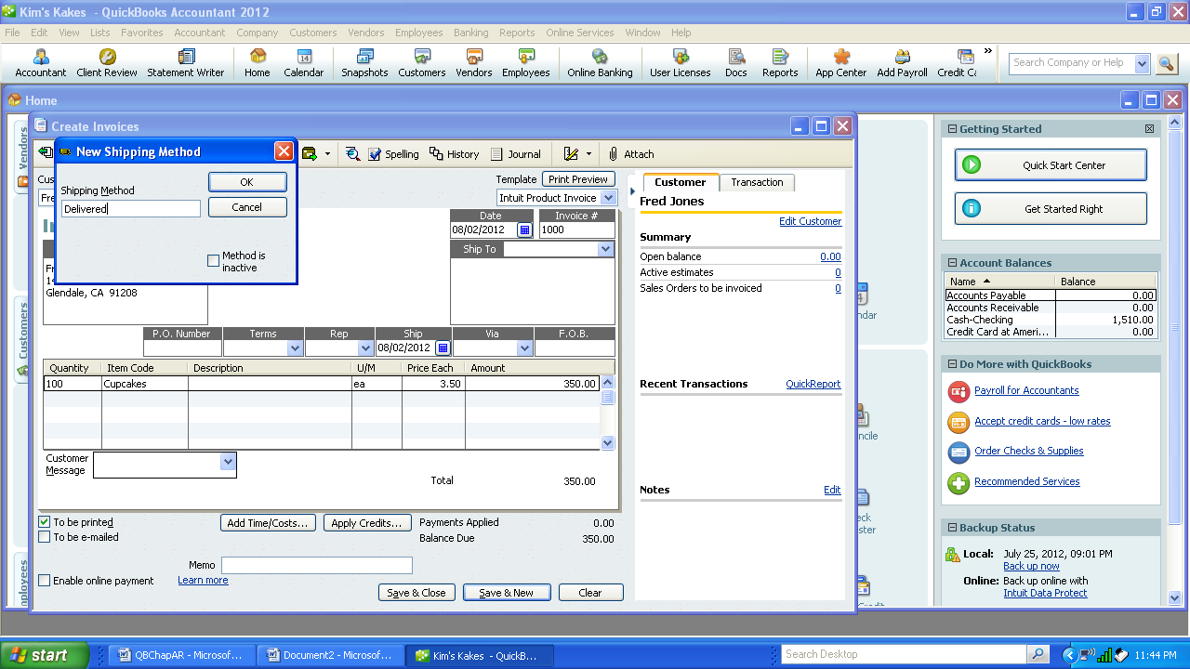

1. Enter Quantity and add the item as a new item.

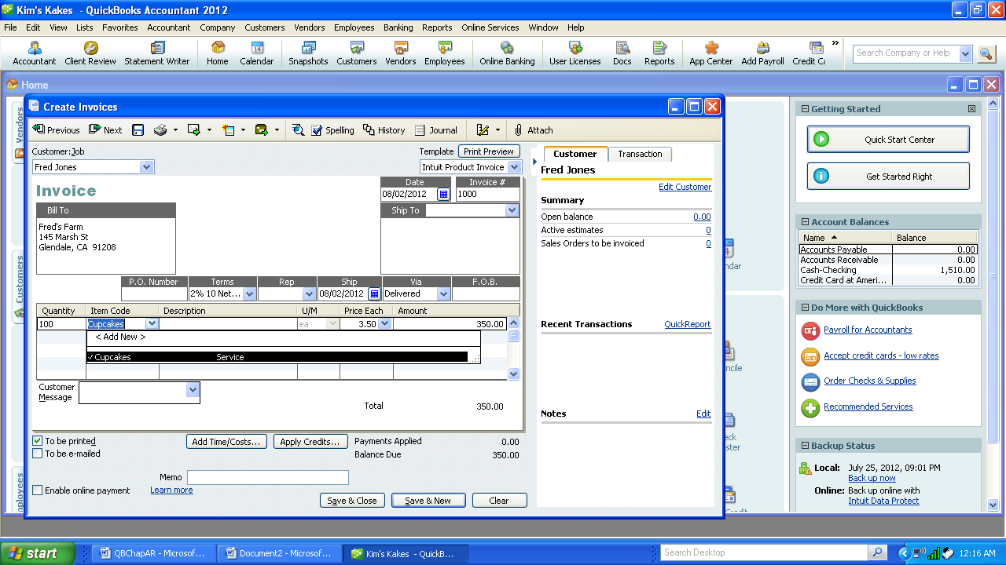

1. Enter the information for the item cupcakes. Then OK.

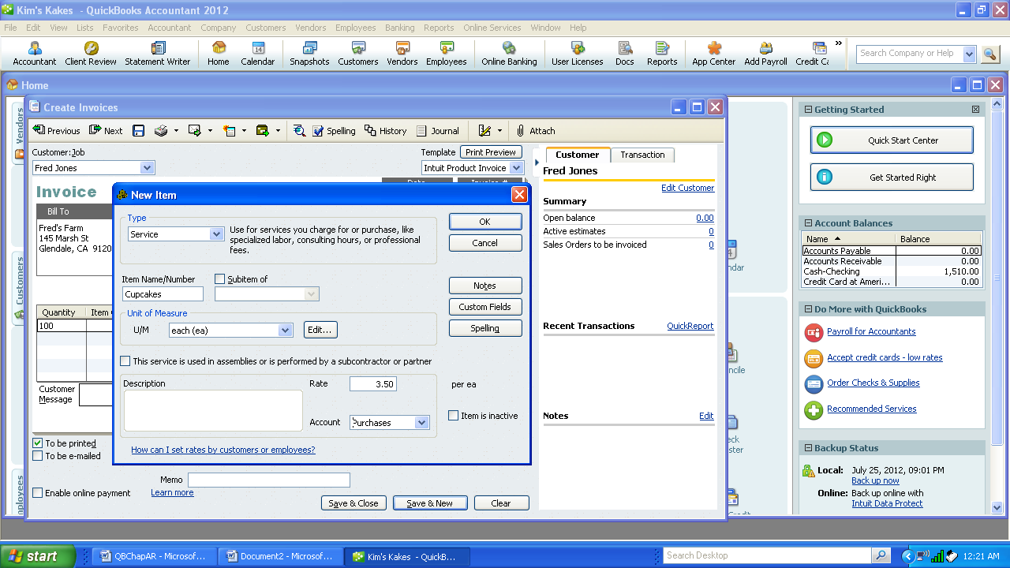

This method is entering the new item when the invoice is created. Another way is to add all the items as a set-up feature of the Customer/Accounts Receivable module. To accomplish this select

1. Customer (top menu line), Item List and then select New. All the items can be entered at this time. Customers and Items can all be at the beginning to make the data entry easier. But entering the customers and items on the fly tends to be easier.

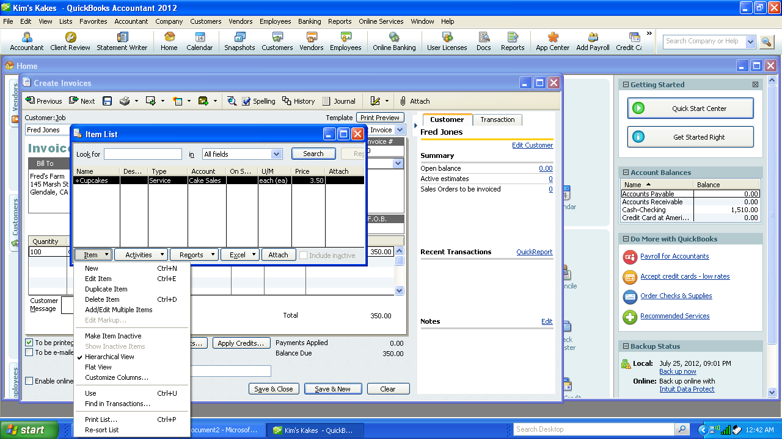

1. Double check that all the information has been entered for invoice #1000. If correct select print preview before printing. If correct, Select print to print Fred’s Farms invoice.

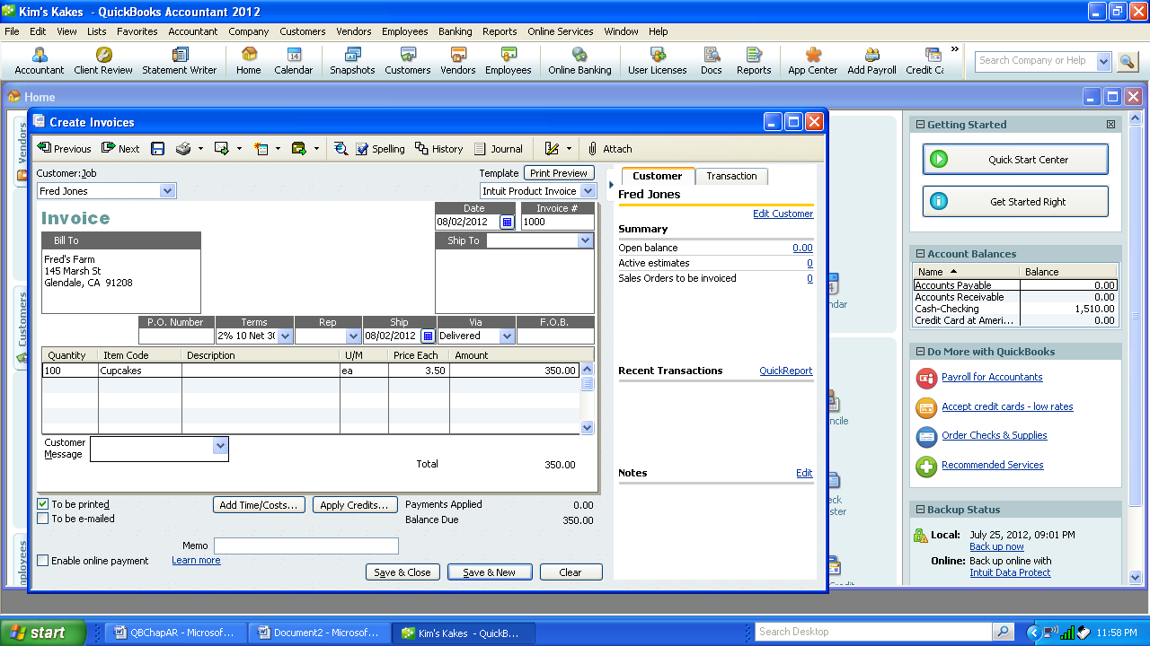

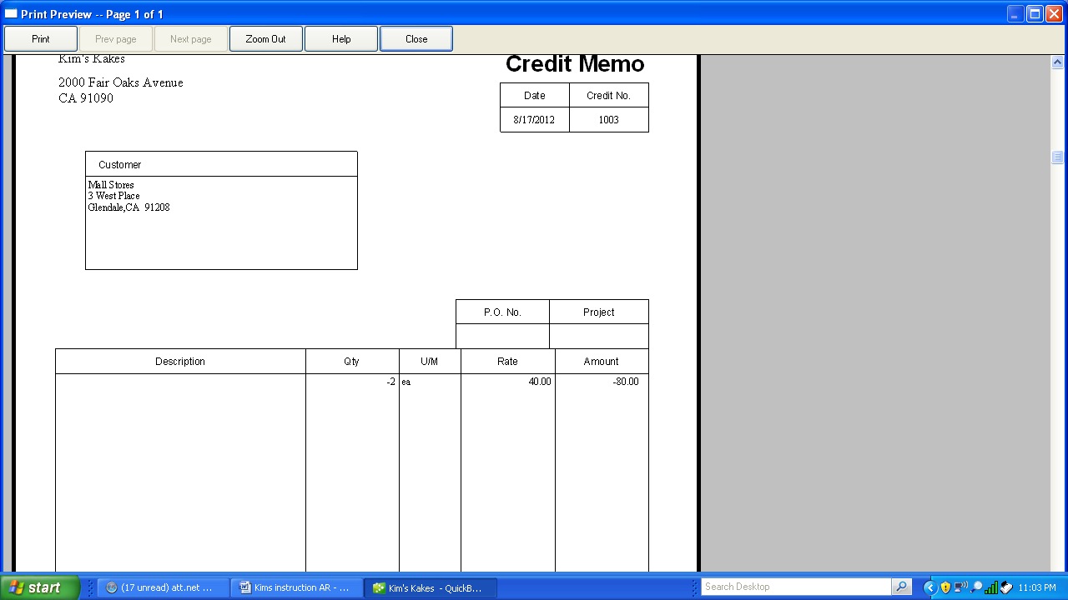

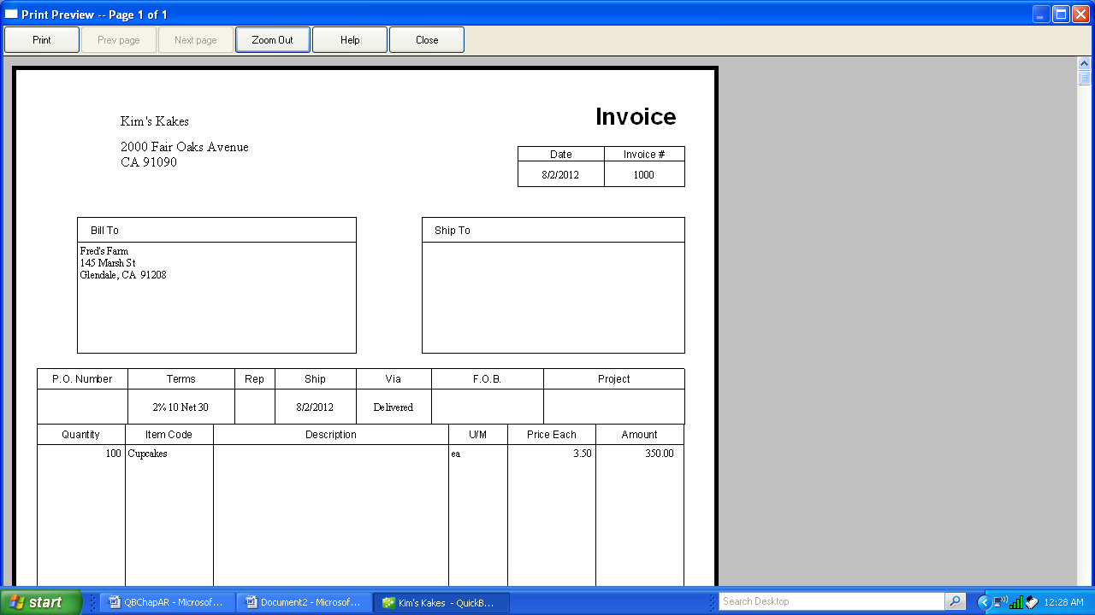

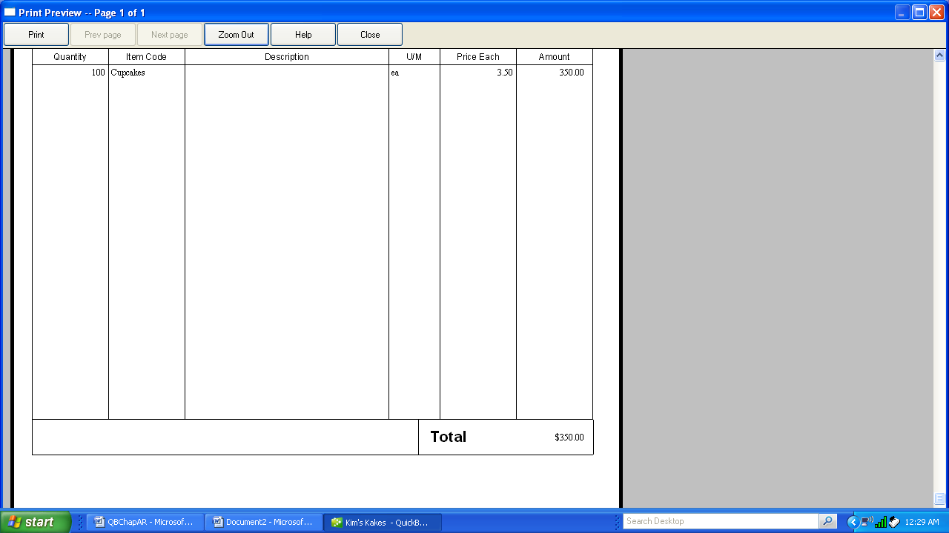

**Create Sales Order**

c. August 3, 200X *Little Rock School District, 80 River Ave,* Your City, Your State, Zip ordered 30 sheet cakes @ $40 each to P.O. #00576. Order to be picked up and paid on August 31.

1. Select Customer-Sales Order from the pull down menu or from the Sales Order icon from the Customer Area.

2. “Add New” Customer: Little Rock School District and “Add New” Item: Sheet Cakes as described in the previous transaction.

3. Continue to add the remaining information for the Sales Order. Compare with the screen display below. When OK press enter or select Save&Close.

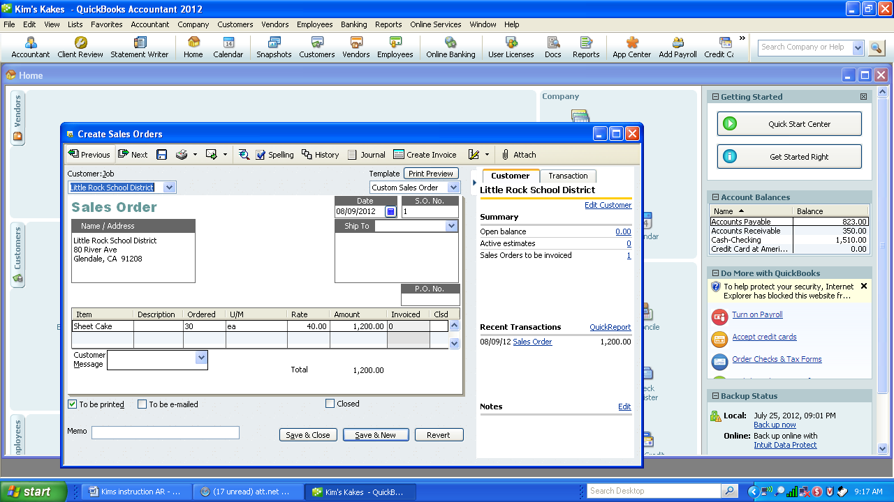

4. Remember if you pressed the enter key at any time and an empty invoice appeared, simply select the previous key above the sales order to return to your invoice.

**Add New Item and Customer “on the fly”**

d. August 4, 200X Create invoice for 50 cake pans @ $3 each to *Bill Norman Design, 1441 Baget Street*, Your City, Your State, Zip for party decorations, $150,

Inv # 1001 2/10 Net 30. UPS

1. Select “Create Invoice” icon or Customer-Create Invoice. Invoice 1001 will appear automatically.
2. Correct the date, if necessary, to 08/04/xx.

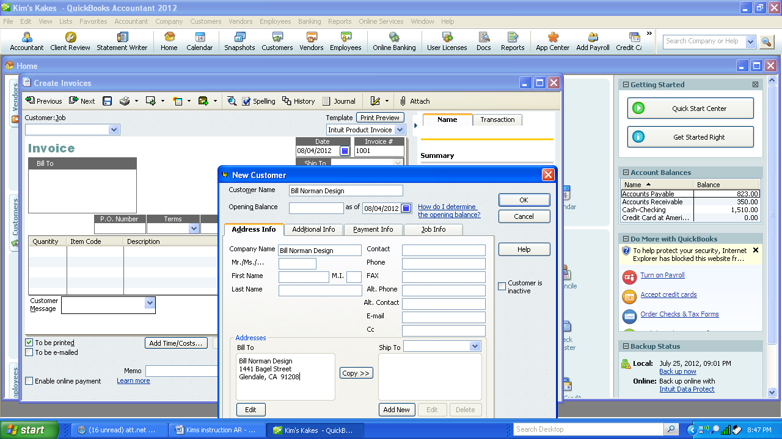

1. Select OK.
2. Enter 50 in Quantity and Add New in Item Code. Enter Cake Pans as the new item, Non-inventory, $3.00 each.

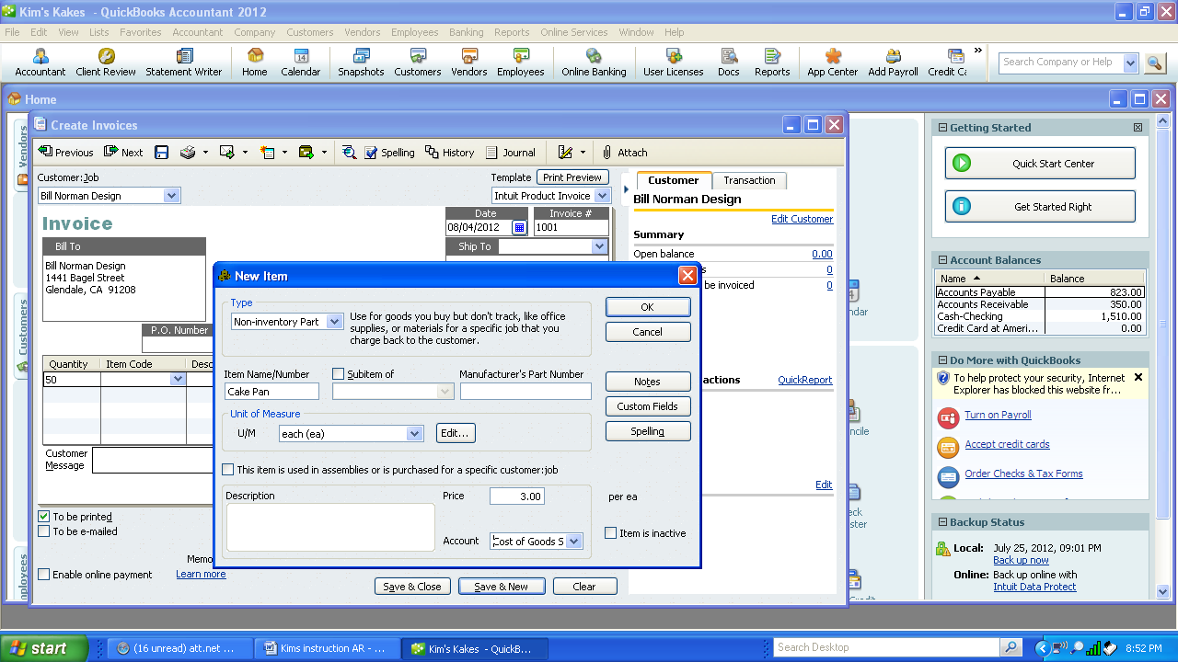

1. Select OK.
2. Select “Save and Close”.

**Record Check paid to Decorating House**

e. August 10, 200X Paid 8/1/0X *Decorating House* Invoice, CK #106, no discount $823 (G/L)

1. Select Company-Make Journal Entries. Be sure to uncheck Adjusting Entry.

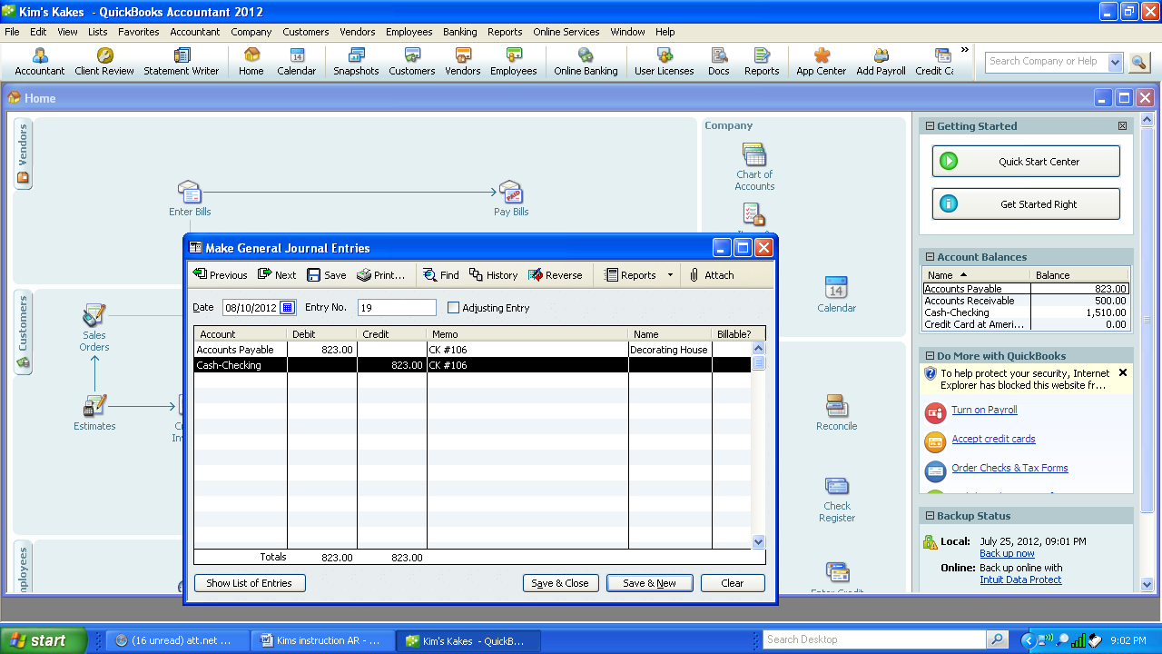

2. Enter Accounts Payable as a $823 debit, memo CK#106, Name of vendor Decorating House, Credit Cash. The remaining information is automatic.

3. Select Save & New to enter the next transaction.

**Purchased Office Supplies on Account**

f. August 10, 200X Purchased on account office supplies from *Target Stores*, $200. Add account Office Supplies as a current asset. (G/L)

1. Select Company-Make Journal Entries. Date remains the same. Add new account “Office Supplies” as other current asset.

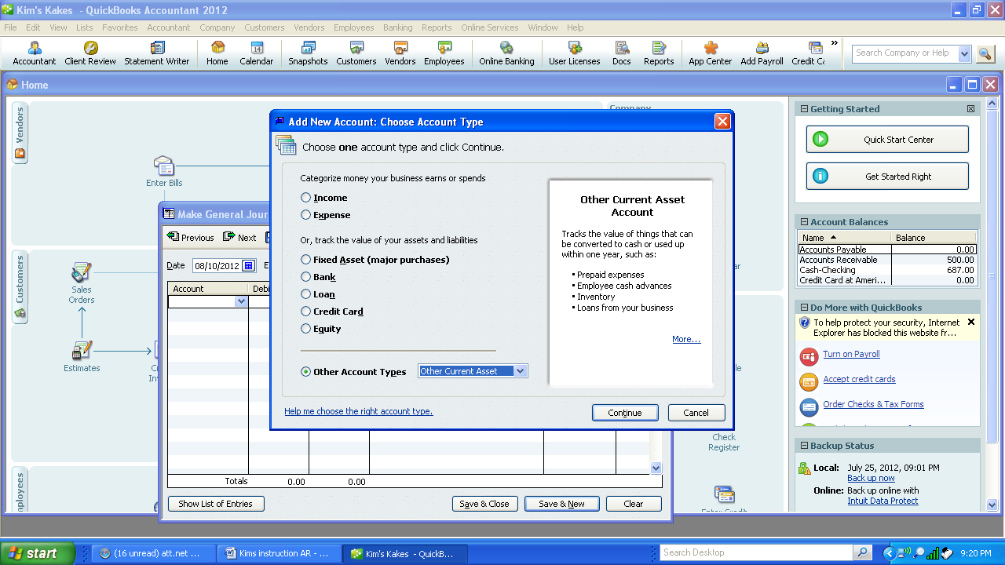

2. Add account name Office Supplies, Save and Close.

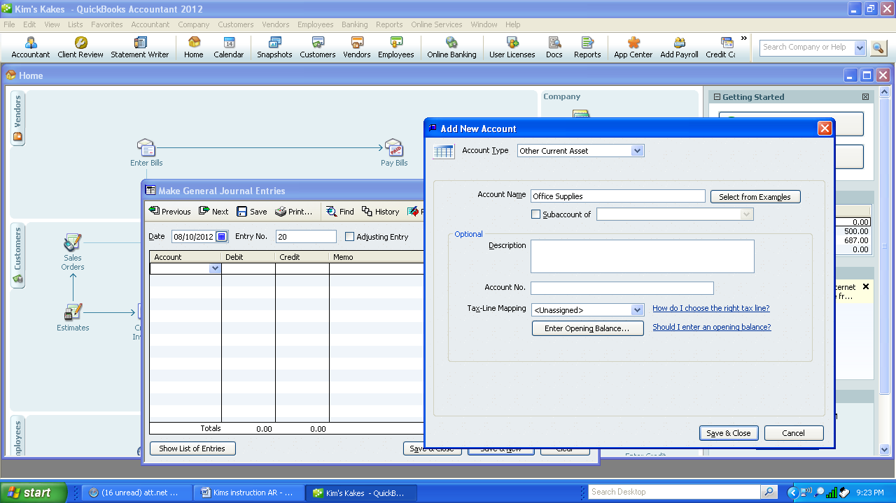

3. Enter the remaining information. Match it to the below screen. Save and Close or press enter.

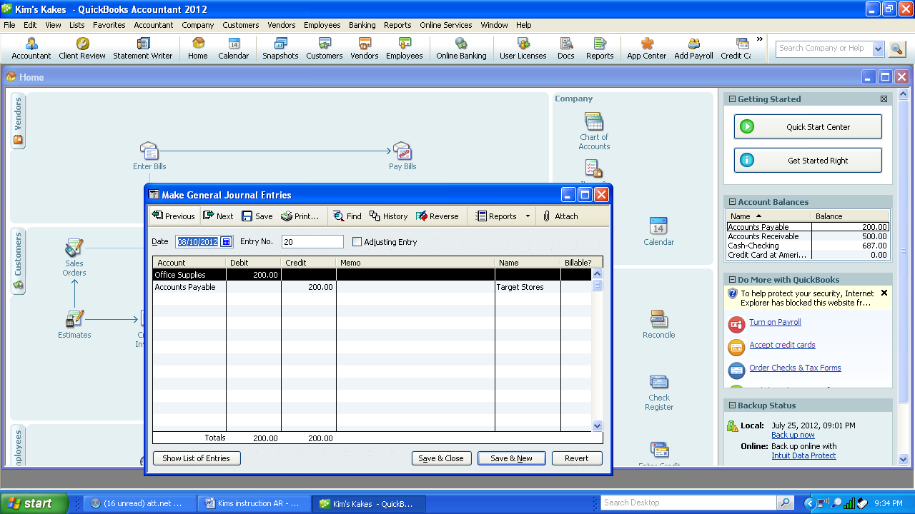

**Receive Payment from Customer**

g. August 12, 200X Received check #1122 for $343 from *Fred’s Farm*. Invoice dated 8/2.

1. Select Customers-Receive Payments or Receive Payment Icon.

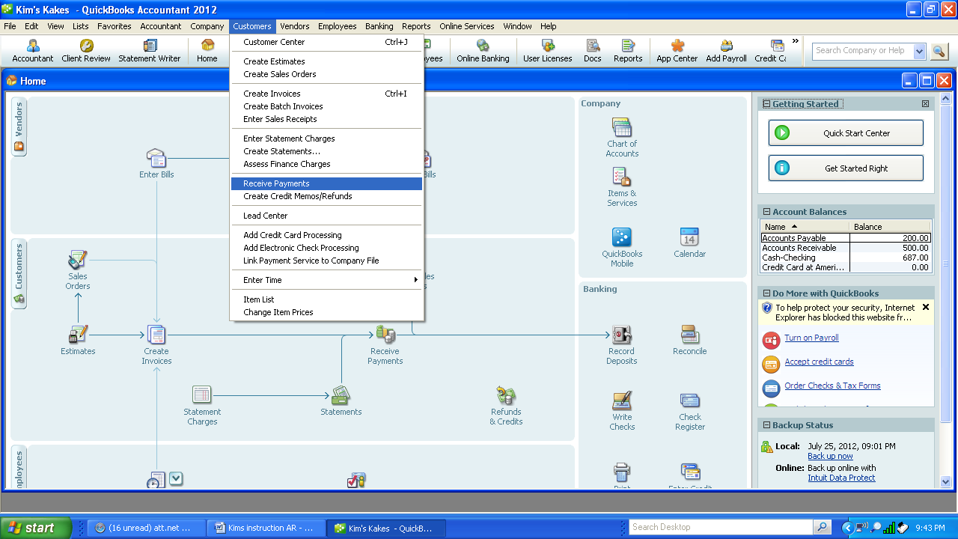

2. Select the Customer on the line Received From.

3. Enter the amount of payment in Amount. Select Discount and Credits. The $7 discount is calculated automatically. Add the account Sales Discount as an Income account.

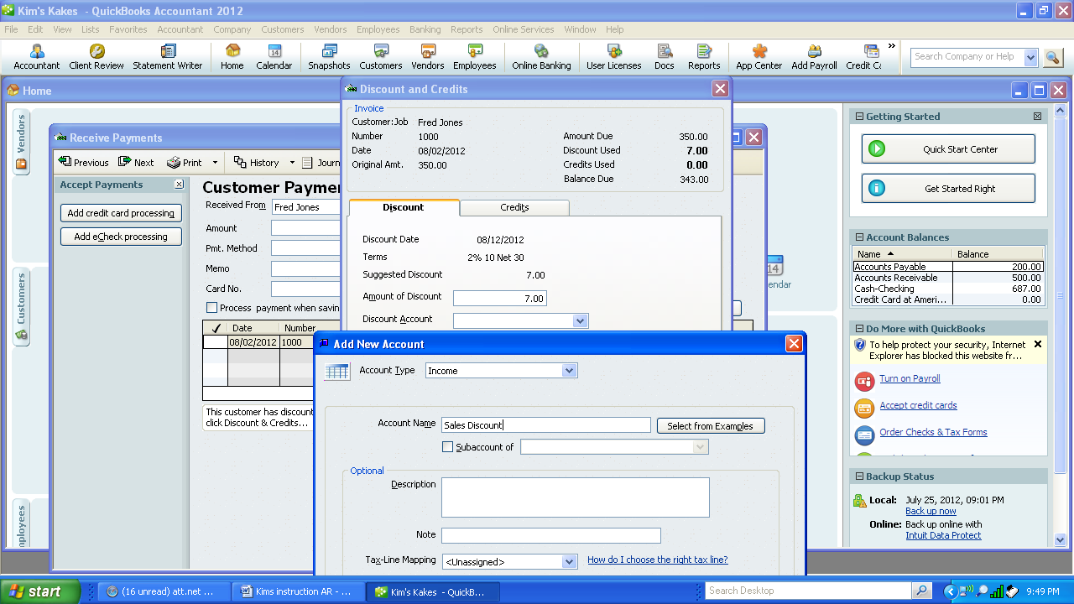

.

4. Once the payment looks like the below, select Save & Close.

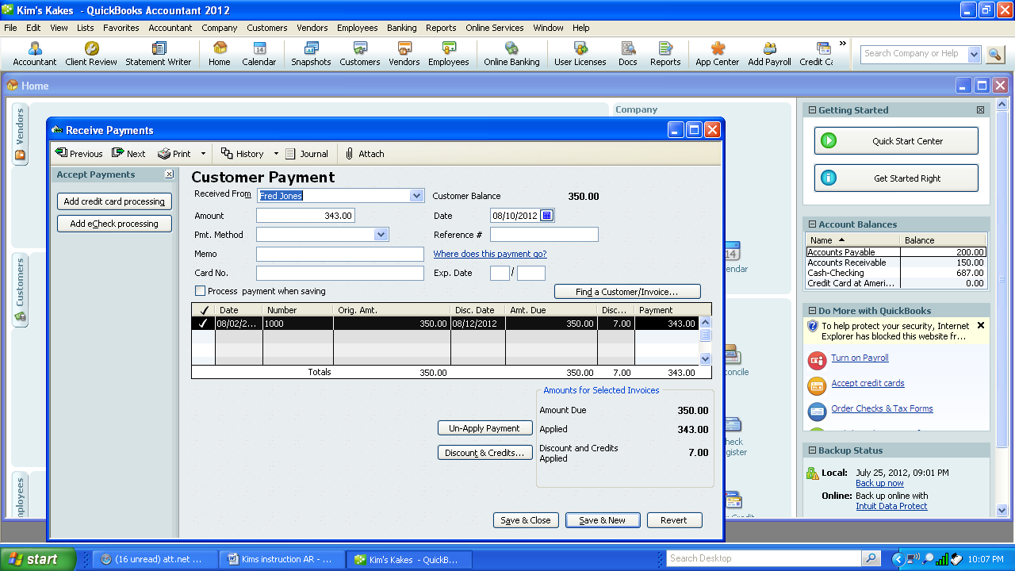

5. Confirm that the payment is recorded correctly by printing the Customer Detail Report by selecting Reports, Customer & Receivable and Customer Detail Report.

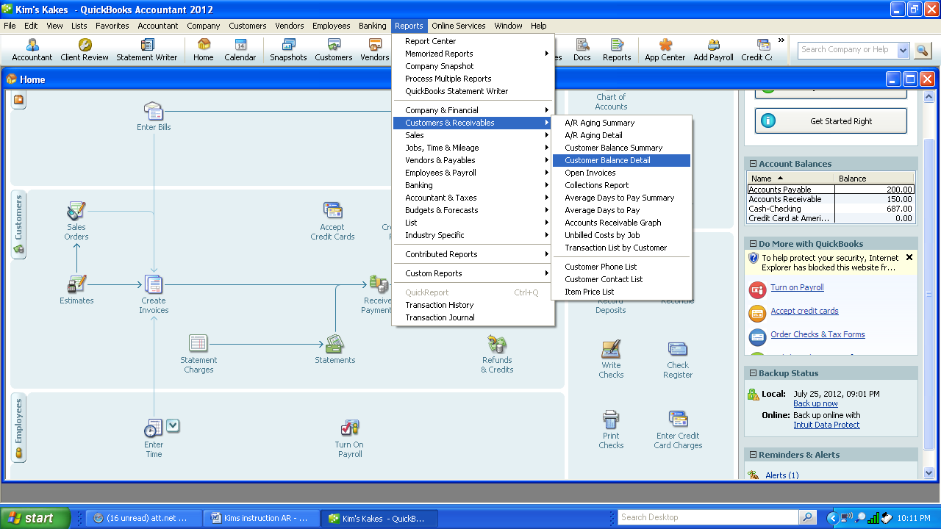

6. Fred Farms account should show the invoice for $350, a payment of $343 and a discount of $7.

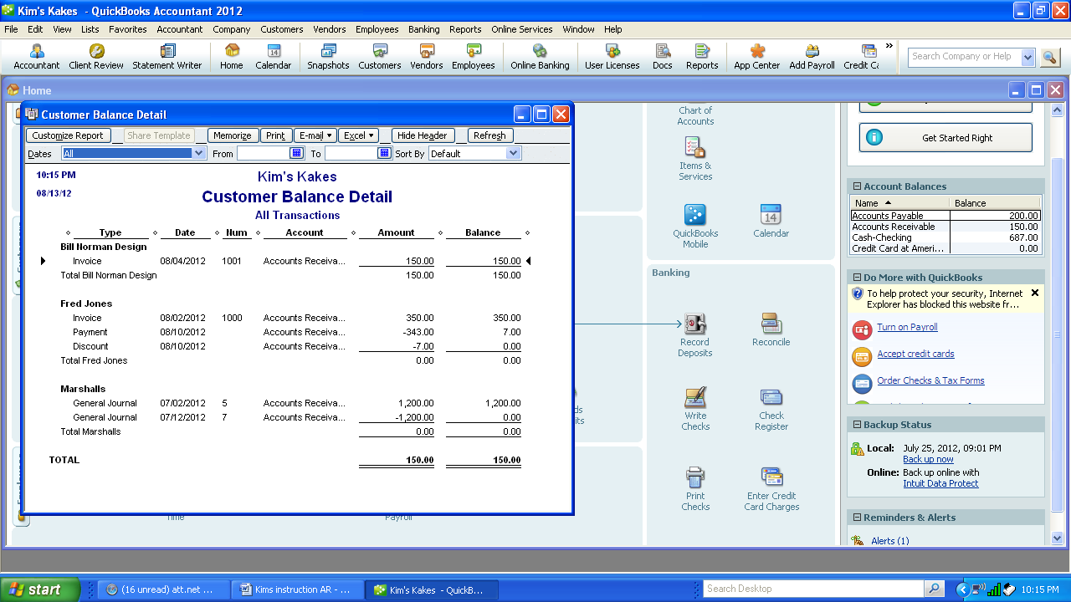

**Create Invoice with Multiple Items**

h. August 16, 200X Billed *Mall's Stores, 3 West Place*, Your City, Your State, Zip. for desserts for their Open House , P.O. 65432. Net 30, $840

Qty Description $each

5 3-layer cakes 100

6 Sheet cakes 40

100 Mini cupcakes 1

1. Select Customer-Create Invoice. Add New Customer: Mall Stores. Select OK.

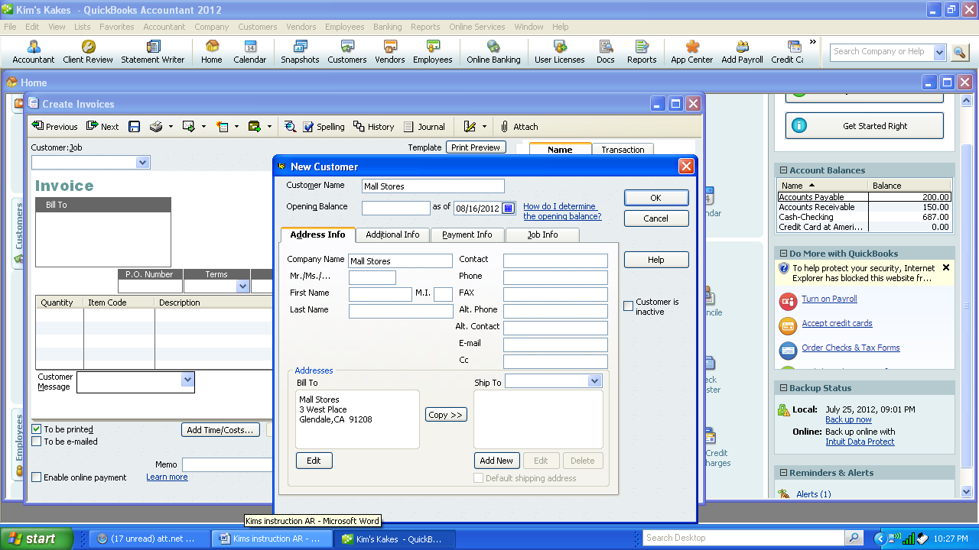

2. Add new item: Layer Cakes. Enter data and press OK.

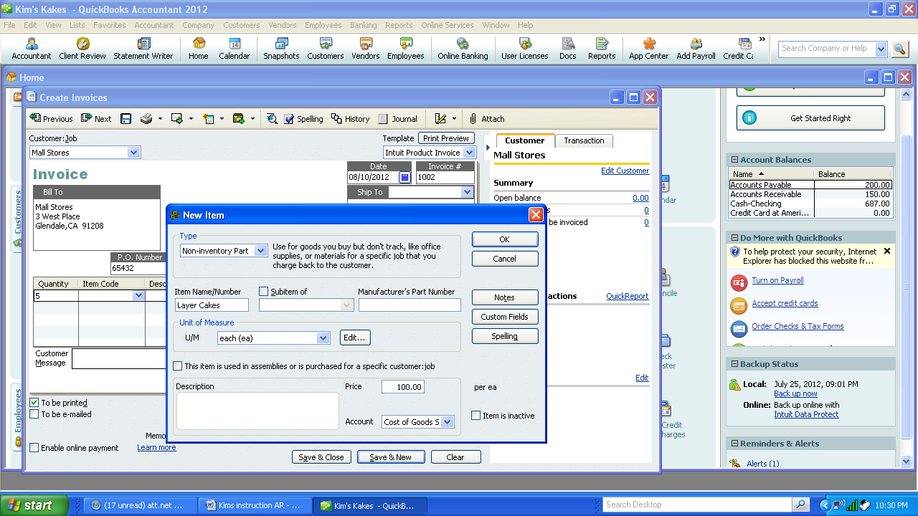

3. Add the next item by moving the cursor to the next line under quantity. Enter 6 under quantity and select sheet cakes. Item total is calculated automatically.

4. For the third line, select quantity , add new item: Mini Cupcakes.

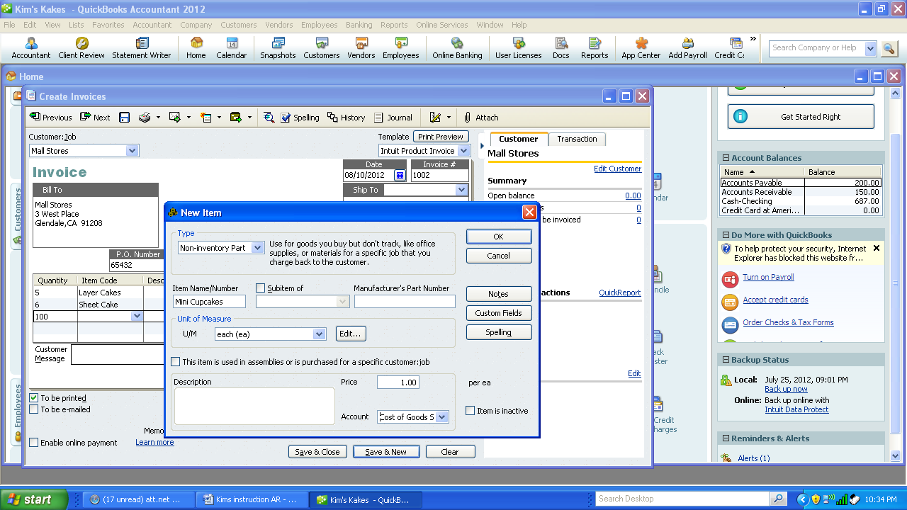

5. Compare the invoice with the following screen display.

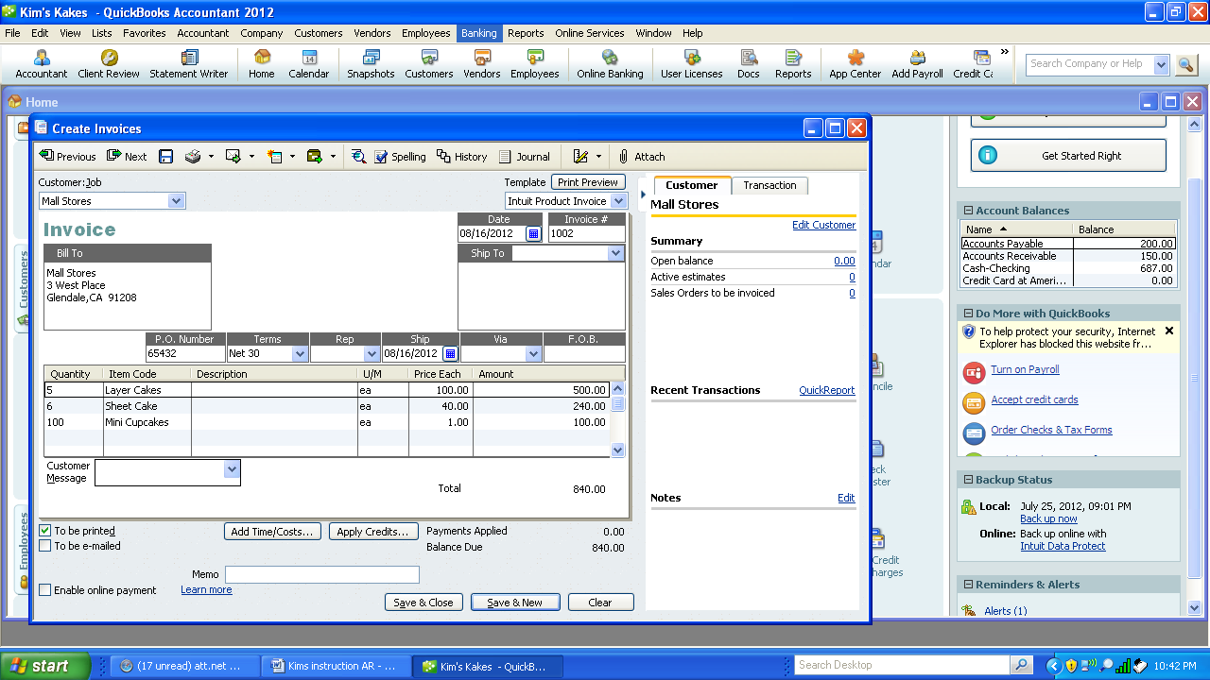

6. Once correct, print preview the invoice, then print.

**Record Return Item**

i. August 17, 200X Two sheet cakes fell while delivering the order. Give Mall Stores credit for two returned sheet cakes from 8/16 invoice. Use Sales Return and Allowance.

1. Select Customer-Create Credit Memos/Refunds or select Refund & Credits Icon.

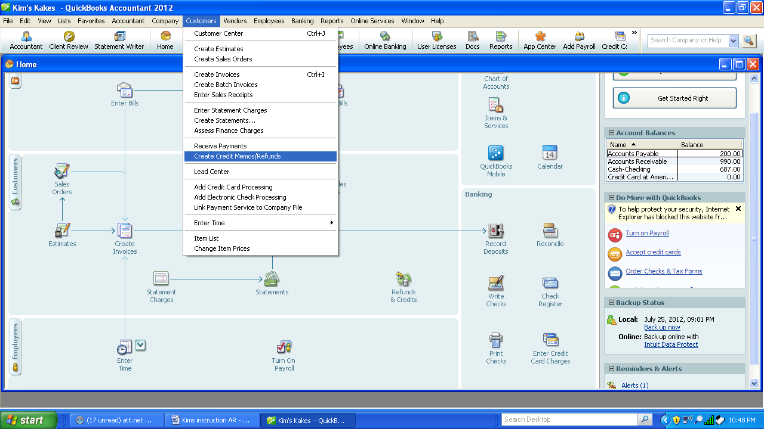

2. Enter the customer, change date, enter item, enter quantity 2, the rest of the information is automatic.

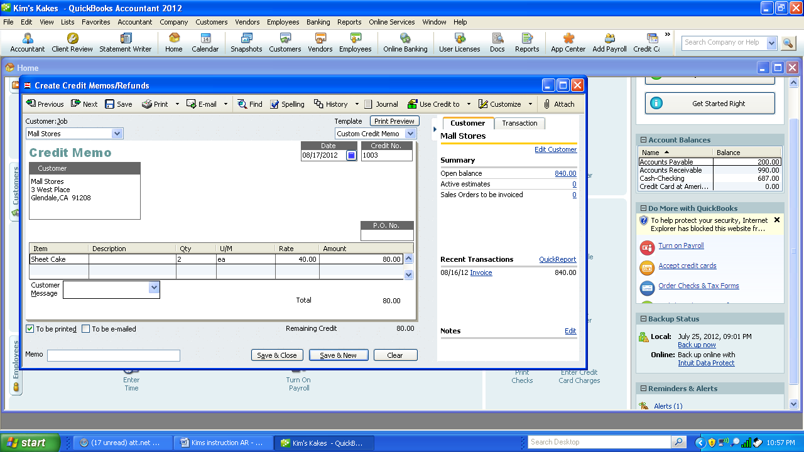

3. Print preview and then print the credit memo. 

4. Save and Close. Apply the credit to the invoice.

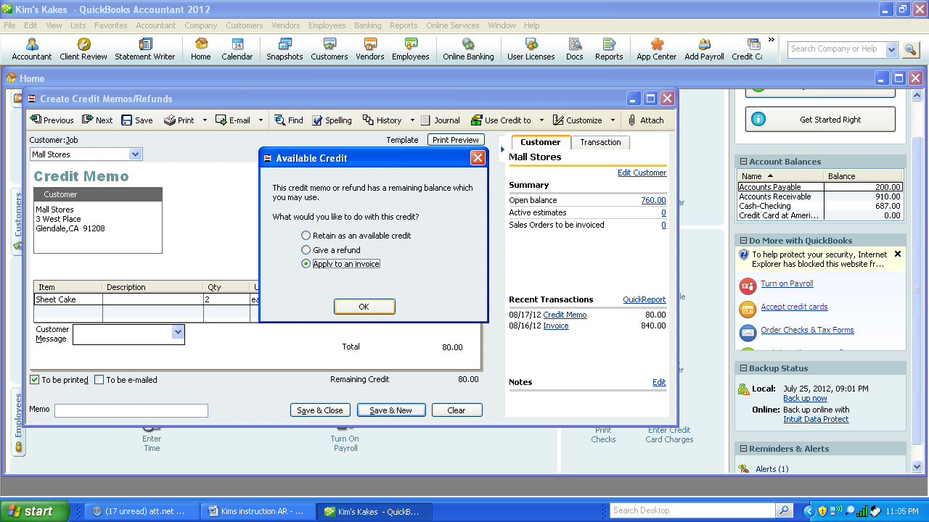

5. Select the correct invoice and select Done.

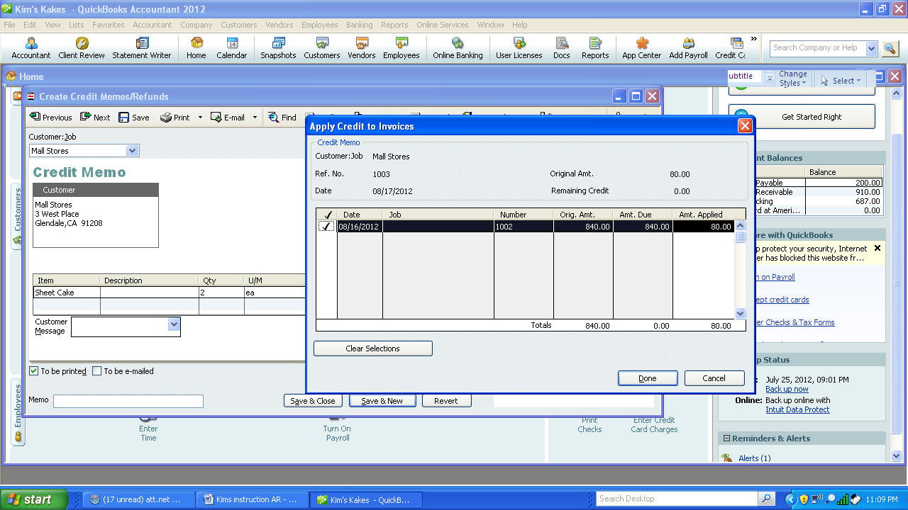

4. Check that the credit memo was recorded properly by printing the customer detail report. Select Reports-Customer-Customer Detail Report.

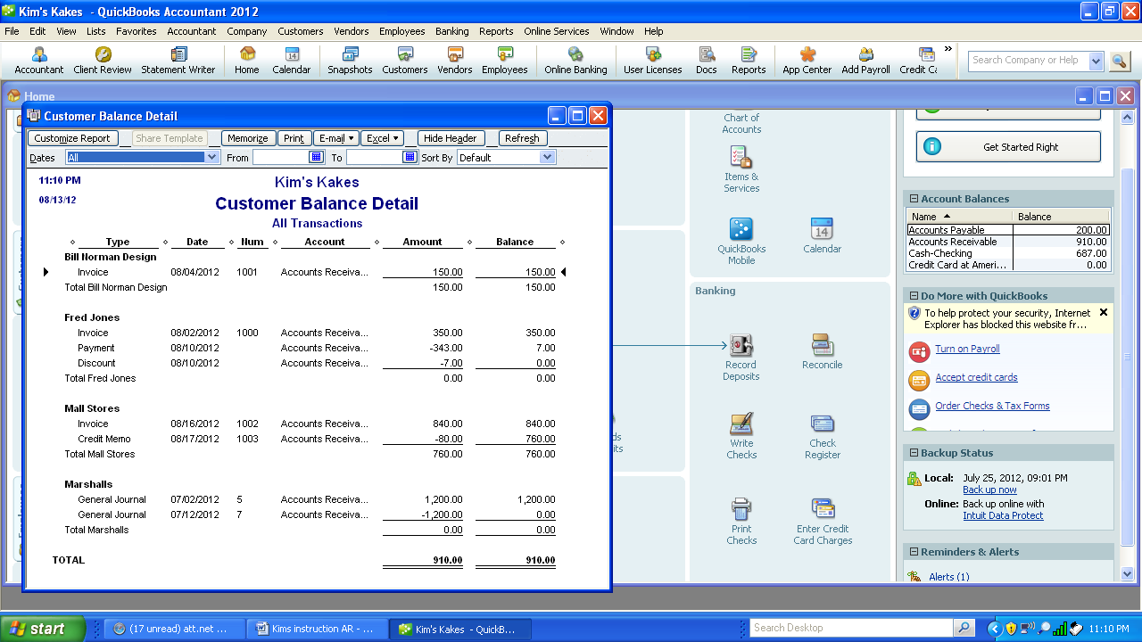

**Create Invoice – Sale on Account**

j. August 18, 200X Invoice Mall’s for 200 cupcakes @ $3.50 each. Net 30 days. Ship via delivered. No Freight. $700

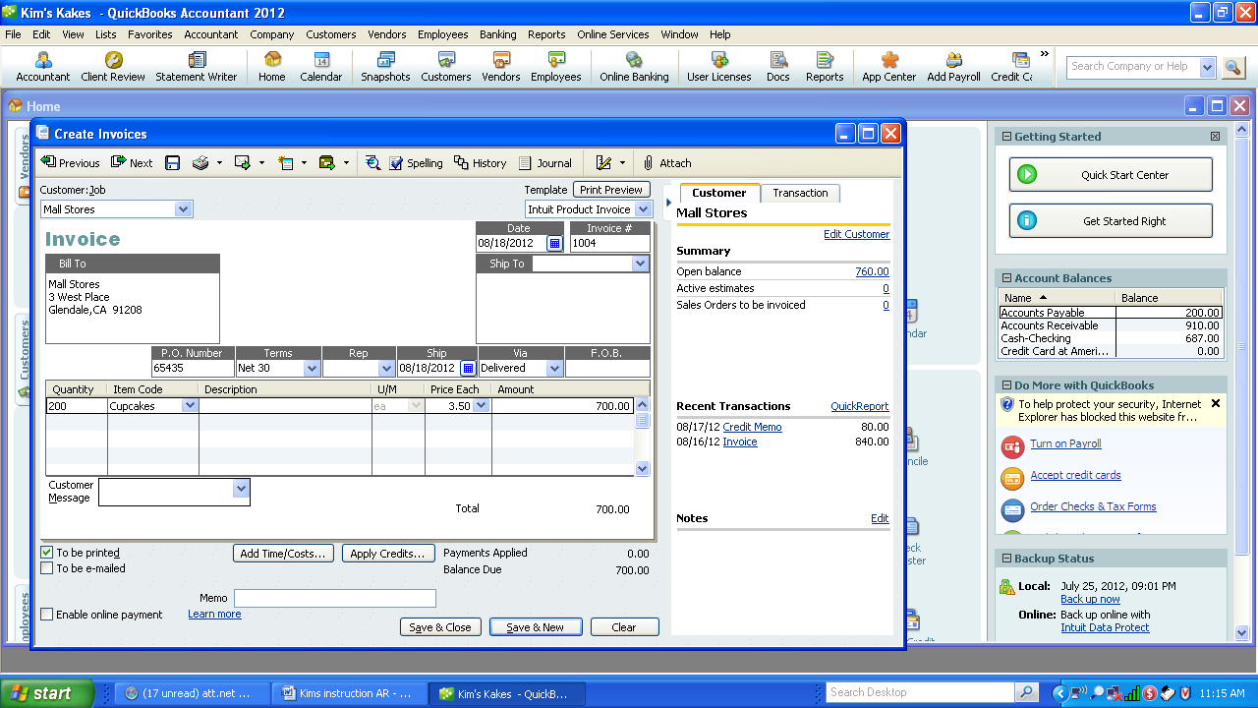

1. Record and print the invoice using previous instructions (transaction b). Note the balance information before the invoice is recorded for Mall Stores to the right.

**Cash Receipt for Mutliple Invoices**

k. August 31, 200X Received CK # 191989 for $1190 from Mall’s for all of 8/16 invoice and 1/2 of 8/17 invoice.

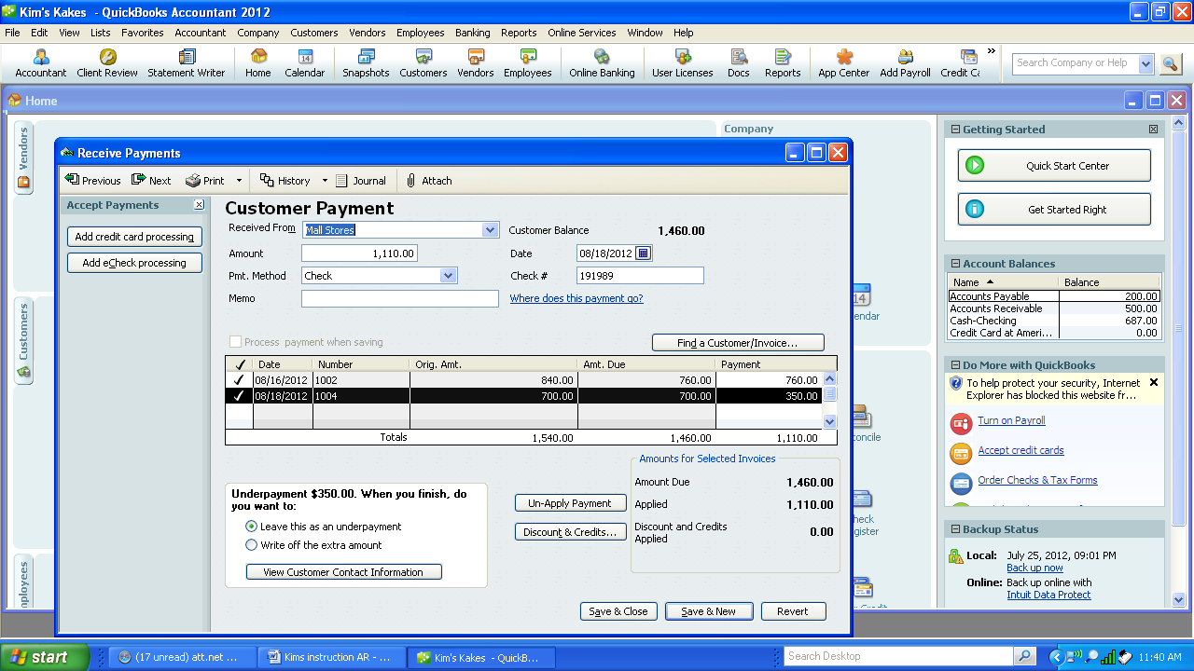

1. Enter the customer name, the amount of the check. Pmt Method is check. At this time Check# appears to enter the check #.
2. The program will automatically assume that the first invoice is fully paid and the next invoice will receive the remaining amount of the check. This can be changed by entering a different amount under payment.
3. Whenever a partial payment is made, a choice to leave the remaining balance alone as an underpayment or write it off.
4. Select Save and Close.
5. Make sure it is correctly entered by reviewing the Customer Detail Report using the previous instructions.

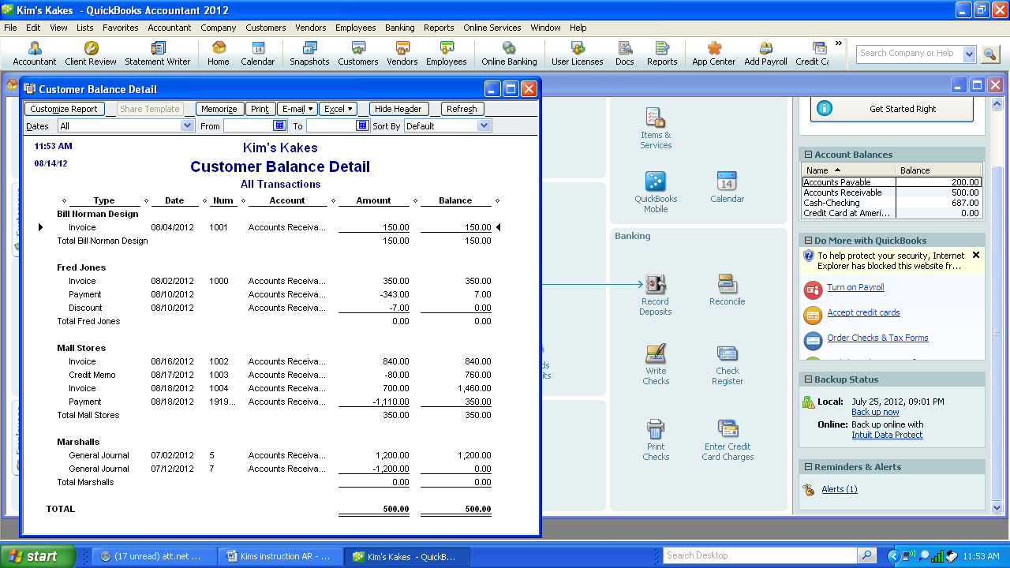

**Record Bad Debt**

l. August 31, 200X Bill Norman was nowhere to be found. Declare his account to be uncollectible. Use Bad Debt Expense to remove his account from the A/R Ledger.

1. Select Accountant Center – Write Off Invoice.

2. Enter Custom in the Age field then change the date to 08/31/xx. The outstanding invoices will appear.

3. Check the Bill Norman invoice for $150.

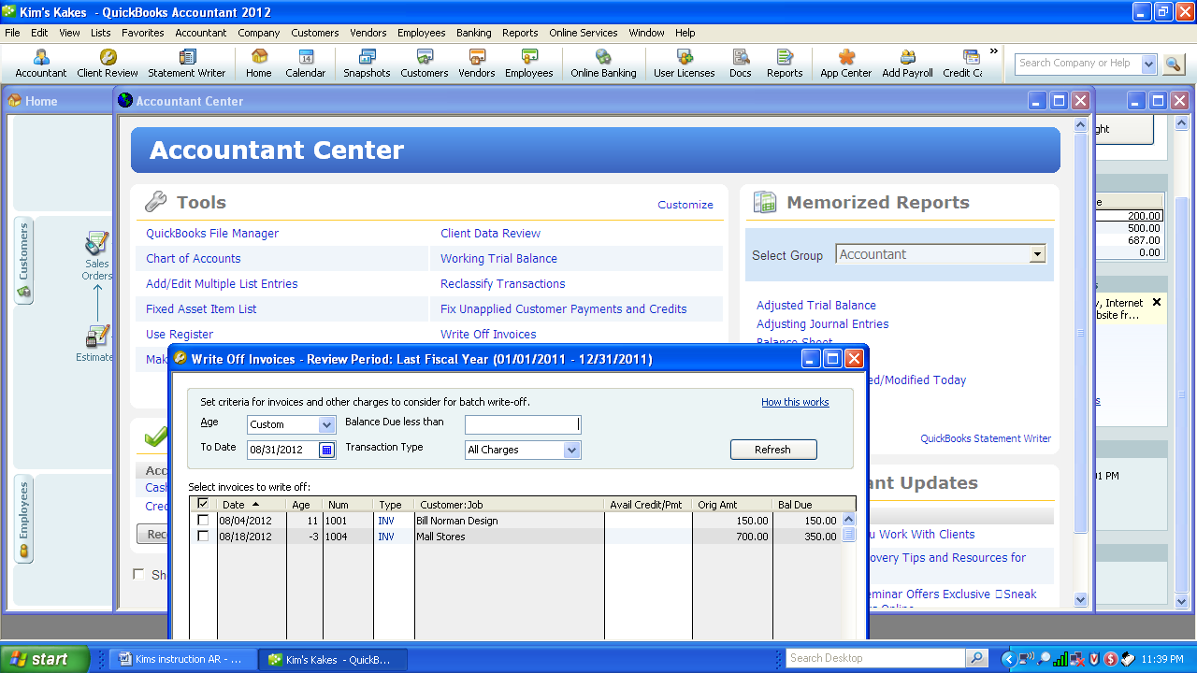

4. Enter the bad debt account “on the fly” in the account field. Change date to 08/31/XX

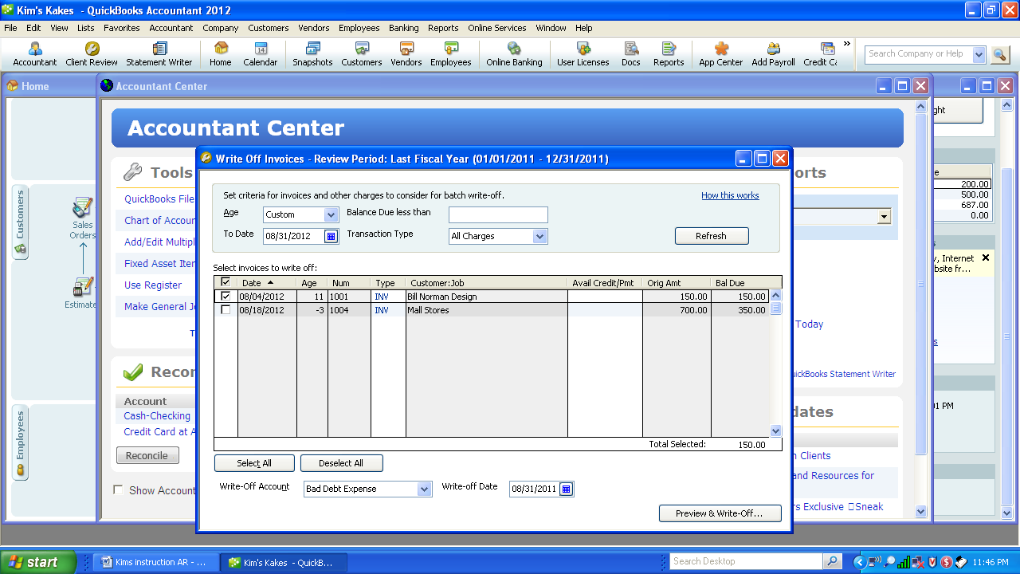

5. Select Preview and Write Off

6. If correct, select Write Off. Make sure the date is 8/31/XX.

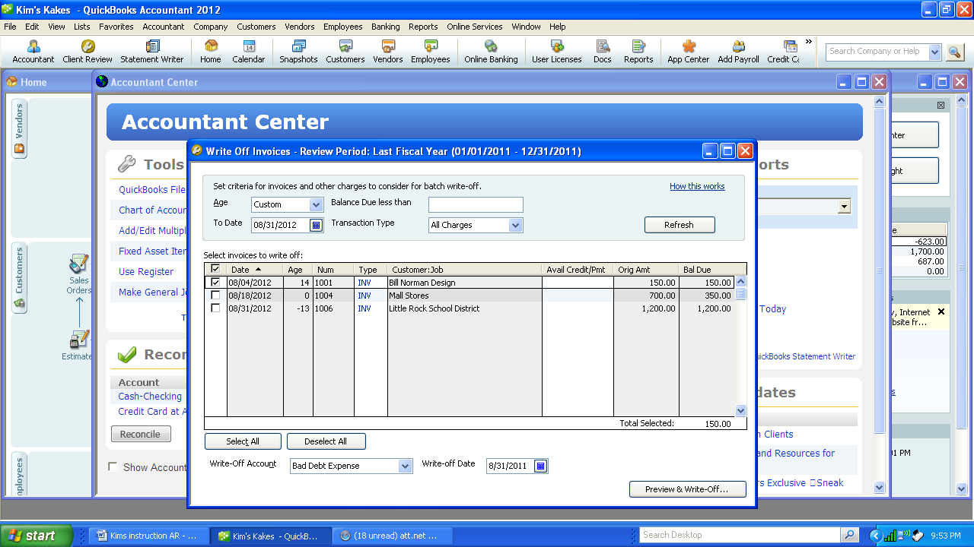

7. Check to see that it is written off into the Bad Debt Expense by going to the General Ledger.

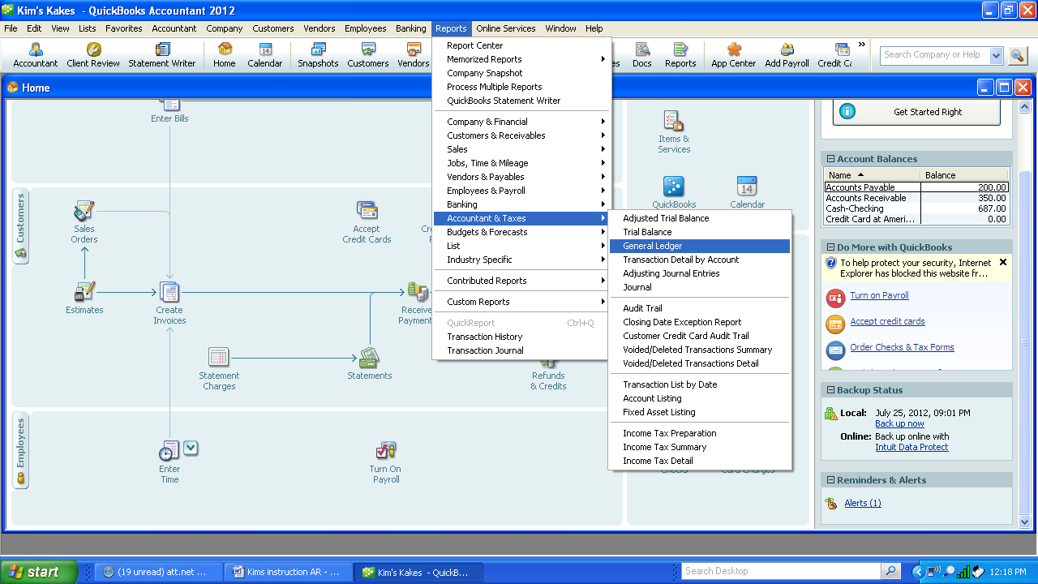

**Paid for part-time help –Add account “on- the- fly”**

m. August 31, 200X Paid Karen Lee $500 for her part-time help. CK#107. Add account: Wages Expense if needed. (G/L)

**Owner Withdrawal**

n. August 31, 200X Kim withdrew $1,000. Check #108. (G/L)

**Sales Invoice from Sales Order**

o. August 31, 200X Little Rock School District picked up and paid for their order, $1200 CK#167898.

1. Click on Create Invoices and select Little Rock School District as customer. Available Sales Orders screen appears. Click on the 8/09/xx Sales Order. Click OK.

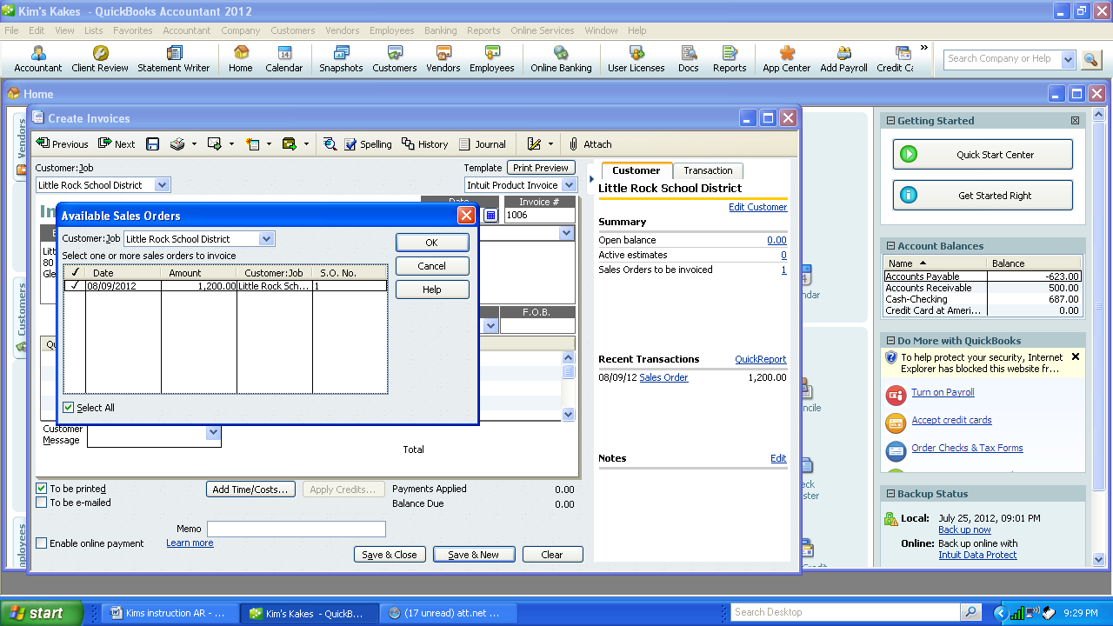

1. Create an invoice for all or some of the invoices. Select all since there is only one sales order.

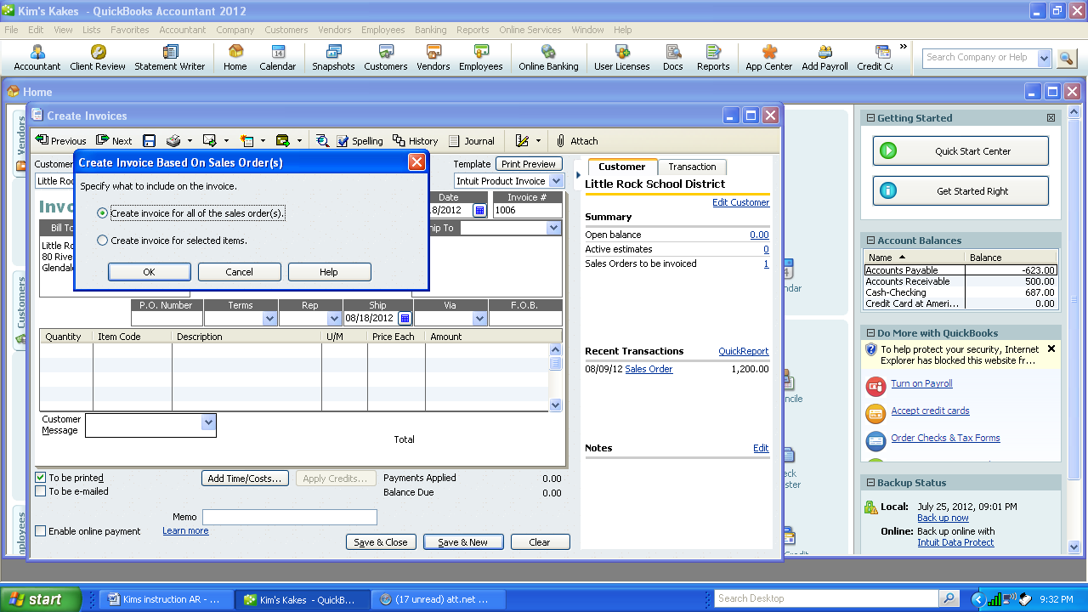

1. Compare the below invoice, if correct, print. Make sure the date is 8/31/xx since Quickbooks is date sensitive.

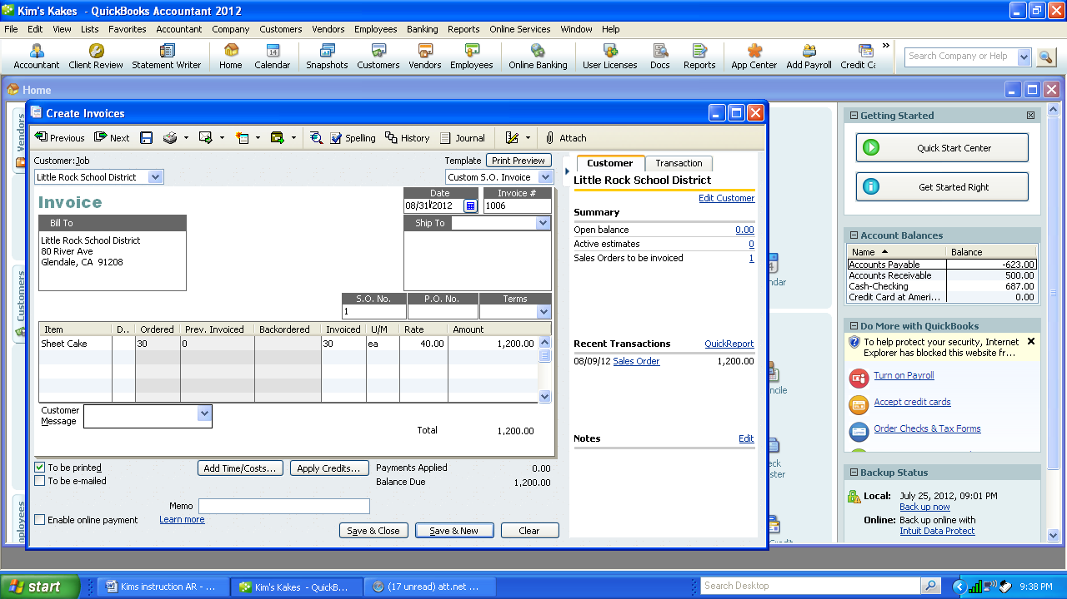

**Cash Deposit**

p. August 31, 200X Make a deposit of the cash receipt for the month. (Note for practice purpose deposits are made at the end of the month. Deposits should be made daily)

1. Select Banking—Make Deposits or Select the Record Deposit icon.

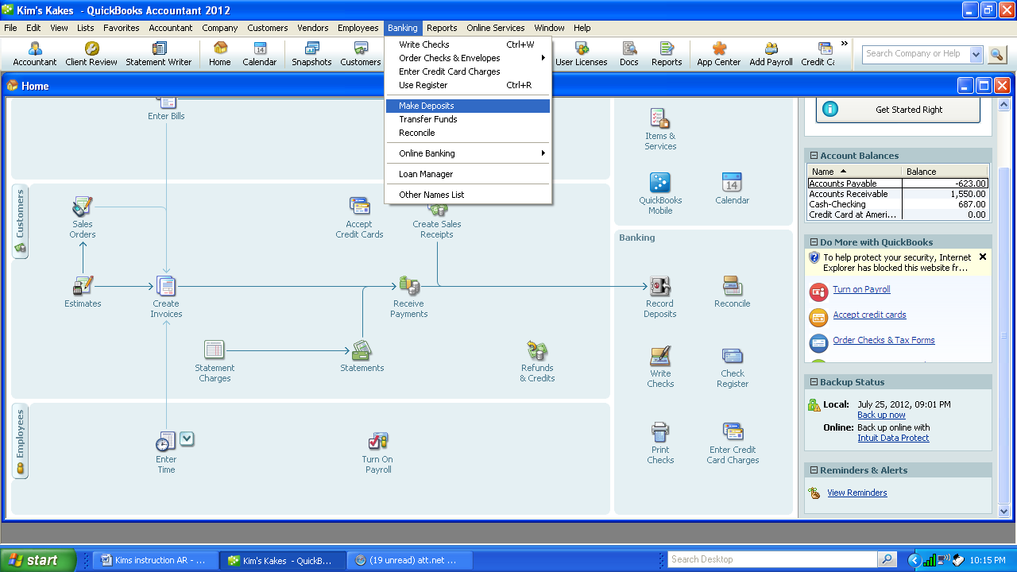

2. Undeposited cash receipts appear by customer. Select all cash receipts. Select OK

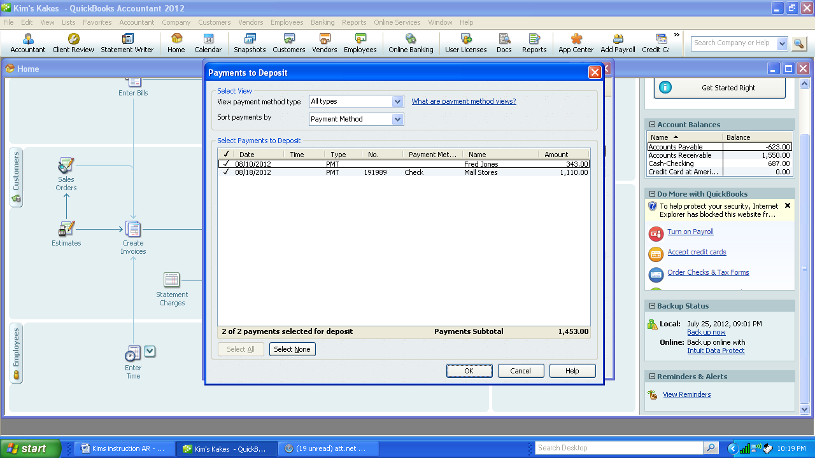

3. Review the amount and cash receipts to be deposited. Select Save and Close.   
 No Cash Back will be required.

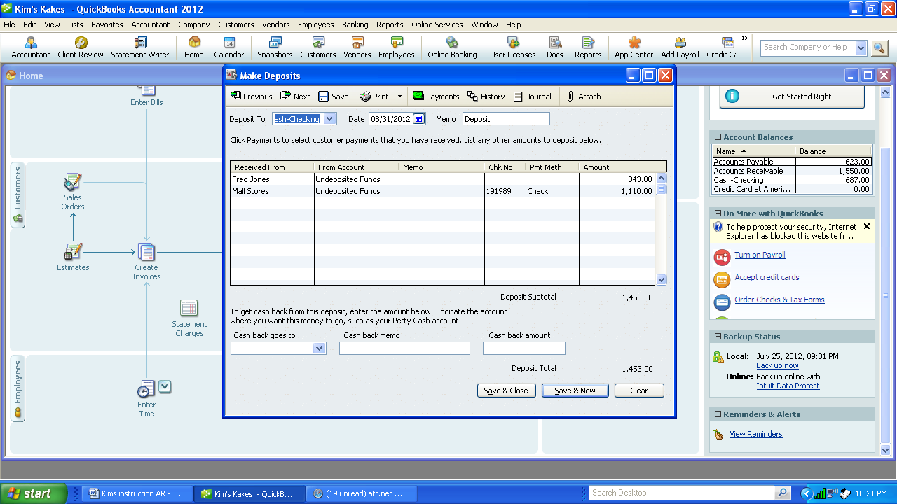

1. Be sure that Cash has increased by the deposit by checking the account “Undeposited Funds” as $0. Be sure the date is 8/31/XX

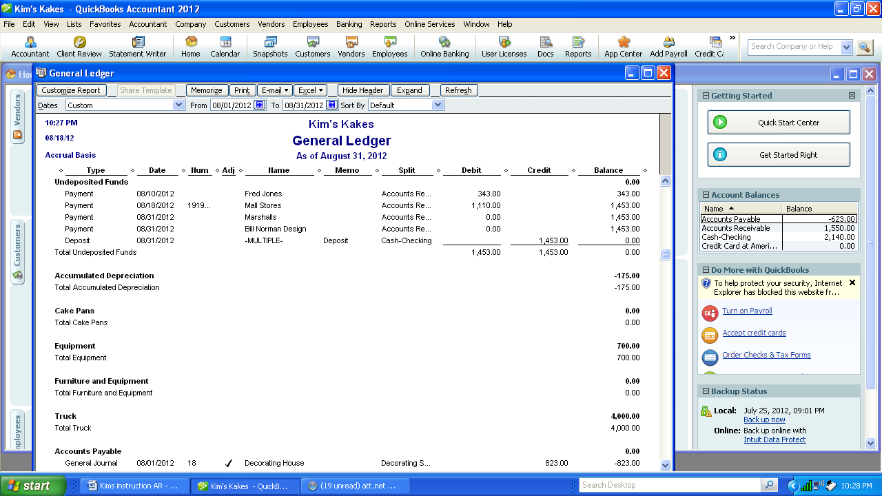

1. Check the General Ledger -Cash account to make sure it has the same amount of deposit.

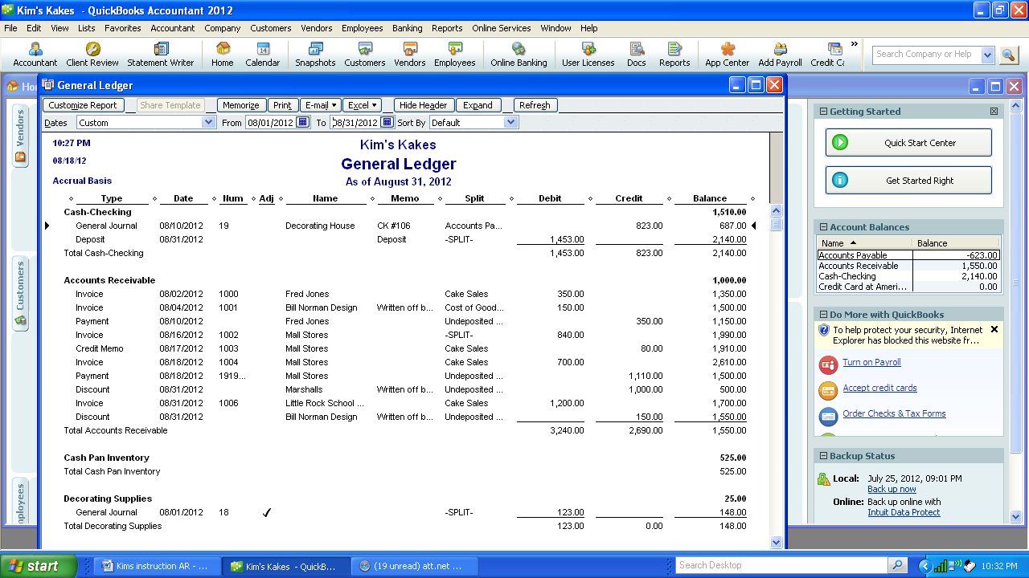

**Adjusting Entries - G/L**

p. August 31, 200X Truck Depreciation $100

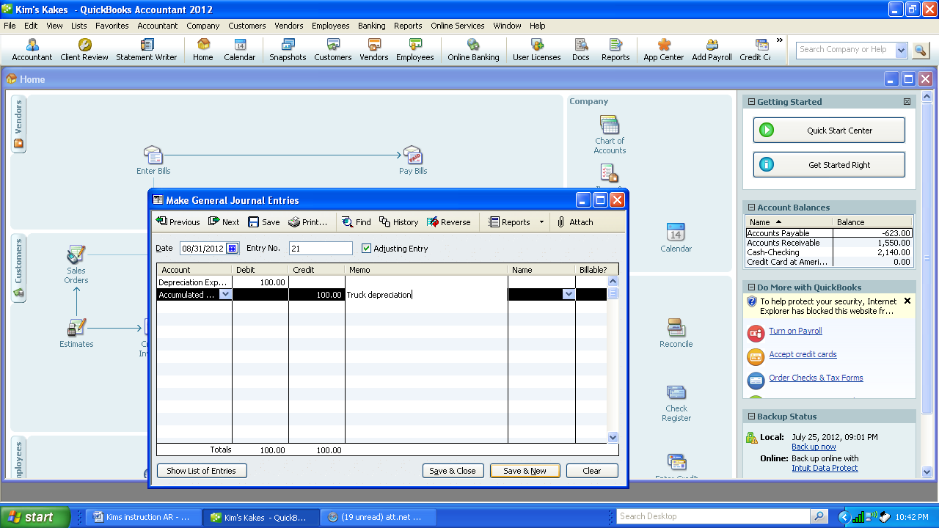

q. August 31, 200X Equipment Depreciation $175

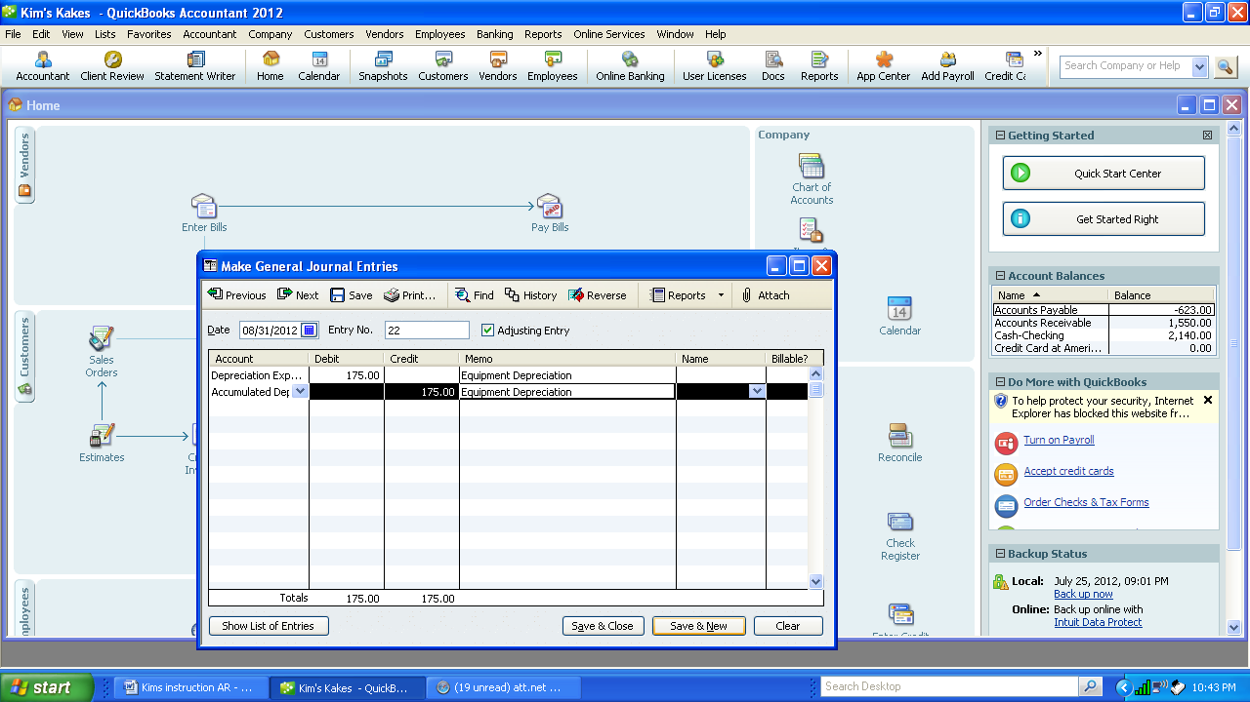

r. August 31, 200X Office Supplies ON HAND, $75 and Decorating Supplies on Hand $100 office supplies and decorating supplies account)

1. Bring the Trial Balance to the screen to determine the current balance in the two accounts: Office Supplies and Decorating supplies.

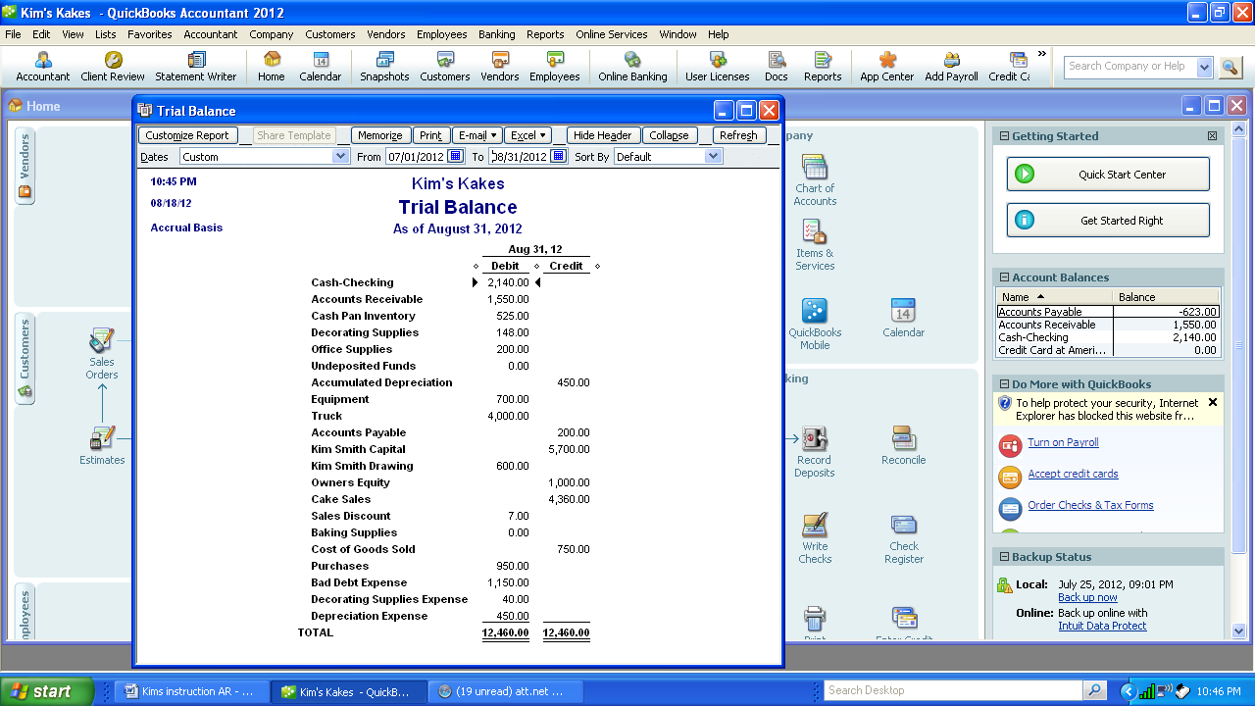

2. Subtract the balance from the amount on hand which is the amount used. The amount used is the amount of the journal entry.

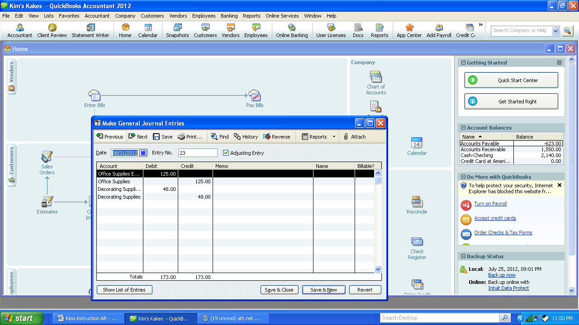

3. Review the Trial Balance to make sure Office Supplies is $75 and Decorating Supplies is $100.

