Name _____________________________ Date_____________

*Kim's Kakes*

*Bakery*

*Cover Sheet*

Chapter Three

Order of Reports to be attached :

Journal Report 7/31

Trial Balance

General Ledger

Income Statement 7/31

Balance Sheet - Standard 7/**31**

Did you make a back-up of your data files?

Section 3: Student Application: Kim’s Kakes Bakery

Basic Instructions

1. Enter the July daily transactions (be sure to uncheck adjusting entry box) and adjusting entries (check the adjusting entry box) as Journal Entries.

Use the date July 1, 201X year. Change your computer date to July 1, 201X to void getting constant error messages

1. Print the Journal Report to the screen to review it for accuracy.
2. Correct any incorrect Journal Entry by changing the data.
3. Print a Trial Balance.
4. Print an Profit & Loss (Income) Statement. Be sure you have a 7/31 date.
5. Print a Balance Sheet-standard. Be sure to use the end of month date 7/31 or your report numbers will be incorrect.
6. Make an archival or back-up disk.
7. Print the General Ledger
8. Close the month.
9. Compile all reports and attach them to the cover sheet in the order given on the cover sheet.

**OVERVIEW OF JULY TRANSACTIONS:**

# Original Investment

a. July 1, 20X2 Kim Smith invested $1,000 cash, $700 equipment, $4,000 truck.

# Purchased Supplies with Cash

b. July 1, 20X2 Purchased decorating supplies from Michaels Store for $65, Check #101

## Sale on Account

c. July 2, 20X2 Kim baked several sheet cakes for Marshall’s Open House, $1,200 Net 30.

## Purchases for Cash

## d. July 10, 20X2 Purchased baking supplies (cake mixes, frosting etc) from Maddie’s Grocery Store, $250, Check #102

**Received Payment on Account**

e. July 12, 20X2 Received $1,200 from Marshall’s, Inc., Check #15123.

**Owner Withdrawals**

f. July 15, 20X2 Kim withdrew $300, Check #103.

**Purchase on Account**

g. July 15, 20X2 Purchased cake pans for resale on account from Decorating House, $525, 2/10 net 30

**Cash Sale**

h. July 16, 20X2 Created a decorated 5 layer cake for Seda Evans’s Wedding. Received full payment at the end of the wedding, $750, Check # 760.

**Paid Vendor on Account**

i. July 30, 20X2 Paid Decorating House $525, Check #104. No Discount

**Owner Withdrawals**

j. July 31, 20X2 Kim withdrew $300, Check # 105.

**Adjusting entries**

k. July 31, 20X2 Truck Depreciation, $100.

l. July 31, 20X2 Equipment depreciation, $75.

m. July 31, 20X2 Decorating supplies on hand, $25 (adj. $40).

**STEP BY STEP INSTRUCTIONS:**

# Instruction 1: Enter July Daily Transactions

# Original Investment

a. July 1, 20X2 Kim Smith invested $1,000 cash, $700 equipment, $4,000 truck.

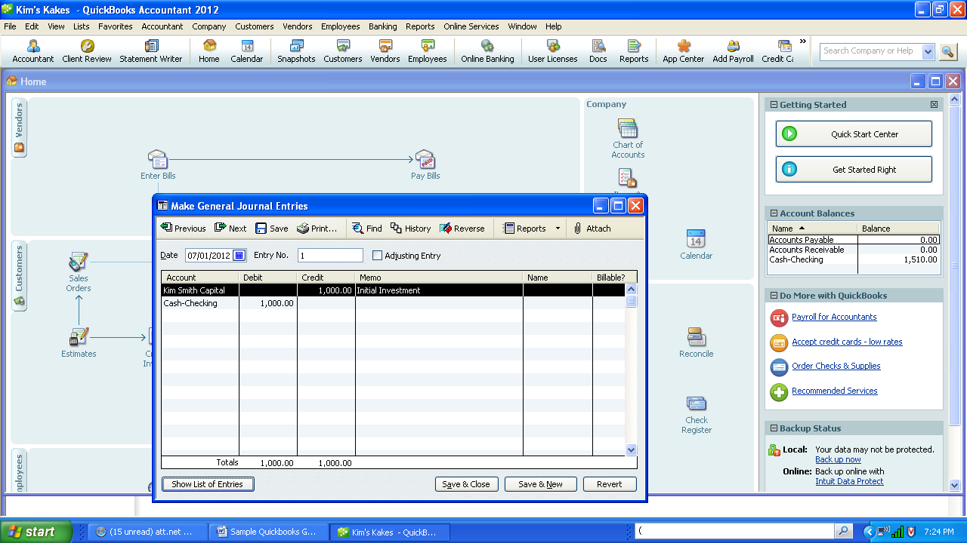

Note: This transaction could be entered as one compound entry or as three separate entries

1. From the Menu Bar select Company, Make General Journal Entries from Pull Down Menu.
2. Make sure to uncheck the Adjusting Entry box.
3. Check transaction date. Change if incorrect.
4. Entry number is automatic. After the first JE it will increase the number by one.
5. Enter Cash in the Account field. Cash- checking account appears automatically. Enter 1000 in the debit field, press tab to enter Initial Investment in the Memo field.
6. Enter the next account Kim Smith Capital Press tab. Enter the 1000 in the credit field.
7. Click on the button “Save & New” to go onto the next transaction.
8. The screen is cleared ready for the next entry.
9. Acounts receivable and Accounts Payable needs to add the customer or the vendor to the journal entry. The customer and vendor name can be added “on-the-fly” by selecting <New>. At this point in time just enter the name. Other information will be provided in the next chapters.

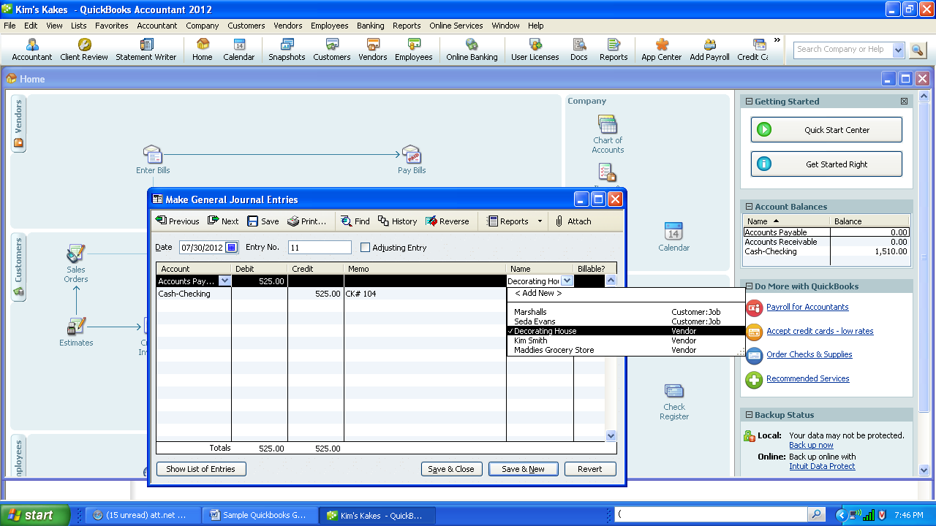

**Instruction 2: Print the journal report to the screen, once correct print a hard copy.**

1. Click on Reports , Accountant & Taxes, Journal.

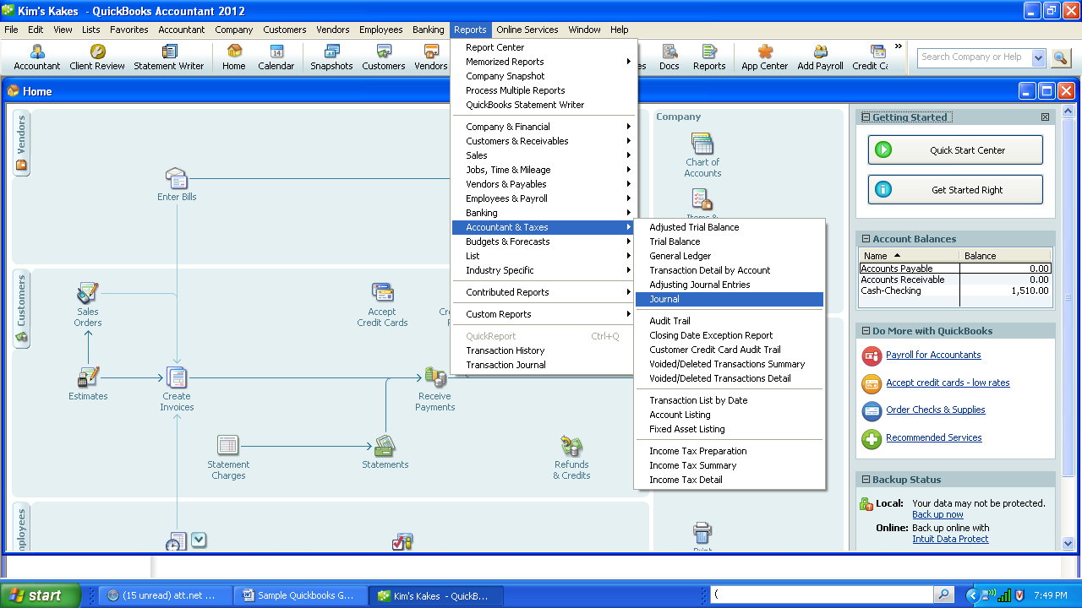

1. Verify this data in each field:

Dates: Month-to-date

From: 7/01/X2 to 07/31/X2

Select Print

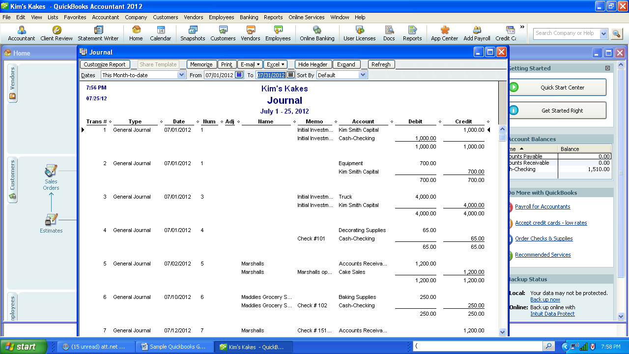

1. Make sure the Printer is the correct one. If not, select the correct printer by clicking on the down arrow to change the printer.

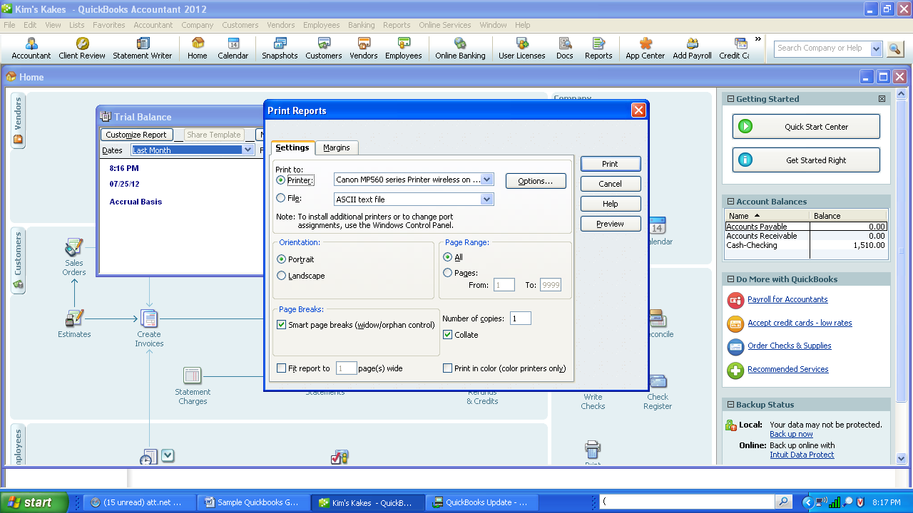

1. Preview the report. Compare your hard copy to the Report 2-1 to verify your numbers.
2. If OK, Click on Print.
3. Also note that the date and time are printed at the top of each report. This is helpful if you print more than one copy of the report.

**Instruction 3: Correct any incorrect journal entry.**



1. Select Previous or Next to get to the transaction Entry No. that needs to be corrected.
2. Change the field that needs to be correct.
3. Press enter and a message box will appear asking for verification of your change. Click on Yes.
4. If you need to delete the transaction, simply select Reverse the entry
5. Note that it is important to learn to correct your entries. Now is a good time to learn as it does not affect your job. Do not be upset if you need to make corrections. Use this safe environment to find the type of errors you normally make.

**Instruction 4: Print Trial Balance**

1. Click on Reports , Accountant & Taxes, Trial Balance
2. Compare to the Report 2-3.

**Instruction 5: Print General Ledger**

1. Click on Reports , Accountant & Taxes, General Ledger
2. Compare to the Report 2-4.

**Instruction 6: Print Profit and Loss (Income) Statement**

1. Click on Reports , Company & Financial, Income Statement
2. Compare it to Reports 2-5

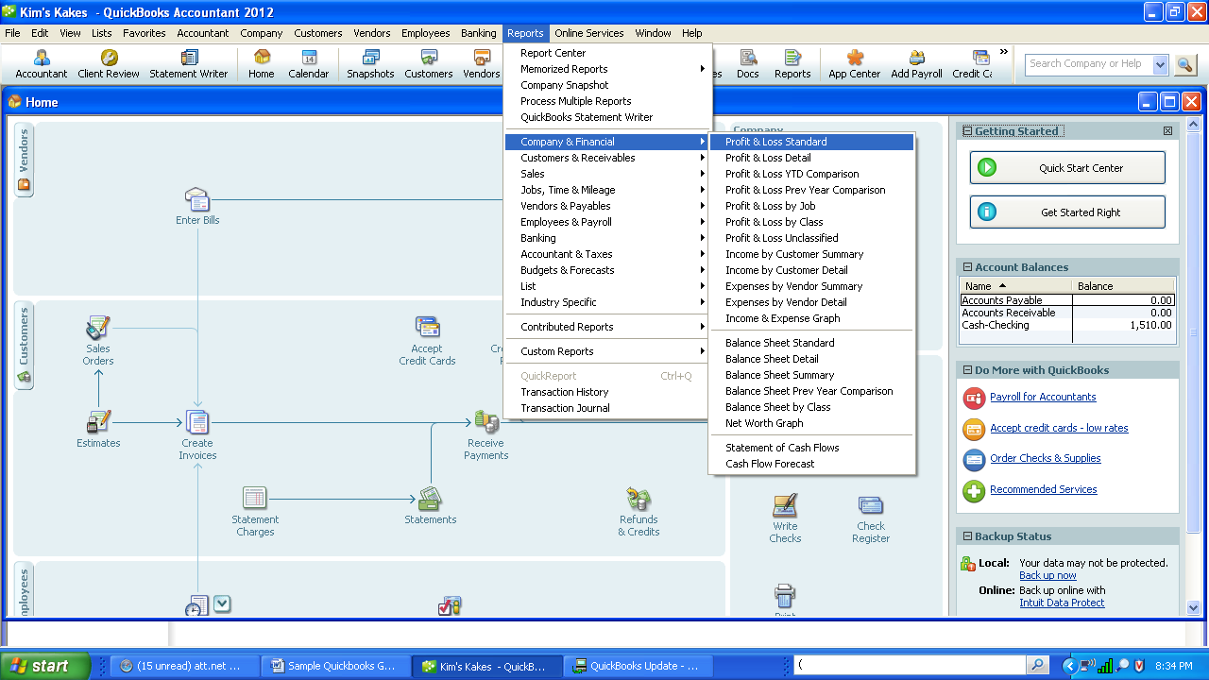

**Instruction 7: Print Balance Sheet- Standard**

1. Click on Reports , Company & Financial, Balance Sheet Standard
2. Compare it to Reports 2-6

**Instruction 7: Make Back-up data (Archival) Disk**

1. Make sure the figures are correct.
2. Insert a CD or a USB Flash Drive.
3. Select Local Back-up

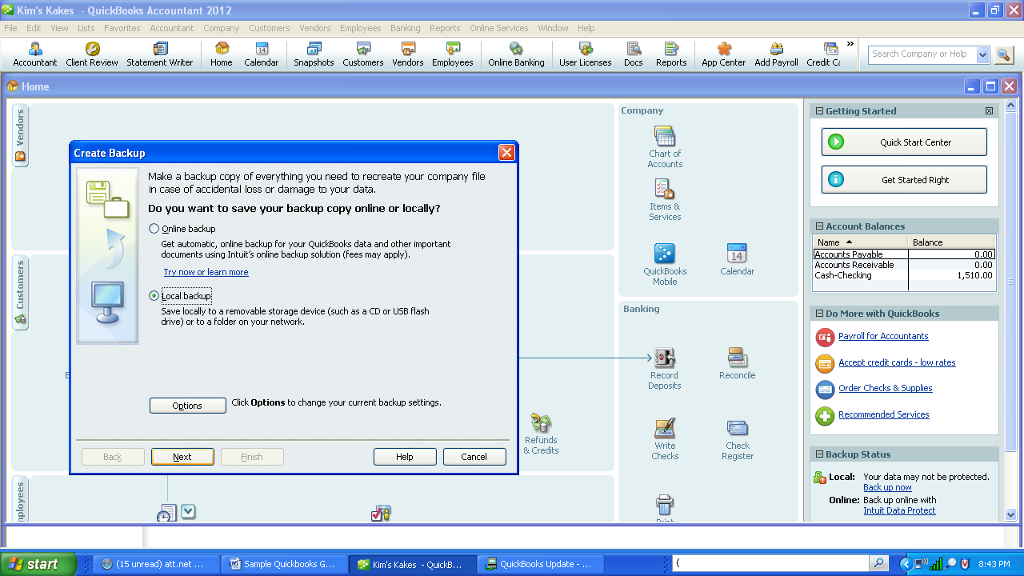

1. Browse to find the location of the USB flashdrive.

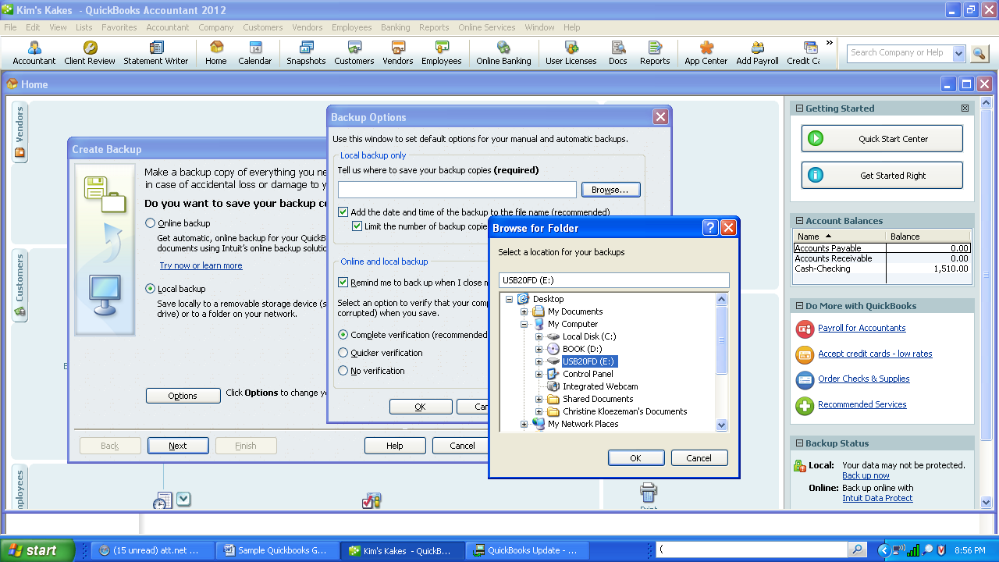

1. Click on “Save It Now”.
2. Make sure the file name is correct Kim's Kakes (Backup Jul 31,20X2 08 59 PM)

Name __________________________ Date __________ Larry’s Auto Repair Service



Cover Sheet Chapter 3 General Ledger

Order of Report to be attached:

Journal Report

Trial Balance

General Ledger

Income Statement 7/31

Balance Sheet - Standard 7/31

Did you make your archival disk and a backup disk?

Name __________________________ Date________

**C:\Documents and Settings\ckloezem\Local Settings\Temporary Internet Files\Content.IE5\GE7WAE0C\MC900020073[1].wmf**

**ABC**

**Daycare Ctr**

**COVER SHEET**

**Chapter Three**

**General Ledger Setup**

**Order of Reports to be attached:**

Journal Detail Report

Trial Balance- Detail

General Ledger - Summary

Profit and Loss Statement 7/31

Statement of Financial Position 7/31

**Did you make an archival disk and a back-up copy?**

A U D I T T E S T

Chapter 3--Kim

1. How much cash was received by the company? ________

(How much is on the debit side of the cash account)

1. How much cash did the company pay out? ________

(How much is on the credit side of the cash account)

1. What is the balance in A/R? ________
2. What is the balance in A/P? ________
3. Balance in Owner's Equity? ________
4. Total Sales or Service Income? ________
5. Total Advertising Expense, if any ________
6. What is the account balance for Cash? ________
7. What is the Total Expense for the month? ________
8. What is the total Net Income for the month? ________
9. How much is the total assets? ________

A U D I T T E S T - Detail

Chapter 3

Detail

1. How much cash was received by the company? ________
2. How much cash did the company pay out? ________
3. What is the balance in A/R? ________
4. What is the balance in A/P? ________
5. Balance in Owner's Equity? ________
6. Total Sales or Service Income? ________
7. Total Advertising Expense? ________
8. What is the account balance for Cash? ________
9. What is the Total Expense for the month? ________
10. What is the total Net Income for the month? ________
11. How much is the total assets? ________

A U D I T T E S T - ABC

Chapter 3

ABC

1. How much cash was received by the company? ________
2. How much cash did the company pay out? ________
3. What is the balance in A/R? ________
4. What is the balance in A/P? ________
5. Balance in Owner's Equity? ________
6. Total Sales or Service Income? ________
7. Total Advertising Expense? ________
8. What is the account balance for Cash? ________
9. What is the Total Expense for the month? ________
10. What is the total Net Income for the month? ________
11. How much is the total assets? ________